Nuclear Radius
Name__________________________
Q1.
(a) Calculate the radius of the U nucleus.
r₀ = 1.3 × 10^{–15} m
___________________________________________________________________
___________________________________________________________________
___________________________________________________________________
___________________________________________________________________
(2)
(b) At a distance of 30 mm from a point source of rays the corrected count rate is C.
Calculate the distance from the source at which the corrected count rate is 0.10 C, assuming that there is no absorption.
___________________________________________________________________
___________________________________________________________________
___________________________________________________________________
___________________________________________________________________
(2)
(c) The activity of a source of β particles falls to 85% of its initial value in 52 s.
Calculate the decay constant of the source.
___________________________________________________________________
___________________________________________________________________
___________________________________________________________________
___________________________________________________________________
___________________________________________________________________
(3)
(d) Explain why the isotope of technetium, ⁹⁹Tc _{m}, is often chosen as a suitable source of radiation for use in medical diagnosis.
You may be awarded additional marks to those shown in brackets for the quality of written communication in your answer.
___________________________________________________________________
___________________________________________________________________
___________________________________________________________________
___________________________________________________________________
___________________________________________________________________
___________________________________________________________________
___________________________________________________________________
(3)
(Total 10 marks)
Q2.
The radius of a nucleus, R, is related to its nucleon number, A, by
, where r₀ is a constant.
The table lists values of nuclear radius for various isotopes.

Element | R/10^{–15} m | A
carbon | 2.66 | 12
silicon | 3.43 | 28
iron | 4.35 | 56
tin | 5.49 | 120
lead | 6.66 | 208
(a) Use the data to plot a straight line graph and use it to estimate the value of r₀.
___________________________________________________________________
___________________________________________________________________
___________________________________________________________________
___________________________________________________________________
___________________________________________________________________
___________________________________________________________________
___________________________________________________________________
___________________________________________________________________

(8)
(b) Assuming that the mass of a nucleon is 1.67 × 10^{–27} kg, calculate the approximate density of nuclear matter, stating one assumption you have made.
___________________________________________________________________
___________________________________________________________________
___________________________________________________________________
___________________________________________________________________
___________________________________________________________________
___________________________________________________________________
(4)
(Total 12 marks)
Q3.
Which graph shows how intensity I varies with angle θ when electrons are diffracted by a nucleus?

A | 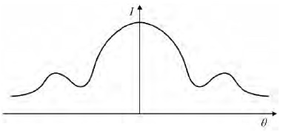
B | 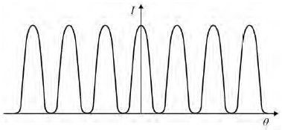
C | 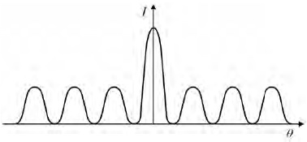
D | 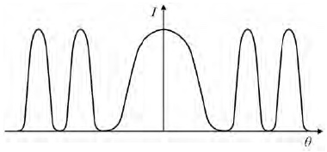
(Total 1 mark)
Q4.
An α particle with an initial kinetic energy of 4.9 MeV is directed towards the centre of a gold nucleus of radius R which contains 79 protons. The α particle is brought to rest at point S, a distance r from the centre of the nucleus as shown in the diagram below.
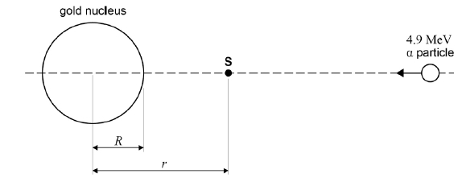
(a) Calculate the electric potential energy, in J, of the α particle at point S.
electric potential energy = ___________________ J
(2)
(b) Calculate r, the distance of closest approach of the α particle to the nucleus.
r = ___________________ m
(3)
(c) Determine the number of nucleons in the gold nucleus.
R, radius of the gold nucleus = 7.16 × 10⁻¹⁵ m
R₀ = 1.23 × 10⁻¹⁵ m
number of nucleons = ________________
(3)
(d) The target nucleus is changed to one that has fewer protons. The α particle is given the same initial kinetic energy.
Explain, without further calculation, any changes that occur to the distance r. Ignore any recoil effects.
___________________________________________________________________
___________________________________________________________________
___________________________________________________________________
___________________________________________________________________
(2)
(Total 10 marks)
Q5.
(a) The radius of a nucleus may be determined by electron diffraction. In an electron diffraction experiment a beam of electrons is fired at oxygen-16 nuclei. Each electron has an energy of 5.94 × 10⁻¹¹ J.
The approximation, momentum = 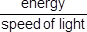 can be used for electrons at this energy.
(i) Show that the de Broglie wavelength λ of each electron in the beam is about 3.3 × 10⁻¹⁵ m.

(2)
(ii) The graph shows how the relative intensity of the scattered electrons varies with angle due to diffraction by the oxygen-16 nuclei. The angle is measured from the original direction of the beam.
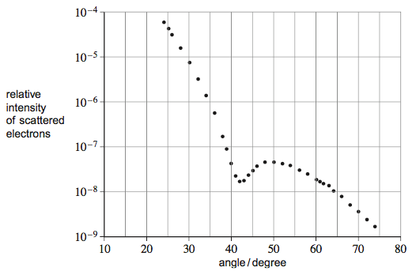
The angle θ of the first minimum in the electron-diffraction pattern is given by
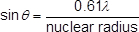
Calculate the radius of an oxygen-16 nucleus using information from the graph.
radius = ____________________ m
(1)
(b) Rutherford used the scattering of α particles to provide evidence for the structure of the atom.
(i) Sketch a labelled diagram showing the experimental arrangement of the apparatus used by Rutherford.

(2)
(ii) State and explain the results of the scattering experiment.
Your answer should include the following:
• the main observations
• the significance of each observation
• how the observtions placed an upper limit on the nuclear radius.
The quality of your written communication will be assessed in your answer.
______________________________________________________________
______________________________________________________________
______________________________________________________________
______________________________________________________________
______________________________________________________________
______________________________________________________________
______________________________________________________________
______________________________________________________________
______________________________________________________________
______________________________________________________________
______________________________________________________________
______________________________________________________________
(6)
(Total 11 marks)

Mark schemes
Q1.
(a) R (= r₀A^{1/3}) = 1.3 × 10^{–5} × (238)^{1/3} (1)
= 8.0(6) × 10^{–15}m (1)
2
(b) (use of inverse square law e.g. 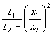 gives)
10 = 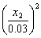 (1)
x = 0.095 m (1)
(0.0949 m)
2
(c) (use of A = A_{o}exp(–λt gives) 0.85 = 1.0 exp (–λ52) (1)
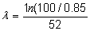 (1)
= 3.1(3) × 10^{–3}s^{–1} (1)
3
(d) it only emits γ rays (1)
relevant properties of γ radiation e.g. may be detected outside
the body/weak ioniser and causes little damage (1)
it has a short enough half-life and will not remain active
in the body after use (1)
it has a long enough half-life to remain active during diagnosis (1)
the substance has a toxicity that can be tolerated by the body (1)
it may be prepared on site (1)
any three (1)(1)(1)
3
[10]
Q2.
(a)

plot R³ against A with axes labelled (1)
units on axes (1)
scales chosen to use more than 50% of page (1)

element | R/10^{–15} m | A | R³/10^{–45} m³
carbon | 2.66 | 12 | 18.8
silicon | 3.43 | 28 | 40.4
iron | 4.35 | 56 | 82.3
tin | 5.49 | 120 | 165.5
lead | 6.66 | 208 | 295
calculate data for table (1)
plot data (1)(1) lose one mark for each error
calculation of gradient
e.g. gradient = (1) (= 1.41 × 10^{–45} m³)
r₀ (= gradient)^{⅓} (1)
= (1.41 × 10^{–45})^{⅓} = 1.1(2) × 10^{–15} m (1)
alternative:
plot R against A^{1/3} with axes labelled (1)
units on axes (1)
scales chosen to use more than 50% of page (1)

element | R/10^{–15} m | A | A^{1/3}
carbon | 2.66 | 12 | 2.29
silicon | 3.43 | 28 | 3.04
iron | 4.35 | 56 | 3.83
tin | 5.49 | 120 | 4.93
lead | 6.66 | 208 | 5.93
calculate data for table (1)
plot data (1)(1) lose one mark for each error
calculation of gradient
e.g. gradient = 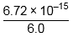 (1) = (1.1(2) × 10^{–45} m³)
r₀ = gradient (1)
= 1.1(2) × 10^{–15} m (1)
[or plot lnR against lnA...]
(max 8)
(b) assuming the nucleus is spherical
ignoring the gaps between nucleons
assuming all nuclei have same density
assuming total mass is equal to mass of constituent nucleus
any one assumption (1)
M = πR³ρ (1)
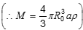
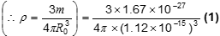
= 2.8 × 10¹⁷ kg m^{–3} (1)
(4)
[12]
Q3.
A
[1]
Q4.
(a) 1eV = 1.6 × 10⁻¹⁹ J
kinetic energy = 1.6 × 10⁻¹⁹ × 4.9 × 10⁶ = 7.8(4) × 10⁻¹³ J ✔
ke lost = pe gained = 7.8(4) × 10⁻¹³ J ✔
2
(b) using V = Q / 4πε_{o}r and E_{p} = qV
r = qQ/4πε_{o}E_{p}✔
= (2 × 1.6 × 10⁻¹⁹) (79 × 1.6 × 10⁻¹⁹)/4π × 8.85 × 10⁻¹² × 7.84 × 10⁻¹³✔
r = 4.67(4.64) × 10⁻¹⁴ m ✔
3
(c) A = (R/R₀)³ ✔
= (7.16 × 10⁻¹⁵ / 1.23 × 10⁻¹⁵ m)³ ✔
= 197 placed on the dotted line ✔
3
(d) r gets smaller ✔
less force so needs to travel further to lose same initial ke ✔
Fewer protons means that r will be smaller when alpha particle has the same electrostatic potential energy (as initial kinetic energy)
2
[10]
Q5.
(a) (i) momentum (= E/c)
= 5.94 × 10⁻¹¹ / 3.00 × 10⁸ = 2.0 × 10⁻¹⁹ (kg m s⁻¹)
(= 1.98 × 10⁻¹⁹ kg m s⁻¹)
Or evidence of use of E = hc / λ ✔
λ = (h / mv = 6.63 × 10⁻³⁴ / 1.98 × 10⁻¹⁹) = 3.35 × 10⁻¹⁵ (m) ✔
(allowable range 3.32 × 10⁻¹⁵ - 3.37 × 10⁻¹⁵ m)
3.348 × 10⁻¹⁵ m alone may score 1 mark
A completed calculation to at least 3 sf must be seen for 2nd mark
2
(ii) nuclear radius = 0.61 λ / sin θ = 0.61 × 3.35 × 10⁻¹⁵ / sin 42°
= 3.1 × 10⁻¹⁵ (m) ✔ (allow 2.95 – 3.1 × 10⁻¹⁵ m which is a range
incorporating 3.32 × 10⁻¹⁵ - 3.37 × 10⁻¹⁵ m and 42° – 43°)
(The answer must be to 2 sf or better
note 3.3 × 10⁻¹⁵ , 42° gives 3.008 x 10⁻¹⁵ m i.e. 3.0 × 10⁻¹⁵)
1
(b) (i) diagram to show a labelled α source, foil target and detector (which is not simply a forward facing screen so there must be some indication it can move around the target e.g. a curved arrow / positioned at an angle / or screen curved round target or detectors shown in at least two positions) ✔
with evacuated vessel or an item to collimate the beam ✔ (the evacuated vessel does not have to be drawn so a simple label of ‘in a vacuum’ will gain the mark.) (A tube or a plate(s) must be drawn with a collimator label or a label on an emergent alpha beam from the drawn item (which is distinct from the source) will gain a mark)
‘detector’ has alternatives e.g. fluorescent screen / scintillator / zinc sulphide
2
(ii) The mark scheme for this part of the question includes an overall assessment for the Quality of Written Communication (QWC).
Descriptor
High Level – Good to Excellent
Both observations should be given ie most α particles pass straight through the foil and that some α’s are backscattered. Again both of these must be explained. Additionally one approach to finding the upper limit to the radius must be given and interpreted.
The information presented as a whole should be well organised using appropriate specialist vocabulary. There should only be one or two spelling or grammatical errors for this mark.
6 marks = all 3 bullet points covered in full.
5 marks = Same as 6 marks but one explanation is omitted or poorly expressed
5 - 6
Intermediate Level – Modest to Adequate
Both observations should be given ie most α particles pass straight through the foil and that some α’s are backscattered. Both of these observations can be explained or one of them explained along with the observation necessary to obtain the upper limit to the nuclear radius but without the explanation of how to use the data.
The grammar and spelling may have a few shortcomings but the ideas must be clear.
4 marks = for first two bullet points covered in full.
Alternatively both observations given but only one explained along with an observation necessary to find the upper limit to the nuclear radius.
3 marks = for both observations given but only one explained
3 - 4
Low Level – Poor to Limited
Any two observations or interpretations but an interpretation must come with the appropriate observation.
There may be many grammatical and spelling errors and the information may be poorly organised.
2 marks for two observations or one observation along with its interpretation.
1 mark = Any observation..
1 - 2
The description expected in a competent answer should include:
1. most α particles pass straight through
2. which suggests an atom is composed of mainly open space
3. α particles can be backscattered or scattered by more than 90°
4. which suggests
i. they have collided with something more massive than themselves (using momentum considerations)
ii. they have been repelled by a concentrated positive charge (using coulomb repulsion)
these together suggest a ‘solar system’ configuration for the atom.
5. Consider the proportion of α’s passing straight through the foil, i.e. how much of the straight through beam is stopped by the foil.
Or
Appreciate that scattering of α’s close to 180° takes place which means the α’s have not touched the nuclear surface.
6. First alternative data can be related to how much of the beam is intercepted by nuclei. Using the number of atomic layers / thickness of foil and the nuclear cross-sectional area the upper limit to the radius may be found
Or If second alternative is used some detail is needed to gain this point.
Either a discussion of the loss KE = gain PE to find upper limit to the radius
Or the idea that backscattering is not observed / falls off if the alpha comes close to the nucleus because the strong nuclear force (SNF) takes over and so provides an upper limit to the radius.
(owtte)
Do not award ‘large space between atoms’.
The question is a QWC and not all the points are expected to be given as detailed on the left. This check list gives a brief idea of the main parts expected.
(note the pairing of 1 and 2, 3 and 4, 5 and 6 where the second of each pair cannot be given in isolation but the first of each pair does not have to perfect)
If it is obvious the candidate is talking about an alpha particle but calls it something different do not over penalise. E.g. miss out a pairing of marks then mark as if alpha)
Quick check list.
1. Most alpha’s go straight on
2. Because an atom has mainly empty space
3. A few alpha’s are backscattered
4. Because of nuclear positive charge or large nuclear mass
5. Method suggested to find R (drop in straight on beam Or backscattering means α’s have not touched nucleus)
6. Some detail such as ref. to (nuclear) area and (foil) thickness Or alpha KE to PE giving r Or if α’s touch surface SNF stops scattering.
[11]

