Series & Parallel Circuits

B
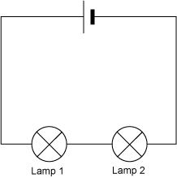
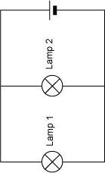
Diagram 1 Diagram 2

A
C

- What components do the letters A, B and C represent?

A................................. B..................................... C...................................

- What is the name given to the way the bulbs are arranged in Diagram 1?

....................................................................................................................................................

- What is the name given to the way the bulbs are arranged in Diagram 2?

....................................................................................................................................................

- In a series circuit, like in Diagram 1, how is the brightness of the first bulb affected when the second bulb is connected? Explain why this happens?

....................................................................................................................................................

....................................................................................................................................................

- In a parallel circuit, like in Diagram 2, how is the brightness of the first bulb affected when the second bulb is connected? Explain why this happens?

....................................................................................................................................................

....................................................................................................................................................

- Give one example of where we might find a series circuit in everyday life.

....................................................................................................................................................

- Give one example of where we might find a parallel circuit in everyday life.

....................................................................................................................................................

- Explain one advantage of using a parallel circuit rather than a series circuit.

....................................................................................................................................................

- Dan and Tom build a circuit like the one shown below.

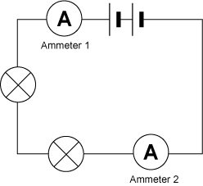
X

- Name the component labelled X ........................................................

- What are Dan and Tom using the component labelled X to measure? ................................

- Dan says, “Ammeter 1 will show a lower reading than Ammeter 2 because the bulbs in the circuit use up the current.”
Tom says, “Ammeter 1 will show the same reading as Ammeter 2 because current is not used up.”
Who is right? ..................................................

- If Ammeter 1 has a reading of 1.5A, what reading will Ammeter 2 show? ....................A

- (a) The circuit above contains 2 cells. Describe what would happen to the bulbs if Dan and Tom added another cell.

....................................................................................................................................................

(b) Describe how the reading on the reading on the ammeters would change if another cell was added to the circuit.

....................................................................................................................................................

