SOURCE: https://www.savemyexams.co.uk/

The Heart

The double circulatory system
- The human heart is part of a double circulatory system
- The circulatory system is a system of blood vessels with a pump (the heart) and valves that maintain a one-way flow of blood around the body
- The heart has four chambers separated into two halves:
  - The right side of the heart pumps blood to the lungs for gas exchange (this is the pulmonary circuit)
  - The left side of the heart pumps blood under high pressure to the body (this is systemic circulation)
- The benefits of a double circulatory system:
  - Blood travelling through the small capillaries in the lungs loses a lot of pressure which reduces the speed at which it can flow
  - By returning oxygenated blood to the heart from the lungs, the pressure can be raised before sending it to the body, meaning cells can be supplied with oxygenated blood more quickly

The heart structure
- The heart is labelled as if it was in the chest so what is your left on a diagram is actually the right-hand side (and vice versa)
  - The right side of the heart receives deoxygenated blood from the body and pumps it to the lungs where oxygen diffuses in from the alveoli and carbon dioxide diffuses out
  - The left side of the heart receives oxygenated blood from the lungs and pumps it to the body
- Blood is pumped towards the heart in veins and away from the heart in arteries
- The chambers at the top of the heart are the atria, the chambers at the bottom the ventricles
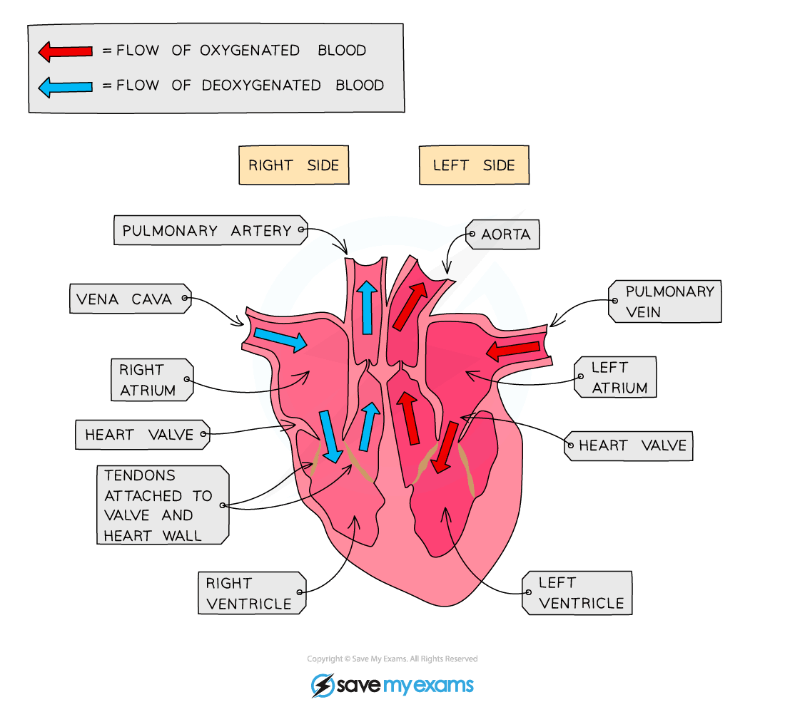
The heart is labelled as if you are looking at it directly in someone’s body – so the left-hand side of an image of the heart is actually the right-hand side of the heart

Pathway of blood through the heart
- Deoxygenated blood enters the heart via the vena cava, emptying into the right atrium
- Blood flows down through a set of atrioventricular valves into the right ventricle
- When the ventricles contract, blood travels up through the pulmonary artery to the nearby lungs where gas exchange occurs (and the blood becomes oxygenated)
- Oxygenated blood returns to the heart via the pulmonary vein, emptying into the left atrium
- Blood flows down through a set of atrioventricular valves into the left ventricle
- When the ventricles contract, blood travels up through the aorta, and to the rest of the body

Adaptations of the heart
- The walls of the ventricles are much thicker than those of the atria as they are responsible for pumping blood out of the heart and so need to generate a higher pressure
- The wall of the left ventricle is much thicker than that of the right ventricle as it has to pump blood at high pressure around the entire body, whereas the right ventricle is pumping blood at lower pressure to the lungs (which are close to the heart)
- There are two sets of valves inside the heart which function to prevent the backflow of blood in the heart:
  - The atrioventricular valves separate the atria from the ventricles
  - The semilunar valves are found in the two blood arteries that come out of the top of the heart
  - They are unusual in that they are the only two arteries in the body that contain valves
  - These valves open when the ventricles contract so blood squeezes past them out of the heart, but then shut to avoid blood flowing back into the heart
- The two sides of the heart are separated by the septum (with the portion separating the atria the atrial septum, the portion separating the ventricles the ventricular septum)
  - The septum is very important – it prevents the mixing of deoxygenated and oxygenated blood inside the heart
  - If blood were to mix, then less oxygenated blood would be pumped around the body
- The heart is made of a special type of cardiac muscle tissue which does not fatigue like skeletal muscle
- The coronary arteries supply the tissue of the heart with oxygenated blood – the heart needs a constant supply of oxygen (and glucose) for aerobic respiration to release energy to allow continued muscle contraction

Exam Tip
The pulmonary artery is the only artery of the body to carry deoxygenated blood, with the pulmonary vein the only vein to carry oxygenated blood, in the body.
You need to know the names and be able to locate the four main blood vessels associated with the heart in the exam.
Remember arteries carry blood away from the heart, veins towards it.

Heart Rate
- The natural resting heart rate is controlled by a group of cells located in the right atrium
- These cells form a structure called the pacemaker
- The role of the pacemaker is to coordinate the contraction of the heart muscle, therefore it regulates the heart rate
- Up to a point, the faster the heart contracts, the more quickly oxygenated blood can be delivered around the body
  - When a person is at rest, the oxygen demand of their cells is relatively low and so a lower heart rate is maintained
  - When a person is exercising, the oxygen demand of their muscle cells increases and so a higher heart rate is necessary
- The pacemaker sends out an electrical impulse which spreads to the surrounding muscle cells, causing them to contract
  - The pacemaker does this every time the heart needs to “beat”, so if a person has a resting heart rate of 60 beats per minute (bpm), then the SAN will be sending out electrical impulses on average once every second
- Sometimes, the pacemaker of the heart stops functioning properly (this can cause an irregular heartbeat)
- Artificial pacemakers are electrical devices used to correct irregularities in the heart rate
- The device is implanted just under the skin, with a wire that delivers an electrical current to the heart to help it contract regularly

Exam Tip
The pacemaker is located in the wall of the right atrium – you may be asked to locate it on a diagram in the exam

Blood Vessels
- The body contains three different types of blood vessel:
  - Arteries: transport blood away from the heart (usually at high pressure)
  - Veins: transport blood to the heart (usually at low pressure)
  - Capillaries: have thin walls which are “leaky”, allowing substances to leave the blood to reach the body’s tissues
- The walls of each type of blood vessel have a structure that relates to the function of the vessel
- Blood flows through the lumen of a blood vessel; the size of the lumen varies depending on the type of blood vessel (with arteries having a narrow lumen, and the veins a wider one)
  - The lumen of the capillaries is extremely narrow, at the smallest the width of a red blood cell!
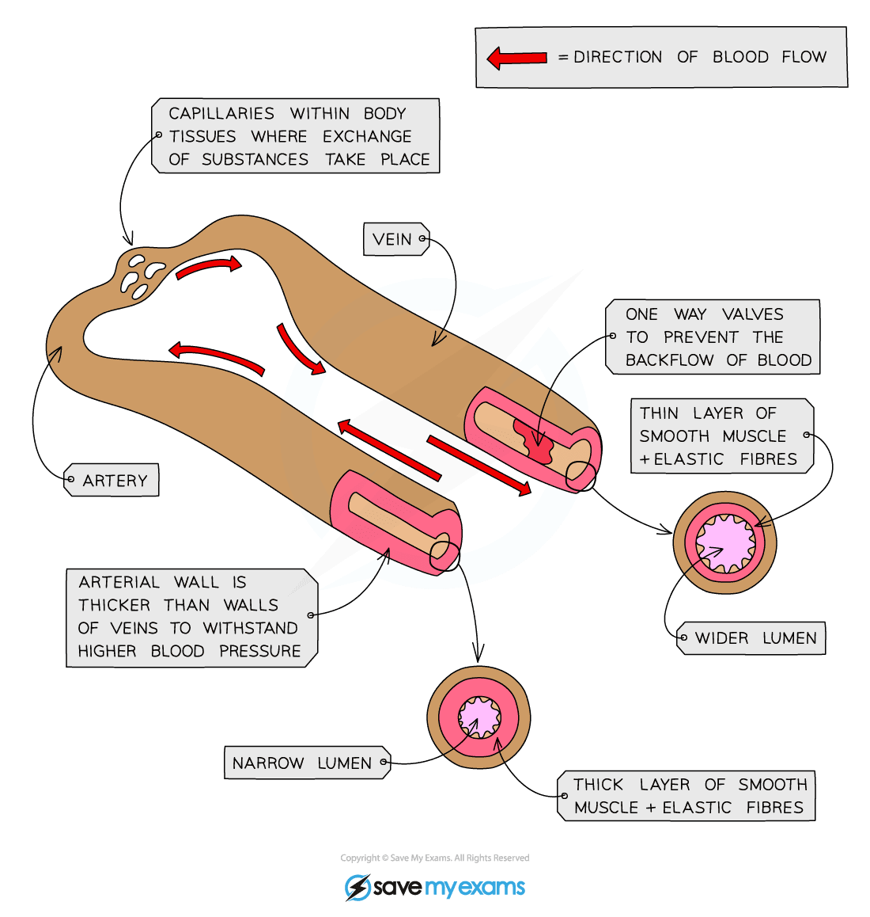
The blood vessels form a continuous network; the structure of each allows it to carry out its function

How structure relates to function
- Arteries must be able to withstand high pressures generated by the contracting heart, and maintain these pressures when the heart is relaxed
  - The wall of the artery is relatively thick with layers of collagen, smooth muscle and elastic fibres
  - The elastic fibres allow the artery wall to expand around blood surging through at high pressure when the heart contracts, these fibres then recoil when the heart relaxes – this alongside a narrow lumen maintains high blood pressure
- In contrast, veins receive blood that has passed through capillary networks; blood is at very low pressure and must be returned to the heart
  - The wall of the vein is relatively thin with thinner layers of collagen, smooth muscle and elastic fibres
  - The lumen of the vein is much larger than that of an artery
  - Veins contain valves that prevent the backflow of blood, helping return blood to the heart
- The wall of the capillary is made solely from a single layer of endothelial cells (this layer is also found lining the lumen in arteries and veins)
  - The wall is only one cell thick – this reduces the diffusion distance for oxygen and carbon dioxide between the blood and the tissues of the body
  - The cells of the wall have gaps called pores which allow blood plasma to leak out and form tissue fluid

Exam Tip
Do not confuse the wall of the capillary being ‘one cell thick’ to mean that the cells that form the capillary wall have “cell walls”. Animal cells never have cell walls.

Rate Calculations: Blood Flow
- The rate of blood flow can be calculated if the volume of blood flow and the time is known
- For example; if 2460 ml of blood flows through a blood vessel in 4 minutes, the rate of blood flow = volume of blood / number of minutes = 2460 / 4 = 615 ml/minute
- From this you may be asked to determine how much blood flows through the same vessel in one hour = rate of blood flow (ml/min) x 60 = 615 x 60 = 36 900 ml

Structure & Function: Blood
- The role of blood in the body is to transport useful substances to every cell of the body, and to remove harmful waste substances
  - It also plays a vital role in transferring heat from “active” organs to cooler parts of the body (such as the extremities – hands and feet)
- Blood is a tissue consisting of the fluid plasma (which is largely water with dissolved substances in it)
- Red blood cells, white blood cells and platelets are suspended in blood plasma

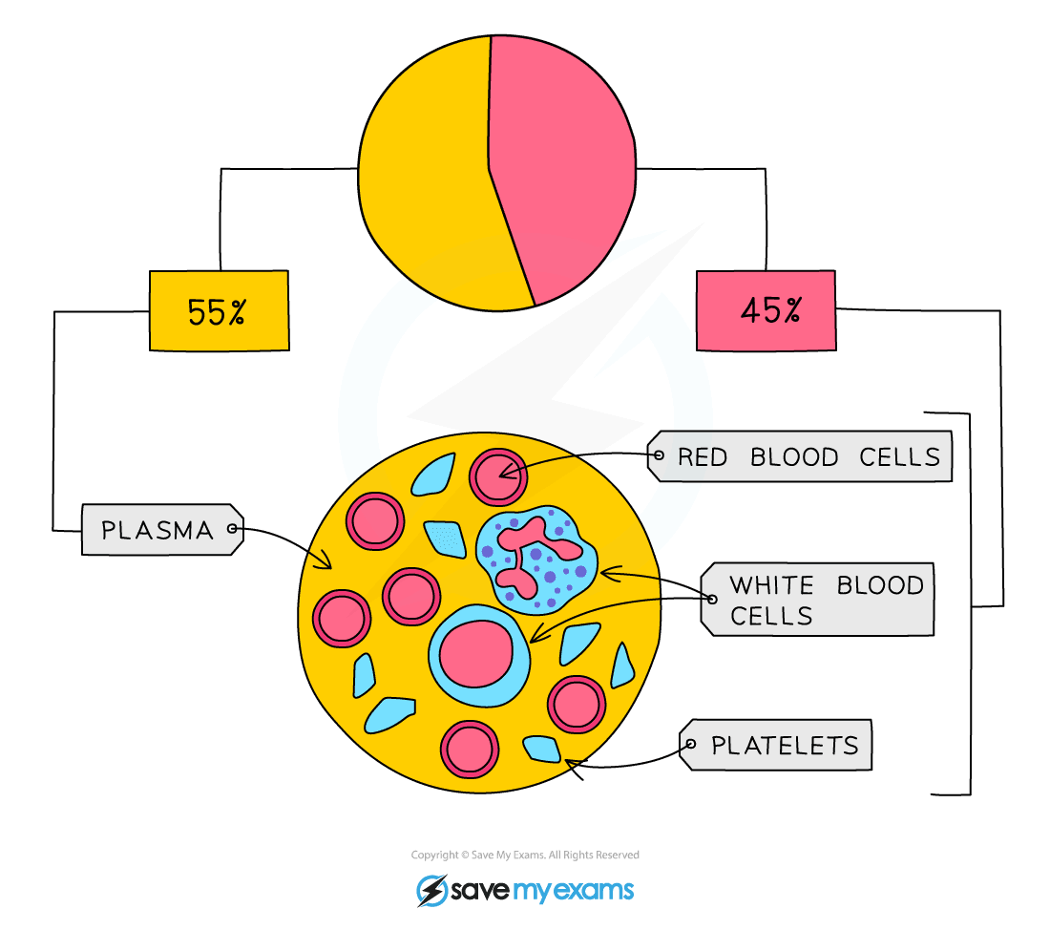
The human blood is composed largely of plasma and red blood cells, with white blood cells and platelets making up a smaller proportion of total volume

Red blood cells
- Red blood cells (RBCs) are cells with a distinctive biconcave disc shape
- This shape is a result of RBCs not having a nucleus
  - The biconcave shape gives RBCs a large surface to volume ratio; this is a key adaptation to maximise the efficiency of diffusion of gases into and out of the cell
- The cytoplasm of an RBC is packed with the protein haemoglobin
- Oxygen binds reversibly with haemoglobin, forming the red pigment oxyhaemoglobin:
  - oxygen + haemoglobin ⇌ oxyhaemoglobin

White blood cells
- White blood cells (WBCs) are part of the immune system, responsible for defending the body from infection by recognising and destroying pathogens
- WBCs defend the body in three particular ways:
  - Phagocytes engulf and digest pathogens, destroying them
  - Lymphocytes produce specific antibodies that help enhance phagocyte activity by sticking them together (clumping) or disabling pathogens
  - Some lymphocytes produce a type of antibody called an antitoxin which is able to bind to toxic substances produced by pathogens, neutralising them
- WBCs have a variety of adaptations:
  - Phagocytes have a lobed nucleus and are autonomous – they leave the blood and patrol the tissues
  - Lymphocytes have a large nucleus and can produce antibodies extremely quickly

Platelets
- Platelets are fragments of cells (they contain cytoplasm but no nucleus)
- When damage to a blood vessel occurs, the platelets are involved in forming a blood clot to prevent blood loss
- Individuals with insufficient platelets cannot clot their blood effectively – this can be life-threatening if excessive damage occurs

Recognising Blood Cells
- In an exam, you may be shown a photograph or diagram and be asked to identify the types of blood cell present
- Observing and drawing cells under the microscope is also an important skill you will need to develop

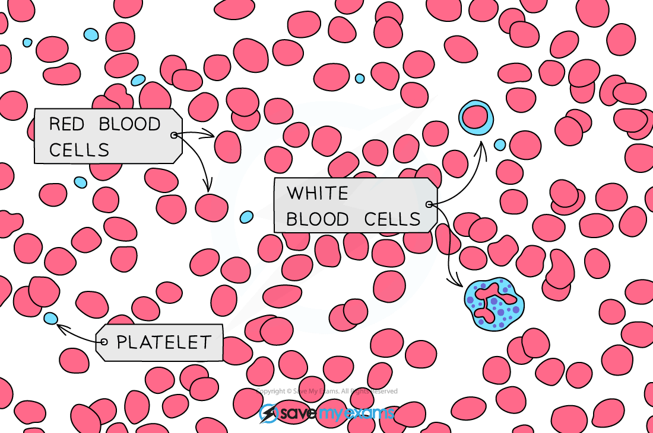
This is an image of how blood might look under a microscope. White blood cells are larger than red blood cells, with platelets being smaller again

