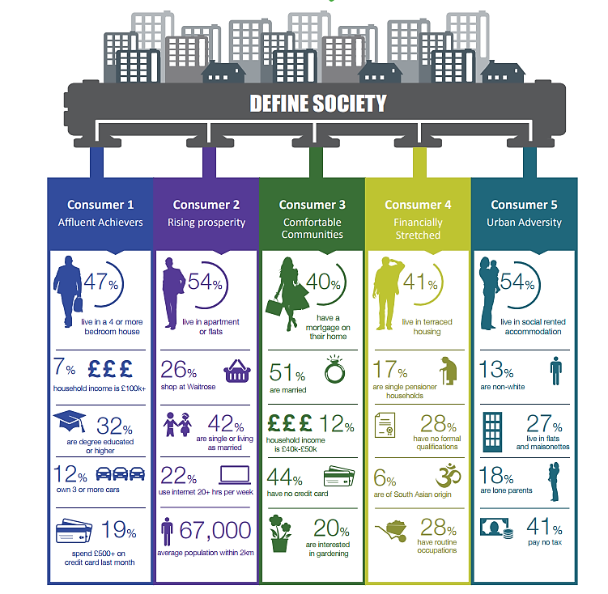
ACORN is an organisation which groups people in society according to their income and other social factors.

Why would the ACORN classification information be useful to a firm?

1
2
3
4

