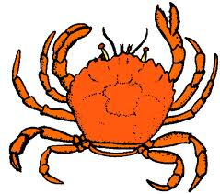
SPECIALISED CELLS
C____________ CELL  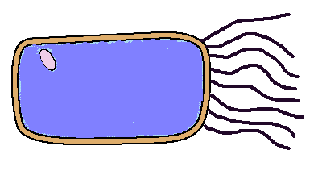 | - What is special about this cell?  __________________________  - Where is this cell found? _______  __________________________  - What does it do? _____________  __________________________  - How can smoking damage them? __  ___________________________
R______ H______ CELL  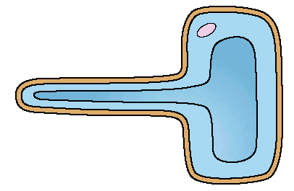 | - What is special about this cell?  __________________________  - Where is this cell found? _______  __________________________  - What does it do? _____________  __________________________  - Describe one thing different about this plant cell compared to other plant cells  ____________________________
R___ B_____ CELL  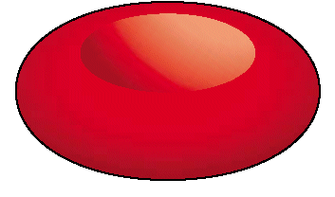 | - What is special about this cell?  __________________________  - Where is this cell found? _______  __________________________  - What does it do? _____________  __________________________  - Describe one thing different about this cell compared to other cells  ____________________________

S_______ CELL  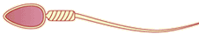 | - What is special about this cell?  __________________________  - Where is this cell found? _______  __________________________  - What does it do? _____________  __________________________
P________ CELL  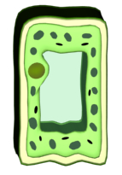 | - What is special about this cell?  __________________________ __________________________  - Where is this cell found? _______  __________________________  - What does it do? _____________  __________________________
E______ Cell  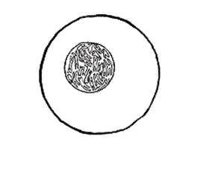 | - What is special about this cell?  __________________________  - Where is this cell found? _______  __________________________  - What does it do? _____________  __________________________

