3.2.3 Understanding the role and importance

of stakeholders

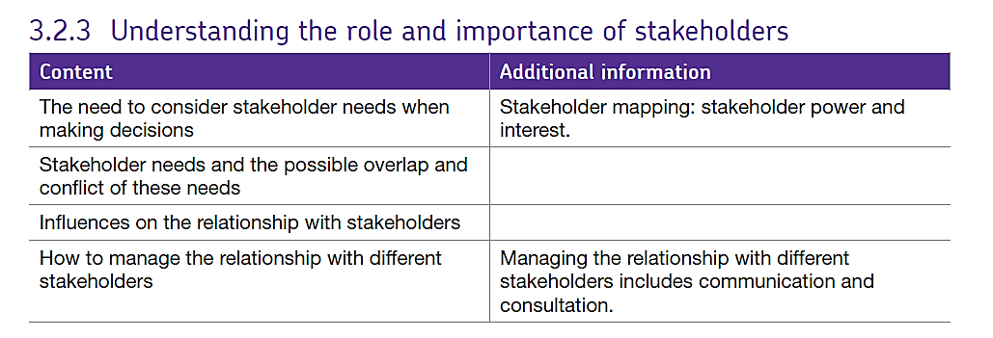

What is a stakeholder?
A Stakeholder is anyone individual or group which has an interest in the activities of a business.

Categorising stakeholders
There are a number of ways in which stakeholders can be categorised such as:
Primary stakeholders are individuals or groups that are affected by a particular business activity. Examples of this category of stakeholders include suppliers, customers, employees, creditors or anyone else with a functional or financial interest in the business.
Secondary stakeholders are groups of individuals or organisations with an indirect functional or financial relationship with the business. However, these stakeholders may be affected by the actions of the business or they can influence the actions. Examples include the general public, local communities, activists groups and the media.
Internal stakeholders are stakeholders who are considered to be part of the organisation and include managers, employees and shareholders.
External stakeholders exist outside of the business and include the local and national government, the media, customers and pressure groups. This might also include shareholders when the company is first launched in the stock market.
Each stakeholder group will have its own objectives and needs. These may not always be the same as the business objectives! Each different group of stakeholders has different needs and it can be hard for the firm to balance them all.
Sometimes what the stakeholder expects and what the business expects come into conflict – but not always. Occasionally what the stakeholder expects and what the business expects match – this makes things easier.
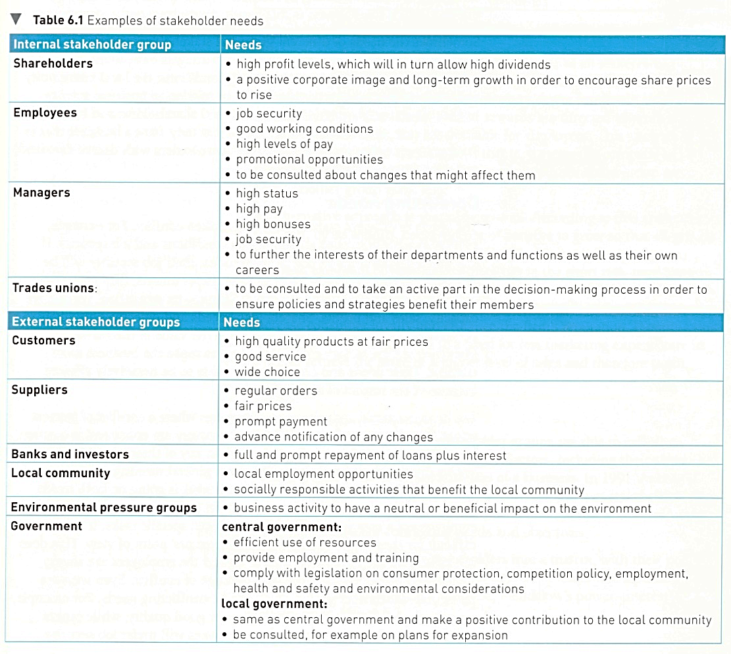

Stakeholder mapping

Stakeholders have different levels of power and influence within the business, depending where they are on the stakeholder map, the business may have to prioritise their feelings about any decisions they are making.

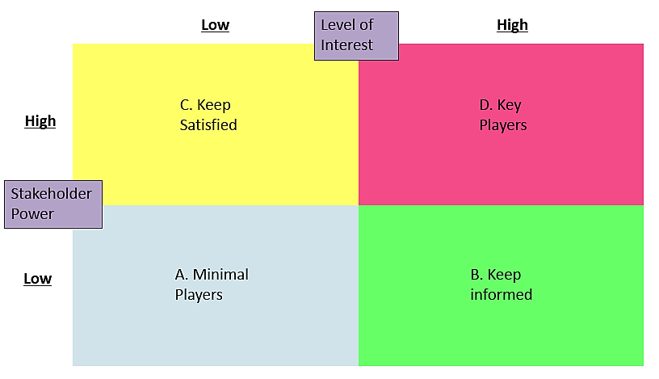

A: Minimal effort - a stakeholder in this group is more likely to accept what they are told.
B: Keep informed – a stakeholder in this group is interested in the project but lack power in relation to it. Consultation with this type of stakeholder will keep them more time to adjust to the idea and therefore reduce dissatisfaction.
C: Keep satisfied – a stakeholder in this group has power but has little interest, therefore this group must be kept satisfied, otherwise they will start to get involved.
D: Key player - a stakeholder in this group is a key player because have both power and interest therefore they can have a major influence in the success/ failure of a change to the business.

Influences in the relationships with stakeholders

Some businesses view all stakeholders as important and strive to meet all their needs. Others focus their time and energy in meeting the needs of the key stakeholders only. There are a number of factors which influence the relationship between the business and their stakeholders and these factors can be classed as either internal or external.

Internal factors

Business objectives
This may be the strongest influence of all. For example, a company wanting to pursue ethical or social objectives would give high priority to the objectives of as many stakeholders as possible and this would have a significant impact on decision making. Alternatively, a business focused on maximising profits will prioritise this objective over the needs of others. For example, a focus on minimising costs might result in zero hours contracts which would have a negative impact on the workforce, in which case, communication and consultation are likely to be minimal.

Management and leadership styles
Managers with an autocratic approach are unlikely to consider the needs of their employees when making decisions. These types of managers are also unlikely to worry about good relationships with the local community which may lead to resentment and opposition to decisions made. Democratic and consultative managers are likely to receive more support from employees. The two way communication which is fostered under this style of management is likely to have a positive impact on other stakeholder groups too.

The size and ownership of the business
For some small businesses, it can be simpler to communicate with and involve stakeholders in decision making purely because there are fewer of them. For example, a sole trader may have fostered strong harmonious relationships with customers and may communicate with them regularly. However, a large PLC will have different relationships with its stakeholders. Some Boards of Directors may be under immense pressure from powerful shareholder groups to maximise profits. This may result in suppliers being forced to drive prices down as low as possible and workers being offered minimum pay increases. This in turn is likely to lead to a poor reputation and poor customer service.

External factors

Market conditions
A number of factors determine the market conditions. For example, the potential for market growth and the current market share of the business is important here. The intensity of the competition is also important. In a business facing particularly intense competition from rivals they may deliberately try to engage more with customers, employees and suppliers in order to gain a reputation for meeting the needs of stakeholders. This may help the business foster loyalty from its various stakeholder groups. In some markets, one or two businesses may be dominant and this may have an impact on some stakeholder groups such as suppliers. For example, in the UK supermarkets have been criticised for withholding payment from suppliers or imposing tough conditions on them under the threat of withdrawing their custom. A dominant business may also be able to exploit customers by charging prices which are far too high. The six major suppliers of gas and electricity in the UK have been criticised for this.

The power of stakeholder groups
Some stakeholder groups have considerable power to influence the activities and success of a business. For example, large pension funds and insurance companies invest people’s savings in a range of ways including buying shares in public limited companies. Because the size of the shareholding is likely to be large, managers are likely to consider their reaction when they make decisions. Also, some management teams will actively seek to avoid becoming too reliant on a certain customer or supplier for fear that these stakeholders could gain too much influence over decision making.

Government policies
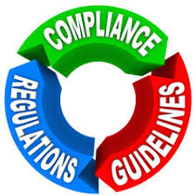
The UK government can influence the way in which a business manages their relationships with stakeholders. It uses laws and less formal codes of conduct to ensure that these relationships are as harmonious as possible. For example, when certain public sector services were privatised, the government established regulatory authorities to oversee them. This included monitoring how the newly privatised companies engaged in competition and also ensuring they do not overcharge customers. An example of this would be the Water Services Regulation Authority (Ofwat) which was established in 1989 at a time when the ten water authorities in England and Wales were privatised.

In all situations, the business has to decide how to please the stakeholders – who is most powerful and how / if a balance can be achieved.

Win-lose situation – one stakeholder wins while one loses.

If money is directed to shareholders to keep them satisfied then there is less for employees and vice versa.
This creates a conflict between the two.
Employees Shareholders
Unhappy with low rates happy with the firm’s
of pay and benefits profits and dividends

Win-win situation - all stakeholders ultimately win.

If employees are treated fairly with good working conditions and rewards then they work harder and therefore increase the value of the business. However to do this the shareholders’ rewards may need to be reduced for the short term but ultimately it should increase the return on capital employed (ROCE) for shareholders.
Employees Shareholders
Motivated to work, efficiency improves less likely to be absent so profit margins rise

Stakeholder common interests – converging

Shareholders receiving good dividends and share price rising
Employees happy and working hard

Point where all stakeholder groups needs are being met
Suppliers happy to be receiving more orders as firm grows

Read the information sheet about Aldi’s Stakeholders.

ACTIVITY 1 - Create a three way Venn diagram to show how some of Aldi’s stakeholder needs converge.

ACTIVITY 2 – Analyse why some of Aldi’s stakeholders’ expectations may diverge over time. (9 marks)

