3.3.4 The marketing mix (part 1)

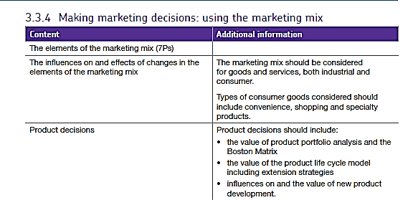

Extended Marketing Mix (7P's)
The marketing mix is the combination of elements used by a business to enable it to meet the needs and expectations of customers.
It is called a marketing mix because each element of the marketing mix is related to the others. The challenge for marketing is to ensure that the elements of the mix work together to achieve the marketing objectives. Traditionally the marketing mix has been taken to comprise four elements: (product, price, promotion and place).
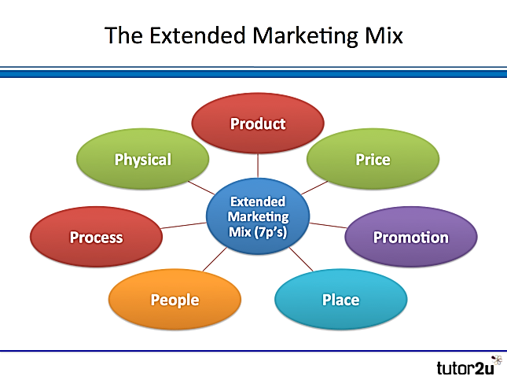
However, in recent years it has become more common to add three new elements to the traditional marketing mix, making a combined 7p’s. This is the so-called extended marketing mix.
The 7p's extended marketing mix therefore comprises the following elements:
- Product: the good or service that the customer buys
- Price: how much the customer pays for the product
- Place: how the product is distributed to the customer
- Promotion: how the customer is found & persuaded to buy
- People: the people who make contact with customers in delivering the product
- Process: the systems and processes that deliver a product to a customer
- Physical: the elements of the physical environment the customer experiences
A key implication of an extended marketing mix is that the seven elements need to work even closer together for marketing to be effective for example:
- Customer service, HR (recruitment & training) - technology becomes increasingly important

- The role of IT in e-commerce & customer communication - intangible elements such as branding play an enhanced role
Extending the marketing mix by adding Physical, Process and People to usual 4P’s connects the marketing function much closer to both human resource management and operations.
Examples are illustrated below:

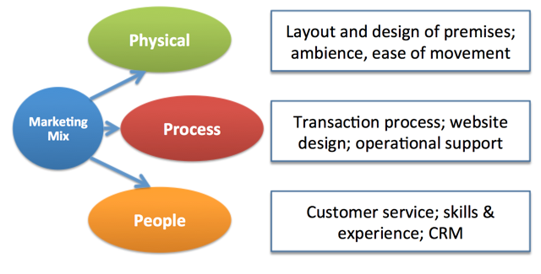

Consumer and Industrial Products
One way of categorising products is in terms of who the intended consumer or customer is. A broad distinction can be made between goods and services intended for use by individuals and households (consumer products) and for use by other businesses (industrial products).
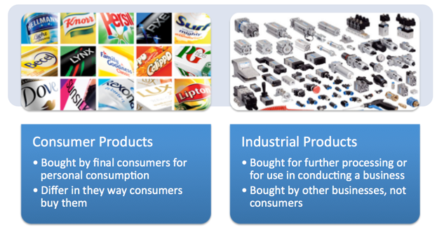

The three main types of consumer products are summarised below together with the elements of the marketing mix that tends to be emphasised:
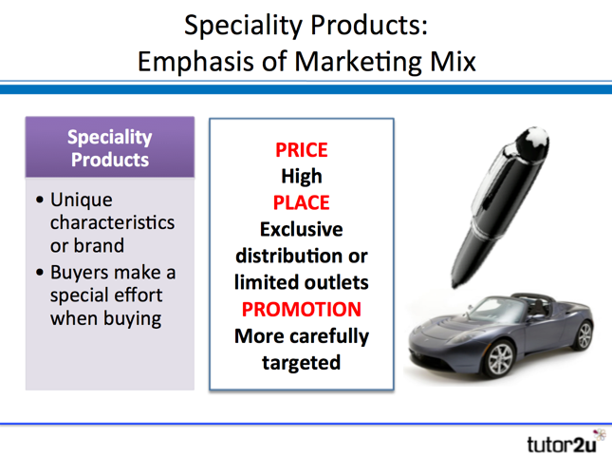
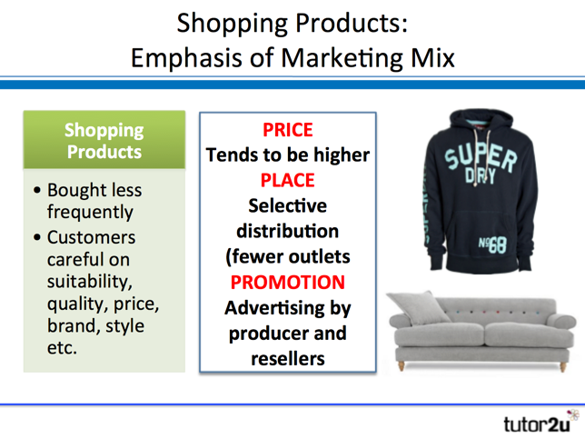
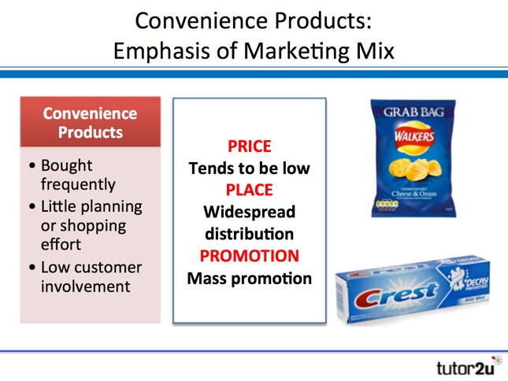

Industrial Products
Industrial products are perhaps less exciting than consumer products, but they industrial product markets are often significant in terms of market size. For example, all producers of consumer products need themselves to buy industrial products in order to operate.
The three main types of industrial product are:
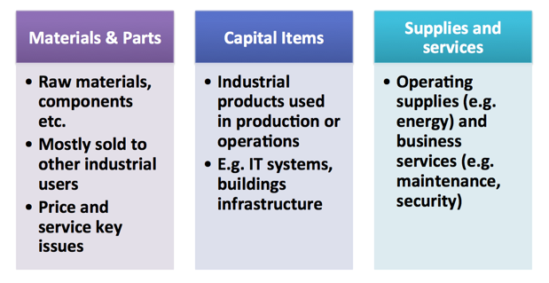

The marketing mix for industrial products is quite different from that for consumer products due to the features of selling "business to business"

- Specialist buyers and sellers: buyers are businesses – will have specialist requirements and more experience. Often dealing with professional “buyers”
- Buyer-seller relationship: strong emphasis on customer relationship management and repeat business
- Transaction value: purchase value often substantial in a single transaction (e.g. bulk purchase contract)
- Quality and Price: greater emphasis on product quality and price (where there are acceptable alternative products). Price is often negotiated by the buyer
- Support: greater requirement for after-sales support

Boston Matrix and Product Portfolio.
A business with a range of products has a portfolio of products. However, owning a product portfolio poses a problem for a business. It must decide how to allocate investment (e.g. in product development, promotion) across the portfolio.

What is the Boston Matrix?
A portfolio of products can be analysed using the Boston Matrix. This categorises the products into one of four different areas, based on:
Market share – does the product being sold have a low or high market share?
Market growth – are the numbers of potential customers (and therefore likely sales) in the market growing or not
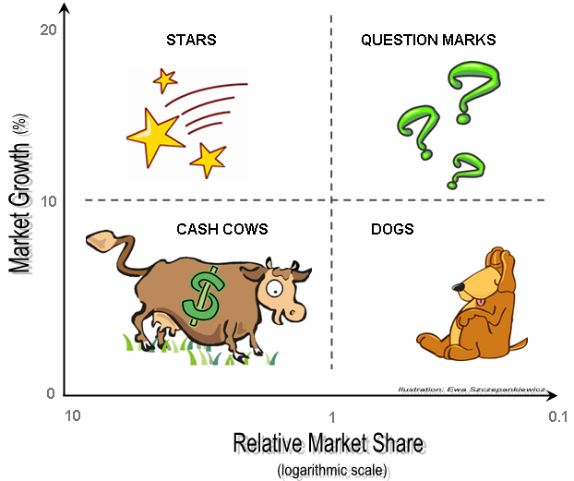

How does the Boston Matrix work?
The four categories can be described as follows:
- Stars are high growth products competing in markets where they are strong compared with the competition. Often Stars need heavy investment to sustain growth. Eventually growth will slow and, assuming they keep their market share, Stars will become Cash Cows
- Cash cows are low-growth products with a high market share. These are mature, successful products with relatively little need for investment. They need to be managed for continued profit - so that they continue to generate the strong cash flows that the company needs for its Stars
- Question marks are products with low market share operating in high growth markets. This suggests that they have potential, but may need substantial investment to grow market share at the expense of larger competitors. Management have to think hard about “Question Marks" - which ones should they invest in? Which ones should they allow to fail or shrink?
- Unsurprisingly, the term “dogs" refers to products that have a low market share in unattractive, low-growth markets. Dogs may generate enough cash to break-even, but they are rarely, if ever, worth investing in. Dogs are usually sold or closed.
Ideally a business would prefer products in all categories (apart from Dogs!) to give it a balanced portfolio of products.

The main values of using the Boston Matrix include:
- The model is a useful tool for analysing product portfolio decisions
- It helps managers categorise products and decide on what to do next.
For example:
- If all of the products are cash cows, managers might worry about the future success of the organisation. This is because sales growth is slow, eventually these cash cows will become dogs so managers must develop some questions marks & stars for future sales.

- If all the products of a business were dogs, managers would definitely worry. This is because they all have low market share and slow growth.

- Managers will aim for some well-established products (cash cows) to help fund the development and success of new products (question marks and stars). They want a balanced portfolio where established products generate revenue which can help fund new product developments.

However, the model can be criticised in several ways:
- But it is only a snapshot of the current position
- Has little or no predictive value – it doesn’t forecast anything
- Does not take account of factors in the external environment
- Market growth is an inadequate measure of a market's attractiveness – there are other aspects to consider
- Market share is not always an adequate measure of a product’s ability to generate cash
- The focus on market share and market growth ignores issues such as developing a sustainable competitive advantage

Product lifecycle.

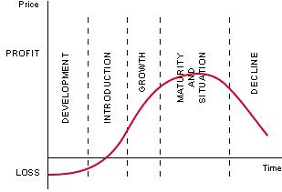
The lifecycle shows the stages which a product goes through from first concept to the point at which it is taken off the market.
In the first stage – development, the firm is spending money but not receiving any revenue and so may have cash flow problems or have to borrow money to fund this stage.
It is not until the growth section when a firm starts to make revenue from a product and can repay its investment.
The Product lifecycle and the Boston Matrix can be thought of together as the stages do correlate with each other.
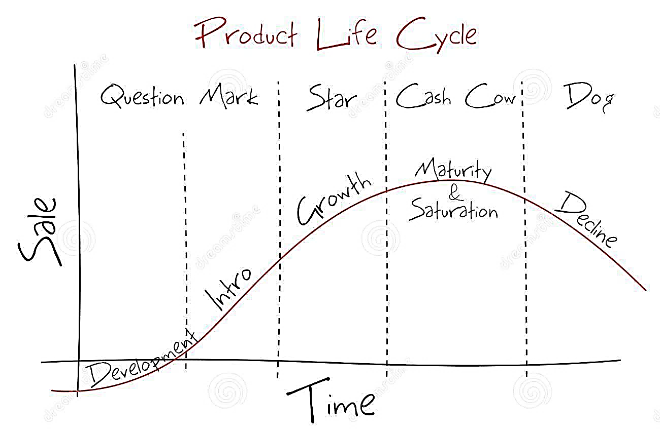

A firm will try and have products moving through the lifecycle and around the matrix at the same time , they use the funds generated in the growth and maturity stages (Star / Cash cow on the Boston Matrix) to fund research and development of other products.

New product development.
To grow fast, businesses need to develop new products. But before a business can launch a new product, it needs to go through several stages before it appears in the market place.

The main stages are:

- Marketing research – find out what customers want, who they are, and where the gaps are in the marketplace
- Product development and testing – make prototypes; experiment by allowing a sample of potential customers to trial the product before it is launched
- Distribution of product to outlets – the product cannot be sold unless it is in a position for customers to buy it – books will need to be in the bookshops and hammers in the hardware stores
- Promotional launch to inform customers features of new product – this might be done locally, nationally or internationally – the customers need to know that the product is ready, available and that it might be the sort of thing they want to buy

At the first two stages (marketing research and product development/testing) many products are rejected because the findings of research show that it will not be successful, or they cannot make a satisfactory prototype. Product testing might show that customers react badly to the product.
The new product launch needs all the elements of the mix to be in place to be successful.

