3.6.3 Organisational design and HR flow.
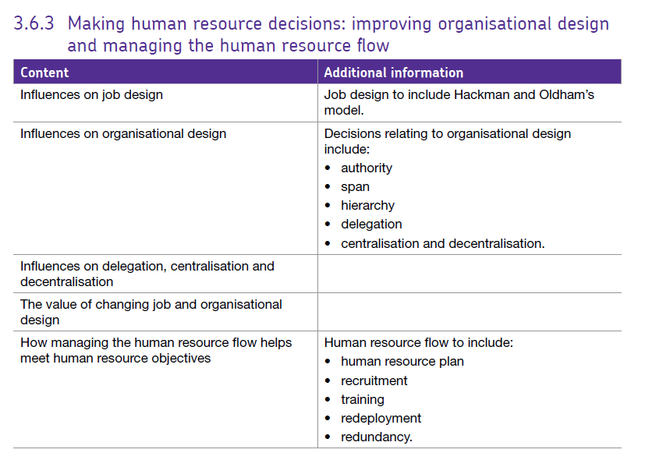

Contents
Job Design 2
Influences on job design 2
Internal influences 2
External influences 2
Employee-related influences 3
Hackman and Oldham 3
Job Enlargement 4
Job Rotation 4
Job Enrichment 4
Empowerment 4
Organisational Design and Structure 5
Organisational Design 5
Organisational Structure 5
Key factors in organisation design 6
Types of organisational structures 9
Influences on organisational design and structure, delegation, centralisation and decentralisation 10
The value of changing job design and organisational design 10
Human Resource Flow 11
Methods of Training 14
4. Redundancy 15
Redeployment 16

Job Design

Ultimately, most business want workers who enjoy their jobs and work hard, they come to work and are motivated to prouce good products or offer good service.


Job design is the content of the job in terms of duties and responsibilities and also includes the methods of carrying out the job such as the techniques, systems and procedures involved. It also includes the relationships which exist beween the job holder, their superiors, subordinates and colleagues. Better job design can improve motivation and productivity and reduce labour turnover and absenteeism.

Influences on job design

Internal influences include:
- The nature of the product and the nature of the production methods involved e.g. whether the product is complex and innovative and staff need autonomy or basic and staff can be controlled easily.
- The aims and objectives of the company - if they produce a high quality product then, for example, staff may need to be required to check their work for quality.
- Some jobs can be done away from the office using home working, others may be better suited to team work.
- The speed required by the organisation’s activities - if speed is essential then capital intensive production will be used and this will impact on the number and type of jobs.

External influences include:
- Technological developments which enable tasks to be performed in different ways. Many of the repetitive jobs have now been mechanised / automated. In the service industry, the internet / e-commerce have become important.
- The availability of skills and the level of education in the economy. For example, there is growing demand for skills in computing, science, engineering and design.
- Social changes – for example, the customer’s expectation of 24/7 service.

Employee-related influences include:
- Employees’ health, wellbeing and safety
- Employees need for job satisfaction
- The skills and qualities of the employees.

Hackman and Oldham

What role does the job (or tasks) that employees are asked to do have on their motivation at work?

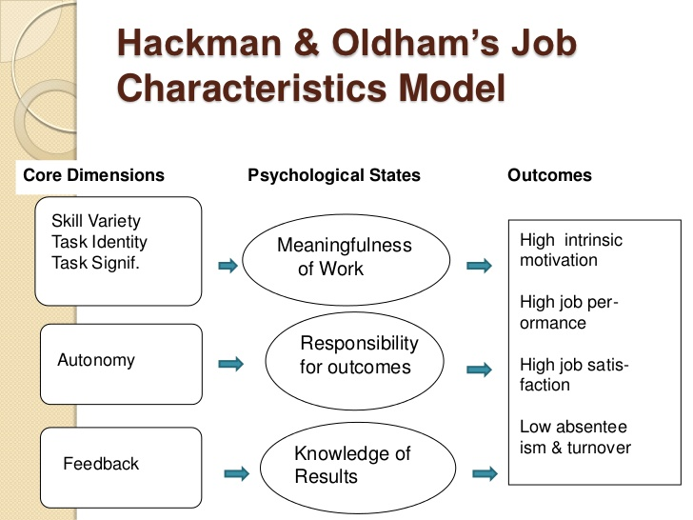
Hackman & Oldham’s job characteristics model is based on the belief that the task itself is key to employee motivation, that a boring and monotonous job stifles motivation, whereas a challenging job enhances it. The model argues that it is possible to design jobs that add to employee motivation.

Variety, autonomy and decision authority are three ways of adding challenge to a job. Job enrichment and job rotation are the two ways of adding variety and challenge. Hackman & Oldham suggested that there are five job characteristics that can be studied to help predict job satisfaction:

Skill variety
- How many different skills and talents does the job require of a person?
- Are they asked to do a lot of different things, or is it a monotonous, repetitive job?

Task identity
- Is there a clearly defined beginning, middle and end to a given task?
- Does a worker know what he or she is supposed to do, and when he or she is successfully completed the task?

Task significance
- Does the job have “a substantial impact?
- Will it matter to people, either within the organisation or to society?
- Is this job/given task meaningful?

Autonomy
- How much freedom does an individual have to accomplish his or her tasks?
- Does this freedom include the ability to schedule work as well as figuring out how to get the tasks done?

Job feedback
- Is an employee kept in the loop about their performance?
- Are they being told when they are doing well and when they are not?

Hackman and Oldham feel that organisations should be able to design or redesign their jobs around the FIVE core principles in order to motivate and engage employees. This might involve:
- Varying the pattern of work in order to broaden the skills variety and make the tasks more meaningful.
- Reorganising work so that groups of employees can focus on production of the whole product rather than just a small part of it.
- Ensuring employees understand the value of their work in relation the company objectives, stakeholders and wider society.
- Delegating tasks as much as possible to improve the skills level of workers.
- Providing appropriate feedback to employees.

When designing jobs, managers will also consider the following:

Job Enlargement
This is often referred to as horizontal loading since is involves simply giving workers more tasks to do of the same complexity as the jobs they are already doing.

Job Rotation
This is a particular type of job enlargement whereby employees switch regularly from one duty to another e.g. a supermarket may require employees to complete a week on check-outs, a week stacking shelves followed by a week on customer service.

Job Enrichment
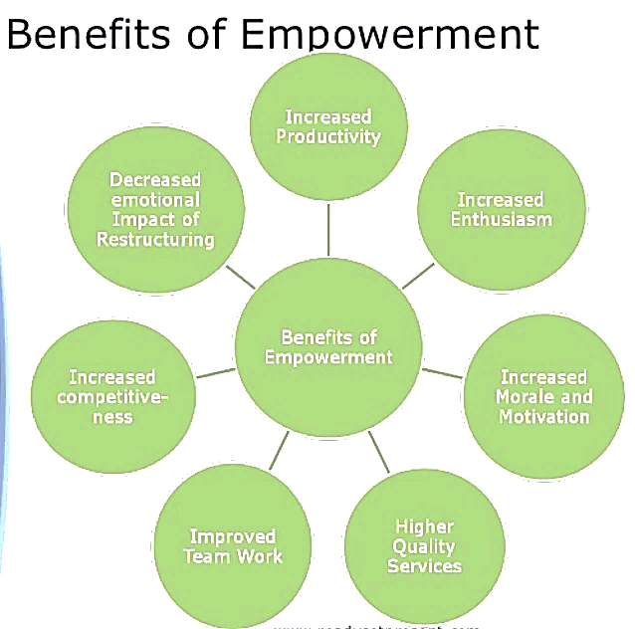
Jobs are redesigned to provide workers with a wider variety of tasks which are more challenging and complex. It is often referred to as vertical loading. Workers are given greater responsibility for managing themselves and given the authority to identify and solve problems. However, managers must ensure that workers are capable of completing the tasks required of them.

Empowerment
Employees are given greater control over their work. Empowered workers can suggest and implement changes.
This theory fits well with motivation theories such as Herzberg’s concept of their being motivational factors at work or Maslow’s idea of people having esteem needs which can be met through work.
Any question which asks how employees’ jobs can be improved to improve productivity and employee satisfaction can include reference to Hackman and Oldham.
There are lots of relevant news stories but here are two examples, try and think about how use of Hackman and Oldham would help in these situations.
BBC report on workplaces and employee satisfaction
Guardian article about how jobs will be affected by automation

Organisational Design and Structure

Organisational Design
This is the process of shaping an organisation’s structure so that it meets the organisation’s purpose and helps deliver its objectives. It enables a business to bring together departments (functional areas) and the employees of the organisation.

Organisational Structure
This represents the formal lines of authority and power and the relationship between different people and functions within a business. Organisational structures are usually presented in the form of organisational charts; diagrams showing the lines of authority and the various management layers in the hierarchy.
Communication can pass up and down the organisation (vertical communication). It can also pass across the organisation (horizontal communication). Those high up the organisational hierarchy will delegate tasks to those who are subordinate to them. While accountability rests with those higher up the hierarchy. This relationship is shown below:
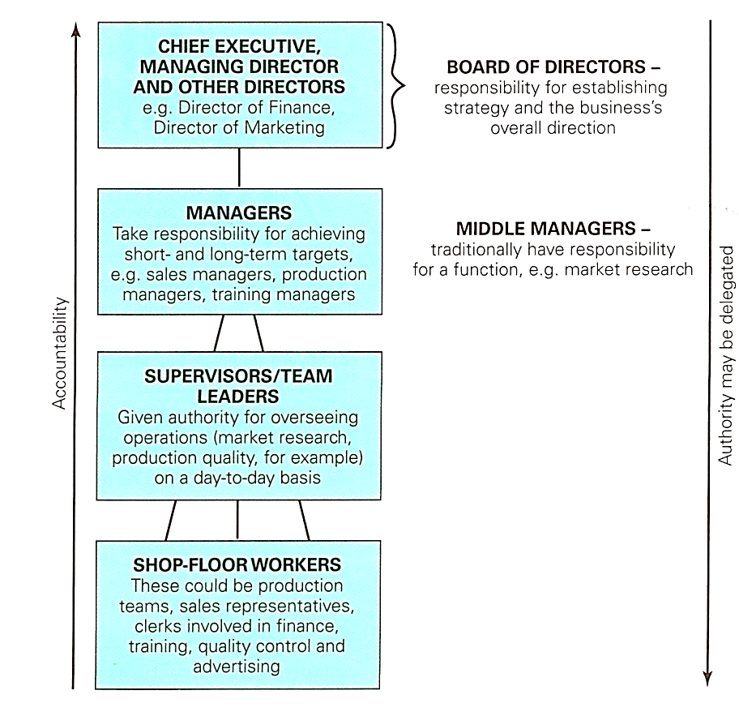

Key factors in organisation design

- Levels of the hierarchy
Organisations with only a few levels in their hierarchy are referred to as flat structures (organisation B) whereas organisations with many layers are referred to as tall structures (organisation A).

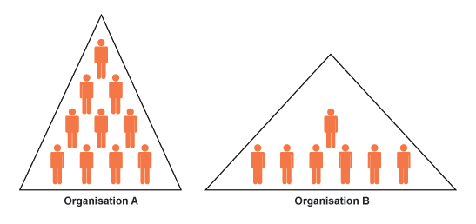

Traditionally, UK businesses have tended to use tall structures with long chains of command. A chain of command is the line of communication in an organisation; thus a shop floor worker reports to a supervisor who reports to their departmental manager and so on.
The lines of communication / chains of command are likely to be longer for a tall structured organisation. Messages can take longer to pass up / down the organisation and messages and instructions may get distorted. In order to improve chains of command, many businesses have delayered their organisation by taking out the layer of middle managers.
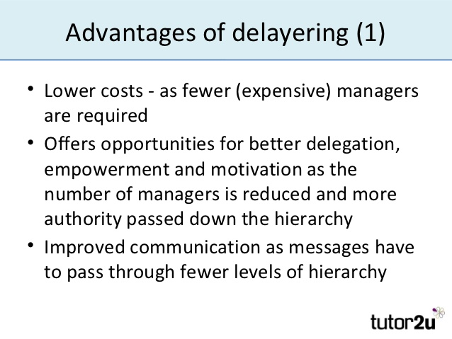
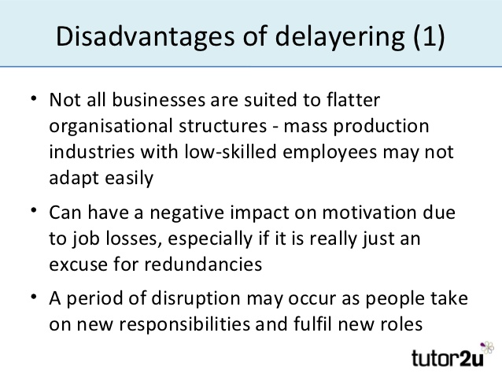

- Span of control
A span of control is the number of people who report directly to a manager. A flat organisational structure will have wide spans of control whereas a tall organisational structure will have narrow
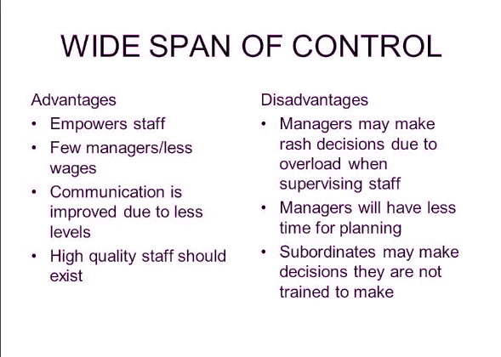
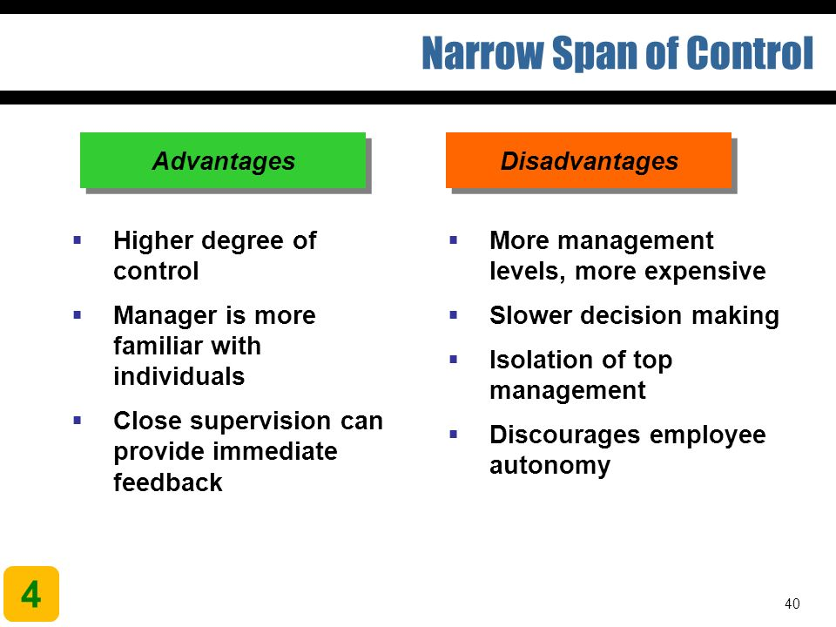
spans of control. A manager with a wide span of control will need to delegate work and trust employees to complete tasks; there will be little time to supervise closely. This would suit democratic and consultative forms of management. Very narrow spans of control allow the manager to ‘micro manage’ their employees and there will be very little delegation. This would suit an autocratic style of management.
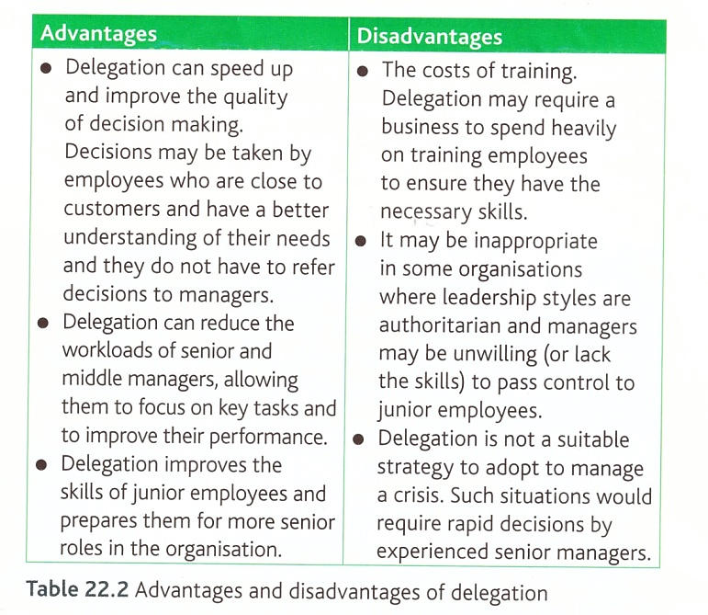

- Delegation
This is the passing down of authority through the organisation. In a very small business, the entrepreneur will make all the necessary decisions. However, as an organisation grows, this may become more difficult and delegation is then required. Giving people greater authority can be an important feature of organisational design. It reduces the workload of the manager or team leader as they do not have to monitor subordinates closely.
Authority
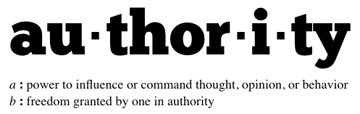
Authority and delegation are linked as delegation involves passing authority further down the organisational structure. Where the authority resides is an important decision within an organisation. Giving employee’s authority can empower them to make decisions and act upon them. Authority also carries the responsibility of success or failure of delegated tasks.
- Centralisation and Decentralisation
Centralised structures are organisations that keep their decision making power firmly at the top of the organisation rather than delegating responsibility to employees further down the hierarchy.
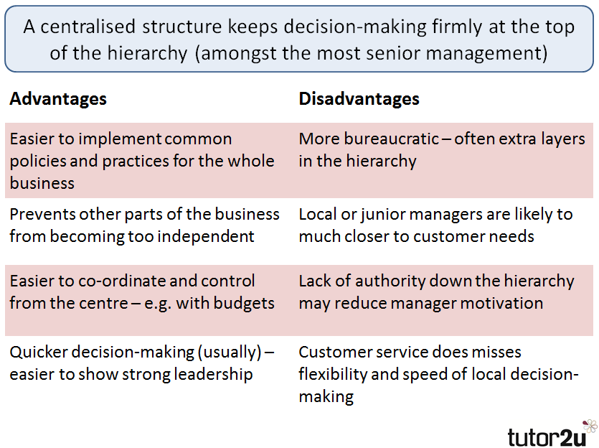
A decentralised structure is where the power and authority to make decisions is delegated from Head Office to managers or employees lower down the hierarchy of the organisation. Decentralisation involves less uniformity in how things are done as decisions are likely to be made in relation to local circumstances and opportunities.

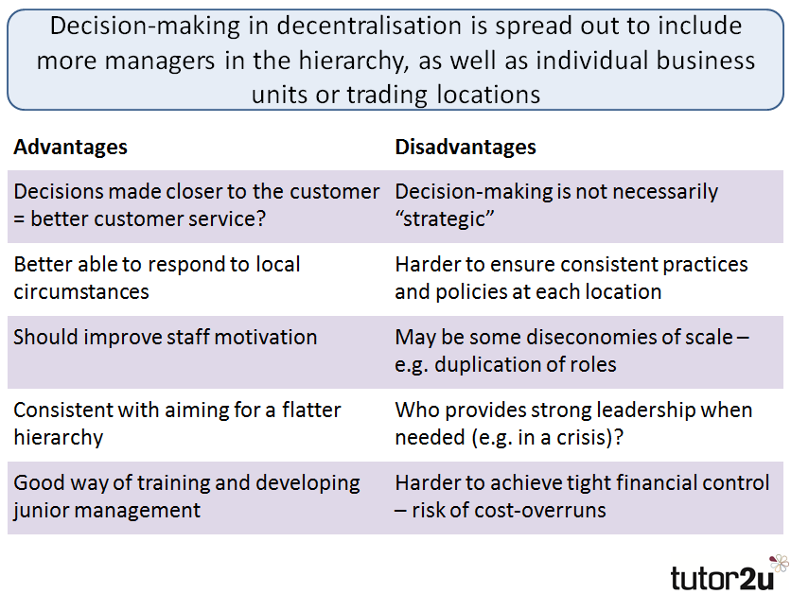

Types of organisational structures
There are many types of organisational structures. The common types are:
- Functional organisational structure which is the traditional type already discussed.
- Geographical organisational structure is where the business is organised according to the location of production.
- Product line based organisational structures
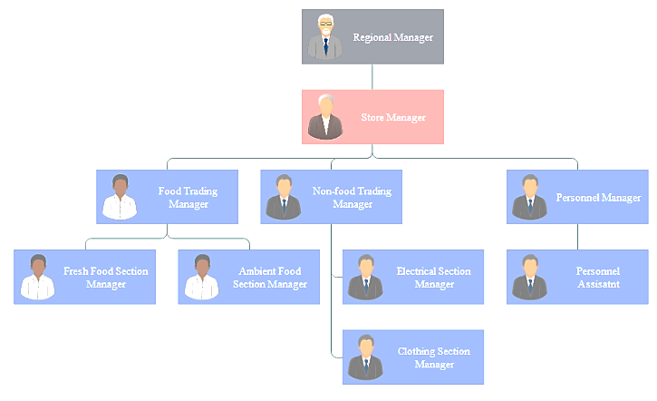
- Matrix structure

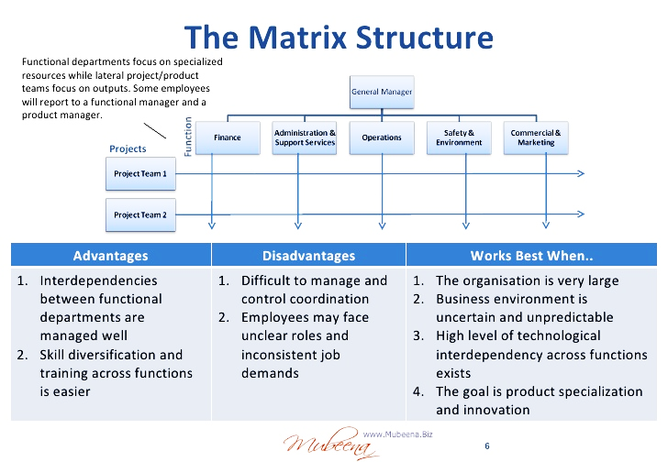
This type of structure tends to be used alongside the functional organisational structure. The business has project teams whose members are taken from across the functional areas of the organisation. Therefore, each project team will consist of members from Operations Management (production), Marketing, Human Resources and Finance.

Influences on organisational design and structure, delegation, centralisation and decentralisation

Business objectives: Ensuring that the choice of organisation design matches the purpose of the business.
Size of the organisation: The larger the organisation, the more complex its structure and design and the more layers in the hierarchy there will be.
Nature of the organisation: Is the business in the primary, secondary or tertiary sector? Is it national or international? Does it manufacture a single product or multiproduct?
Attitudes of senior management: Is the management style autocratic and controlling or democratic and participating? Autocratic management prefer centralised structures with tall management hierarchies. Whereas companies such as Google prefer flat structured companies with decentralised power.
Skills and experience of workforce: Are the majority of workers low skilled employed in repetitive jobs? Are they highly skilled doing highly complex jobs? The latter will require flat organisational structures with decentralised control.
External environment: Businesses need to be aware of the constantly changing business environment. A tall organisational structure may need to delayer in the face of competition. This will speed up and improve the quality of decision making.
Stakeholders: A business needs to check that stakeholders’ needs are being met and if not, organisational changes can then be made to address the situation.

The value of changing job design and organisational design
Enables the business to become more competitive.
It will allow the business to meet its objectives and meet customers’ demands.
Changes in job design and structure can help the business to improve the performance of the workforce by creating more interesting and motivating jobs.
It can positively impact on unit labour costs, productivity and labour turnover etc.
Delayering an organisation can reduce wage costs but also empower the remaining workers through job enrichment, delegation and empowerment.

Human Resource Flow
The human resource flow comprises a number of elements that reflect an employee’s movement through the organisation.
- Human resource planning
A human resource plan assesses the current and future needs of the business and takes action to ensure that the business will have sufficient staff. Future needs are compared with existing staff levels taking into account untapped skills of the current workforce. The company may carry out a skills audit of the existing workforce in order to achieve this. Once the comparison of current and future needs of the businesses is completed, the business will be in a position to recruit and train existing staff, make redundancies or redeploy staff.
- Recruitment and selection
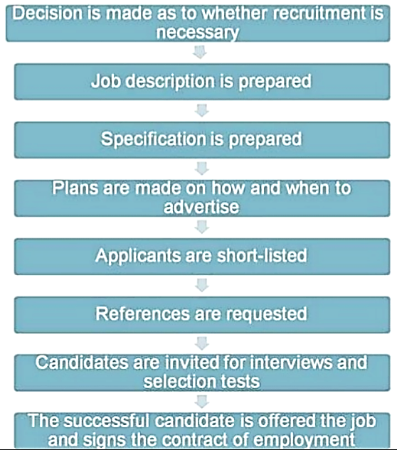
The process of recruitment and selection is summarised below:

Job descriptions contain details of the tasks, duties and employment conditions associated with the job.
Person specification sets out the qualification and qualities of the person.
Once these have been drawn up, the business will then be in a position to draw up the job advertisement and match the job applications to the requirements of the business. The business will also need to decide whether the vacancy should be advertised internally or externally:

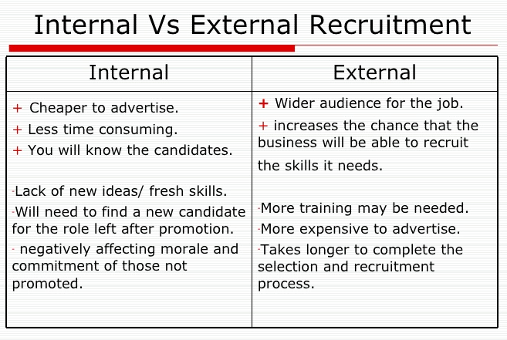
If external recruitment is being used, the method by which it is done will depend upon the post being advertised. The business can use a local, regional or national newspaper, local Job Centres (now called Job Centre Plus) to advertise the position.
They can also use specialist recruitment agencies that will carry out the initial interviews and produce a shortlist of candidates for the business. In return, the recruitment agency will receive a percentage of the annual salary of the person who has been recruited. Additionally, the business can use their website and also specialist magazines such as Accountancy Today.
Potential candidates will be asked to apply for the post in a number of ways. For example:
- Submission of curriculum vitae (CV).
- Application form
- Application letter
- By telephone
Once a shortlist has been produced, the business can then select the most appropriate candidate. Methods of selection include:
- Interviews
- Personality or aptitude tests such as psychometric testing
- Role plays
- Presentation
- Group tasks
- Assessment centres where recruitment is carried out away from the workplace and usually occurs over the day. It will include a series of tests, interviews and group activities.
- References
Once a suitable candidate has been selected, they will be offered the post subject to background checks such as criminal record checks. Most employees are recruited on a three or six-month contract initially.

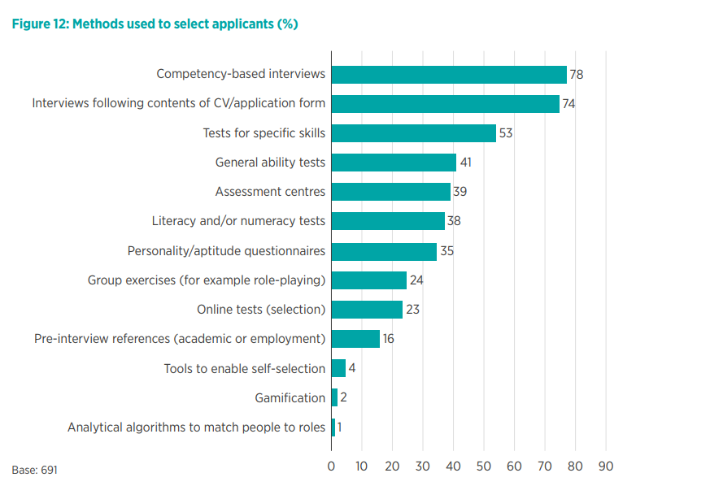
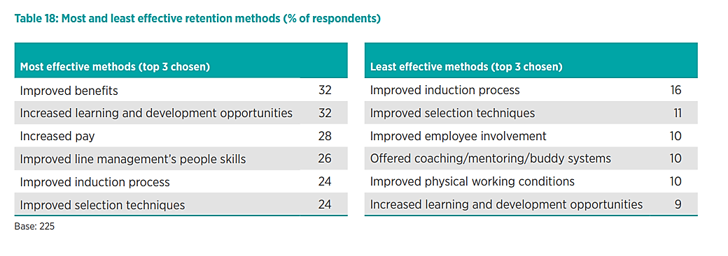
The charts below are taken from the CIPD annual survey of recruiting trends.

https://www.cipd.co.uk/Images/resourcing-talent-planning_2017_tcm18-23747.pdf

Importance of effective recruitment and selection
Ineffective selection can cause increased labour turnover which in turn leads to additional costs in terms of further advertising, interviewing and training as well as its impact on productivity and employee motivation. Effective recruitment and selection could lead to lower labour turnover, lower costs, improved productivity and more highly motivated employees.
- Training
Training is a process by which someone acquires skills and knowledge. Training helps the firm to retain staff and so lower turnover and recruitment costs – it is one of a number of retention methods (see table below). This can help the employee to develop but also assist the business in achieving its own aims and objectives. The need for training is essential when the knowledge and skills required by the firm exceed or differ from those that the workers currently possess, changes which may require additional training include:
- The development or introduction of new products and services.
- The introduction of new technology just as computers and robots on the production line.
- Restructuring of the firm e.g. job enlargement as a consequence of delayering.
- Changes to procedures including changes to customer service.
- When there is high labour turnover.
- Changes in legislation.

Methods of Training
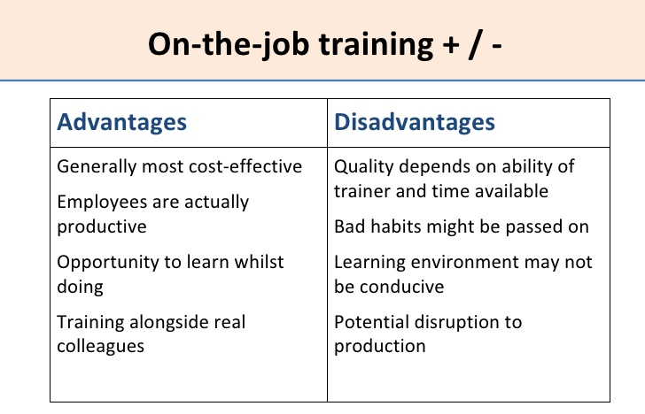
Induction training is required to help new employees settle in quickly and includes familiarising them with the layout of the organisation, health and safety issues, the management hierarchy and the main policies of the organisation. An effective induction programme is likely to reduce labour turnover and improve retention rates, increase motivation and enable employees to contribute to the organisation quickly.
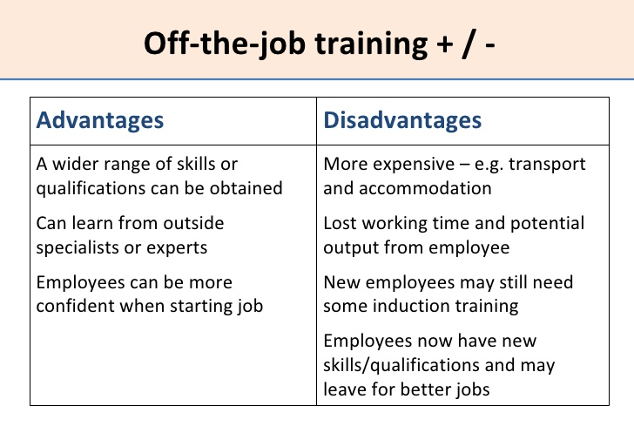
On the job training will take place within the organisation with the main benefits being that it is cheaper. Also, new recruit can become quickly familiar with the existing staff and what is required of them. An experienced employee is chosen to train or coach new staff.
Off the job training involves all forms of employee education apart from that carried on in the immediate workplace. It may be conducted internally – for example in a conference room. Or, it may take place externally for example, at a college or training centre.

Redundancy
Redundancy takes places when an employee is dismissed because a job no longer exists. The process of making someone redundant usually involves extensive consultation with recognised trade unions or elected employee representatives. Employees must not be unfairly selected for redundancy since this could be classed as unfair dismissal. Criteria for selection might include:
- Length of service | - Attendance
- Disciplinary | - Skills and qualifications
- Work experience | - Performance records

Employees may be entitled to redundancy pay if they are made redundant. Redundancies can demotivate staff and are therefore avoided if possible. Ways of avoiding redundancy include:
- Natural wastage and recruitment freezes meaning that whenever an employee leaves, they are not replaced
- Stopping or reducing any overtime
- Pay freezes / Pay cuts
- Asking people to volunteer for early retirement
- Short term working

Redeployment
Redeployment may be offered when jobs are being made redundant but there are vacancies elsewhere in the organisation. For example, in a multi-product firm, the demand for one product line might be falling while the demand for another product line is increasing. Redeployment might also occur for personal reasons such as the result of medical conditions experienced by the employee etc.
The advantages of redeployment are that it:
- Maintains job security for employees whose current jobs are at risk
- Improves morale of the workforce
- Retains valuable skills, knowledge and experience
- Reduces the costs and time associated with external recruitment

