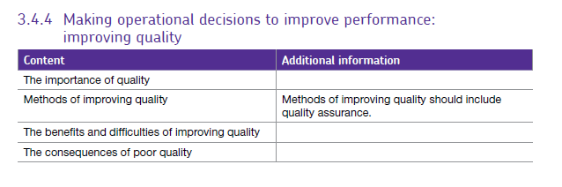
3.4.4 Quality

Quality is important to businesses but can be quite hard to define, essentially quality is about meeting the needs and expectations of customers. Customers want quality that is appropriate to the price that they are prepared to pay and the level of competition in the market.
Key aspects of quality for the customer include:
- Good design – looks and style
- Good functionality – it does the job well
- Reliable – acceptable level of breakdowns or failure
- Consistency, durability – lasts as long as it should
- Good after sales service
- Value for money
'Value for money' is especially important, because in most markets there is room for products of different overall levels of quality, and the customer must be satisfied that the price fairly reflects the quality. Some products and services are marketed as 'basic', having none of the extra features and benefits of more expensive alternatives. Good examples would be Easyjet and George at Asda clothing ranges. Even though it may be 'low quality' in terms of style or features, these products still give good value for money for their overall level of quality.
For the firm, good design is fundamental, so that the product can be produced efficiently, reliably and at the lowest possible cost.
Quality helps determine a firm's success in a number of ways:
- Customer loyalty – they return, make repeat purchases and recommend the firm to others.
- Strong brand reputation for quality
- As the product is perceived to be better value for money, it may command a premium price and will become more price inelastic encouraging retailers to stock the product
- Fewer returns and replacements lead to reduced costs
- Attracting and retaining good staff

These points can each help support the marketing function in a business. However, firms have to work hard to maintain and improve their reputation for quality, which can easily be damaged by a news story about a quality failure.

Measuring quality.

Given the importance of quality to almost all businesses, it is important that quality is measured. There are many ways to do this.
Businesses can measure quality aspects such as:
- Failure or reject rates
- Level of product returns
- Customer complaints
- Customer satisfaction – usually measured by a survey
- Customer loyalty – evident from repeat purchases, or renewal rates
However, it is important to remember that quality is subjective, it is a matter of personal opinion and what constitutes an acceptable level of quality will vary from one individual to another. Not all aspects of quality are tangible – for example the degree of assurance given by a firm's name or reputation can be very important even though it is hard to measure.
Quality is always evolving because of things like improved technology, better materials, new manufacturing techniques and fresh competitors. No firm can afford to stand still as far as quality is concerned. Whilst controlling quality has benefits to the firm, it can also be costly to do, so it is important that the benefits outweigh the costs in the long term

Benefits and difficulties of improving quality.

Methods of improving quality

The important thing to remember about quality is that the business must first establish what their customers expect from the product or service. The business must then ensure that they deliver the expected standard of quality consistently. In order to do this, the business must use a quality system. Quality systems are methods by which the business can monitor quality and consists of either quality control or quality assurance. We will look at these in turn:

Quality control

This is the traditional method of monitoring quality. The business employs an inspector who will check a sample of products at the end of the production line for faults. If faults are found, the product will be disposed of or it will be reworked (taken apart) and put back together.

Benefits of quality control

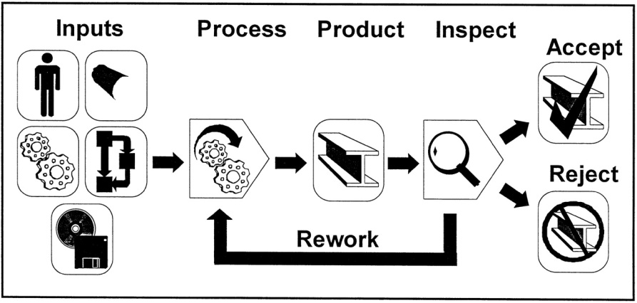
- A detection of a fault at the end of the production process will stop the faulty product from reaching the customer. If the product is produced in a batch, the entire batch might be disposed of.
- Quality is the responsibility of the inspector. The inspector is a specialist and can be trusted rather than leaving it to each individual employee of the production line.

Drawbacks of quality control

- Individuals on the production line are not made accountable for the quality of their own work. Workers on the production line see that quality is the responsibility of the inspector and not them.
- Employing an inspector or an inspection team is an additional expense to the business.
- Giving workers responsibility for their own work can increase motivation and interest within the job.
- The inspector may only check a sample of products which means that not all faulty products will be detected. If a customer receives a faulty product, it could damage the reputation of the business.

Quality Assurance

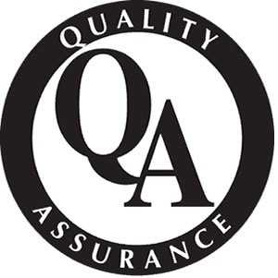
As a result of the drawbacks listed above, many businesses have moved from quality control to quality assurance. Quality control involved checking products at the end of the production process whereas quality assurance involves checking products during the production process. Every employee of the production line is responsible for their own quality. Workers are also responsible for checking the quality of the work completed by the person before them in the production process.

Benefits of quality assurance

- Workers now take responsibility for their own quality. Theorists such as Herzberg argue that will have positive effects on motivation because workers will feel a sense of ownership of their own work.
- Costs are reduced because there is less waste, less need to rework faulty products and no need to employee inspectors.
- Faults can be detected straight away rather than further down the line or at the end of the production process. This makes it much easier and quicker to rectify.
- Because workers are checking not only their own work, but the work of the person before them in the manufacturing process, there is more chance that the company will achieve zero defects. This avoids the bad reputation which can follow if a customer receives faulty products. Zero defects can also be used for marketing purposes.

Drawbacks of quality assurance

- It can be time consuming. This is because workers are constantly checking their own work and the work of the person before them on the production line.
- If a fault is found, it can cause delays further down the production line.
- It can place stress on individual workers.
- Workers must be trusted to check their own work.

Other systems associated with quality assurance
Quality assurance is regarded as being part of lean production covered earlier. The following are also part of quality assurance and therefore also part of lean production.

Total quality management (TQM)
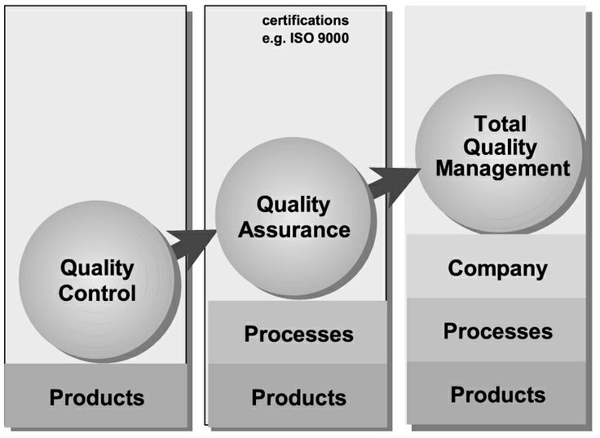
So far we have considered quality on the production line only. However under TQM, all employees are required to take responsibility for their own quality. This includes the cleaners to office workers to the senior managers. Every task undertaken by each and every employee must be completed to the highest standard possible and employees are expected to ‘get it right first time, every time’. Each employee and functional area of the business contributes to the quality of the firm’s products or services.

Kaizen
Again, Kaizen is also part of lean production and means continuous improvement. The gradual incremental changes to improve the production process or the product is invariably suggested by employees by the use of quality circles.

Difficulties of improving quality
A business trying to improve quality can face a number of obstacles and difficulties. These include:
- Many quality systems give greater responsibility to staff. This may require additional training and also a form of management which is happy with delegation.
- Resistance to change may occur either from management or from workers on the production line. This is because quality systems need a culture which is sympathetic to quality issues.
- Improving quality can be expensive. Introducing and updating information systems and allocating more time to workers on the production line so they can check quality.

Costs of Poor Quality

The potential costs of poor quality go well beyond the actual cost of the product or service that has failed to meet customer expectations. You can probably come up with several examples from your own experience of when you have come across poor quality: e.g.
- Product fails – e.g. a breakdown or unexpected wear and tear or the product does not perform as promised
- Product is delivered late
- Poor instructions/directions for use make using the product difficult or frustrating
- Unresponsive customer service
Poor customer service as listed above results in additional business costs:
- Lost customers (expensive to replace – and they may tell others about their bad experience)
- Cost of reworking or remaking product and wasted materials
- Costs of replacements or refunds
You can see from the list above that poor quality is a source of competitive disadvantage. If competitors are achieving higher quality, then a business will suffer.
The flip side of the above is that a business can benefit by improving its quality. The key benefits of improved quality are:
- Improved image & reputation, fewer customer complaints (& more satisfied customers)
- Higher demand, which may in turn mean greater production volumes (maybe economies of scale)
- Lower unit costs because of less waste and rejected output
- Potentially higher selling prices (less need to discount)

