3.5.3 Sources of finance
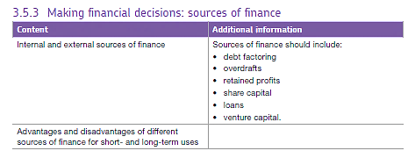
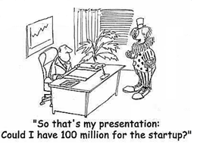
All business activity requires finance; there are several sources of finance to choose from and the management of the business must decide which source is the most appropriate.

Factors to consider when choosing a source of finance

Managers must consider the following when choosing a source of finance:

- The amount of money required by the business.
- The type of business. For example, only limited companies have access to share capital whereas a sole trader may rely more on personal savings or friends and family.
- The financial position of the business is important since some sources of finance are more expensive than others e.g. have they a good cash flow?
- The reason they need the money - if the finance is required purely to boost cash flow then a short term source of finance such as an overdraft is appropriate. Whereas if the finance is required for the purpose of purchasing a non- current asset such as land or buildings then a long term source of finance is required. For example, a mortgage. Non-current assets are items the business owns which have a long term life in the business i.e. for one year or longer.
- Levels of risk are important to consider because if the business is considered to be high risk, it will be more difficult to obtain a bank loan or may only be offered it at a high interest rate.
- Views of the owners should also be considered especially if the finance involves losing control of the business.

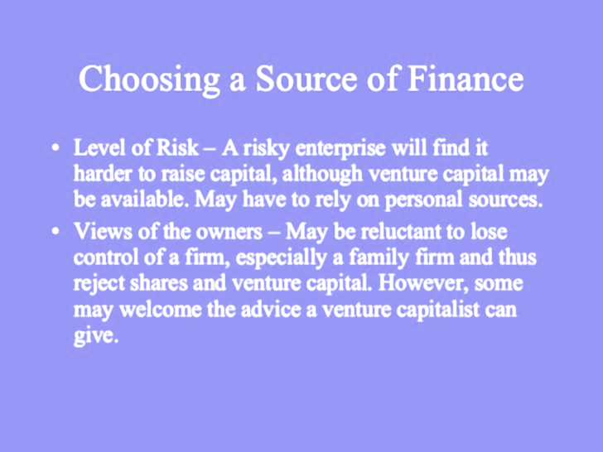
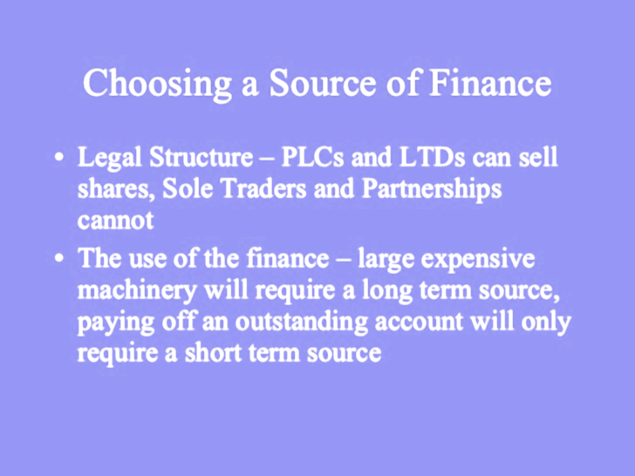

Classifying sources of finance
There are a number of ways to categorise sources of finance. These are:

Long term sources of finance are those sources of finance that are required for a longer period of time, usually over a year.

Short term sources of finance are needed for a limited period of time, normally less than one year.

Possible sources of long term and short term finance
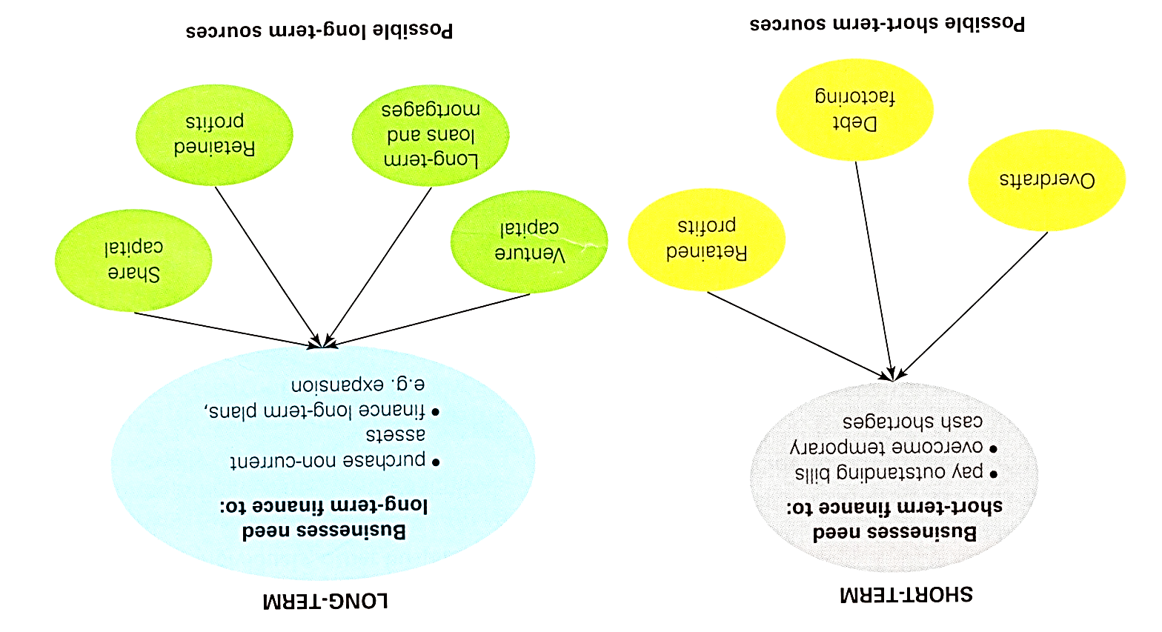

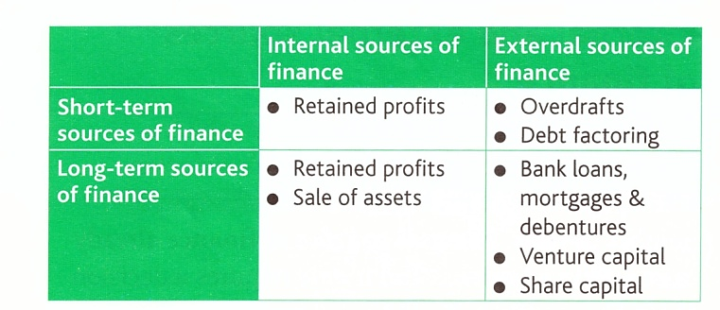
As well as being long and short term, finance can also be Internal (sources of finance that exist within the business) and External (sources of finance from outside the business such as a bank loan or overdraft).

What will the finance be used for?
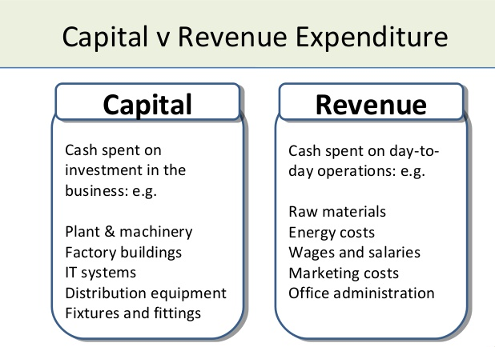
There are 2 types of expenditure within businesses - capital expenditure and revenue expenditure

When considering sources of finance, the most critical factor is the length of time for which the finance is needed. Finance is used to fund two types of spending as shown here:

Sources of Finance

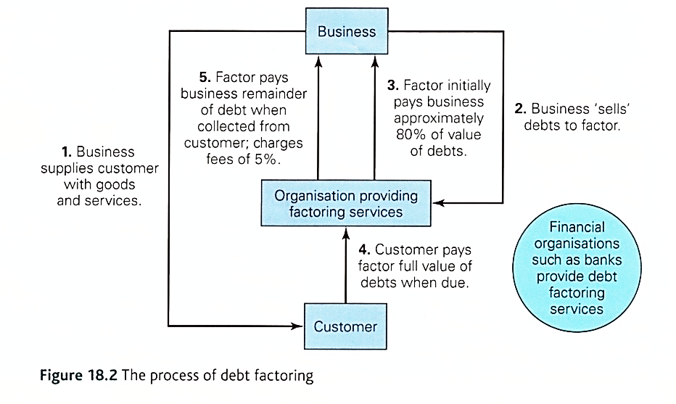
Debt Factoring is an internal source of short term finance and involves a business ‘selling’ its bills (invoices) to a debt factor for approximately 80% of the value of the invoice immediately with a further 15% to be paid when the customer pays the invoice in full to the debt factor.

The debt factoring company will withhold about 5% of the value of the invoice to cover all the costs associated with the debt collection and as their reward.

Overdrafts are an external source of short term finance and are agreed between the business and the bank. The bank will allow the business to go overdrawn on its business account up to an agreed figure but will want to see the business’s cash flow forecast before the overdraft is approved.

Retained profits are an internal source of long term finance. It is the profit kept back in the business (and not distributed to shareholders by way of a dividend if it is an incorporated company) to finance future activities.

Ordinary Share Capital is an external source of long term finance. Remember that ordinary shareholders have voting rights at the Annual General Meeting (AGM) and that shareholders may or may not receive a dividend. If the company is successful and profitable, then the ordinary shareholders may receive a dividend but there is no guarantee. A company which floats on the stock market can raise substantial amounts of money. If the business goes into liquidation, the personal assets of the shareholders are protected by limited liability status. Note: this is different from a Rights Issue which is an internal source of long term finance since existing shareholders are invited to buy further shares in the company.

A bank loan is a sum of money provided to a firm by an individual or by a bank often for an agreed specific purpose. Loans can be both short term (if repayable within a year) or long term sources of finance. Providers of loan capital are known as creditors and they charge interest on the loan. The loan is taken out with an agreed fixed interest rate attached (though sometimes the interest rate is variable over the term of the loan) and repayable over a set period of time.

Venture Capital is an external source of long term finance and commonly involves sums of between £50,000 and £150,000 which are provided by individuals (often known as business angels) or merchant banks. A merchant bank is a financial organisation which specialises in providing finance to support businesses and trade. Many venture capitalists want a say in the running of the company and it may involve part ownership through the purchase of share capital in the business. This is often referred to as an equity stake.

Other sources of finance

Sale of assets is an internal source of finance and is where the business may sell off unwanted long term assets in the business to generate a quick cash injection or provide a source of further long term finance. If the assets are no longer required and are generating little or no income, then the selling off or liquidating an asset (turning it into cash) can be a rational thing to do. But it must be remembered that assets can only be sold once! Sometimes the business still wishes to use the assets in which case they will sell the asset to a leasing company and then lease it back so that the business can continue to use it. This is referred to as sale and leaseback. However, monthly lease charges will add to overheads and reduce profits.

Mortgages are long term and external sources of finance which are repaid up to a period of fifty years. They are used specifically to purchase property or land. The advantages and disadvantages of this source of finance is the same for loans.

Debentures are issued by PLC companies only and are a special form of long term loan. Debentures are issued with a set repayment date and a set agreed interest. However, unlike long term loans, repayment with interest is not made monthly but it is repaid at some future agreed date and as such this might be a better way of raising finance than a loan. Unlike shareholders, those who purchase a debenture do not have voting rights at the AGM. However, the debenture is secured against the long term assets of the business which means that if the business experiences financial difficulty, the long term assets of the company will be sold in order to repay the debenture.


Crowdfunding involves the use of the internet to advertise the business opportunity requiring finance e.g. through a site such as Kickstarter. The internet can reach a high number of potential investors and has proven to be a good way for new and novel businesses to raise finance. Such businesses would not be funded by high street banks. Crowd funding enables large numbers of investors to invest only small amounts of money to minimise their own risk. However, the business using crowding funding can sometimes raise large amounts of money this way.

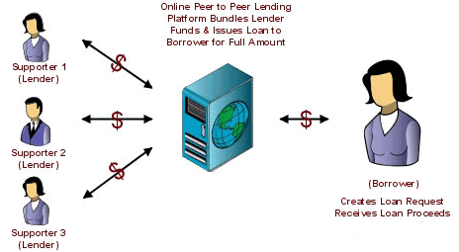
Peer to Peer lending enables more mature businesses to offer funds to other businesses. Like Crowdfunding, these businesses operate exclusively on the internet. Money is raised from large numbers of private investors and lent for specific projects, the lenders carry out some risk assessment and administer the loan. Examples of peer to peer lending include Funding Circle and Zopa.

Personal sources of finance are often important for new start-up businesses and may be provided by the owners own savings or redundancy payments. This source of finance is regarded as an internal source of finance. In some cases, funds are borrowed from family and friends and in which case it is regarded as being an external source of finance.


Recent developments in business financing

Since the credit crunch, banks have been more reluctant to lend to businesses, especially small businesses thought to be of high risk. Government schemes such as Funding for Lending appear to have had little or no impact on this situation.

