Dissecting of the ventilation system of a locust
The purposes of this practical are to:
- study a living locust and try to identify how gases might pass through its shiny, hard, exoskeleton
- practice the skills of dissection (doing minimal damage and removing only material that obscures your view or is to be studied further)
- follow the tubes (tracheae) that run from the pores (spiracles) in a locust’s exoskeleton and see how they connect to the body
- study the tracheae further using temporary stained preparations of locust tissue

Procedure
SAFETY:
- Handling living locusts – skin and droppings in the dust may provoke an allergic response.
- Ethanol IDA, Hazcard 40A – keep away from naked flames and avoid skin contact.
- Avoid skin contact with the solution of methylene blue.

Investigation 1
- Put a living adult locust into a syringe barrel so that its movements are restricted. Handle the locust calmly and carefully so as not to cause it any distress or damage.
- Place it under a stereomicroscope. Look at the thorax and abdomen for apertures through which it is likely that gas could pass.
- Focus on the large aperture (spiracle) on the second thoracic segment just behind and above the insertion of the leg. Observe its movements and record carefully what you see.
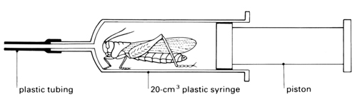

QUESTIONS: Investigation 1
- What are the movements made by the thoracic spiracle which you observed?
- What do you think they achieve?
- What do you think is the function of the spiracles?

Investigation 2
- Fix a dead adult locust to the stage of a monocular microscope and examine the abdominal and thoracic spiracles more closely. You will need strong, oblique, top lighting and a very low magnification, but you should be able to distinguish between a true spiracle and a pit or depression.
- Record the location of the spiracles on a simple outline sketch or digital photograph for future reference.
- Place the dead locust in its normal resting position in the centre of a shallow dish which has a layer of hard wax at the bottom. Fix it by means of pins through the legs and thorax. Cut off the wings if they get in the way.
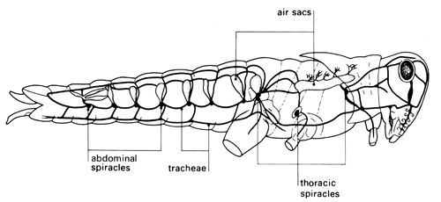
- Pull back the tip of the abdomen with forceps, stretching it slightly, and insert a pin to hold it back and down. With fine-pointed scissors, pierce the exoskeleton between two segments at about the position shown in the diagram. Cut down between the segments on one side and then continue the incision forward to the head along the dotted line shown. As you cut, let the lower blade of your scissors pull the locust up slightly. In this way you will be less likely to damage the internal organs.
- Make a similar cut on the other side and carefully remove the strip of exoskeleton from the animal so that you can see the organs inside. (Use a blunt seeker to separate the strip from the underlying tissues – the heart should remain attached to the strip.) Preserve the strip in a tube containing 70% ethanol if you wish to study locust hearts in more detail at any point.
- Flood the dissection with insect saline or water and explore the cavity and its contents with a seeker. Identify the most prominent organ – the brown alimentary canal (or gut). See diagram overleaf.

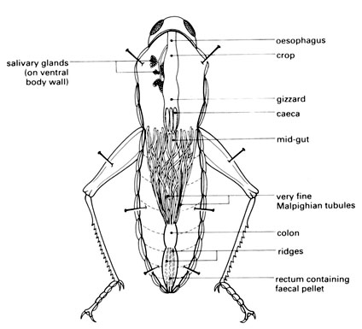
after Thomas, J.G., Dissection of the locust, Witherby, 1963.
- You are looking particularly for structures filled with air which show up as tiny silver threads. (You also get this effect with empty glass tubes under water – they look silver and their surface acts like a mirror.)
- Examine the many silver threads (tracheae) and the associated organs with the aid of a hand lens and stereomicroscope. Try to trace the possible paths of gases moving into or out of the body. Pull the mid-gut upwards gently and look at the air-filled tracheae from the side.
- Compare your dissection with a few others in the group, as the number and size of air sacs can vary considerably from one locust to another.

QUESTIONS: Investigation 2
- Record what you have found out about the general arrangement of tracheae and air sacs in the locust and their connection to the spiracles. Do this by drawing a diagram to show the relative positions of the tracheae and air sacs; it does not need to look like the real organs. Don’t spend too long on this – there is a lot of information, so record what you can in the time available (5-10 minutes).
- Describe the location and appearance of the air sacs. What do you think is their function?
- Is there any anatomical evidence to support the idea that locusts breathe through their mouths?

Investigation 3
- With scissors, remove a small portion (2.5 mm long) of the mid-gut or hind-gut together with some tracheae. Place it in a watchglass containing a little water.
- Cut the portion of gut longitudinally, open it out flat, wash away all trace of the gut contents and mount the specimen in water on a slide beneath a coverslip.
- Observe it under low power and high power. The tracheae will stand out clearly because they contain air and so appear dark grey or silver in transmitted light.
- Remove the coverslip and put a drop of aqueous methylene blue on the tissue.
- While waiting for the stain to take effect, take a small leaf of Impatiens (Busy Lizzie), cut out the midrib, tease it into shreds with needles, mount it in a drop of water and squash it firmly under a coverslip. Examine under low power and see if you can find any structures that have a ringed appearance similar to that of tracheae.
- Return to the preparation of the gut wall, wash away the excess stain and mount in water. Look for nuclei and other details of a cellular structure surrounding the tracheae.
- Compare what you can see with the diagrams below showing part of a tracheal system, and a system that has been immersed in ethanol overnight.

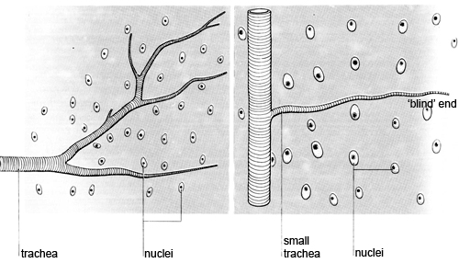
Tracheal system
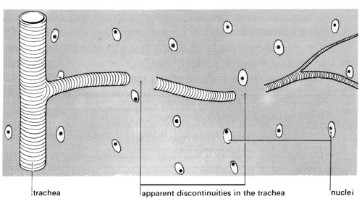
Tracheal system immersed in water overnight
QUESTIONS: Investigation 3
- What function do you think the rings or hoops in the tracheae perform?
- If there are ringed vessels in the midrib of a leaf too, does this suggest that they do a job similar to that of an insect’s tracheae? Do the vessels in the plant appear to contain air?
- How do tracheae end in the gut wall? Is there any evidence that, like blood capillaries, they eventually join larger tracheae to enable air to circulate in one direction?
- If you find a trachea which appears to be discontinuous, does this help you to interpret the ‘blind’ endings of the smallest tracheae?
- To summarise what you have seen, explain briefly the way in which locusts bring about the exchange of gases between their internal organs and the surrounding air.
- In the context of what you now know about the exchange of gases in the locust, comment on the fact that few insects grow to a size where the diameter of their body is greater than 15 mm.

ANSWERS: Investigation 1
- Movements of the thoracic spiracle: The valves of this spiracle separate from one another, both moving, then close again at the midline (see diagram), over a short time period (about 0.3 s).
- This allows some diffusion of gases into and out of the trachea adjoining the spiracle. The rate of diffusion would depend on the differences in concentration of different gases between the external and tracheal atmospheres.
- The function of the spiracles is to balance the need for gas exchange with the need to retain water in the locust. An open tracheal system would more readily allow gas exchange, but would have a greater risk of excessive water loss.

ANSWERS: Investigation 2
- Arrangement of spiracles, tracheae and air sacs in the locust (see diagrams): The purpose of this is to record what the students see – but without producing a detailed anatomical drawing. A digital photograph with additional marks and annotations might be more appropriate than a drawing.
- Describe the location and appearance of the air sacs. What do you think is the function of the air sacs? (see diagram) The number and size of visible air sacs varies considerably. They appear as pale grey, pearl-like structures and occur throughout the abdomen and thorax. They are reservoirs of air, not for reserve oxygen supply, but as an indirect aid to gas exchange. They are not so rigidly supported as the tracheae and collapse readily. When the locust’s abdomen is compressed, some of their contained gas will by expelled, helping to ‘flush’ the tracheal system.
- There is no anatomical evidence to support the idea that locusts breathe through their mouths – but this does not rule out the possibility.

ANSWERS: Investigation 3
- The rings or hoops in the tracheae may prevent the tubes from being squashed flat and being blocked by the pressure of the tissues around them.
- Plant vessels do not appear silvery in this preparation and presumably contain water or sap and not air. Perhaps these vessels are also subject to pressure from surrounding cells and could become blocked. Rings prevent collapse of the vessels in the case of low pressure within them.
- The smallest branches appear to end blindly. There is no evidence that they join together like a capillary bed.
- Tracheae appear to be discontinuous after immersion in liquid – like those in the diagram. ‘Blind’ endings may be filled with liquid – preventing a clear view of the real ending.
- During exercise, muscular contractions telescope the abdomen. This change in volume results in internal pressure changes which act on the thin-walled air sacs to move air through the system, with the sacs acting like bellows.
When the locust is at rest, the movement of air in the system is mainly by simple diffusion. However, this must be slow, considering the diameter of the smallest tracheae.
- The size to which insects can grow is limited by the difficulty of gaseous diffusion through narrow tubes over anything other than very short distances. The rate of gas exchange needs to be fast enough to supply the working tissues. Also, in a larger animal, the mass and pressure of other internal organs would tend to crush the smaller tracheae.

