Revision Part 1

1. Work out 5³

2. Solve $\frac{2x}{3}=8$

3. Simplify a⁵ x a⁷

4. Find the Highest Common Factor of 12 and 20

5. Write 7/25 as a percentage

6. How many minutes are there between 10:47 and 11:16 ?

7. Work out $\frac{3}{8}×\frac{2}{5}$

8. A man runs at a speed of 14.2 kilometres per hour. How far will he run in 3 hours ?

9. Work out the volume of this cuboid

5cm
4cm
10cm
10. What is the value of the 4 in the number 2476 ?

Revision part 2

1. Work out 2³ + 5²

2. Solve x + 1 = 5
2

3. Change 250 000 into standard form

4. Round 17.27 to 1 decimal place

5. Write 0.16 as a fraction in its simplest form

6. A journey from Horsham to Croydon takes 46 minutes. If I leave Horsham at 10:26, which time will I arrive in Croydon ?

7. I am going on holiday to America. I am going to take £350 spending money. If the exchange rate is £1 = $1.47, how many dollars will I have to spend ?

Whilst on holiday in America I spent $380 on my spending money. How many dollars will I have left ?

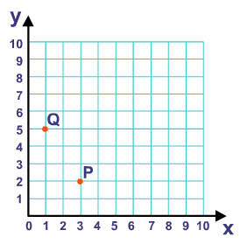
How much will I have in pounds when I convert my remaining dollars into pounds ?
8. Write down the coordinates of P and Q.

9. Work out 23 x 18 (without a calculator)

10. If 176 x 24 = 4224
What does 17.6 x 24 =
What does 1760 x 24 =
Revision part 3

1. A packet of 6 Mars bars cost £3.72.
A packet of 4 Mars bars cost £2.58.
Which is the better buy?
2. Solve $\frac{x}{9}=5$

3. Calculate the size of angle x.
Give your reason. 72
x
4. Round 4739 to the nearest hundred.
5. Lily is 1.46 m tall. Her friend is 6 cm taller than her. How tall is her friend ?
(make sure you write the units correctly for your measurement)

6. When I was on holiday in Spain. A can of coke cost € 2.30.
In London a similar can of coke cost £ 1.30.
The exchange was £1 = € 1.35
What was the difference in the prices (give your answer in either euros or pounds, but make sure you know which currency you are working in)
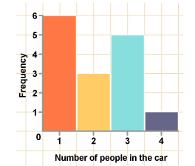
7. What is the total number of cars in the survey ?

8. Here are the scores of 7 people in a recent
French test.
17 15 15 19 21 16 22
a) What is the mode ?
b) What is the median ?
c) What is the range ?
9. Expand 3a(5a – 7b)
10. Solve 4(x + 2) = 36
Revision part 4

1. Recipe for pancakes for 4 people
200 ml of milk
120g of plain flour
2 eggs.
How much of each ingredient do you need to make pancakes for 10 people?
2. Solve 5x + 2 = 20 (it is not a whole number answer

3. Calculate the size of angle x.
Give your reason. 72
x
4. Round 24739 to the nearest thousand

5. Solve the inequality 3x + 4 < 25

6. When I was on holiday in France. A watch cost € 170.
In London a similar watch cost £ 125.
The exchange was £1 = € 1.35
What was the difference in the prices (give your answer in either euros or pounds, but make sure you know which currency you are working in)
7. Here are the scores of 7 people in a recent German test.
57 25 23 27 42 25 48
a) What is the mode ?
b) What is the median ?
c) What is the range ?
d) What is the mean (use your calculator) ?
8. Use your calculator to work out $\frac{17.6×23.4}{9.8-3.6}$

9. In a cinema there are 28 rows of seats. Each row has 41 seats. Tickets are priced at £3.95 per seat. If every seat is sold work an ESTIMATE for the total money that will be paid for the seats.
10. Increase £36 by 15%

