Revision Part 5
1. 3 Crème Eggs cost £1.32. How much would 7 cost?
2. Solve 4x + 1 = 22 (it is not a whole number answer)

3. Find x. 2x + 13 2x - 5

X + 40 x + 30

4. Work out the value of 3a + 2b when a = -5 and b = 4

5. Solve the inequality 4x + 3 > 31

6. Here are the cost of some fruit
1 kg of apples 80p
1 kg of carrots 60p
1 kg of beans £1.20
Work out how much 2kg of carrots, 500g of apples and 250g of beans would cost.
How much change would you get from £5 ?

7. Work out 4/9 of 27
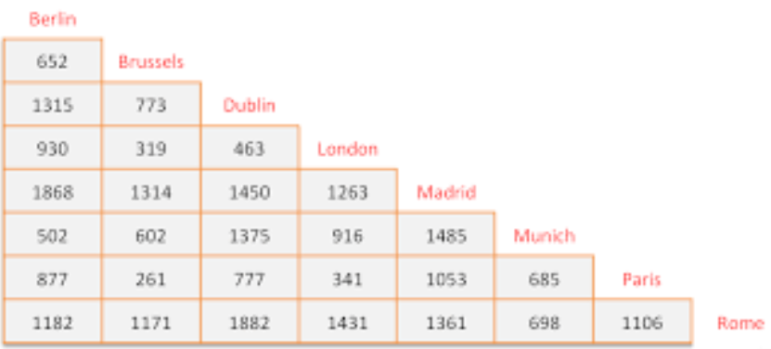
8. How far is it
a) from Brussels to Madrid
b) from Dublin to Paris
c) Which two places are furthest apart ?

9. Work out √81

10. Decrease £44 by 15%

Revision part 6
1. Use this list of numbers 4, 7, 11, 13, 16, 30
a) Write down a square number
b) Write down ALL the odd numbers
c) Write all the square numbers

2. Write the number twenty-thousand, six hundred and thirty-four in figures.

3. Write down the nth term for this sequence 5, 8, 11, 14, 17

4. Work out the √121

5. The perimeter of this rectangle is 38cm. Find x
2x + 1

x - 3

6. Work out the value of x² + 2x – 3 when x = 2

7. Work out 4/9 of 27

8. Here is a sequence 5 13 21 29
a) Write down the next TWO terms of this sequence
b) Does the number 82 appear in this sequence ? Give your reason.

9. Work out the area of this shape
10cm

3cm

10. Change (a) 2 km into metres
(b) 25 mm into centimetres
(c) 4700 grams into kilograms

Revision part 7
1. Use this list of numbers 4, 7, 11, 13, 16, 30
a) Write down two prime numbers
b) Write down ALL the even numbers
c) Write all the factors of 16

2. Write the number 20 074 in words

3. Write down the nth term for this sequence 2, 7, 12, 17, 22

4. I buy a watch in France for € 85. If the exchange rate is £1 = € 1.36, what is the price of the watch in pounds ?

5. Work out the area of this shape.
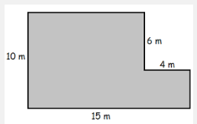

6. Work out the value of x² + 2x – 1 when x = -3
7. Work out 9% of 450
8. Here is a sequence 4 7 10 13
a) Write down the next TWO terms of this sequence
b) Work out the 20th term of the sequence

9. Work out the area of this shape
8cm

5cm

10. Change (a) 2 litres into millilitres
(b) 470 mm into centimetres

Revision part 8
1. Find the area and perimeter of each of these shapes (assume that each box is 1cm long)
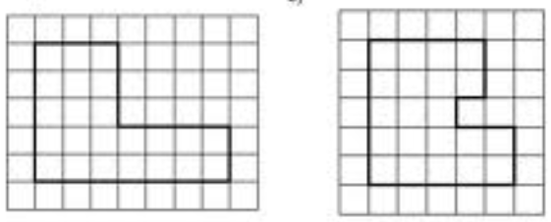
2. Expand 4(3x – 5)

3. Solve 5x – 3 = 27

4. I buy a watch in England for £ 70. If the exchange rate is £1 = € 1.36, what is the price of the watch in euros ?

5. Calculate the shaded area in the diagram below
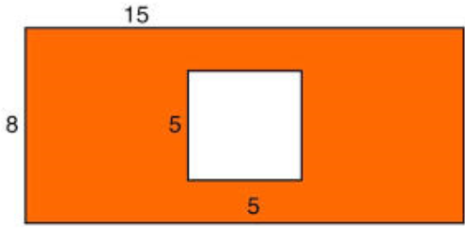
6. Work out the value of x² + 2x – 1 when x = 0
7. Write 7% as a decimal
8. Work 2.4 x 1.7
9. Work out the area of this shape 6cm
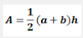
5cm
10cm

10. I have a piece of wood that is 1.72 metres long. I then attach another piece of wood that is 63 cm long to the end of it. What is the total length of the combined piece of wood ?

