Revision part 25
1. What is the value of the 4 in the number 25 462
2. a) Change 270 cm into metres
b) Change 157 mm into centimetres
c) Change 2.75 metres into centimetres
d) Change 3500 grams into kilograms
3. Expand x(x + 7)
4. Expand (x + 5)(x – 3)
5. The price of a CD is normally £12. In a clearance sale, all prices are REDUCED by 30%. What is the price of the CD in the sale ?
6. A builder uses the following formula to work out the price of a job
Price = £25 per hour plus £30
How much will a job lasting 7 hours cost ?

7. Work out the circumference of this shape.
10cm

8. Work out the area of this shape
9cm

5cm

4cm

9. Work out the length of side x
x
5cm
Round your answer to 1 decimal
place
8cm

10. What is the VOLUME of this shape ?

8cm
6cm
10cm

Revision part 26

1. Using this set of data 2 3 3 7 8 13
a) What is the mode ?
b) What is the range ?
c) What is the median ?
d) What is the mean ?
2. a) Change 2.5 kilograms cm into grams
b) Change 20.8 centimetres into millimetres
c) Change 750 grams into kilograms
d) Change 4.2 kilometres into metres
3. Expand and simplify 2(x – 4) + 3(x + 5)
4. Expand (x - 4)(x + 6)
5. Work out 21% of 240
6. The perimeter of this rectangle is 50cm.
2x + 1
x + 3

Find the value of x. Then find the length and width of the rectangle

7. Work out the area of this shape.
10cm

8. Work out the area of this shape
Use the formula 4cm
Area of trapezium = ½ (a+b)h 5cm
8cm

9. Work out the length of side x
5cm x
Round your answer to 1 decimal
place

2cm

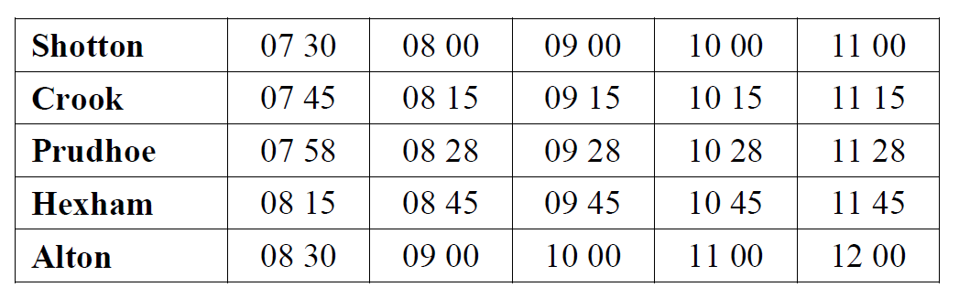
10.

Use the bus timetable above

a) A bus leaves Shotton at 07 30. What time does it arrive at Hexham ?

b) A bus leaves Crook at 08 15. How long does it take to get to Prudhoe ?

c) I need to be at meeting at Hexham at 11 25. I live in Crook what is the latest bus I can take to arrive in time for my meeting ?

Revision part 27

1. Using this set of data 1 2 2 7 7 7
a) What is the mode ?
b) What is the median ?

2. a) Change 270 centimetres into metres
b) Change 45000 grams into kilograms

3. Expand and simplify 5(x – 2) + 4(x - 3)

4. Expand (x + 3)(x - 7)

5. Decrease 240 by 15%

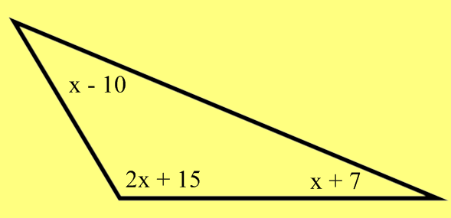
6. Use the information on the diagram to work out the value of x.

7. Solve 5x – 2 > 32

8. Work out the area of this shape
Use the formula 6cm
Area of trapezium = ½ (a+b)h 4cm
10cm
9. There are 176 students in Year 10.

Write 176 out of 800 as a percentage.

10. The probability that a biased dice will land on a 5 is 0.3

Zoe is going to roll the dice 200 times.

Work out how many times you would expect the dice will land on a 5.
Revision part 28

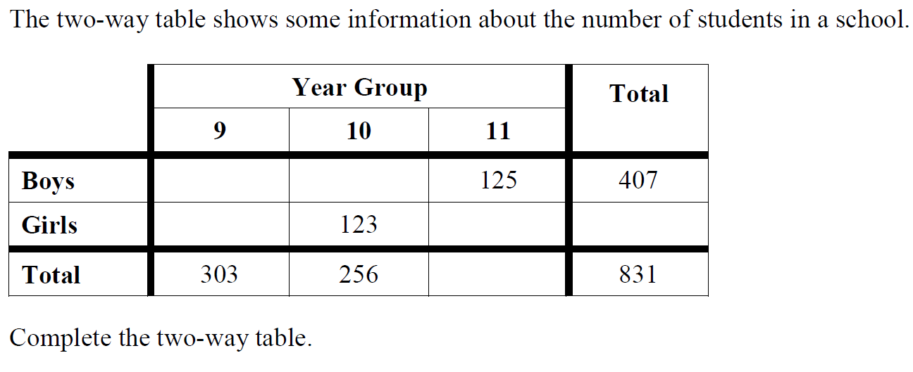
1.

2. a) Change 5 litres into millilitres
b) Change 45 millimetres into centimetres

3. Work out 3/5 of 35

4. Expand (x - 3)(x - 6)

5. Work out the area of this shape
Use the formula 7cm
Area of trapezium = ½ (a+b)h 4cm
11cm

6. What is probability of getting a number greater 4 on a fair six-sided dice ?

7. Write 80 as a product of its prime factors

8. Simplify 8a + 3b – 5a – 7b

9. Simplify a⁷ x a⁵

10. Work out 127 ÷ 5

