Revision Part 17
1. Work out a) 4 x 5 + 3
b) 30 – 4 x 7
c) (9 – 2)² + 16

2. Work out a) 3 x 5
4 8

b) 7 - 3
8 5

c) 5 ÷ 4
6 7

3. Factorise a) 5x – 20
b) 4ab + 12ac
4. Change a) 0.05 into a percentage
b) 0.7 into a fraction
c) 0.12 into a fraction in its simplest form
d) 34% into a fraction in its simplest form
5. Expand (x - 3)(x – 7)
6. A man runs at a speed of 14 kilometres per hour. How far will he run in 2 hours and 15 minutes ?

7. Write 96 as a product of its prime factors
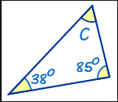
8. Calculate the size of angle c,
Give your reason.

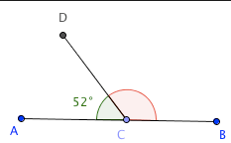
9. Give the size of the missing
Angle. Give your reason.

10. What do the angles inside a quadrilateral add up to ?

Revision Part 18
1. Solve 5x – 1 = 17 (not a whole number answer)
2. What is the largest integer (whole number) that satisfies the inequality
3x + 1 < 16
3. Change 4.2 x 10⁷ into a normal number
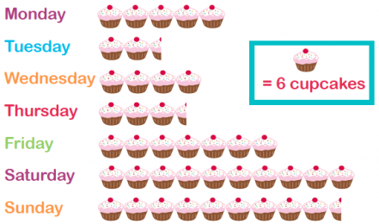
4. Write the number 126 476 in words
5. The pictogram shows the
number of cupcakes baked on each day.
a) How many cupcakes were baked on Thursday ?
b) On which day were the fewest baked ?

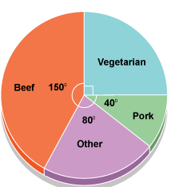
6. The pie chart shows people’s meat preferences.
a) What fraction are vegetarians ?
b) If 20 people said they liked pork, how many people said they liked Beef ?

7. Work out the value of 2a – 5b when a = -2 and b = 4
8. Order the following smallest to largest
0.45 0.404 0.4 0.41 0.444

9. Round the following numbers:
a) 127 to the nearest 10
b) 12.47 to 1 decimal place
c) 1876 to 2 significant figures

10. If you were to choose one letter from the word S C R A B B L E,
What is the probability of choosing a “B” ?

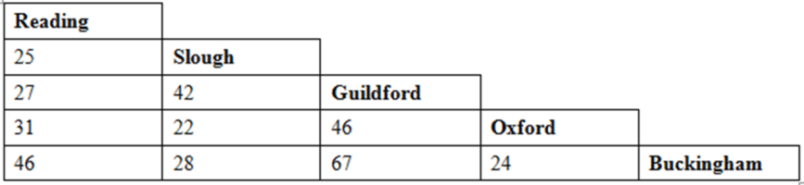
Revision Part 19
1. Use the distance chart to work out
a) the distance between Reading and Oxford
b) find the two places closest together
2. Write 52 as a product of its prime factors
3. Work out the area of this parallelogram

8cm

12cm
4. Name this shape

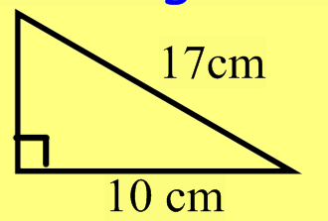
5. Work out the length of the missing side, giving your answer to 1 decimal place

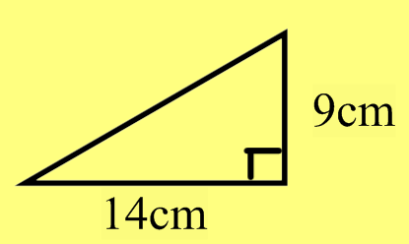
6. Work out the length of the missing side, giving your answer to 1 decimal place

7. Write 0.0087 in standard form

8. Which is bigger 3.2 x 10³ or 45000 ?
9. Expand (x – 3)(x + 7)
10. Factorise 6xy + 9yz

Revision Part 20
1) Work out 24 x 17

2) Work out 35% of 420
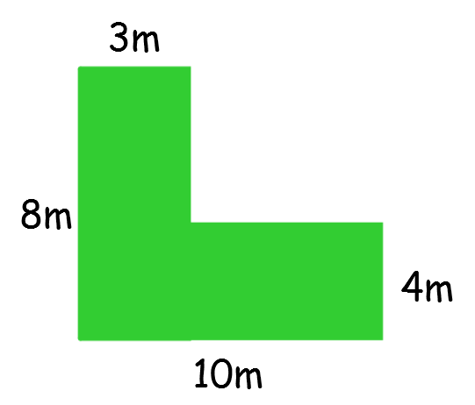
3) Work out the area of this shape

4) Write 45000 in standard form

5) Work out 0.5 x 0.7

6) Work out 2 + 5
7 8

7) Carys and Alice share some sweets in the ratio 3:2.

If Alice has 18 sweets, how many would Carys have ?

8) A tee shirt costs £5 in London and a similar one costs in € 7 in France.
If the exchange is £1 = € 1.35, which is the best place to buy it ?

9) Work out the size of angle x

47 x 64

10) Work out 3 + 4 x 7

11) Solve 5x + 2 = 3x + 10

12) Factorise 4x - 20

