Revision Part 5
1. 3 Crème Eggs cost £1.32. How much would 7 cost ?
One egg costs £1.32 ÷ 3 = £0.44
So 7 eggs cost £0.44 x 7 = £3.08
2. Solve 4x + 1 = 22 (it is not a whole number answer)
-1 -1
4x = 22
÷ 4 ÷4
x = 5.5

3. Find x. 2x + 13 2x - 5
2x + 13 + 2x – 5 + x + 40 + x + 30 = 360
6x + 78 = 360 x + 40 x + 30
6x = 282
x = 47
4. Work out the value of 3a + 2b when a = -5 and b = 4
3 x -5 + 2 x 4 = -15 + 8 = -7

5. Solve the inequality 4x + 3 > 31
-3 -3
4x > 28
÷ 4 ÷ 4
X > 7
6. Here are the costs of some fruit
1 kg of apples 80p
1 kg of carrots 60p
1 kg of beans £1.20
Work out how much 2kg of carrots, 500g of apples and 250g of beans would cost.
How much change would you get from £5 ?
2 kg of carrots cost 120p
500g of apples cost 40p
250g of beans cost 30p
Total = 190p. Change from £5 will be 310p or £3.10

7. Work out 4/9 of 27
(27 ÷ 9) x 4 = 12
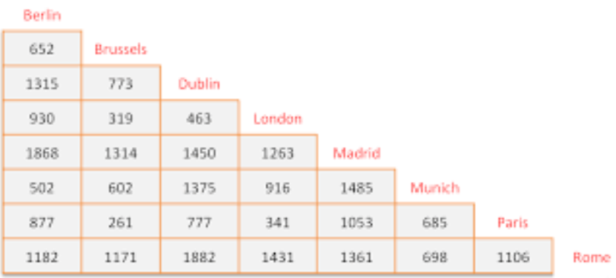
8. How far is it
a) from Brussels to Madrid
1314 km
b) from Dublin to Paris
777 km
c) Which two places are furthest apart ? Dublin and Rome – 1882 km

9. Work out √81 9

10. Decrease £44 by 15%
10% of 44 = 4.40
5% of 44 = 2.20
15% of 44 = 6.60
Work out 44 – 6.60 = £37.40

Revision Part 6
1. Use this list of numbers 4, 7, 11, 13, 16, 30
a) Write down a square number 4 or 16
b) Write down ALL the odd numbers 7, 11, 13
c) Write all the square numbers 4 and 16

2. Write the number twenty-thousand, six hundred and thirty-four in figures.
20 634
3. Write down the nth term for this sequence 5, 8, 11, 14, 17
Gap is 3 3n + 2
4. Work out the √121 11

5. The perimeter of this rectangle is 38cm. Find x
2x + 1 2x + 1 + 2x + 1 + x – 3 + x – 3 = 38
6x – 4 = 38
6x = 42
x – 3 x = 7 cm

6. Work out the value of x² + 2x – 3 when x = 2
2² + (2 x 2) – 3 = 4 + 4 – 3 = 5
7. Work out 4/9 of 27 (27 ÷ 9) x 4 = 12

8. Here is a sequence 5 13 21 29
a) Write down the next TWO terms of this sequence 37 45
b) Does the number 82 appear in this sequence ? Give your reason.
82 is not in the sequence because it is even the rest of the numbers are odd
Nth term for the sequence is 8n – 3. Solving 8n – 3 = 82 does not give a whole number answer, so 82 is not in the sequence.

9. Work out the area of this shape
10cm
(10 x 3) ÷ 2 = 15cm²
3cm

10. Change (a) 2 km into metres 2 x 1000 = 2000 metres
(b) 25 mm into centimetres 25 ÷ 10 = 2.5 centimetres
(c) 4700 grams into kilograms 4700 ÷ 1000 = 4.7 kg

Revision Part 7
1. Use this list of numbers 4, 7, 11, 13, 16, 30
a) Write down two prime numbers Any of 7, 11 or 13
b) Write down ALL the even numbers 4, 16 and 30
c) Write all the factors of 16 4 and 16

2. Write the number 20 074 in words
Twenty thousand and seventy-four
3. Write down the nth term for this sequence 2, 7, 12, 17, 22
Gap 5 5n - 3
4. I buy a watch in France for € 85. If the exchange rate is £1 = € 1.36, what is the price of the watch in pounds ?
85 ÷ 1.36 = £ 62.50
5. Work out the area of this shape.
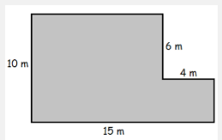
Split the shape into two rectangles.
10 x 11 = 110
4 x 4 = 16
Total area = 126 m²

6. Work out the value of x² + 2x – 1 when x = -3
(-3)² + (2 x – 3) – 1
= 9 – 6 – 1
= 2
7. Work out 9% of 450
10% of 450 = 45
1% of 450 = 4.5
9% of 450 = 40.5

8. Here is a sequence 4 7 10 13
a) Write down the next TWO terms of this sequence 16 and 19
b) Work out the 20th term of the sequence nth term = 3n + 1
20th term = (3 x 20) + 1 = 61

9. Work out the area of this shape
8cm

5cm
Area of triangle = (8 x 5) ÷ 2 = 20cm²

10. Change (a) 2 litres into millilitres 2000 millilitres (ml)
(b) 470 mm into centimetres 47 centimetres (cm)

Revision Part 8
1. Find the area and perimeter of each of these shapes (assume that each box is 1cm long)
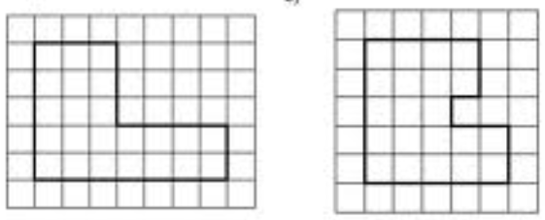
Perimeter = 24 cm Perimeter = 22 cm
Area = 23 cm² (count the squares) Area = 21 cm²

2. Expand 4(3x – 5) 12x - 20

3. Solve 5x – 3 = 27 x = 6

4. I buy a watch in England for £ 70. If the exchange rate is £1 = € 1.36, what is the price of the watch in euros ? 70 x 1.36 = € 95.32

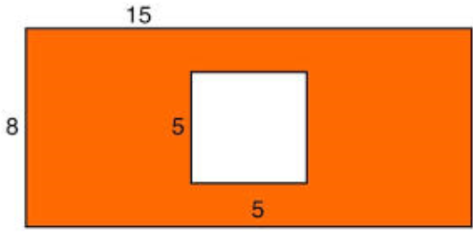
5. Calculate the shaded area in the diagram below
Area of large rectangle = 8 x 15 = 120cm²
Area of square = 5 x 5 = 25 cm²

Area of shaded area = 120 – 25 = 95 cm²
6. Work out the value of x² + 2x – 1 when x = 0
0 + 0 – 1 = -1
7. Write 7% as a decimal 0.07
8. Work 2.4 x 1.7 4.08

9. Work out the area of this shape 6cm
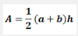
5cm
10cm

Area = (6 + 10) x 5 = 40 cm²
2

10. I have a piece of wood that is 1.72 metres long. I then attach another piece of wood that is 63 cm long to the end of it. What is the total length of the combined piece of wood ?

1.72 + 0.63 = 2.35 metres

Or 172 + 63 = 235 centimetres.

