Revision sheet Part 17
1. Work out a) 4 x 5 + 3 = 20 + 3 = 23
b) 30 – 4 x 7 = 30 – 28 = 2
c) (9 – 2)² + 16 = 7² + 16 = 49 + 16 = 65

2. Work out a) 3 x 5 = 15
4 8 32

b) 7 x5 - 3 x8 = 35 - 24 = 11
8x5 5 x8 40 40 40

c) 5 ÷ 4 = 5 x 7 = 35 = 1 11
6 7 6 4 24 24

3. Factorise a) 5x – 20 5(x – 4)
b) 4ab + 12ac 4a(b + 3c)
4. Change a) 0.05 into a percentage 5%
b) 0.7 into a fraction 7/10
c) 0.12 into a fraction in its simplest form 12/100 = 3/25
d) 34% into a fraction in its simplest form 34/100 = 17/50
5. Expand (x - 3)(x – 7) x² – 10x + 21 (remember -3 x -7 = +21)
6. A man runs at a speed of 14 kilometres per hour. How far will he run in 2 hours and 15 minutes ?
In 2 hours he would run 28 kilometres (2 x 14)
In 15 minutes (a quarter of an hour) he would run 3.5 kilometres.
Altogether he would run 31.5 kilometres.
7. Write 96 as a product of its prime factors 2⁵ x 3
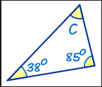
8. Calculate the size of angle c,
Give your reason.
57^{O} – angles in a triangle add up to 180

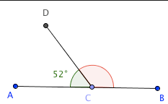
9. Give the size of the missing
Angle. Give your reason.
128º – angles on a straight line add up to 180
10. What do the angles inside a quadrilateral add up to ? 360º
Revision sheet Part 18
1. Solve 5x – 1 = 17 (not a whole number answer)
5x = 18
x = 3.6
2. What is the largest integer (whole number) that satisfies the inequality
3x + 1 < 16
3x < 15
x < 5
So, 4 is the largest integer that is less than 5
3. Change 4.2 x 10⁷ into a normal number 42 000 000
4. Write the number 126 476 in words
One hundred and twenty-six thousand, four hundred and seventy-six
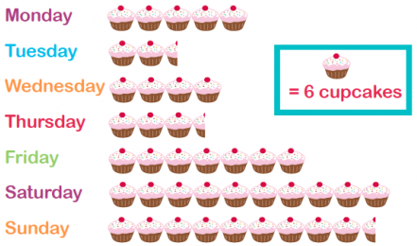
5. The pictogram shows the
number of cupcakes baked on each day.
a) How many cupcakes were baked on Thursday ?
21 cupcakes
b) On which day were the fewest baked ? Tuesday

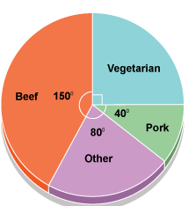
6. The pie chart shows people’s meat preferences.
a) What fraction are vegetarians ? 1/4
b) If 20 people said they liked pork, how many people said they liked Beef ?
20 people represent 40º
1 person represent 2º
So, beef will be 75 people (150 ÷ 2)

7. Work out the value of 2a – 5b when a = -2 and b = 4
(2 x -2) – (5 x 4) = -4 – 20 = -24
8. Order the following smallest to largest
0.450 0.404 0.400 0.410 0.444
5th 2nd 1st 3rd 4th

9. Round the following numbers:
a) 127 to the nearest 10 130
b) 12.47 to 1 decimal place 12.5
c) 1876 to 2 significant figures 1900

10. If you were to choose one letter from the word S C R A B B L E,
What is the probability of choosing a “B” ?
There are two “B”s and a total of eight letters,
So probability = 2/8 = 1/4

Revision sheet Part 19
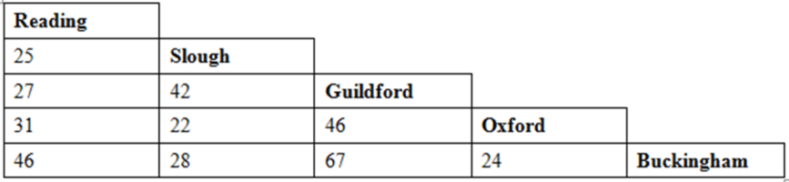
1. Use the distance chart to work out
a) the distance between Reading and Oxford 31 miles
b) find the two places closest together Slough and Oxford (22 miles)
2. Write 52 as a product of its prime factors 2² x 13
3. Work out the area of this parallelogram

8cm

12cm
Area of a parallelogram = length x vertical height = 8 x 12 = 96cm²

4. Name this shape
Pentagon
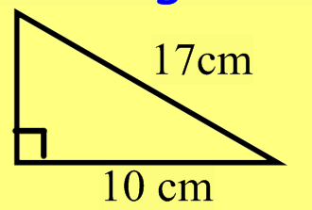
5. Work out the length of the missing side, giving your answer to 1 decimal place
a² + b² = c²
a² + 10² = 17²
a² + 100 = 289
a² = 289 – 100 = 189
a = √189 = 13.74 = 13.7 cm to 1 decimal place
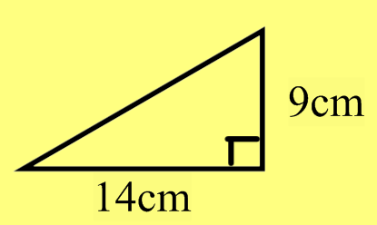
6. Work out the length of the missing side, giving your answer to 1 decimal place
a² + b² = c²
9² + 14² = c²
81 + 100 = c²
c² = 181
c = √181 = 13.45 = 13.5 cm to 1 decimal place

7. Write 0.0087 in standard form 8.7 x 10⁻³

8. Which is bigger 3.2 x 10³ or 45000 ?
3.2 x 10³ = 3200, 45000 is bigger

9. Expand (x – 3)(x + 7) x² + 4x - 21
10. Factorise 6xy + 9yz 3y(2x + 3z)

Revision sheet Part 20
1) Work out 24 x 17
408
2) Work out 35% of 420
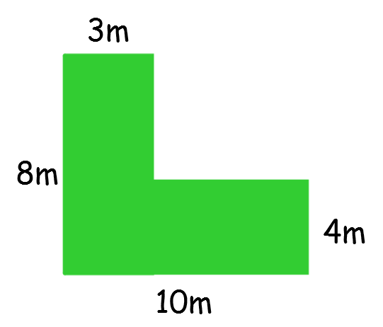
147
3) Work out the area of this shape
Find lengths of missing sides first
(3 x 8) + (7 x 4) = 24 + 28 = 52cm²

4) Write 45000 in standard form
4.5 x 10⁴

5) Work out 0.5 x 0.7
0.35

6) Work out 2 + 5 = 16 + 35
7 8 56 56

7) Carys and Alice share some sweets in the ratio 3:2.

If Alice has 18 sweets, how many would Carys have ?

Carys : Alice
3 : 2
x : 18

So, Carys will get 27 sweets (3 x 9)

8) A tee shirt costs £5 in London and a similar one costs in € 7 in France.
If the exchange is £1 = € 1.35, which is the best place to buy it ?

Approach 1 – change £5 into euros, 5 x 1.35 = € 6.75
So, shirt is € 0.25 cheaper in London

Approach 2 – change € 7 into pounds, 7 ÷ 1.35 = £ 5.18
So, shirt is £0.18 cheaper in London.

9) Work out the size of angle x

47 x 64

47 + 64 = 111
180 – 111 = 69

x = 69º (angles on a straight line add up to 180)

10) Work out 3 + 4 x 7

3 + 28 = 31

11) Solve 5x + 2 = 3x + 10

2x + 2 = 10
2x = 8
X = 4

12) Factorise 4x – 20

4(x – 5)

