3.1.12 Acids & bases
AS Link:
3.1.6 – Equilibria (Le Chatelier’s principle & K_{c})

Brønsted-Lowry acid–base equilibria in aqueous solution

In 1923 Johannes Brønsted and, independently, an Englishman Thomas Lowry extended the acid-base theory to give new definitions of acids and bases:
Definitions:
A Brønsted-Lowry acid is a substance which donates a proton in a reaction.
A Brønsted-Lowry base is a substance which accepts a proton in a reaction.
A Brønsted-Lowry acid-base reaction is a transfer of protons under equilibrium conditions.

Another definition derived by the American called Lewis states an acid is an electron pair acceptor and a base is an electron pair donor, this widens the classification.

The proton in aqueous solution

H⁺ is just a proton because hydrogen only has one electron, if it is lost then only a proton remains. Since it then has no electrons of its own it can only form a bond with a species that has a lone pair of electron. Due to its small size and high electric field it has unusual properties compared to other positive ions. It is never found in isolation; in aqueous solutions it is always bonded to at least one water molecule to form H₃O⁺.

For simplicity a proton is represented as H⁺ (aq) rather than H₃O⁺ (aq).

Acids release hydrogen ions when they dissolve in water, but hydrogen ions don’t exist on their own, they combine with a water molecule to form a hydronium ion H₃O⁺ (also called oxonium ion or hydroxonium ion).

HA (aq) + H₂O (l) → H₃O⁺ (aq) + A⁻(aq)

Bases accept hydrogen ions from water molecules when they are in solution.

B (aq) + H₂O (l) → BH⁺ (aq) + OH⁻(aq)

According to Brønsted and Lowry reactions of acids and bases in aqueous solutions always involves the transfer of protons under equilibrium conditions:

HA (aq) + B (aq) BH⁺ (aq) + A⁻(aq)
acid base

Neutralisation

Hydroxide ions are Brønsted-Lowry bases as they accept protons and will react almost completely with hydrogen ions or hydronium ions to form water.

Simplest ionic equation:
H₃O⁺ (aq) + OH⁻ (aq) 2H₂O (l)
LEARN – neutralisation equation

Simplified to:
H⁺ (aq) + OH⁻ (aq) H₂O (l)

Examples
Brønsted-Lowry acid-base reactions:

HCl (g) + NH₃ (g) → NH₄Cl (s)
acid base

Task: Identify the Brønsted-Lowry acid & base
- Na₂CO₃ + 2HCl → 2NaCl + H₂O + CO₂
base acid base acid

- H₂SO₄ + HNO₃ → H₂NO₃⁺ + HSO₄⁻
acid base acid base

- HCl + H₂O → H₃O⁺ + Cl⁻
acid base acid base

- NH₃ + H₂O → NH₄⁺ + OH⁻
base acid acid base

Sheet: Brønsted-Lowry acids & bases

Dissociation in water

Strong acids and strong bases
In water strong acids are nearly completely dissociated into their ions. N.B. a strong acid does not need to be 100% ionised, anything above 50% dissociation is a strong acid. At normal concentrations strong acid molecules are fully ionised.

STRONG acid  HX (aq) →H⁺(aq) + X⁻(aq) |  | There are only a limited number of strong acids in water:  - Hydrohalic acids  – HCl, HBr, HI  (not HF it is a weak acid)  - Nitric acid – HNO₃  - Sulphuric acid – H₂SO₄  - Phosphoric acid – H₃PO₄

Monoprotic acids dissociate to give one mole H⁺ per mole of acid
- HCl, HBr, HI, HNO₃
Diprotic acids dissociate to give two moles H⁺ per mole of acid
- H₂SO₄
For strong acids the equilibrium lies far to the right – proton transfer is virtually complete:  HCl (aq) + H₂O (l) H₃O⁺ (aq) + Cl⁻ (aq)  acid base | 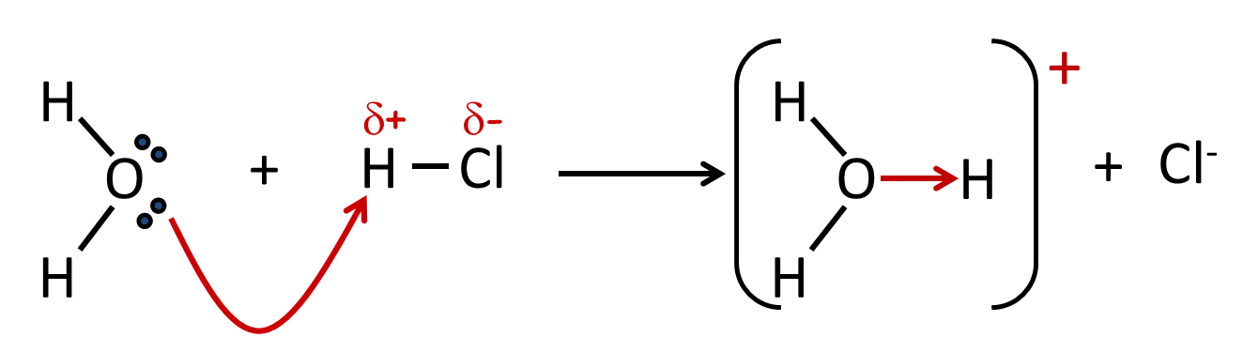

Alkali metal hydroxides are strong bases, they fully dissociate when dissolved in water, forming aqueous hydroxide ions:
water
BOH (aq) B⁺ (aq) + OH⁻ (aq)

Examples of strong bases in water (alkalis):

- NaOH
Monobasic or monoacidic base dissociates to give one mole OH⁻ per mole of alkali
Dibasic or diacidic base dissociates to give two moles OH⁻ per mole of alkali
- LiOH
- KOH
- Ca(OH)₂

Weak acids and bases

The majority of acids and bases are weak, they are partially dissociated when dissolved in water, so at normal concentration in water they are partially ionised. The concentration of acid is not equal to [H⁺].

WEAK acid

HA (aq) H⁺(aq) + A⁻(aq)

Weak acid - ethanoic acid dissociates partially into ethanoate ions and hydrogen ions.

CH₃COOH (aq) H⁺ (aq) + CH₃COO⁻ (aq)

Weak base - ammonia dissociates partially into ammonium ions and hydroxide ions.

NH₄OH (aq) NH₄⁺ (aq) + OH⁻ (aq)

Summary – strength and concentration

The strength of an acid or base indicates the position of equilibrium established when dissolved in water.
Equilibrium:
- right – strong
- left – weak

- Strong – complete dissociation in water
- Weak – partial dissociation in water

The concentration (mol dm⁻³) or an acid or base relates to amount of water present.

So it’s possible to have:
- Diluted strong acid or base
- Concentrated weak acid or base

 | Strength (degree of dissociation) |  |  | Demo: Conductivity strong & weak acid
Concentration (mol dm⁻³) | strong | weak |  | Demo: Conductivity strong & weak acid
high |  |  |  | Demo: Conductivity strong & weak acid
low |  |  |  | Demo: Conductivity strong & weak acid

Ionisation of water

Water dissociates into hydronium ions and hydroxide ions, it acts as a Brønsted-Lowry acid (donating a proton) and Brønsted-Lowry base (accepting a proton), so an equilibrium exists:

H₂O(l) + H₂O(l) H₃O⁺(aq) + OH⁻(aq)

Task: Identify the Brønsted-Lowry acid & base on both sides of the equation

lost H⁺

H₂O (l) + H₂O (l) H₃O⁺ (aq) + OH⁻ (aq)

gained H⁺

acid base acid base

This simplified equilibrium is established: H₂O (l) H⁺ (aq) + OH⁻ (aq)

With the equilibrium constant: K_{c} = [H⁺] [OH⁻]
[H₂O]

Water only dissociates slightly so the equilibrium far to the left (few H⁺ and OH⁻) giving a large constant concentration of water. By multiplying the expression [H₂O]
A new constant can be derived called the ionic product of water with symbol, K_{w.}

K_{w} = K_{c} x [H₂O(l)] = [H⁺] [OH⁻] x [H₂O(l)]
[H₂O]

So K_{w} = [H⁺(aq)]_{eqm} [OH⁻(aq)]_{eqm}

Gives the ionic product of water
Units = (mol dm⁻³)² = mol² dm⁻⁶
K_{w} = [H⁺] [OH⁻]

K_{w} always has the same value for an aqueous solution at a given temperature. The value of K_{w} changes as the temperature changes. At 298K K_{w} = 1.00 x 10⁻¹⁴ mol² dm⁻⁶.

Fact recall: CGP98 Q1-4

pH scale

In 1909 Danish biochemist Søren Sørenson worked for Carlsberg brewery. Brewing requires controlling acidity so yeast can grow but unwanted bacteria can’t and allows fermentation process. The concentrations of acid used were very small one ten-thousandth of a mole per litre so Sorenson looked for a way to avoid using numbers such as 0.0001 (1 x 10⁻⁴). By taking the log₁₀ it gives you - 4, then he took away the negative to give a simple number 4. The pH scale was born.
The acidity of a solution depends on the concentration of H⁺ (aq) and is measured on the pH scale.
pH = -log₁₀ [H⁺(aq)]

pH normally quoted to 2 decimal places

[H⁺] represents concentration Units: mol dm⁻³
On the pH scale:

- Higher [H⁺] the lower the pH
  - [H⁺] > 1.0 mol dm⁻³ give pH < 1 e.g. [H⁺] 10.0 mol dm⁻³ pH -1
- A difference on one pH means a tenfold difference in [H⁺]
  - e.g. pH 0 [H⁺] 1.0 mol dm⁻³ pH 2 [H⁺] 0.1 mol dm⁻³ pH 3 [H⁺] 0.01 mol dm⁻³
- Measures alkalinity as well – as [H⁺] decreases [OH⁻] increases
  - If solution [H⁺] > [OH⁻] – acidic with pH < 7
  - If solution [H⁺] = [OH⁻] – neutral with pH < 7 (only at 298K)
  - If solution [H⁺] < [OH⁻] – alkaline with pH > 7
- Measure using universal indicators (a mixture of indicators to give a range of colours)
- Measure using pH meters
Demo: Rainbow fizz
[OH⁻]  mol dm⁻³ | pH | [H⁺]  mol dm⁻³ | [OH⁻]  mol dm⁻³ | pH | [H⁺]  mol dm⁻³
1.0 x 10⁻¹⁴ | 0 | 1.0 | 1.0 x 10⁻⁶ | 8 | 1.0 x 10⁻⁸
1.0 x 10⁻¹³ | 1 | 1.0 x 10⁻¹ | 1.0 x 10⁻⁵ | 9 | 1.0 x 10⁻⁹
1.0 x 10⁻¹² | 2 | 1.0 x 10⁻² | 1.0 x 10⁻⁴ | 10 | 1.0 x 10⁻¹⁰
1.0 x 10⁻¹¹ | 3 | 1.0 x 10⁻³ | 1.0 x 10⁻³ | 11 | 1.0 x 10⁻¹¹
1.0 x 10⁻¹⁰ | 4 | 1.0 x 10⁻⁴ | 1.0 x 10⁻² | 12 | 1.0 x 10⁻¹²
1.0 x 10⁻⁹ | 5 | 1.0 x 10⁻⁵ | 1.0 x 10⁻¹ | 13 | 1.0 x 10⁻¹³
1.0 x 10⁻⁸ | 6 | 1.0 x 10⁻⁶ | 1.0 | 14 | 1.0 x 10⁻¹⁴
1.0 x 10⁻⁷ | 7 | 1.0 x 10⁻⁷

pH of water
The equilibrium reaction for the dissociation of water is endothermic.

H₂O (l) H⁺ (aq) + OH⁻ (aq) ∆H= +57.3 kJ mol⁻¹

K_{w} = [H⁺] [OH⁻]

In pure water there is always one mole H⁺ ion for each mole OH⁻ ion, so [H⁺] = [OH⁻].

Therefore, for pure water:
K_{w} = [H⁺]²

Calculating the pH of pure water
For pure water K_{w} = [H⁺]². If the value of K_{w} is known then the pH of water can be calculated.

[H⁺] = √K_{w}

pH = -log₁₀ [H⁺]

At 298K, K_{w} is 1.0 x 10⁻¹⁴ mol² dm⁻⁶.

K_{w} = 1.0 x 10⁻¹⁴ = [H⁺]²

[H⁺ (aq)] = $\sqrt{1.0 x 10-14 }$ = 1.0 x 10⁻⁷ mol dm⁻³

pH = -log₁₀ 1.0 x 10⁻⁷ = 7.00

Since K_{w} is temperature dependant and in neutral solution the concentration of hydrogen ions and hydroxide ions are equal, [H⁺] = [OH⁻], the pH must vary with temperature. Only at 298K does water have pH of 7.00.

Task: Calculate pH of water at these temperatures

Temp/K | Temp/ºC | K_{w}/mol² dm⁻⁶ | pH
273 | 0 | 0.1 x 10⁻¹⁴ | 7.50
293 |  | 0.7 x 10⁻¹⁴ | 7.08
298 | 25 | 1.0 x 10⁻¹⁴ | 7.00
303 |  | 1.5 x 10⁻¹⁴ | 6.91
333 |  | 5.6 x 10⁻¹⁴ | 6.63
373 | 100 | 51.3 x 10⁻¹⁴ | 6.14

This shows that when the temperature increases K_{w} increases and the forward reaction must be endothermic.

Therefore, the value of K_{w} increases with temperature as the equilibrium will move to the right to oppose the increase, resulting in an increase in hydrogen ions and a decrease in pH.

At its boiling point water has a pH of about 6, it is still neutral because it has an equal number of H⁺ and OH⁻, i.e. [H⁺] = [OH⁻].

Starter: 3.1 – pH and K_{w}

Sheet: Ionic product of water

pH calculations for strong acids and bases

Finding pH of a strong acid from a known concentration

Strong acids can be regarded as fully ionised in dilute aqueous solutions, so the hydrogen ion concentration of a monoprotic acid is equal to the concentration of the acid. If the [H⁺] is known then the pH can be calculated.
[monoprotic acid] = [H⁺] [diprotic acid] = 2 [H⁺]

pH = -log₁₀ [H⁺(aq)]

Example – CGP100
Calculate the pH of a 0.10 mol dm⁻³ solution of HCl

Method
[H⁺] = [HCl] = 0.10 mol dm⁻³

Answer
pH = -log₁₀ [H⁺] = -log₁₀ 0.10 = 1.00 N.B. 2 d.p

Example – CGP100
Calculate the pH of a 0.10 mol dm⁻³ solution of H₂SO₄

Method – diprotic acid
[H⁺] = 2 x [H₂SO₄] = 2 x 0.10 = 0.20 mol dm⁻³

Answer
pH = -log₁₀ [H⁺] = -log₁₀ 0.20 = 0.70 N.B. 2 d.p

Task:
Calculate pH of 1.00 mol dm⁻³ solution of HCl
[H⁺] = [HCl] = 1.00 mol dm⁻³
pH = -log₁₀ 1.00 = 0.00

Calculate pH of 0.160 mol dm⁻³ solution of H₂SO₄
[H⁺] = 2 x [H₂SO₄] = 0.320 mol dm⁻³
pH = -log₁₀ 0.320 = 0.49

Finding concentration of a strong acid from a known pH

This is the reverse of the calculation to work out the pH, reverse or antilogs logs.
[H⁺] = 10^{-pH}

Example
An aqueous solution of a strong monoprotic acid, HX, has a pH of 2.50. Calculate the concentration of the acid.

Method
[H⁺] = 10^{-pH}

Answer
Hence [H⁺] = antilog (-2.50) = 10^{-2.5} = 3.20 x 10⁻³ mol dm⁻³ N.B. Units

Comment
Since monoprotic acid is strong, it’s fully dissociated [HX] = [H⁺] so is 3.2 x 10⁻³ mol dm⁻³

Example – CGP99
A solution of sulphuric acid has a pH of 1.52. What is the hydrogen ion concentration?

Method
[H⁺] = 10^{-pH}

Answer
Hence [H⁺] = antilog (-1.52) = 10^{-1.52} = 3.0 x 10⁻² mol dm⁻³

Comment
Although a diprotic acid pH = [H⁺]

Task:
Calculate [H⁺] of HCl with pH of 3.00
pH = antilog (-3.00) = 10^{-3.00}
[H⁺] = 1.0 x 10⁻³ mol dm⁻³

Calculate concentration of H₂SO₄ with pH of 5.52
pH = antilog (-5.52) = 10^{-5.52}
[H⁺] = 3.0 x 10⁻⁶ mol dm⁻³
[H⁺] = ½ [H₂SO₄] = 3.0 x 10⁻⁶ / 2 = 1.5 x 10⁻⁶ mol dm⁻³

Dilution of a strong acid

If an acid is diluted by adding water the moles of the acid won’t change, but the total volume will change and so the concentration of hydrogen ions changes.
The pH will change

Example
Calculate the pH of the solution formed when 50cm³ of water is added to 50cm³ of 0.10 mol dm⁻³ HCl.

nHCl_{original} 0.1 x 50 x 10⁻³ = 5.00 x 10⁻³ mol
New total volume = 50 + 50 = 100 cm³
new [HCl] 5.00 x 10⁻³ / 100 x 10⁻³ = 0.05 mol dm⁻³

[H⁺] = 0.05

pH = -log 0.05 = 1.30

Example
Calculate the volume of water which must be added to 25.0cm³ of 0.5 mol dm⁻³ HCl to increase its pH from 0.30 to 0.60.

Final [H⁺] = 10^{-0.6} = 0.251 mol dm⁻³

If n₁ = n₂ then c₁v₁ = c₂v₂
v₂ = final volume
0.5 x 25 x 10⁻³ = 0.251 x v₂

v₂ = 0.0498 dm³ = 49.8 cm³
New total volume after adding water

Water added = 49.8 – 25 = 24.8 cm³

Sheet: pH of strong acids

Application: CGP99 PQ1-3

Finding pH of a strong base from a known concentration
Strong bases are nearly completely ionised in water, so the concentration of the hydroxide ions is the same as the concentration of the base. But pH is the log of the concentration of hydrogen ions; however, the ionic product of water expression can be used to find the concentration of hydrogen ions as long as the value for K_{w} is known. Then the pH can be calculated.

Ionic product of water
K_{w} = [H⁺] [OH⁻]

Example – CGP101
The value of K_{w} at 298K is 1.0 x 10⁻¹⁴ mol² dm⁻⁶. Find the pH of a 0.100 mol dm⁻³ solution of NaOH at 298K.

Method
Since NaOH is fully ionised in aqueous solution and will donate one mole of OH⁻ ions per mole of base.

[NaOH] = [OH⁻] = 0.100 mol dm⁻³

Answer
K_{w} = [H⁺] [OH⁻] = 1.0 x 10⁻¹⁴ mol² dm⁻⁶

Rearrange [H⁺] = K_{w} = 1.0 x 10⁻¹⁴ = 1.0 x 10⁻¹³ mol dm⁻³
[OH⁻] 0.100

So pH = -log₁₀ (1.0 x 10⁻¹³) = 13.00

Task: Find the pH of 1.00 mol dm⁻³ NaOH

[OH⁻] = 1.00 mol dm⁻³

K_{w} = [H⁺] [OH⁻] = 1.0 x 10⁻¹⁴ mol² dm⁻⁶

[H⁺] = K_{w} = 1.0 x 10⁻¹⁴ = 1.00 x 10⁻¹⁴ mol dm⁻³
[OH⁻] 1.00

pH = -log₁₀ (1.00 x 10⁻¹⁴) = 14.00

Task: Find the pH of 0.15 mol dm⁻³ Ca(OH)₂

[OH⁻] = 2 x [Ca(OH)₂] = 0.30 mol dm⁻³

K_{w} = [H⁺] [OH⁻] = 1.0 x 10⁻¹⁴ mol² dm⁻⁶

[H⁺] = K_{w} = 1.0 x 10⁻¹⁴ = 3.33 x 10⁻¹⁴ mol dm⁻³
[OH⁻] 0.30

pH = -log₁₀ (3.33 x 10⁻¹⁴) = 13.48

Application: CGP101 PQ1-3

Fact recall: CGP101 Q1-2
Finding concentration of a strong base from a known pH

This is the reverse of the calculation for working out the pH of a strong base. Convert the pH into [H⁺] using antilogs, then use K_{w} to calculate [OH⁻].

Example
An aqueous solution of a strong monobasic base, MOH has a pH of 12.60. Calculate the concentration of the base.

Answer
pH = 12.60 = -log₁₀ [H⁺]

Hence [H⁺] = antilog (-12.60) = 10^{-12.6} = 2.51 x 10⁻¹³ mol dm⁻³

K_{w} = [H⁺] [OH⁻] = 1.0 x 10⁻¹⁴ mol² dm⁻⁶

Rearrange [OH⁻] = K_{w} = 1.0 x 10⁻¹⁴ = 4.0 x 10⁻² mol dm⁻³
[H⁺] 2.51 x 10⁻¹³

Comment
Monobasic base is strong it’s fully dissociated [MOH] = [OH⁻]

Task: Calculate [OH⁻] of NaOH with pH of 10.00

[H⁺] = antilog (-10.00) = 10⁻¹⁰ = 1.0 x 10⁻¹⁰ mol dm⁻³

K_{w} = [H⁺] [OH⁻] = 1.0 x 10⁻¹⁴ mol² dm⁻⁶

[OH⁻] = K_{w} = 1.0 x 10⁻¹⁴ = 1.0 x 10⁻⁴ mol dm⁻³
[H⁺] 1.0 x 10⁻¹⁰

Calculate concentration of OH⁻ ions and concentration of Ca(OH₂) with pH of 8.00

[H⁺] = antilog (-8.00) = 10⁻⁸ = 1.0 x 10⁻⁸ mol dm⁻³

K_{w} = [H⁺] [OH⁻] = 1.0 x 10⁻¹⁴ mol² dm⁻⁶

[OH⁻] = K_{w} = 1.0 x 10⁻¹⁴ = 1.0 x 10⁻⁶ mol dm⁻³
[H⁺] 1.0 x 10⁻⁸

N.B. [Ca(OH₂)] = 2[OH⁻] so [Ca(OH)₂] = 1.0 x 10⁻⁶ / 2 = 5.0 x 10⁻⁷ mol dm⁻³

Starter: 3.3 – pH and bases

Sheet: pH of strong bases

Acid dissociation constant for weak acids

Since weak acid only partially dissociate in water, as shown by this equation:

HA (aq) H⁺ (aq) + A⁻ (aq)

Therefore the concentration of hydrogen ion is not the same as the concentration of the acid. These assumptions can be made:

[HA(aq)] >> [H⁺(aq)] so [HA(aq)]_{start} = [HA(aq)]_{eqm}
An equilibrium constant can be derived.

K_{c} = [H⁺] [A⁻]
[HA]

For weak acid K_{a} is used instead of K_{c} and is called the acid dissociation constant.
K_{a} = [H⁺(aq)] [A⁻(aq)]
[HA (aq)]

Task: Work out the units for the acid dissociation constant

K_{a} = [H⁺] [A⁻] = (mol dm⁻³) (mol dm⁻³) = mol dm⁻³
[HA] (mol dm⁻³)

The degree of dissociation can be determined by the acid dissociation constant.
- K_{a} > 1 RHS strong acid
- K_{a} < 1 LHS weak acid

Task: Classify acids as weak or strong

Acid | K_{a}/mol dm⁻³ | Weak/strong |  | Strength of an acid is relative, so HF is the stronger acid of the 3 weak ones.
HCl | 1.0 x 10⁷ | Strong
HNO₃ | 4.0 x 10¹ | Strong
HF | 5.6 x 10⁻⁴ | Weak
CH₃COOH | 1.7 x 10⁻⁵ | Weak
HCN | 4.9 x 10⁻¹⁰ | Weak

Weak-acid approximation

K_{a} = [H⁺(aq)] [A⁻(aq)]
[HA (aq)]

This expression can be approximated because the extent of HA dissociation is small. The [HA (aq)] can be replaced by [HA]_{tot} which is the total original concentration of HA.

The [H⁺] can be assumed to arise solely from the dissociation of the acid and not from the ionisation of water. So [H⁺] is approximately equal to [A⁻], therefore [H⁺] [A⁻] can be written as [H⁺]².

This gives the weak-acid approximation:

K_{a} $≈$ [H⁺]²  [HA]_{tot} | Use to find [H+]  Re-arrange H⁺ = [H⁺] = $\sqrt{Ka \left[HA\right]}$

This can only be used in situations where the acid alone is added to water. If it is acidified or a base added, this approximation is no longer valid as the equilibrium will be disturbed.

Finding the pH for weak acids from a known K_{a}

With weak acids there is only partial dissociation so unable to use concentration of acid to give [H⁺] and so pH. The acid dissociation expression must be used.

Method:
- Write an expression for K_{a} for the weak acid
- Re-arrange the equation and substitute values to find [H⁺]²
- Take the square root of number to find [H⁺]
- Substitute [H⁺] into pH equation to find the pH.

Example – CGP102
Find the pH of a 0.020 mol dm⁻³ solution of propanoic acid (CH₃CH₂COOH) at 298K.
K_{a} for propanoic acid is 1.30 x 10⁻⁵ mol dm⁻³.

Method

CH₃CH₂COOH (aq) H⁺ (aq) + CH₃CH₂COO⁻ (aq)

K_{a} = [H⁺(aq)] [A⁻(aq)] = K_{a} = [H⁺] [CH₃CH₂COO⁻]
[HA (aq)] [CH₃CH₂COOH]

$≈$ [H⁺]² (the weak-acid approximation) Therefore [H⁺] = $\sqrt{Ka \left[HA\right]tot}$
[HA]_{tot}

Answer
K_{a} = 1.30 x 10⁻⁵ mol dm⁻³

[CH₃CH₂COOH]_{tot} = 0.020 mol dm⁻³

So [H⁺] = $\sqrt{1.30 x 10-5 x 0.020}$ = $\sqrt{2.6 x 10-7}$ = 5.10 x 10⁻⁴ mol dm⁻³

pH = -log₁₀ 5.10 x 10⁻⁴ = 3.29

Task:
Calculate pH of 1.00 mol dm⁻³ ethanoic acid, K_{a} is 1.74 x 10⁻⁵
K_{a} = [H⁺(aq)] [A⁻(aq)] = K_{a} = [H⁺ (aq)] [CH₃COO⁻(aq)] $≈$ [H⁺]²
[HA (aq)] [CH₃COOH (aq)] [HA]_{tot}

[H⁺] = √K_{a} [HA]_{tot} = √1.74 x 10⁻⁵ x 1.00 = 4.17 x 10⁻³ mol dm⁻³

pH = -log₁₀ 4.12 x 10⁻³ = 2.38

Calculate pH of 0.10 mol dm⁻³ ethanoic acid, K_{a} is 1.74 x 10⁻⁵
K_{a} = [H⁺(aq)] [A⁻(aq)] = K_{a} = [H⁺ (aq)] [CH₃COO⁻(aq)] $≈$ [H⁺]²
[HA (aq)] [CH₃COOH (aq)] [HA]_{tot}

[H⁺] = √K_{a} [HA]_{tot} = √1.74 x 10⁻⁵ x 0.1 = 1.31 x 10⁻³ mol dm⁻³

pH = -log₁₀ 1.30 x 10⁻³ = 2.88

Starter: 3.2 – pH and acids

Finding the concentration of weak acids from a known pH

If the pH is known then the concentration of a weak acid can be calculated.

Method:
- Substitute pH into the inverse pH equations to calculate [H⁺]
- Write an expression for K_{a} for the weak acid
- Re-arrange the equation to give the concentration of the acid
- Substitute the values for K_{a} and [H⁺] into the equation to find the concentration of the acid.

Example – CGP103
The pH of an ethanoic acid (CH₃COOH) solution is 3.02 at 298K. Calculate the molar concentration. K_{a} for ethanoic acid is 1.75 x 10⁻⁵ mol dm⁻³ at 298K.

Method
[H⁺] = 10^{-pH} = 10^{-3.02} = 9.5 x 10⁻⁴ mol dm³

K_{a} = [H⁺] [CH₃COO⁻] = [H⁺]²
[CH₃COOH] [CH₃COOH]

Re-arrange to give concentration of weak acid

[CH₃COOH] = [H⁺]²
K_{a}

Answer
K_{a} = 1.75 x 10⁻⁵ mol dm⁻³

[H⁺] = 9.5 x 10⁻⁴ mol dm⁻³

[CH₃COOH] = (9.5 x 10⁻⁴)² = 0.052 mol dm⁻³
1.75 x 10⁻⁵

Task: Calculate concentration of methanoic acid (HCOOH) with pH 3.77,
K_{a} is 1.78 x 10⁻⁴ mol dm⁻³

K_{a} = [H⁺] [HCOO⁻] = [H⁺]²
[HCOOH] [HCOOH]

Re-arrange to give concentration of weak acid

[HCOOH] = [H⁺]²
K_{a}

[H⁺] = 10^{-pH} = 10^{-3.77} = 1.70 x 10⁻⁴ mol dm³

[COOH] = (1.7 x 10⁻⁴)² = 1.62 x 10⁻⁴ mol dm⁻³
1.78 x 10⁻⁴

Finding the K_{a} for weak acids

If the concentration and pH are known for a weak acid then the K_{a} for that acid can be found by substituting them into the weak-acid approximation.

Example – CGP103
A solution of 0.162 mol dm⁻³ HCN has a pH of 5.05 at 298K. What is the value of K_{a}?

Equation HCN (aq) H⁺(aq) + CN⁻ (aq)

Method
Use pH to find [H⁺]
[H⁺] = 10^{-pH} = 10^{-5.05} = 8.91 x 10⁻⁶ mol dm⁻³

K_{a} = [H⁺] [CN⁻] = [H⁺]²
[HCN] [HCN]

Answer
[H⁺] = 8.91 x 10⁻⁶
[HCN] = 0.162

K_{a} = (8.91 x 10⁻⁶)² = 4.90 x 10⁻¹⁰ mol dm⁻³
0.162

Task: A 0.28 mol dm⁻³ solution of a weak acid (HA) has a pH of 4.11 at 298K. Calculate the K_{a} value.

[H⁺] = 10^{-pH} = 10^{-4.11} = 7.76 x 10⁻⁵ mol dm⁻³

K_{a} = [H⁺] [A⁻] = [H⁺]²
[HA] [HA]

K_{a} = (7.76 x 10⁻⁵)² = 2.15 x 10⁻⁸ mol dm⁻³
0.28

Definition of pK_{a}

The value of K_{a} varies from one acid to another which can make the numbers difficult to work with so pK_{a} is often used. pH is used for strong acids and bases, with weak acids and bases pK_{a} is used and it’s calculated in the same way as pH.
N.B. 2 d.p.
K_{a} = 10^{-pKa}
pK_{a} = -log₁₀ K_{a}

Example – CGP104
An acid with K_{a} value of 1.50 x 10⁻⁷ mol dm⁻³. Calculate pK_{a}.

pK_{a} = -log₁₀ K_{a} = -log₁₀ 1.50 x 10⁻⁷ = 6.82

Example – CGP104
An acid with pK_{a} value of 4.32. Calculate K_{a}.

K_{a} = 10^{-pKa} = 10^{-4.32} = 4.79 x 10⁻⁵ mol dm⁻³

Task: Add pK_{a} and find out how it relates to the strength of an acid

Acid | K_{a}/mol dm⁻³ | Weak/strong | pK_{a}  Trend:  Smaller K_{a}  Bigger pK_{a}  Weaker the acid
HCl | 1.0 x 10⁷ | Strong | -7.00
HNO₃ | 4.0 x 10¹ | Strong | -1.60
HF | 5.6 x 10⁻⁴ | Weak | 3.25
CH₃COOH | 1.7 x 10⁻⁵ | Weak | 4.77
HCN | 4.9 x 10⁻¹⁰ | Weak | 9.31

In relative terms – the stronger the acid the equilibrium will:
- > RHS
K_{a} = [H⁺] [A⁻] so if [H⁺] & [A⁻] increase then K_{a} increases
[HA]
- > [H⁺] [A⁻] & < [HA]
- >K_{a} & < pK_{a}

Prac: Finding K_{a} for a weak acid

Calculating pH from pK_{a}

Example – CGP104
Calculate the pH of a 0.050 mol dm⁻³ solution of methanoic acid with a pK_{a} 3.75 at 289K.

Method
HCOOH(aq) H⁺ (aq) + HCOO⁻ (aq)

K_{a} = [H⁺] [HCOO⁻] ≈ [H⁺]² (the weak-acid approximation)
[HCOOH] [HCOOH]_{tot}

Therefore [H⁺] = √K_{a} [HCOOH]_{tot}

Answer
Not given K_{a} so use pK_{a} and convert to K_{a}

K_{a} = 10^{-3.75} = 1.78 x 10⁻⁴ mol dm⁻³

[HCOOH]_{tot} = 0.050 mol dm⁻³

[H⁺] = √1.78 x 10⁻⁴ x 0.050 = √8.9 x 10⁻⁶ = 2.98 x 10⁻³ mol dm⁻³

pH = -log₁₀ (2.98 x 10⁻³) = 2.53

Task: Calculate the pH of a 0.025 mol dm⁻³ solution of nitric(III)acid (nitrous acid), pK_{a} = 3.37

HNO₂ (aq) H⁺ (aq) + NO₂⁻ (aq)

K_{a} = [H⁺] [NO₂⁻] ≈ [H⁺]²
[HNO₂] [HNO₂]

Therefore [H⁺] = √K_{a} [HNO₂]

Hence K_{a} = 10^{-3.37} = 4.26 x 10⁻⁴ mol dm⁻³

[HNO₂]_{tot} = 0.025 mol dm⁻³

[H⁺] = √4.26 x 10⁻⁴ x 0.025 = 3.27 x 10⁻³

pH = -log₁₀ (3.27 x 10⁻³) = 2.49

Task: Calculate pH of 0.50 mol dm⁻³ solution of ammonium chloride, work out if NH₄Cl is an acid or base? pK_{a} = 9.25. When ammonium chloride dissolves in water they form aqueous ammonium ions which dissociate according to this equation.

NH₄⁺ (aq) H⁺ (aq) + NH₃ (aq)

K_{a} = [H⁺] [NH₃] $≈$ [H⁺]²
[NH₄⁺ ] [NH₄⁺]_{tot}

Therefore [H⁺] = √K_{a} [NH₄ ⁺]_{tot}

K_{a} = 10^{-9.25} = 5.62 x 10⁻¹⁰ mol dm⁻³
[NH₄⁺]_{tot} = 0.5 mol dm⁻³

[H⁺] = √5.62 x 10⁻¹⁰ x 0.50 = 1.68 x 10⁻⁵

pH = -log10 (1.68 x 10⁻⁵) = 4.78

Comment
The aqueous ammonium ions, formed when ammonium chloride dissolves in water, is a weak acid. The pH of the resulting solution is on the acid side of neutral.

Application: CGP105 PQ1-9

Fact recall: CGP105 Q1-4

Sheet: Weak acids

pH curves, titrations and indicators
AS Link:
3.1.2 – Amount of substance

A titration is used to find the concentration of a solution by gradually adding it to a second solution which reacts to it. One of the solutions needs to be of a known concentration and the equation of the reaction must also be known.

pH curves

In acid-base titrations the concentration of the acid or alkali can be determined. The use of a pH meter or data logger allows the neutralisation reaction during a titration to be followed by measuring the pH; therefore an indicator is not needed. | 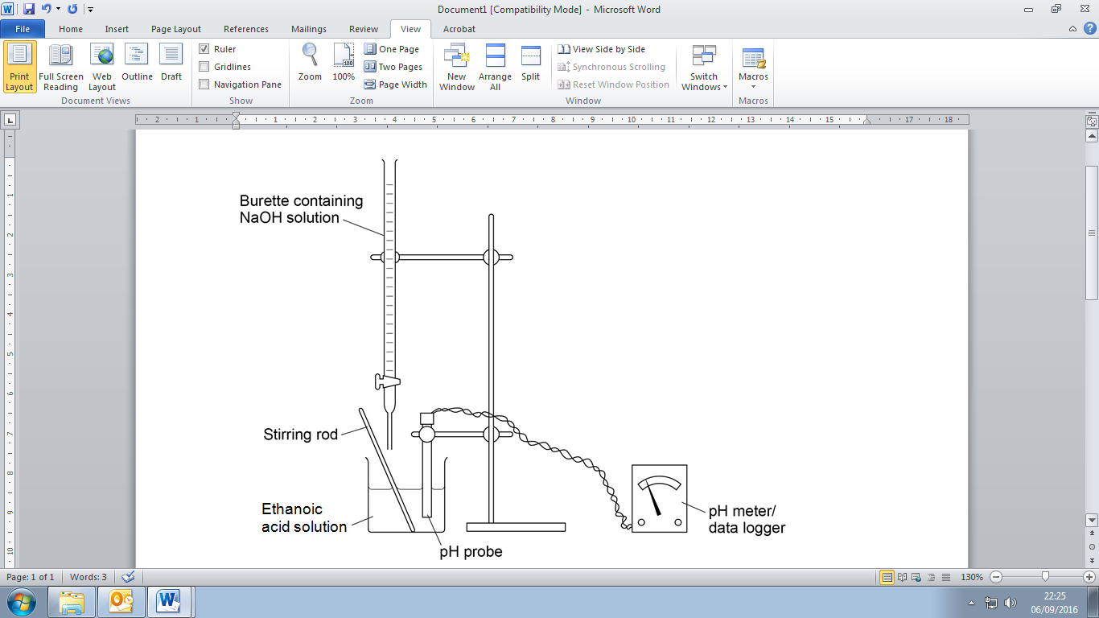

The data pH can be plotted against the volume of acid or base added giving a pH curve. They have a characteristic S-shape but vary slightly depending on whether it is a strong or weak acid or strong or weak base involved in the titration.

Alkali added to acid | Acid added to alkali

The shape of each curve is typical for the type of acid-base titration.

strong acid – strong base | strong acid – weak base
weak acid – strong base | weak acid – weak base

Required practical 9: Investigate how pH changes when a weak acid reacts with a strong base

Equivalence point from a pH curve

All the graphs except the weak acid-weak base curve have a vertical section; the mid-point of the vertical section is called the equivalence point. At this point tiny amounts of either acid or base result in a large change in pH because neutralisation takes place at this point.

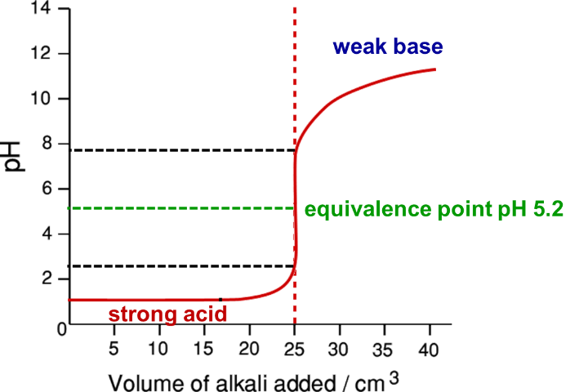
At this point there are stoichiometrically equal amounts of acid and base i.e.
[H⁺] = [OH⁻]. The equivalence point will be a pH value; it’s not always exactly 7 depending on the combination of acid and base titrated.
Definition:
Equivalence-point is the point on a titration curve at which stoichiometrically equivalent amounts of acid and base have been added N.B. pH value

The equivalence point corresponds to the end-point (this will be a volume), which is the term used to describe the point at which the colour changes with an indicator.
The change in pH during the titration can be used to determine the equivalence point, (also known as the stoichiometric point).

Indicators
The purpose of an acid-base indicator is to change colour at exactly the end point of a titration, a specific pH range.

Properties of indicators:
- sharp colour change at end point (only 1 drop acid or base needed to give change)
- end point must be same as equivalence point, colour change occurs over equivalence point
- distinct colour change.

There are many different indicators, methyl orange and phenolphthalein are often used, each changes colour over a different pH range:

Indicator | Colour at low pH  Acid (HIn) | Transition pH range | Colour at high pH  Base (In⁻)
Methyl orange | red | 3.1-4.4 | yellow
Phenolphthalein | colourless | 8.2-10.0 | pink

Acid-base indicators are used to find the concentration of a solution of acid or alkali; they show the end-point of a titration with a colour change, this allows the volume of acid or alkali added to be measured.

Acid-base indicators are water-soluble, weak organic acids that have different coloured acid (HIn) and base (In⁻) forms.

The indicator equilibrium:

HIn H⁺ + In⁻  colour 1 colour 2  lower pH higher pH  acid base  proton donor proton acceptor | - Low pH (excess H⁺) – more HIn due to H⁺ from acid pushing equilibrium to left  - Colour of HIn  - High pH (excess OH⁻) – more In⁻ due to OH⁻ reacting with H⁺ and equilibrium being pushed to right  - Colour of In⁻

The equivalence point is when there are equal amounts [H⁺] and [OH⁻]. The correct indicator must be chosen if the equivalence point and end point are to be the same. At the equivalence-point of the pH changes very rapidly through several pH units, so the indicator equilibrium swings from almost all HIn to virtually all In⁻ (or vice-versa) and a colour change is seen as its equilibrium is moved due to the changing concentration of H⁺ ions.

Choice of indicators
Demo: Indicators

The colour change of most indicators takes place over a pH range of 2 units, centred around the pK_{a} for the indicator, so that a colour change is seen.

Not all indicator are suitable for all titrations, universal is not suitable for any titration because of its gradual colour change.

An indicator is appropriate if the rapid change of pH at the equivalence point overlaps the range of activity of the indicator, so the pH range of the indicator’s colour change must be within the range of the pH change at the end-point.

Phenolphthalein | colourless | 8.2-10.0 | pink
Methyl orange | red | 3.1-4.4 | yellow

Methyl orange

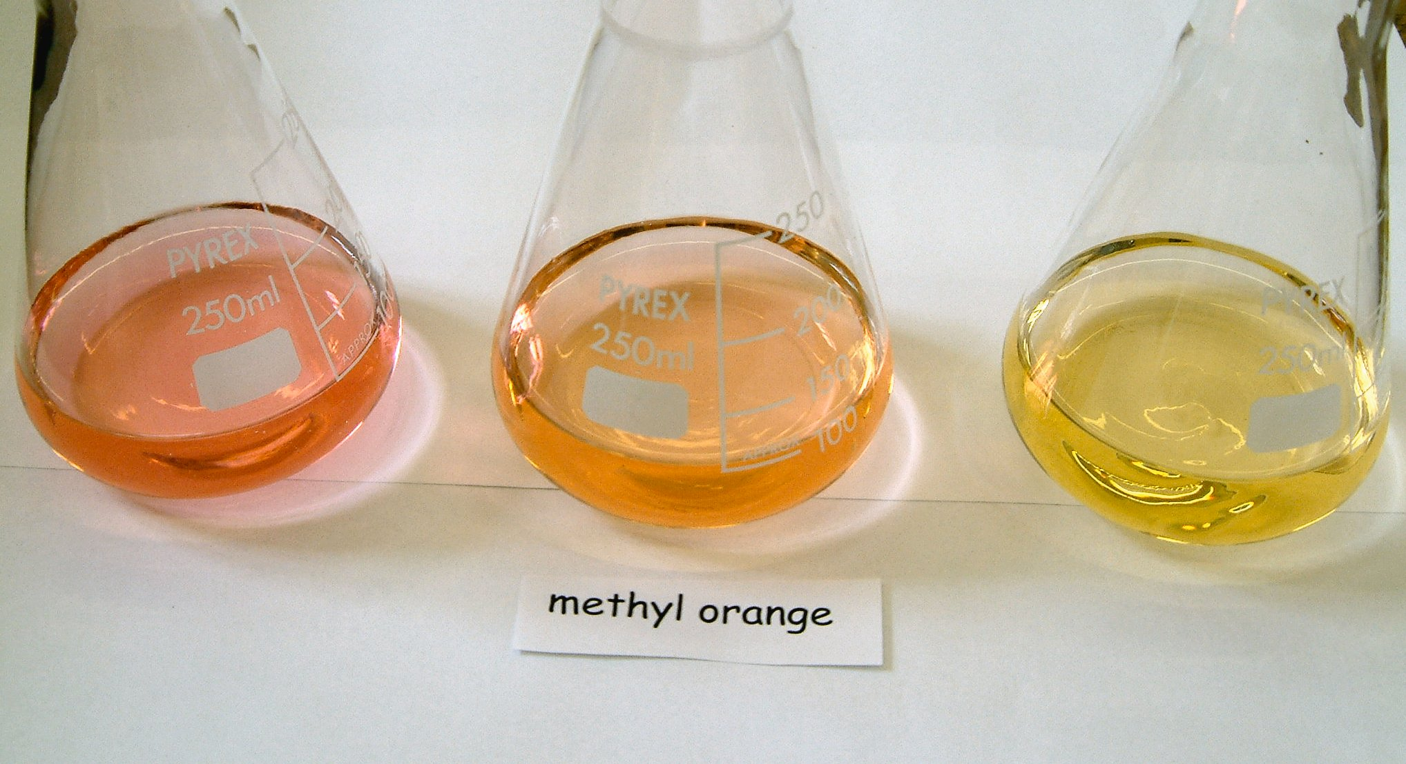
Phenolphthalein

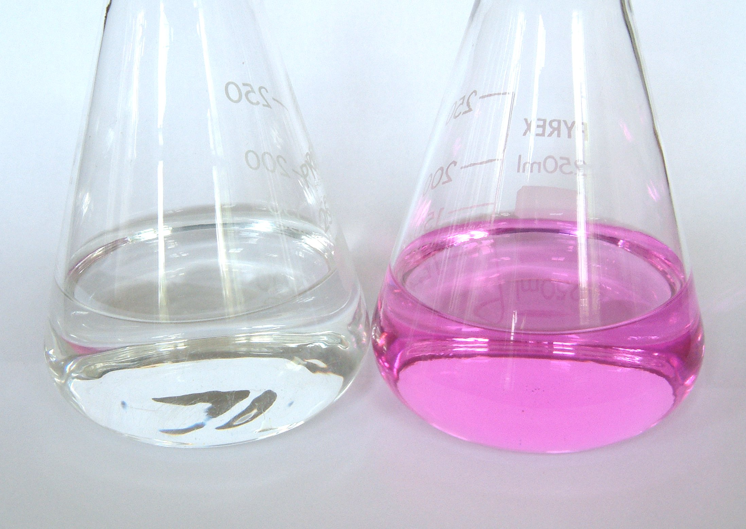

pH curve graphs compare suitability of these indicators for different titrations by looking to see if the indicator changes at the pH equivalence.

Example
Find a suitable indicator

Strong acid-strong base | Strong acid-weak base
Phenolphthalein  Methyl orange | Methyl orange
Weak acid-strong base | Weak acid-weak base
Phenolphthalein | None suitable  vertical position of curve < 2 pH units

Task: Find a suitable indicator

A strong acid is added to a weak base; select an indicator form the table below. | 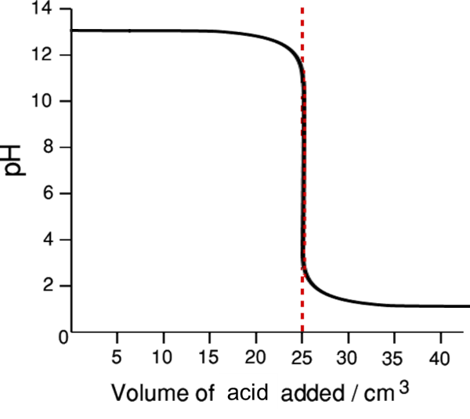
  Indicator | pH range
  Bromothymol blue | 3.0 – 4.6
  Litmus | 5.0 – 8.0
  Cresol purple | 7.6 – 9.2
Answer
Graph shows vertical part is in range pH 2-6.
So only suitable indicator that will change colour within that range is bromothymol blue.

Starter: 3.4 – Acid-base titrations
Sheet: pH curves & indicators

Application: CGP109 PQ1-2

Fact recall: CGP109 Q1-3

Working out concentrations from titrations

The equivalence point as shown by the pH curves can be used to give the neutralisation volume and so work out the concentration of the unknown acid or base.

Method:
- Balanced equation
- Number of moles of known substance n = cv
- Equivalence moles from the balanced equation
- Number of moles of unknown substance
- Concentration of unknown substance c = n/v

Monoprotic acids

Example – CGP111
25.0 cm³ of a 0.500 mol dm⁻³ solution of HCl was titrated against 35.0 cm³ of NaOH. Calculate the concentration of the NaOH.

HCl + NaOH → NaCl + H₂O

nHCl = 0.5 x 25.0 x 10⁻³ = 0.0125 mol

From equation 1 mole HCl neutralises 1 mole NaOH

nNaOH = 0.0125 mol

cNaOH = 0.0125 / 35.0 x 10⁻³ = 0.357 mol dm⁻³

Diprotic acids
A diprotic acid can release two hydrogen ions so when it is neutralised with a monobasic base such as sodium hydroxide the reaction occurs in two stages. This means that there are two equivalence points as shown on the pH curve. | 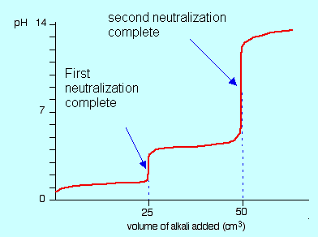
Example
Ethanedioic acid (HOOC-COOH) is neutralised like this.

1st equivalence point: HOOC-COOH + OH⁻ → HOOC-COO⁻ + H₂O
2nd equivalence point: HOOC-COO⁻ + OH⁻ → ⁻OOC-COO⁻ + H₂O
Combined: HOOC-COOH + 2OH⁻ → ⁻OOC-COO⁻ + 2H₂O

The calculations are the same as for monoprotic acids, only the molar ratio changes.
Example – CGP112
25.0 cm³ of ethanedioic acid was completely neutralised by 20.0cm³ of 0.100 mol dm⁻³ of KOH solution. Calculate the concentration of the acid.

H₂C₂O₄ + 2KOH → K₂C₂O₄+ 2H₂O

nKOH = 0.1 x 20.0 x 10⁻³ = 0.002 mol
From equation 2 mole KOH neutralises 1 mole C₂H₂O₄
nH₂C₂O₄ = 0.002 / 2 = 0.001 mol
cH₂C₂O₄ = 0.001 / 25.0 x 10⁻³ = 0.040 mol dm⁻³

Task: Calculate the concentration of ethanedioic acid
25 cm³ of a solution of ethanedioic acid (H₂C₂O₄) is neutralised by 28.6 cm³ 0.28
mol dm⁻³ solution of NaOH.

H₂C₂O₄ (aq) + 2NaOH (aq) → Na₂C₂O₄ (aq) + 2H₂O (l)

nNaOH = 0.28 x 28.6 x 10⁻³ = 8.01 x 10⁻³ mol
ratio 2 NaOH : 1 H₂C₂O₄
nH₂C₂O₄ = 8.01 x 10⁻³ / 2 = 4.04 x 10⁻³ mol
cH₂C₂O₄ = 4.04 x 10⁻³ / 25 x 10⁻³ = 0.16 mol dm³

Task: Calculate the concentration of this dibasic base
28.4 cm³ of a 0.22 mol dm⁻³ solution of Ba(OH)₂ are required to neutralise 25.0 cm³ of a solution of HCl. Calculate the concentration of the HCl solution.

2HCl (aq) + Ba(OH)₂ (aq) → BaCl₂ (aq) + 2H₂O (l)

nBa(OH)₂: 0.22 x 28.4 x 10⁻³ = 6.25 x 10⁻³
ratio 2 HCl : 1 Ba(OH)₂
nHCl = 2 x 6.25 x 10⁻³ = 1.25 x 10⁻² in 25cm³
cHCl = 1.25 x 10⁻² / 25 x 10⁻³ = 0.5 mol dm³

Sheet: Concentrations from strong acid-strong base titrations

The pH of a weak acid at half-neutralisation point

On a titration curve there is always a very gently sloping, almost horizontal, part of the curve before the steep line on which the equivalence point lies. As acid or base is added there is very little change in pH, almost up to the volume of the equivalence point.  The point half-way between the zero and the equivalence point is the half-neutralisation point. | 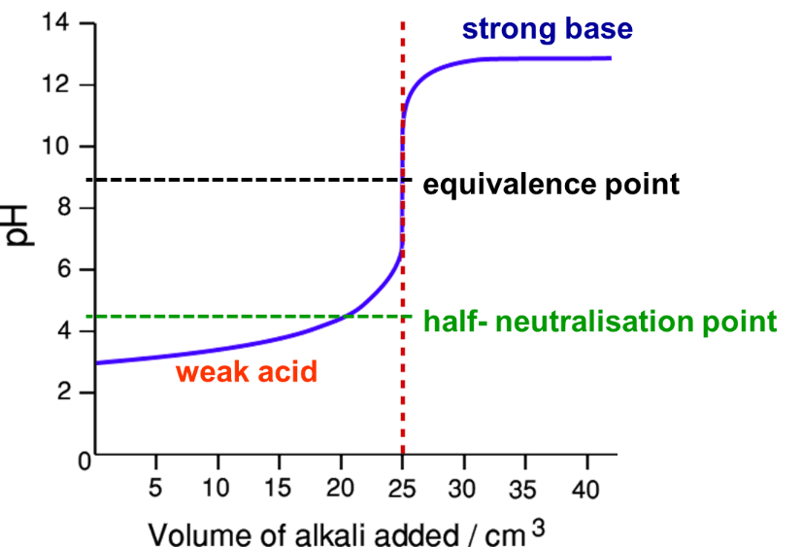

This shows that an acid or base can be added almost up to this point with little change in the pH which is relevant to the theory of buffers made between a weak acid and a strong base. It also allows the pK_{a} of the weak acid to be determined.

HA + OH⁻ → A⁻ + H₂O

At the half-neutralisation point half the HA has been converted into A⁻ and half remains, so [HA] = [A⁻] for a weak acid HA.

For equilibrium: HA H⁺ + A⁻

The expression for K_{a} can be used to find [H⁺] and so pH:

K_{a} = [H⁺] [A⁻]
[HA]

[H⁺] = K_{a} [HA] If [HA] = [A⁻] at ½ equivalence then [H⁺] = K_{a} [HA]
[A⁻] [A⁻]
For a weak acid only
So [H⁺] = K_{a} and pH = pK_{a}

So if the pH is measured in a titration at half-neutralisation point then pK_{a} is able to be determined. It also allows the value for K_{a} to be worked out.
Definition:
At half-neutralisation, the pH of a solution of a weak acid has the same value as pK_{a}

In practical terms a titration is carried out to determine equivalence point and then the titration is repeated with half the volume at the equivalence point.

Working out pH values – strong acid-strong base titrations

Two stages are involved in calculating the pH at any point during a titration:

- find the number of moles of the component that is in excess
  - if base is added to acid – acid will be in excess before equivalence point and the base after equivalence
  - if acid is added to base – base will be in excess before equivalence point and the acid after equivalence
- find the total volume of solution

Once both are known the concentration of the excess component can be calculated and from this the pH at this point of the titration can be found.

Method:
- moles H⁺/OH⁻ at start
- moles H⁺/OH⁻ added
N.B. If OH- in excess use
K_{w} = [H⁺] [OH⁻] to find [H⁺]
- moles H⁺/OH⁻ in excess (to determine if it’s the acid or base)
- total volume (acid + base)
- concentration H⁺/OH⁻ in excess
- concentration H⁺
- pH

Example (base added, acid in excess)
Calculate the pH in the titration of 10.0 cm³ of a 0.15 mol dm⁻³ solution of HCl at the point when 10.0 cm³ of a 0.10 mol dm⁻³ solution of NaOH has been added. | 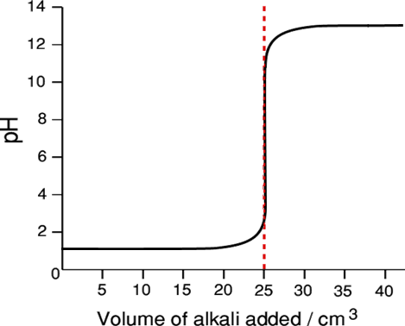

Method
Calculate the number of moles of acid originally present, the number of moles of base added, the number of moles of acid in excess, and the total volume of the solution.

HCl (aq) + NaOH (aq) → NaCl (aq) + H₂O (l)

Answer

Moles H⁺ originally: = 0.15 x 10 x 10⁻³ = 0.0015 mol

Moles OH⁻ added: = 0.01 x 10 x 10⁻³ = 0.0010 mol

Moles H⁺ in excess = moles H⁺ originally added – moles H⁺ reacted with OH⁻

(i.e. moles OH⁻ added - in this example ratio is 1:1)

Moles H⁺ in excess = 0.0015 – 0.0010 = 0.0005 mol

Total volume = 10.0 + 10.0 = 20.0 cm³

Hence [H⁺] =n/v = 0.0005 / 20x10⁻³ = 0.025 mol dm⁻³

pH = -log₁₀ [H⁺] = 1.60

Comment
The acid is in excess, so the titration has not yet reached equivalence. The concentration of the excess acid gives [H⁺] and so the pH.

Example (acid added, base in excess)
Calculate the pH in the titration of 16.0 cm³ of a 0.16 mol dm⁻³ solution of NaOH at the point when 12.0 cm³ of a 0.10 mol dm⁻³ solution of H₂SO₄ has been added. | 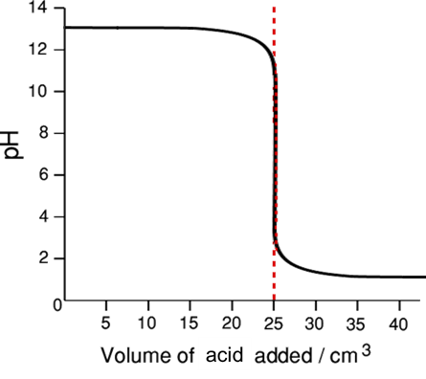

Method
2NaOH (aq) + H₂SO₄ (aq) → Na₂SO₄ (aq) + 2H₂O (l)
H₂SO₄ is a diprotic acid so acid-base stoichiometry is 1:2

Ionises: H₂SO₄ (aq) → 2H⁺ (aq) + SO₄²⁻ (l)
1 mole → 2 moles (i.e. for every 1 mole acid added 2 moles H⁺ added)

Answer
Moles OH⁻ originally: = 0.16 x 16 x 10⁻³ = 0.00256 mol
Moles H₂SO₄ added: = 0.10 x 12 x 10⁻³ = 0.00120 mol
Moles H⁺ added: = 2 x 0.10 x 12 x 10⁻³ = 0.00240 mol
Moles OH⁻ in excess = moles OH⁻ originally added – moles OH⁻ added
Moles OH⁻ in excess = 0.00256 – 0.00240 = 0.00016 mol
Total volume = 16.0 + 12.0 = 28.0 cm³
[OH⁻] =n/v = 0.00016 / 28.0 x 10⁻³ = 0.00571 mol dm⁻³

Use ionic product of water equation to calculate [H⁺] K_{w} = [H⁺] [OH⁻] = 1.0 x 10⁻¹⁴
[H⁺] = K_{w}
[OH⁻]_{xs}

[H⁺] = 1.0 x 10⁻¹⁴ / 0.00571 = 1.75 x 10⁻¹² mol dm⁻³
pH = -log₁₀ [H⁺] = 11.76

Comment
The base is in excess, so the concentration of the excess base is used to calculate the [H⁺] and so the pH of the mixture at this point in the titration.

Sheet: pH values of strong acid-strong base titrations

Application: CGP112/3 PQ1-6

Fact recall: CGP113 Q1-4

Working out pH values – weak acid-strong base titrations

The technique used depends on how far the titration has progressed.

Before equivalence – relative proportions of weak acid and its anion have to be determined and then used to calculate K_{a}, from this [H⁺] can be calculated and so pH.

Example (base added, weak acid in excess)
Calculate the pH in the titration of 10.0 cm³ of a 0.10 mol dm⁻³ solution of NaOH has been added to 10.0 cm³ of a 0.25 mol dm⁻³ solution of ethanoic acid (K_{a} = 1.76 x 10⁻⁵ mol dm⁻³). | 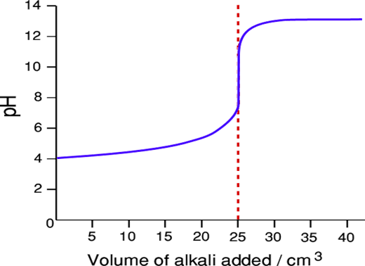

Method

Reaction equation: CH₃COOH + OH⁻ → CH₃COO⁻ + H₂O

Because acid is in excess and it’s weak it’s not fully disassociated, the extent of dissociation is not known so need to find the concentration of the alkali that reacts with the ethanoic acid to form ethanoate ions.

Write equation for acid dissociation, then equilibrium constant equation.

CH₃COOH (aq) CH₃COO⁻ (aq) + H⁺ (aq)

Answer
Moles CH₃COOH originally = 0.25 x 10 x 10⁻³ = 0.0025 mol
Moles OH⁻ added = 0.10x 10 x 10⁻³ = 0.0010 mol
Moles CH₃COOH remaining = excess – reacted = 0.0025 – 0.0010 = 0.0015 mol
Moles CH₃COO⁻ formed = moles OH⁻ added (molar ratio is 1:1) = 0.0010 mol

c = n/v

So [CH₃COOH] = 0.0015/v
and [CH₃COO⁻] = 0.0010/v

Since ethanoic acid and ethanoate ions both exist together in same overall volume, concentration ratio = mole ratio and volumes cancel.

K_{a} = [H⁺] [CH₃COO⁻]
[CH₃COOH]

So [H⁺] = K_{a} x [CH₃COOH]_{eqm}
[CH₃COO⁻]_{eqm}

So [H⁺] = K_{a} x mole ratio = 1.76 x 10⁻⁵ x 0.0015 / 0.0010 = 2.64 x 10⁻⁵ mol dm³

pH = -log₁₀ [H⁺] = 4.58

Comment
pH is in the acidic region. Only the ratio of the concentration of the weak acid and its anion that matters here, so there is no need to consider the total volume as
mole ratio $≡$ concentration ratio.
After equivalence – excess of strong base has to be found, plus the total volume, then the concentration can be calculated and hence the pH as in the above calculations

Example (strong base added, base in excess)
Calculate the pH in the titration of 16.0 cm³ of a 0.16 mol dm⁻³ solution of NaOH has been added to 12.0 cm³ of a 0.20 mol dm⁻³ solution of ethanoic acid

Method
Because alkali is in excess and it’s reacting with a weak acid it will fully react with the acid just as it would with a strong acid, so follow the calculation for a strong acid- strong base.

Reaction equation: CH₃COOH + OH⁻ → CH₃COO⁻ + H₂O

Answer
Moles OH⁻ added (n_{OH}⁻): = 0.16 x 16 x 10⁻³ = 0.00256 mol
Moles H⁺ originally (n_{H}⁺): = 0.20 x 12 x 10⁻³ = 0.00240 mol
Moles OH⁻ in excess = moles OH⁻ originally added – moles OH⁻ reacted with added H⁺
Moles OH⁻ in excess = 0.00256 – 0.00240 = 0.00016 mol
Total volume = 16.0 + 12.0 = 28.0 cm³
[OH⁻] = n/v = 0.00016 / 28.0 x 10⁻³ = 0.00571 mol dm⁻³
K_{w} = [H⁺] [OH⁻] = 1.0 x 10⁻¹⁴ so [H⁺] = K_{w}
[OH⁻]_{xs}

Hence [H⁺] = 1.0 x 10⁻¹⁴ / 0.00571 = 1.75 x 10⁻¹² mol dm⁻³
pH = -log₁₀ [H⁺] = 11.76

Sheet: pH values of weak acid-strong base titrations

Buffer action
Buffers are solutions that resist changes of acidity or alkalinity, so when small amounts of acid or alkali are added or it is diluted their pH remains almost constant.

They work by keeping the concentration of hydrogen ions and hydroxide ions almost unchanged. They are based on an equilibrium reaction which will move in the direction to remove either additional hydrogen ions or hydroxide ions.

Buffers don’t ensure no change in pH, the addition of acids or alkalis will still change the pH slightly. It’s also possible to ‘saturate’ a buffer solution by adding too much acid or alkali.
Definitions:
A buffer solution is one that is able to resist change in pH when small amounts of acid or base are added. It is also able to maintain its pH in the face of dilution with water.

An acidic buffer is one which maintains a solution at a pH below 7 and, typically, consists of a weak acid and one of its salts.

A basic buffer is one which maintains a solution at a pH above 7 and, typically, consists of a weak base and one of its salts.

Two method of making a buffer:
- weak acid or base plus salt of the acid or base
- partial neutralisation of weak acid with strong base

Uses of buffers
- Buffers are used to calibrate pH meters.

- Biological systems e.g. growth of bacteria in hospital tests.

- Blood – maintained at exactly 7.4, a change of 0.5 units would be fatal, many mechanism are in operation, the most important one is:

CO₂ (aq) + H₂O (l) H⁺ (aq) + HCO₃⁻ (aq)

- Detergents and shampoos contain buffers to prevent damage to fabric or skin or hair if they were too acidic or basic.

- Oceans and seas are buffered slightly alkaline, pH 7.5 -8.4.

Sheet: HSW – Biological buffers

Fact recall: CGP116 Q1-6

Acidic buffers – maintain pH < 7

These are made from weak acids and one of its soluble salts (sodium or potassium), they work because the dissociation of the acid is in equilibrium, so with a weak acid:

HA (aq) H⁺ (aq) + A⁻ (aq)

This shows [H⁺] is equal to [A⁻] and as it is a weak acid both are very small because most of HA is undissociated. To ensure there is a high concentration of A⁻ a soluble salt (fully ionises) of the acid is mixed with the acid which.

NaA(aq) → Na⁺(aq) + A⁻(aq)

This is important in the functioning of the buffer when an acid is added to prevent the supply of A⁻ running out.

Resisting a base | Resisting an acid
The added OH⁻ ions will react with H⁺ to produce water. This removes H⁺ ions and affects the weak acid equilibria, this opposes the change by moving to the right, and the weak acid dissociates to increase the H⁺. The hydrogen ion concentration is restored and the hydroxide ions have been removed so the pH remains almost the same.  OH⁻ (aq) + H⁺ (aq) → H₂O (l) | The added H⁺ reacts with the A⁻ to produce HA.  H⁺ (aq) + A⁻ (aq) → HA (aq)  This reduces the hydrogen ion concentration, so the concentration is restored as the H⁺ have been removed and the pH remains almost the same.  The fully ionised salt of the acid (Na⁺A⁻) ensures a plentiful supply of A⁻ ions so more of the H⁺ can be used up. If there was only a weak acid present the supply of A⁻ would soon runs out because the concentration is low and it would no longer act as a buffer.
addition of OH⁻ | addition of H⁺
HA (aq) H⁺ (aq) + A⁻ (aq) | HA (aq) H⁺ (aq) + A⁻ (aq)

Example – CGP114
A mixture of ethanoic acid & sodium ethanoate (CH₃COO⁻Na⁺)

The ethanoic acid is only slightly dissociated:

CH₃COOH (aq) CH₃COO⁻ (aq) + H⁺ (aq)

The salt is fully dissociated:

CH₃COO⁻Na⁺ (aq) → CH₃COO⁻ (aq) + Na⁺ (aq)

Task – Explain what would happen if a little acid is added
Added H⁺ will react with ethanoate ions to produce ethanoic acid will move equilibrium to left and cause the hydrogen ion concentration to return to its previous concentration and pH remains the same.

Task – Explain what would happen if a little base is added
The OH⁻ will react with the ethanoic acid producing ethanoate ions and water, the weak acid equilibrium opposes this change in hydrogen ion concentration by moving to the right to increase the hydrogen ion concentration and pH remains the same.

Basic buffers – maintain pH > 7

They are made from weak bases and a soluble salt of the base, usually a chloride.

The weak base is slightly dissociated according to this equilibrium:

B (aq) + H₂O (l) BH⁺ (aq) + OH⁻ (aq)

The salt is fully dissociated:

BCl (aq) → B⁺ (aq) + Cl⁻ (aq)

It is added to prevent the B⁺ from running out.

Resisting a base | Resisting an acid
The addition of a small amount of base causes the hydroxide ion concentration to increase. The extra OH⁻ ions will react with the base cations (BH⁺) to form the base and water. To oppose this change the equilibrium will shift to the left, removing the extra hydroxide ions and the pH remains almost the same. | The addition of small amounts of acid causes the hydrogen ion concentration to increase. The H⁺ ions will react with OH⁻ ions from the dissociated base to form water. To oppose this the equilibrium to move to the right to replace the hydroxide ions that have been used up. Since the hydrogen ions have been removed the pH remains almost the same.
addition of OH⁻ | addition of H⁺
B (aq) + H₂O (l) BH⁺ (aq) + OH⁻ (aq) | B (aq) + H₂O (l) BH⁺ (aq) + OH⁻ (aq)
CGP116
Example – CGP115
A solution of ammonia and ammonium chloride.

The ammonia will react with water to give this equilibrium:

NH₃ (aq) + H₂O (l) NH₄⁺ (aq) + OH⁻ (aq)

The salt is fully dissociated:

NH₄Cl (aq) → NH₄⁺ (aq) + Cl⁻ (aq)

Diluting buffer solutions

Adding small amounts of water to a buffer will not affect the pH because the number of moles of each component will be the same hence the ratio of the concentration will remain the same and so the pH is unchanged. Although water is slightly dissociated the extra hydrogen ions and hydroxide ions will push the buffer equilibrium equally in both directions, leaving it unchanged.

Buffers can be represented by this chemical equation: HA (aq) H⁺ (aq) + A⁻ (aq)

So K_{a} = [H⁺] [A⁻]
[HA]
Since K_{a} is a constant and if water is added the ratio of [HA] to [A⁻] isn’t changed the [H⁺] will remain the same.
And [H⁺] = K_{a} [HA]
[A⁻]

Prac: Making a buffer solution

Calculating the pH of a buffer

This is for a buffer solution may be made by mixing solutions of the weak acid and its salt.

Method:
- Write out the expression for K_{a} of the weak acid
- Re-arrange to give an expression for [H⁺]
- Substitute the value for K_{a} and the concentration of the acid [HA] and salt [A⁻]
- Solve the equation to give the [H⁺]
- Substitute [H⁺] into pH equation to calculate the pH.

Example – CGP117
A buffer solution contains 0.400 mol dm⁻³ methanoic acid, HCOOH, and 0.600 mol dm⁻³ sodium methanoate, HCOO⁻Na⁺. For methanoic acid K_{a} = 1.6 x 10⁻⁴ mol dm⁻³. What is the pH of the buffer?

HCOOH (aq) HCOO⁻ (aq) + H⁺ (aq) K_{a} = [H⁺] [HCOO⁻]
[HCOOH]
from salt
from acid
[H⁺] = K_{a} [HCOOH]
[HCOO⁻]

Substitute initial concentration of acid and salt.

[H⁺] = 1.6 x 10⁻⁴ x 0.400 = 1.07 x 10⁻⁴ mol dm⁻³
0.600

pH = -log[H⁺] = -log(1.07 x 10⁻⁴) = 3.97

Task: A buffer consists of 0.100 mol dm⁻³ solution of ethanoic acid and 0.100 mol dm⁻³ sodium ethanoate. (Ethanoic acid K_{a} = 1.74 x 10⁻⁵ mol dm⁻³). Calculate the pH.

CH₃COOH (aq) CH₃COO⁻ (aq) + H⁺ (aq) K_{a} = [H⁺] [CH₃COO⁻]
[CH₃COOH]
[H⁺] = K_{a} [CH₃COOH]
[CH₃COO⁻]

Volumes not given so use:

[CH₃COOH] = 0.100 mol dm⁻³

[CH₃COO⁻] = 0.100 mol dm⁻³

[H⁺] = 1.74 x 10⁻⁵ x 0.100 = 1.74 x 10⁻⁵
0.100

pH = 4.76

Calculate the pK_{a}

pK_{a} = -logK_{a} = 4.76

Comment
When equal concentrations of acid and salt are used the pH is equal to the pH of the acid used and the half neutralisation point.

Task: Calculate the pH of a buffer made by mixing 14.0 cm³ of a 2.0 mol dm⁻³ solution of ethanoic acid (K_{a} = 1.74 x 10⁻⁵ mol dm⁻³) with 15.0 cm³ of a solution of 1.50 mol dm⁻³ sodium ethanoate.

CH₃COOH (aq) H⁺ (aq) + CH₃COO⁻ (aq)

K_{a} = [H⁺] [CH₃COO⁻]
[CH₃COOH]

[H⁺] = K_{a} [CH₃COOH]
[CH₃COO⁻]

Use n = cv

Moles (CH₃COOH) = 2.0 x 14.0 x 10⁻³ = 0.0280 mol

Moles (CH₃COO⁻) = 1.5 x 15.0 x 10⁻³ = 0.0225 mol

[H⁺] = K_{a} 0.0280/v N.B. v cancels
0.0225/v

= 1.74 x 10⁻⁵ x 2.0

= 2.17 x 10⁻⁵ mol dm⁻³

pH = -log [H⁺] = 4.66

Starter: 3.3 – Buffer solutions

Sheet: Buffer solutions – Extension Q1
Partial neutralisation buffers

See section on pH of weak acid at  half-equivalence point. | 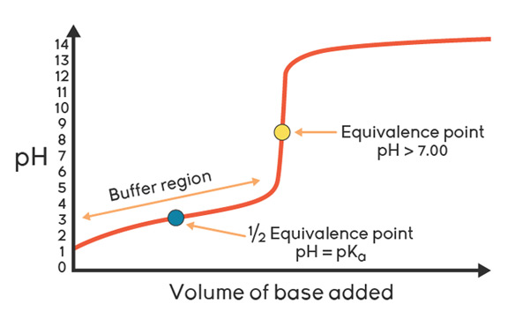

Buffers can also be made by partial neutralisation of the weak acid with a strong base (e.g. by adding about half the stoichiometric amount of sodium hydroxide to a solution of ethanoic acid). In either case an equimolar mix of components or a half neutralised weak acid will have:

[H⁺] = K_{a} and hence pH = pK_{a}

The find the equimolar mix of HA and H⁺ (half-equivalence):
- Titrate with phenolphthalein to note equivalence volume
- Repeat with ½ equivalence and no indicator
- Solution has [HA] = [A⁻]

Method:
- Write out balanced equation for neutralisation: acid + base → salt + water
- Calculate number of mole of acid and base at start
- Use molar ratios to work out moles of acid and salt left at end of reaction
- Calculate concentration of acid and salt in buffer solution by dividing by the volume of solution (total volume of acid and base)
- Calculate pH

Example – CGP118
A buffer is formed by mixing 15cm³ of 0.1 mol dm⁻³ NaOH and 30cm³ of 0.6 mol dm⁻³ propanoic acid (CH₃CH₂COOH). Calculate the pH of the buffer solution.
K_{a} = 1.35 x 10⁻⁵ mol dm⁻³.

CH₃CH₂COOH + NaOH → CH₃CH₂COONa + H₂O
excess limiting same number of moles as NaOH added

As reactions proceed the moles of acid decrease and moles of salt increase by the number of moles of base added.
Partial neutralisation so some acid has reacted with the base
initial nCH₃CH₂COOH = 0.6 x 30 x 10⁻³ = 0.018 mol

nNaOH = 0.1 x 15 x 10⁻³ = 0.0015 mol limiting
acid and base react in 1:1 molar ratio so 0.0015 moles base will react with 0.0015 moles acid giving 0.0015 mol salt

acid is in excess nCH₃CH₂COOH 0.018 – 0.0015 = 0.0165 mol acid remains
Don’t need to calculate concentration as it’s the same total volume Can use moles
K_{a} = [H⁺] [CH₃CH₂COO⁻]
[CH₃CH₂COOH]

[H⁺] = K_{a} [CH₃CH₂COOH] = 1.35 x 10⁻⁵ x 0.0165/v = 1.485 x 10⁻⁴ mol dm⁻³
[CH₃CH₂COO⁻] 0.0015/v

pH = -log₁₀ (1.485 x 10⁻⁴) = 3.83

Task: Calculate the pH of the buffer formed when 500 cm³ of 0.400 mol dm⁻³ NaOH is added to 500 cm³ 1.00 mol dm⁻³ HA. K_{a} = 6.25 x 10⁻⁵ mol dm⁻³

HA + NaOH → NaA + H₂O

nHA = 1.00 x 500 x 10⁻³ = 0.500 mol

nOH⁻ = 0.400 x 500 x 10⁻³ = 0.200 mol

HA in excess so at the end there was 0.500 – 0.200 = 0.300 mol HA left
nA⁻ = 0.200 mol (i.e. same as OH⁻ moles)

K_{a} = [H⁺] [A⁻]
[HA]

[H⁺] = K_{a} [HA]
[A⁻]

[H⁺] = 6.25 x 10⁻⁵ x 0.300 = 9.375 x 10⁻⁵
0.200

pH = 4.03

Sheet: Buffer solutions – Extension Q2&3

Calculating changes in pH when acids or bases are added to a buffer solution
Example – addition of acid
A buffer with a pH 4.66 is made by mixing 14.0 cm³ of a 2.0 mol dm⁻³ solution of ethanoic acid with 15.0 cm³ of a solution of 1.50 mol dm⁻³ sodium ethanoate. Calculate the change in pH after the addition of 10.0 cm³ of 0.1 mol dm⁻³ hydrochloric acid.
K_{a} = 1.74 x 10⁻⁵ mol dm⁻³

Method
The addition of acid shifts the equilibrium to the left, as it reacts with the ethanoate ions (acid increases by same amount as anions decrease):

CH₃COOH (aq) H⁺ (aq) + CH₃COO⁻ (aq)

Need to decrease the number of moles of CH₃COO⁻ by the number of moles of HCl added and increase the number of moles of CH₃COOH by the same amount.

Answer
Use c = n/v so n = cv

Moles (H⁺ in HCl) = 0.10 x 10.0 x 10⁻³ = 0.0010 mol

Initial moles (CH₃COO⁻) = 1.5 x 15.0 x 10⁻³ = 0.0225 mol

So new moles (CH₃COO⁻) = 0.0225 – 0.0010 = 0.0215 mol

Initial moles (CH₃COOH) = 2.0 x 14.0 x 10⁻³ = 0.0280 mol

So new moles (CH₃COOH) = 0.0280 + 0.0010 = 0.0290 mol

K_{a} = [H⁺] [CH₃COO⁻]
[CH₃COOH]

[H⁺] = K_{a} [CH₃COOH] = 1.74 x 10⁻⁵ x 0.0290/v = 2.347 x 10⁻⁵ mol dm⁻³ N.B. v cancels
[CH₃COO⁻] 0.0215/v

pH = -log [H⁺] = 4.63 Previously it was 4.66

So the change in pH is reduced by 0.03 units

Comment
Adding a substantial volume of a 0.10 mol dm⁻³ solution of HCl has only a slight effect on the pH, as is predicted by a buffer solution.

Task: 1.00 dm³ of a buffer solution consisting of 0.10 mol dm⁻³ ethanoic acid and 0.10 mol dm⁻³ of sodium ethanoate. K_{a} 1.74 x 10⁻⁵ and pH 4.77. 10.0 cm³ of 1.00 mol dm⁻³ HCl is added, virtually all the H⁺ will react with the ethanoate ions A⁻ to form ethanoic acid. Calculate the new pH and work out the difference.

Method
CH₃COOH (aq) CH₃COO⁻ (aq) + H⁺ (aq) Addition of HCl shifts equilibrium to left
as the H⁺ ions react with the ethanoate ions
Answer
Moles H⁺ in HCl = 1 x 10.0 x 10⁻³ = 0.01 mol
Initial moles (CH₃COO⁻) = 0.1 x 1 = 0.10 mol
So new moles (CH₃COO⁻) = 0.1 – 0.01 = 0.09 mol
Initial moles (CH₃COOH) = 0.1 x 1 = 0.10 mol
So new moles (CH₃COOH) = 0.1 + 0.01 = 0.11 mol

[H⁺] = K_{a} [CH₃COOH]
[CH₃COO⁻]

[H⁺] = 1.74 x 10⁻⁵ x 0.11/v = 2.13 x 10⁻⁵ mol dm⁻³
0.09/v

pH = 4.67 Previously it was 4.77 (from earlier task)

So the change in pH is reduced by 0.10 units

Example – addition of base
A buffer with a pH 3.78 was prepared by adding 0.013 mol of a salt NaA to 250 cm³ of a 0.500 mol dm⁻³ solution of a weak acid HA and thoroughly mixing. Calculate the pH of the buffer after the addition of 3.00 x 10⁻³ mol NaOH.
K_{a} = 1.74 x 10⁻⁵ mol dm⁻³

Method
The addition of base shifts the equilibrium to the right, as it reacts with the H⁺ (acid decreases by same amount as anions increase):

HA (aq) H⁺ (aq) + A⁻ (aq)

Need to decrease the number of moles of NaOH by the number of moles of HA in the buffer and increase the number of moles of A⁻ by the same amount.

Answer

Moles OH⁻ in NaOH = 3.00 x 10⁻³ mol

Initial moles (HA) = 0.5 x 250 x 10⁻³ = 0.125 mol

So new moles (HA) = 0.125 – 3.00 x 10⁻³ = 0.122 mol

Initial moles (A⁻) = 0.0130 mol

So new moles (A⁻) = 0.0130 + 3.00 x 10⁻³ = 0.016 mol

K_{a} = [H⁺] [A⁻]
[HA]

[H⁺] = K_{a} [HA] = 1.74 x 10⁻⁵ x 0.122/v N.B. v cancels
[A⁻] 0.016/v

= 1.33 x 10⁻⁴ mol dm⁻³

pH = -log [H⁺] = 3.89

Sheet: Buffer solutions

Sheet: Stretch & challenge - Buffer solutions

Starter: 3.6 – More complex buffer solutions

Sheet: Exam questions

Application: CGP119 PQ1-4

Exam questions: Oxford p78-79 Q1-4

