3.2.6 Reactions of ions in aqueous solution
AS & A Level Link:
3.1.6 – Equilibria
3.1.7 – Redox (oxidation states, oxidation, reduction, redox equations)
3.1.10 – Equilibrium constant
3.1.12 – Acids & bases
3.2.5 – Transition metals

Hydration of metal ions

Dissolving a salt of a transition metal in water will result in the water molecules acting as ligands. They use a lone pair of electrons to form co-ordinate bonds with the metal ion and a complex ion is formed called a metal-aqua ion.

Six water molecules will surround a metal ion forming an octahedral shaped complex.

Example CGP159

Copper(II)  [Cu(H₂O)₆]²⁺ | Iron(II)  [Fe(H₂O)₆]²⁺ | Aluminium  [Al(H₂O)₆]³⁺
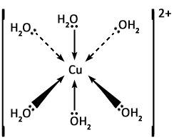 | 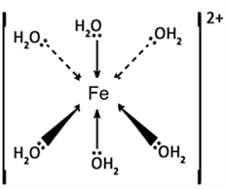 | 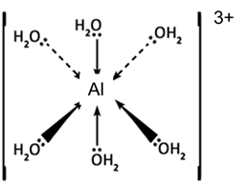

Acidity of metal-aqua ions

Reminder – Brønsted-Lowry acids and bases:
- Acid – proton donor
- Base – proton acceptor

Another theory developed by Gilbert Lewis is also use to describe acids and bases.
Definition
Lewis acid is an electron pair acceptor
Lewis base is an electron pair donor

The donor pair of electrons forms a co-ordinate (dative) covalent bond, e.g.

H⁺ + OH⁻ → H₂O

H⁺ + ⁻ ˸O-H → H←O-H

A water molecule has two lone pairs of electrons and it can use one of them to accept a proton (acting as a Lewis base and a Brønsted-Lowry base).

H₂O + H⁺ → H₃O⁺
Lewis Lewis
base acid

Another example is the reaction between boron trifluoride and ammonia:

BF₃ + NH₃ → [F₃B ← NH₃]
Lewis Lewis
acid base

In BF₃ there are 3 electrons from boron plus 3 from the fluorines, this give a total
of 6, so it is clearly electron deficient and can accept a further 2 electrons. Ammonia has a lone pair of electrons which it can donate.

Boron trifluoride acts as a Lewis acid and ammonia as a Lewis base. This illustrates that the Lewis definition is wider than the Brønsted-Lowry definition. Boron trifluoride contains no protons so cannot be an acid under the Brønsted-Lowry definition. Hydrogen ions have no electrons so they can only form a bond by accepting an electron pair.

In transition metal chemistry:
- ligands are Lewis bases
- metal cations are Lewis acids.

Hydrolysis or acidity reactions

Consider a hexaaqua ion, [M(H₂O)₆]^{n+}

Task: Which bonds could break?
O-H covalent bond – acidity reaction or hydrolysis
O-M co-ordinate bond – ligand substitution

The only reaction that occurs without breaking these bonds is a redox reaction, where there is a loss or gain of an electron.

[M(H₂O)₆]²⁺ → [M(H₂O)₆]³⁺ + e⁻

In solution metal aqua ion complexes release hydrogen ions forming an acidic solution.

Example CGP160
Metal-aqua 2+ ion:
[Fe(H₂O)₆]²⁺(aq) + H₂O(l) [Fe(H₂O)₅(OH)]⁺(aq) + H₃O⁺(aq)

Metal-aqua 3+ ions react in the same way:
[Al(H₂O)₆]³⁺(aq) + H₂O(l) [Al(H₂O)₅(OH)]²⁺(aq) + H₃O⁺(aq)

An equilibrium is set up when a metal aqua ion is placed in water, where a O-H bond breaks in a water molecule co-ordinated to the metal ion, forming an hydronium ion.

[M(H₂O)₆]^{n+} + H₂O [M(H₂O)₅(OH)]^{(n-1)+} + H₃O⁺
acid

This is called hydrolysis because a water molecule has split into H⁺ and OH⁻. It’s also called an acidity reaction because hydrolysis leads to the formation of H₃O⁺ ions.

Relative acidity of 2+ and 3+ metal-aqua ions

With metal-aqua ions the equilibrium lies very much to the LHS, so it is only slightly acidic. The degree of acidity is measured by the magnitude of the acid dissociation constant (K_{a}). For the above equilibrium, the acid dissociation constant or acid constant is:

K_{a} = [M(H₂O)₅(OH)]^{(n-1)+}] [H₃O⁺]
[M(H₂O)₆]^{n+}] [H₂O]

For metal(II) ions K_{a} values are between 10⁻⁶ and 10⁻¹¹ showing the equilibrium lies far to the left.

For metal(III) ions the equilibrium lies further to the right giving K_{a} between 10⁻² and 10⁻⁵, which is still weakly acidic but stronger than metal(II) aqua ions.

Two factors decide the acidity of metal ions:

- Charge on the metal ion acidity increases with charge
- Size of the metal ion acidity decreases as size increases

The charge-to-size ratio or charge density can be used to predict the relative acidity of metal ions. Small highly charged cations are the strongest acids in aqueous solutions. The ratio reflects the polarising power (the ability of a metal ion to attract electron density from a covalent bond).

Ions with a 3+ charge are small and highly charged compared to 2+ metal ions, making them more strongly polarising.

They will therefore attract electrons from the oxygen atoms in the co-ordinated water molecules making the O-H bond weaken.

Hydrogen ions are more likely to be released making a more acidic solution.

This can be summarised:
[M(H₂O)₆]²⁺  smaller charge density  larger ion  less charge  less polarising  very weak acids  pH ~6 | [M(H₂O)₆]³⁺  greater charge density  smaller ion  greater charge  strongly polarising  weak acids  pH ~ 3
[Fe(H₂O)₆]²⁺  pH ~5 | [Fe(H₂O)₆]³⁺  pH ~ 2/3

Demo: pH of transition metal solutions

Further hydrolysis

Further hydrolysis can occur with the other co-ordinated water molecules if a base (such as OH⁻) is added; these react with the hydronium ions.

When OH⁻ ions are added, they attack the strongest acid, which is H₃O⁺.

OH⁻ + H₃O⁺ → 2H₂O

The equilibrium opposes this and shifts to the right.

[M(H₂O)₆]^{n+} + H₂O [M(H₂O)₅(OH)]^{(n-1)+} + H₃O⁺

A new equilibrium is now set up:

[M(H₂O)₅(OH)]^{(n-1)+} + H₂O [M(H₂O)₄(OH)₂]^{(n-2)+} + H₃O⁺

Again hydroxide ions will react with the hydronium ions pushing the equilibrium to the right.

This is illustrated below for the metal(II) and metal(III) aqua ions.

Metal(II) ions complete hydrolysis:

The neutral metal(II) hydroxide, M(H₂O)₄(OH)₂, is in effect M(OH)₂, which is uncharged and insoluble so forms a precipitate. The overall equation is:

Metal(III) ions complete hydrolysis:
The reaction are the same except it occurs three times.

The neutral metal(III) hydroxide, M(H₂O)₃(OH)₃, is in effect M(OH)₃, which is uncharged and insoluble so forms a precipitate. The overall equation is:

The final metal hydroxide has little hydration energy to overcome the lattice energy so they always appear as precipitates. All transition metals hydroxides are insoluble in water and are formed when a base (e.g. NaOH or NH₃) is added to a solution of metal ions.

Example
If iron(III) nitrate nonahydrate, Fe(NO₃)₂.9H₂O (pale violet solid) is added to water a brown solution forms. It contains the very pale violet hexaaqua ion [Fe(H₂O)₆]³⁺ but the colour indicates that it’s undergoing hydrolysis. The brown colour of this ion is more intense than the hexaaqua ion so this is the only colour that is seen. However, the equilibrium still lies far to the left.

[Fe(H₂O)₆]³⁺(aq) + H₂O(l) [Fe(H₂O)₅(OH)]²⁺(aq) + H₃O⁺(aq)
very pale violet solution brown solution

Adding hydroxide ions produces a brown precipitate of Fe(OH)₃:

[Fe(H₂O)₅(OH)]²⁺(aq) + H₂O(l) [Fe(H₂O)₄(OH)₂]⁺(aq) + H₃O⁺(aq)

[Fe(H₂O)₄(OH)₂]²⁺(aq) + H₂O(l) [Fe(H₂O)₃(OH)₃](s) + H₃O⁺(aq)
brown precipitate

These reactions can be reversed with the addition of an acid.

Demo: Equilibrium of iron(III) nitrate nonahydrate – addition of NaOH & nitric acid

Addition of acid e.g. nitric | Addition of base e.g. sodium hydroxide
Brown colour disappears  Almost colourless (very pale violet) solution appears | Solution turns darker brown  Eventually a brown precipitate (Fe(OH)₃) appears  (the next stages of hydrolysis occur)
Equilibrium moves to the left to remove excess acid | Equilibrium moves to the right as the base reacts with the H₃O⁺ ions

Hydrolysis reactions of aqua ions with bases

- Sodium hydroxide
- Ammonia solution
- Sodium carbonate

Sodium hydroxide - adding sodium hydroxide always gives a precipitate of the metal hydroxide.

Demo: Reactions of aqua ion with bases – addition of NaOH

The following reaction with the aqua ions take place as the hydroxide ions react with hydrogen ions from the water ligands:

[M(H₂O)₆]²⁺(aq) + 2OH⁻(aq) → [M(H₂O)₄(OH)₂](s) + 2H₂O(l)

[M(H₂O)₆]³⁺(aq) + 3OH⁻(aq) → [M(H₂O)₃(OH)₃](s) + 3H₂O(l)

Copper(II) aqua-ion

Major species: [Cu(H₂O)₆]²⁺(aq)
Minor species: [Cu(H₂O)₅(OH)]⁺(aq) + H₃O⁺

As hydroxide ions are added, further H₃O⁺ are removed and blue copper(II) hydroxide precipitates.

[Cu(H₂O)₆]²⁺(aq) + 2OH⁻(aq) [Cu(OH)₂(H₂O)₄](s) + 2H₂O(l)
blue soln blue ppt

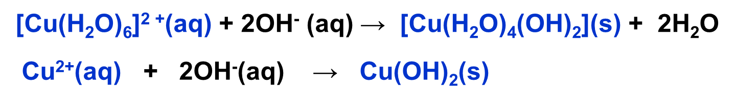 | 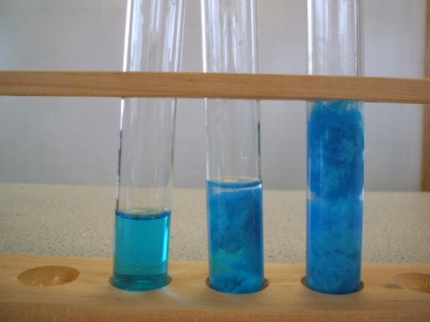

The same sequence of reactions occurs with other metal ions.

Iron(II) aqua-ion

[Fe(H₂O)₆]²⁺(aq) + 2OH⁻(aq ) [Fe(H₂O)₄(OH)₂](s) + 2H₂O(l)
green soln green ppt

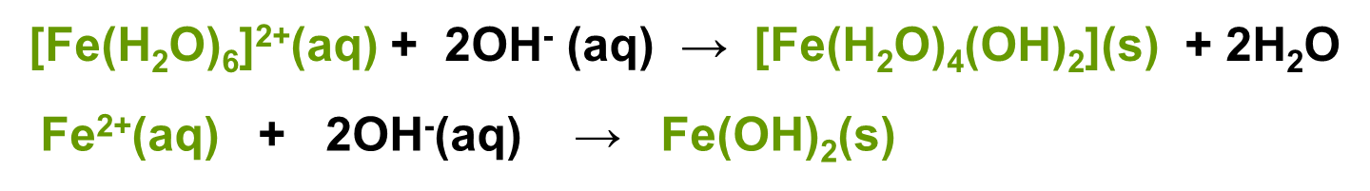 | 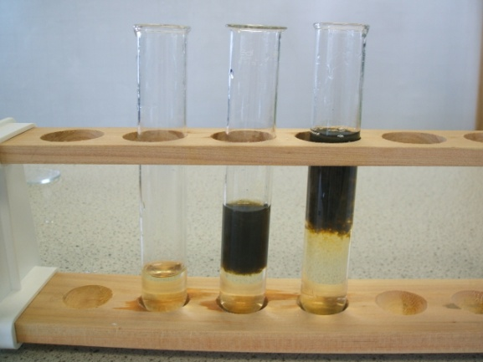

The green precipitate of iron(II)hydroxide can be oxidised by oxygen in the air to give the brown precipitate of iron(III) hydroxide.

[Fe(H₂O)₄(OH)₂](s) → [Fe(H₂O)₃(OH)₃](s) + e⁻

Fe²⁺ → Fe³⁺ + e⁻

Cobalt(II) aqua-ion

[Co(H₂O)₆]²⁺(aq) + 2OH⁻(aq) [Co(H₂O)₄(OH)₂](s) + 2H₂O(l)
pink soln blue ppt

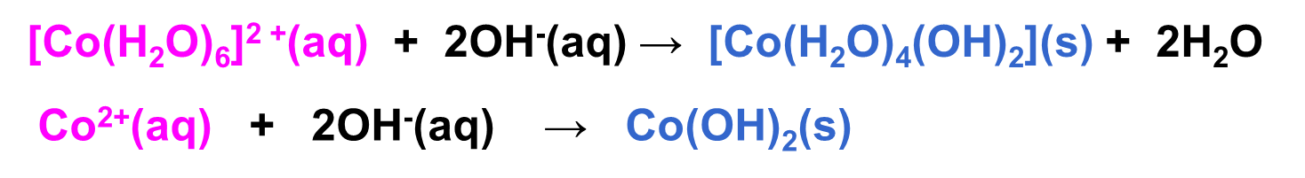 | 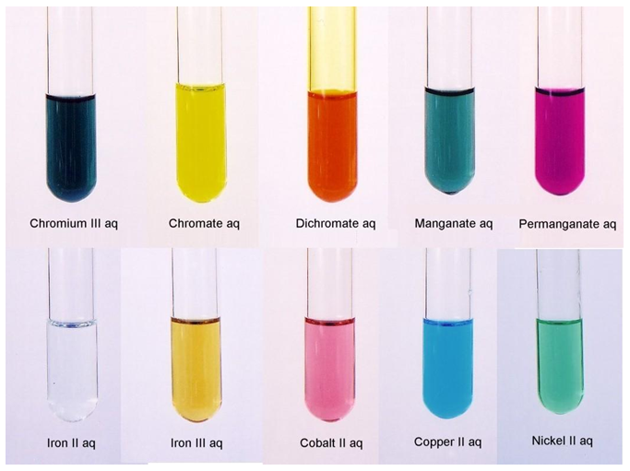  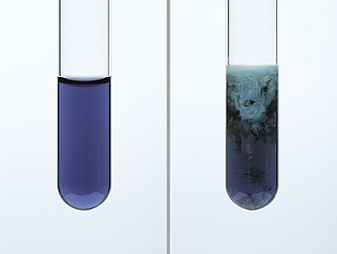

Iron(III) aqua-ion

[Fe(H₂O)₆]³⁺(aq) + 3OH⁻(aq) [Fe(H₂O)₃(OH)₃](s) + 3H₂O(l)
purple soln brown ppt
(appears yellow-brown due to hydrolysis) (may appear orange-brown)

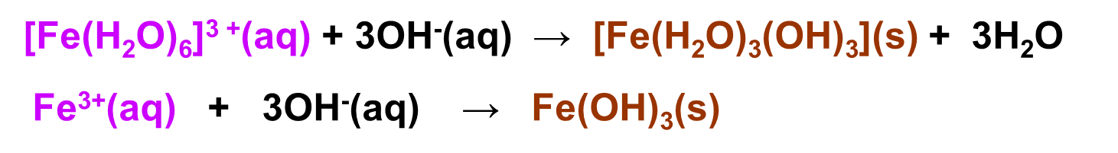 | 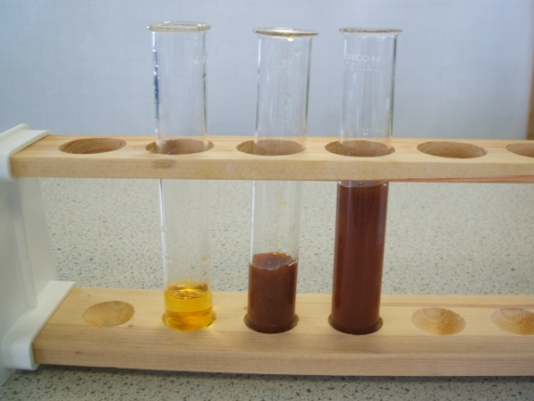

Aluminium(III) aqua-ion

[Al(H₂O)₆]³⁺(aq) + 3OH⁻(aq) [Al(H₂O)₃(OH)₃](s) + 3H₂O(l)
colourless soln white ppt

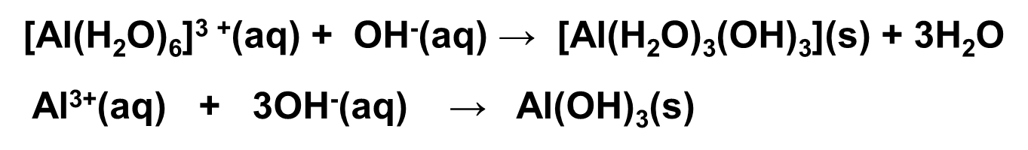 | 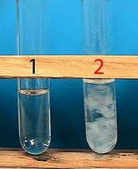

Aqueous ammonia – adding ammonia solution always gives a precipitate of the metal hydroxide initially.

If excess is added ammonia acts as a ligand and substitution reactions occur with some of these metal complexes resulting in a solution being produced. See Topic 3.2.5.

The same sequence of reactions takes place with ammonia solution as with sodium hydroxide. When ammonia dissolves in water it can accept protons from the water molecules forming ammonium ions and hydroxide ligands.

NH₃(g) + H₂O(l) → NH₄⁺(aq) + OH⁻(aq)

The following reaction with the aqua ions can then take place:

[M(H₂O)₆]²⁺(aq) + 2NH₃(aq) → [M(H₂O)₄(OH)₂](s) + 2NH₄⁺(aq)

[M(H₂O)₆]³⁺(aq) + 3NH₃(aq) → [M(H₂O)₃(OH)₃](s) + 3NH₄⁺(aq)

Reactions and colours are the same as with sodium hydroxide:

Demo: Reactions of aqua ion with bases – addition of NH₃(aq)
Copper(II) aqua-ion
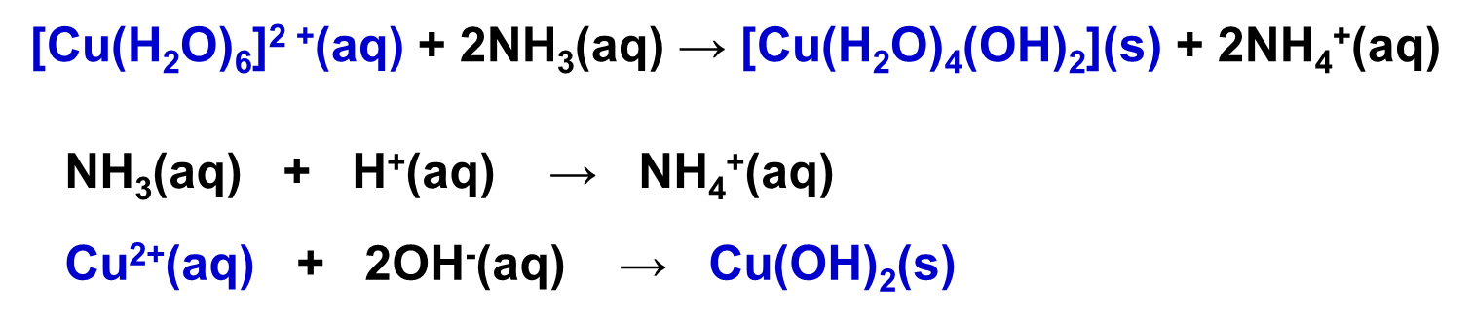

Iron(II) aqua-ion
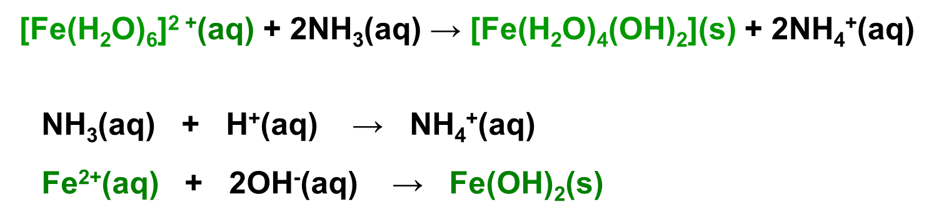

Cobalt(II) aqua-ion
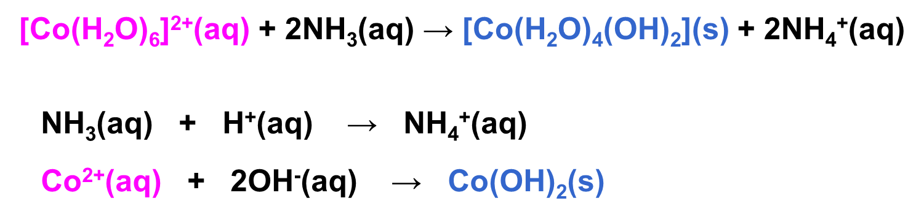

Iron(III) aqua-ion
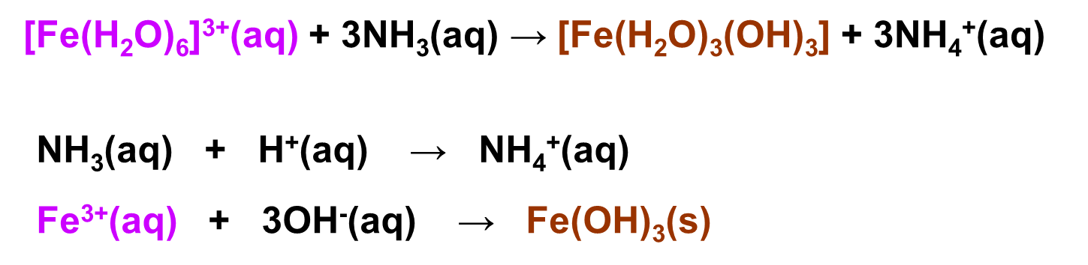

Aluminium(III) aqua-ion
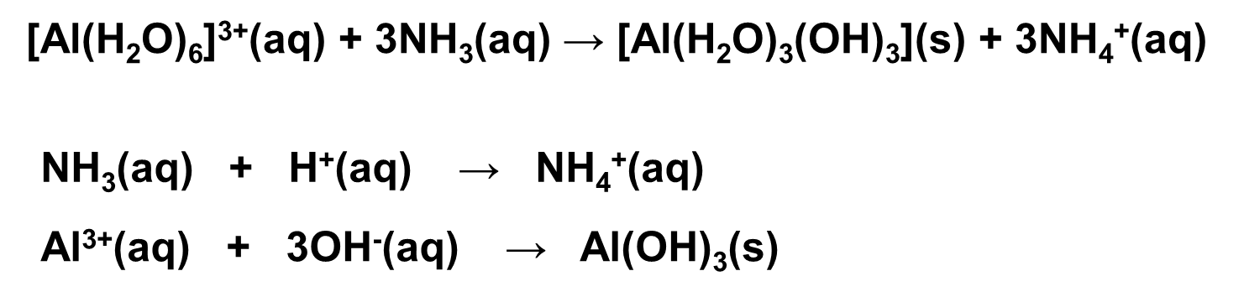

Starter: 14.2 – Brønsted-Lowry or Lewis base?

Carbonate ions – addition of sodium carbonate solution always results in a precipitate of the metal(II) carbonate or the metal(III) hydroxide with carbon dioxide.

Metal(II) ions are insufficiently acidic to displace carbonic acid from carbonates, so the ions form insoluble metal(II) carbonates, MCO₃(s). No carbon dioxide is produced.

The following reaction occurs:

[M(H₂O)₆]²⁺(aq) + CO₃²⁻(aq) → MCO₃(s) + 6H₂O(l)

The following reactions occur:

Demo: Reactions of aqua metal(II) ions with bases – addition of Na₂CO₃(aq)

Copper(II) aqua-ion  [Cu(H₂O)₆]²⁺(aq) + CO₃²⁻(aq) → CuCO₃(s) + 6H₂O(l)  blue soln blue-green ppt | 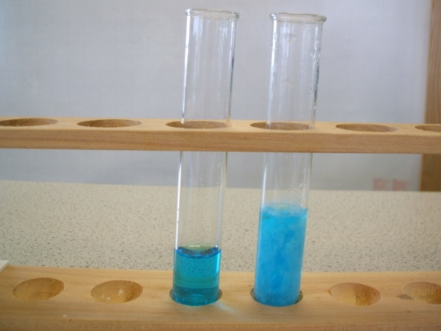

Iron(II) aqua-ion  [Fe(H₂O)₆]²⁺(aq) + CO₃²⁻(aq) → FeCO₃(s) + 6H₂O(l)  green soln green ppt | 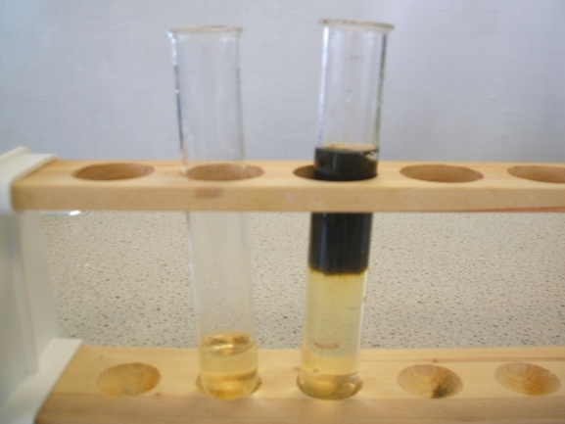

Cobalt(II) aqua-ion  [Co(H₂O)₆]²⁺(aq) + CO₃²⁻(aq) → CoCO₃(s) + 6H₂O(l)  pink soln purple ppt |  | 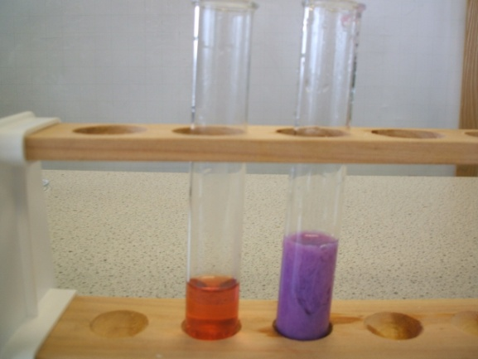

Metal(III) ion complexes are more acidic and so carbonate ions react with them to form the hydrogencarbonate ion then carbonic acid (H₂CO₃), which rapidly becomes carbon dioxide and water. Effervescence is best observed with solid Na₂CO₃.

CO₃²⁻ + H₃O⁺ HCO₃⁻ + H₂O

HCO₃⁻ + H₃O⁺ CO₂ + 2H₂O

The following reaction occurs resulting in effervescence of carbon dioxide and precipitation of the metal(III) hydroxide.

2[M(H₂O)₆]³⁺(aq) + 3CO₃²⁻(aq) → 2[M(H₂O)₃(OH)₃](s) + 3CO₂(g) + 3H₂O(l)
As a result metal(III) carbonates can’t be prepared in aqueous solution and so they don’t exist, hydroxides form each time. For example, Al₂(CO₃)₃, Fe₂(CO₃)₃, Cr₂(CO₃)₃ can’t be prepared in aqueous solutions and so are unknown.

The following reactions occur and effervescence is seen.

Demo: Reactions of aqua metal(III) ions with bases – addition of Na₂CO₃(aq) & Na₂CO₃(s)
Iron(III) aqua-ion

2[Fe(H₂O)₆]³⁺(aq) + 3CO₃²⁻(aq) 2[Fe(H₂O)₃(OH)₃](s) + 3CO₂(g) + 3H₂O(l)
purple soln brown ppt
(appears yellow-brown due to hydrolysis) (may appear orange-brown)
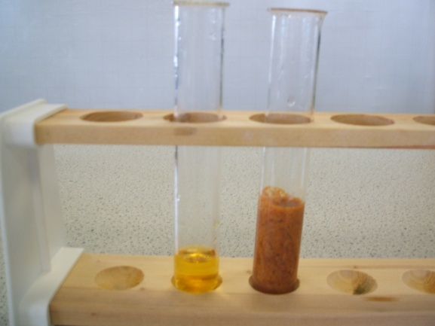

Aluminium(III) aqua-ion

2[Al(H₂O)₆]³⁺(aq) + 3CO₃²⁻(aq) 2[Al(H₂O)₃(OH)₃](s) + 3CO₂(g) + 3H₂O(l)
colourless soln white ppt

Starter: 14.1 – Acid-base chemistry

Starter: 14.4 – Inference from aqueous tests

Amphoteric character
Definition
Amphoteric means showing both acidic and basic properties.

An amphoteric substance will react with both an acid and a base.

The general scheme for metal(III) ions is:
[M(H₂O)₆]³⁺(aq) |  | [M(H₂O)₃(OH)₃](s) |  | [M(H₂O)₂(OH)₄]⁻(aq)
in acidic solution |  | in neutral solution |  | in alkaline solution

Demo: Amphoteric behaviour aluminium chloride solution with HCl & NaOH
Example CGP161
Aluminium hydroxide is amphoteric. It can act as a Brønsted-Lowry acid and donates hydrogen ions.

[Al(H₂O)₃(OH)₃](s) + OH⁻(aq) [Al (H₂O)₂(OH)₄]⁻(aq) + H₂O(l)

It can also act as a Brønsted-Lowry base accepting hydrogen ions.

[Al(H₂O)₃(OH)₃] (s) + 3H⁺(aq) [Al(H₂O)₆]³⁺(aq)

Both reactions are summarised:
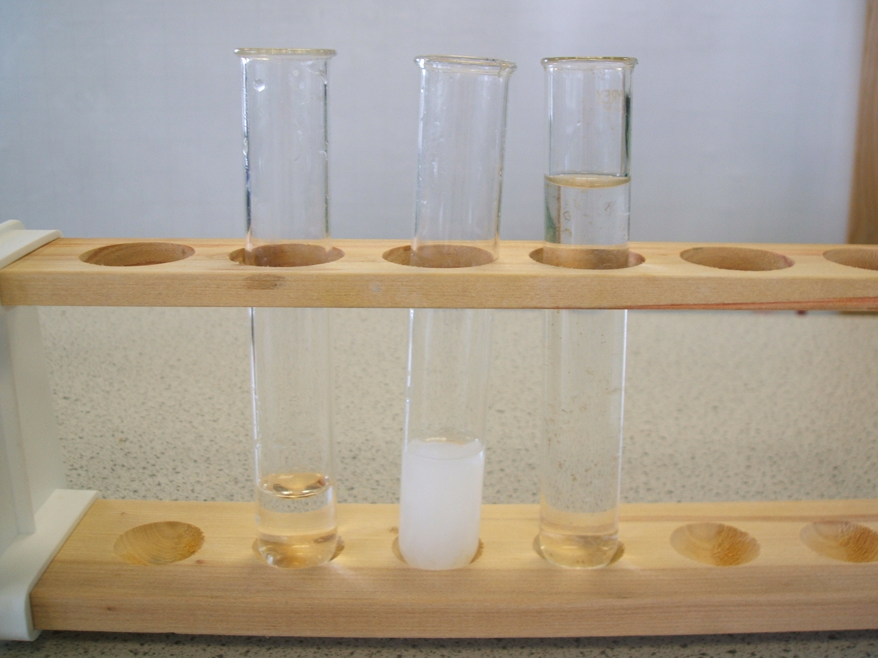

Summary

Sheet: AQA Reactions of metal ions in aqueous solution

Colours of the transition metal salts in water

Mostly due to the colours of the aqua ions.

Complex | Colour
[Cu(H₂O)₆]²⁺(aq) | blue  solution
[Co(H₂O)₆]²⁺(aq) | pink  solution
[Fe(H₂O)₆]²⁺(aq) | green solution
[Fe(H₂O)₆]³⁺(aq) | purple solution* | pale brown  (straw)
[Al(H₂O)₆]³⁺(aq) | colourless  solution
*Hydrolysis occurs and gives a different coloured solution

Metal(II) ions reactions

[M(H₂O)₆]²⁺(aq)
OH⁻ / NH₃
H⁺
[Cu(H₂O)₆]²⁺(aq)
[Co(H₂O)₆]²⁺(aq)
[Fe(H₂O)₆]²⁺(aq)
[Cu(H₂O)₂(NH₃)₄]²⁺(aq)
[Co(NH₃)₆]²⁺(aq)
Cl⁻
CO₃²⁻
CuCO₃ (s)
CoCO₃ (s)
FeCO₃ (s)
XS NH₃
ligand
substitution
acid/base
hydrolysis
precipitation
[M(H₂O)₄(OH)₂](s)
[Cu(H₂O)₆(OH)₂](s)
[Co(H₂O)₆ (OH)₂](s)
[Fe(H₂O)₆ (OH)₂](s)
XS OH⁻
no reaction
[MCO₃](s)
[CuCl₄]²⁻ (aq)
[CoCl₄]²⁻ (aq)
[MCl₄]²⁻(aq)

Metal(III) ions reactions

Sheet: Summary of aqueous metal ion reactions

Tests to identify metal ions

Test tube reactions provide a qualitative way of working out the identity of unknown metal ions in solution. By adding different reagents to separate samples of a metal ions solution will produce coloured solutions or precipitates. Recording these observations allows the metal ions to be identified.

Describing observations- be specific for colour and state:
- Colour
- States e.g. precipitate (ppt) or solution (aq)
- Describe change e.g. re-dissolving or no visible change or precipitate remains.

Required practical 11: Carry out simple test tube reactions to identify the metal ions in aqueous solutions

Sheet: Reactions of inorganic complex ions exam questions

Application: CGP164 PQ1

Fact recall: CGP164 Q1-5

Exam questions: Oxford p130-131 Q1-4

