3.9.2 Innovation
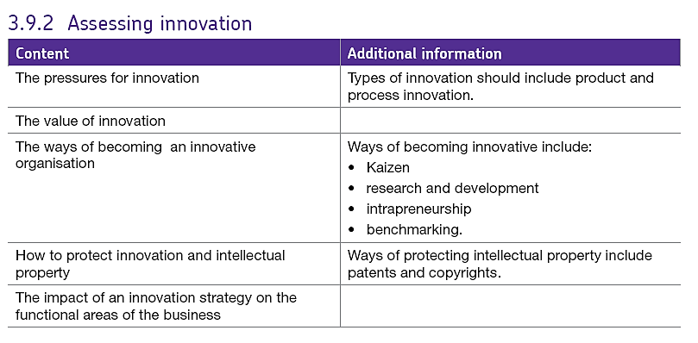
Innovation is about putting a new idea or approach into action. Innovation is commonly described as 'the commercially successful exploitation of ideas'.
Successful innovation is mainly about creating or adding value. It does so either by either improving existing goods, processes or services (process innovation), or by developing goods, processes or services of value that have not existed previously (product innovation)
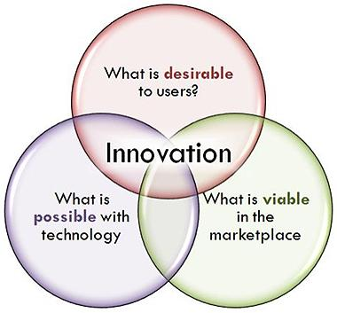
However, both kinds of innovation require a business to:
- Challenge the status quo in a market
- Have a deep understanding of customer needs
- Develop imaginative and novel solutions to how those needs might be met
Innovation can come in many forms:
- Improving or replacing business processes to increase efficiency and productivity, or to enable the business to extend the range or quality of existing products and/or services
- Developing entirely new and improved products and services - often to meet rapidly changing customer or consumer demands or needs
- Adding value to existing products, services or markets to differentiate the business from its competitors and increase the perceived value to the customers and markets
Whatever form it takes, innovation is a creative process. The ideas may come from:
Inside the business – e.g. from employees, in-house designers, sales staff
Outside the business, e.g. suppliers, customers, media reports, market research insights or from contacts at local universities or other research organisations.
Successful innovation comes from filtering those ideas, identifying those that the business will focus on and applying resources to exploit them.
The benefits to business of innovation can be significant, but so too can be the risks!

BENEFITS OF INNOVATION
Improved productivity & reduced costs
A lot of process innovation is about reducing unit costs. This might be achieved by improving the production capacity and/or flexibility of the business – to enable it to exploit economies of scale
Better quality
By definition, better quality products and services are more likely to meet customer needs. Assuming that they are effectively marketed, that should result in higher sales and profits
Building a product range
A business with a single product or limited product range would almost certainly benefit from innovation. A broader product range provides an opportunity for higher sales and profits and also reduces the risk for shareholders
To handle legal and environmental issues
Innovation might enable the business to reduce it carbon emissions, produce less waste or perhaps comply with changing product legislation. Changes in laws often force business to innovate when they might not otherwise do so
More added value
Effective innovation is a great way to establish a unique selling proposition ("USP") for a product – something which the customer is prepared to pay more for and which helps a business differentiate itself from competitors
Improved staff retention, motivation and easier recruitment
Not an obvious benefit, but often significant. Potential good quality recruits are often drawn to a business with a reputation for innovation. Innovative businesses have a reputation for being inspiring places in which to work.

RISKS OF INNOVATION
A strategy of investing in R&D and innovation can bring significant rewards, but it is not without risk. Amongst the potential pitfalls are:
Competition
An innovation only confers a competitive advantage if competitors are not able to replicate it in their own businesses. Whilst patents provide some legal protection, the reality is that many innovative products and processes are hard to protect. One danger is that one research-driven, innovative company makes the initial investment and takes all the risk – only to find it is competing with many me-too competitors riding on the coat-tails of the innovation.
Uncertain commercial returns
Much research is speculative and there is no guarantee of future revenues and profits. The longer the development timescale the greater the risk that research is overtaken by competitors too.
Availability of finance
Like other business activities, R&D has to compete for scarce cash. Given the risks involved, R&D demands a high required rate of return. That means that for businesses that have limited cash resources, the opportunity cost of investing in R&D can be very high.
Intrapreneurship involves people within a business creating or discovering new business opportunities, which leads to the creation of new parts of the business or even new businesses. An intrapreneur involves people within a business taking risks in an effort to solve a given problem.

Two famous examples of products that were the result of intrapreneurial activity are:
Gmail (Google)

Employees at Google are allowed time for personal projects. Some of Google’s best projects come out of their 20 percent time policy. One of these was Gmail, launched on 1 April 2004.

PlayStation (Sony)
Ken Kutaragi, a relatively junior Sony Employee, spent hours tinkering with his daughters Nintendo to make it more powerful and user friendly. What came from his work turned into one of the world’s most recognisable brands - the Sony PlayStation

Potential business benefits of intrapreneurship
In addition to identifying and executing new business opportunities, intrapreneurs can help drive innovation within businesses. In a similar role to that of entrepreneurs, intrapreneurs seek to provide solutions to problems, e.g. low productivity, excess waste, poor quality.

What can a business do to encourage intrapreneurship?
- Look out for – and encourage - entrepreneurial activity
- Give employees ownership of projects / train employees in innovation
- Make risk-taking and failure acceptable
- Give employees time outside the confines of their job description
- Encourage networking & collaboration
- Reward entrepreneurial thinking and activity

Some reasons why large businesses are not entrepreneurial
- Complacency / arrogance
- Bureaucracy (stifling initiative)
- Reward systems do not provide an incentive to innovate
- Short-termism (the idea of discouraging long-term thinking or risk-taking)

The Benchmarking Process
Benchmarking involves looking outward (outside a particular business, organisation, industry, region or country) to examine how others achieve their performance levels, and to understand the processes they use.
The objective of benchmarking is to understand and evaluate the current position of a business or organisation in relation to best practice and to identify areas and means of performance improvement.
In this way, benchmarking helps explain the processes behind excellent performance. When lessons learned from a benchmarking exercise are applied appropriately, they facilitate improved performance in critical functions within an organisation or in key areas of the business.
The application of benchmarking involves four key steps:
- Understand in detail existing business processes
- Analyse the business processes of others
- Compare own business performance with that of others analysed
- Implement the steps necessary to close the performance gap
Benchmarking should not be considered a one-off exercise. To be effective, it must become an integral part of an ongoing improvement process, the goal being to abreast of ever-improving best practice.

Why is the rate of innovation important in determining competitiveness?
There is a clear causal connection between the pace of product and process innovation within an economy and (over time) the growing prosperity of a country. Innovation drives progress and determines productivity growth which in turn drives prosperity.
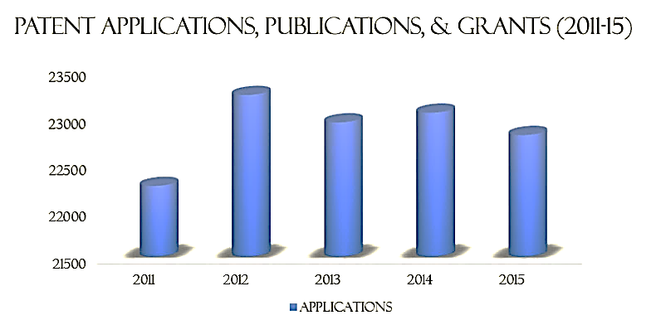

UK data…

Innovation requires strong human capital, institutions and incentives and can be encouraged in a number of different ways:
- Research and Development (R&D) Tax Credits (used in Australia & South Korea)
- Patent Box Initiative – 10% corporation tax (a UK Policy)
- Public R&D and more Funding for Higher Education
- Highly skilled migrants policy e.g. skilled coders
- Nurturing an entrepreneurial culture
- Increasing the intensity of competition within markets by deregulating / lowering the entry/exit costs

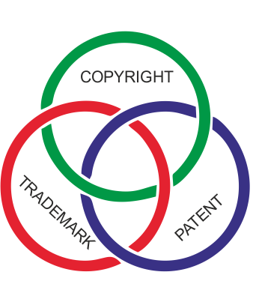
How to protect innovation and intellectual property
Intellectual property includes the businesses name, logo, designs and inventions. All businesses have some form of intellectual property which is likely to be a valuable asset that can:
- Set the company apart from competitors
- Be sold or licensed forming an important source of income
- Offer customers something new and different
- Form an essential part of the marketing or branding
Intellectual property tends to arise from innovation. Innovation is more likely to benefit an organisation if competitors cannot copy the ideas generated from the innovative process. Protection of these ideas can be generated primarily through patents, copyrights and trademarks and we will look at each of these in turn.

Patents

If an individual invents a new process, piece of equipment, component or product, he or she can apply a patent in order to prevent others from copying the invention and then making, selling, importing or using it without permission. To register a patent, the inventor must provide full drawings and plans of the invention and send to the UK Intellectual Property Office (UK IPO).
They must be able to demonstrate the original features and promise that the ideas are their own. The Copyright, Designs and Patents Act 1988 gives patent holders the monopoly right to use, make, license or sell the invention for up to 20 years after it has been registered. The following must be considered in relation to patenting an idea:
Holding the patent allows the product or process to be developed further by the business. They can reap revenue and profits without the fear that it will be copied.
Having a patent means that the invention becomes the property of the inventor. It can then be bought, sold, rented or licensed out.
Purchasing a small business with an existing patent can be a good proposition.
A patent application can be a complex and lengthy process. The initial cost of filing an application for a patent is low but the process takes time and legal services are required if any aspect of the patent is disputed. Also if a business is selling its product abroad then the cost will be much higher because patents must be sought in a number of other countries. Once granted, a fee must be paid each year after the fifth year and up to the twentieth year in order to renew the patent.

Copyrights

If the business creates or employs someone to create an original piece of literary, dramatic, musical or artistic work, it automatically holds the copyright on that work. The material could range from books, information, leaflets and films to computer programs and sound recordings. The material cannot be copied without permission from the owner of the copyright. The law allows the owner of the copyright to decide whether it can be copied and adapted and allows them to charge a royalty or licence fee.
Copyright protection for literary, dramatic, musical and artistic work, including sound recordings, lasts for up to 70 years after the death of the creator. Unlike patents, there is no requirement to register an author’s copyright. The law on copyright is governed by the Copyright, Designs and Patents Act 1988.

Trademarks

These can be a powerful marketing tool, helping customers to recognise the products of the business and distinguish them from the products of other businesses. In order to prevent rivals from copying a symbol or style of wording, the trademark must be registered at the UK Intellectual Property Office (UK-IPO). Once the trade mark has been registered, the company has exclusive rights to its use.

The impact of an innovation strategy on the functional areas of the business

Innovation is organised in different ways in different businesses. In general, process innovation is the responsibility of the operations department as it is their job to produce goods and service in the most cost effective way possible. Product innovation may also arise from the operations department by identifying new product opportunities (product-led innovation) or it may arise from the marketing department’s understanding of the changes in tastes and preferences (market led innovation). The innovative strategy itself is likely to be led and encouraged by the senior managers in the business. Whatever form it takes, innovation will impact on other functional areas.
Finance
Innovation tends to be an expensive undertaking. For this reason, the finance department must be made aware of any financial requirements and plan accordingly. The finance department will carry out investment appraisal. If an innovation or an R&D project is approved by the finance department, cash flow must then be monitored and budgets set. In some cases, it can take several years before any cash inflow results from R&D so the business must ensure it has the necessary financial resources to cover this.
Marketing
In the case of product innovation, the marketing department will be affected in two ways. First, market research will be needed to establish whether the project is likely to appeal to customers. Second, innovation is linked to the product life cycle, so the operations and marketing functions must co-operate. The two functional areas need to work together to plan the launching of new products. They also need to establish the timing of extension strategies to extend the life of existing products. R&D can help to modify products in the maturity stage to prevent sales from falling.
Human resources
Typically the role of HR is to recruit and train suitable employees and then ensure that the business retains their services. Successful innovation can also lead to additional training and recruitment. In their workforce planning, HR must ensure that the impact of innovation and R&D are taken into account. Recently, greater emphasis has been placed on restructuring the organisation, instilling a corporate culture that supports innovation and creativity. These changes require a much greater involvement of HR. If a business is using intrapreneurship to encourage innovation, then the HR department must ensure that right people are recruited and supported to make this happen. Appropriate reward systems will also need to be devised which encouraged collaborative work and creative thinking.

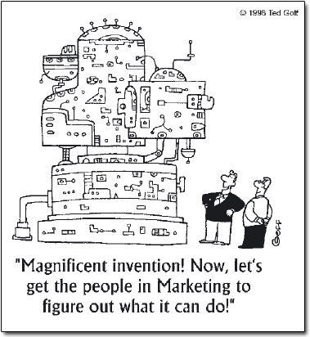
Operations
In most cases, the operations department will be the department most affected by the business’s innovation strategy. Product led innovation will be planned by the operations as will R&D. Process innovation will also be centred on the operations department but they will have to work closely with the finance department to ensure that the financial resources are available to carry out the plans.
Kaizen and benchmarking are also usually led by the operations department and this department will also be involved in applying for any legal protection of ideas such as patents.

