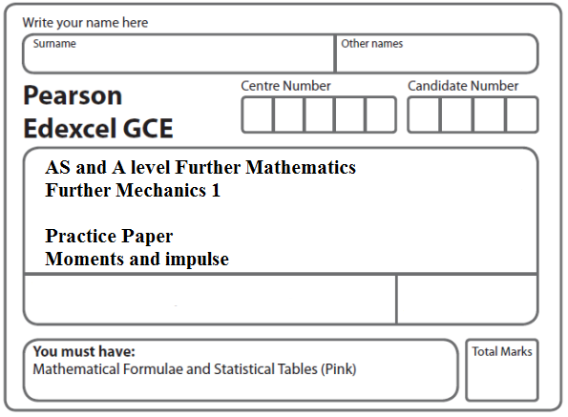

Instructions
- Use black ink or ball-point pen.
- If pencil is used for diagrams/sketches/graphs it must be dark (HB or B).
- Fill in the boxes at the top of this page with your name, centre number and candidate number.
- Answer all the questions and ensure that your answers to parts of questions are clearly labelled.
- Answer the questions in the spaces provided – there may be more space than you need.
- You should show sufficient working to make your methods clear. Answers without working may not gain full credit.
- Inexact answers should be given to three significant figures unless otherwise stated.
Information
- A booklet ‘Mathematical Formulae and Statistical Tables’ is provided.
- There are 8 questions in this question paper. The total mark for this paper is 50.
- The marks for each question are shown in brackets – use this as a guide as to how much time to spend on each question.
- Calculators must not be used for questions marked with a * sign.
Advice
• Read each question carefully before you start to answer it.
• Try to answer every question.
• Check your answers if you have time at the end.
• If you change your mind about an answer, cross it out and put your new answer and any working underneath.

1. Particle P of mass m and particle Q of mass km are moving in opposite directions on a smooth horizontal plane when they collide directly. Immediately before the collision the speed of P is 5u and the speed of Q is u. Immediately after the collision the speed of each particle is halved and the direction of motion of each particle is reversed.
Find
(a) the value of k,
(3)
(b) the magnitude of the impulse exerted on P by Q in the collision.
(3)
(Total 6 marks)
___________________________________________________________________________

2. Two particles A and B, of mass 2 kg and 3 kg respectively, are moving towards each other in opposite directions along the same straight line on a smooth horizontal surface. The particles collide directly. Immediately before the collision the speed of A is 5 m s^{–1} and the speed of B is 6 m s^{–1}. The magnitude of the impulse exerted on B by A is 14 N s.
Find
(a) the speed of A immediately after the collision,
(3)
(b) the speed of B immediately after the collision.
(3)
(Total 6 marks)
___________________________________________________________________________

3. Particle P has mass 3 kg and particle Q has mass m kg. The particles are moving in opposite directions along a smooth horizontal plane when they collide directly. Immediately before the collision, the speed of P is 4 m s^{–1} and the speed of Q is 3 m s^{–1}. In the collision the direction of motion of P is unchanged and the direction of motion of Q is reversed. Immediately after the collision, the speed of P is 1 m s^{–1} and the speed of Q is 1.5 m s^{–1}.
(a) Find the magnitude of the impulse exerted on P in the collision.
(3)
(b) Find the value of m.
(3)
(Total 6 marks)
___________________________________________________________________________
4. A railway truck P, of mass m kg, is moving along a straight horizontal track with speed 15 m s^{–1}. Truck P collides with a truck Q of mass 3000 kg, which is at rest on the same track. Immediately after the collision the speed of P is 3 m s^{–1} and the speed of Q is 9 m s^{–1}. The direction of motion of P is reversed by the collision.
Modelling the trucks as particles, find
(a) the magnitude of the impulse exerted by P on Q,
(2)
(b) the value of m.
(3)
(Total 5 marks)
___________________________________________________________________________

5. Two particles B and C have mass m kg and 3 kg respectively. They are moving towards each other in opposite directions on a smooth horizontal table. The two particles collide directly. Immediately before the collision, the speed of B is 4 m s⁻¹ and the speed of C is 2 m s⁻¹. In the collision the direction of motion of C is reversed and the direction of motion of B is unchanged. Immediately after the collision, the speed of B is 1 m s⁻¹ and the speed of C is 3 m s⁻¹.
Find
(a) the value of m,
(3)
(b) the magnitude of the impulse received by C.
(2)
(Total 5 marks)
___________________________________________________________________________

6. Particle P has mass 3 kg and particle Q has mass 2 kg. The particles are moving in opposite directions on a smooth horizontal plane when they collide directly. Immediately before the collision, P has speed 3 m s^{–1} and Q has speed 2 m s^{–1}. Immediately after the collision, both particles move in the same direction and the difference in their speeds is 1 m s^{–1}.
(a) Find the speed of each particle after the collision.
(5)
(b) Find the magnitude of the impulse exerted on P by Q.
(3)
(Total 8 marks)
___________________________________________________________________________

7. Two particles, P and Q, have masses 2m and 3m respectively. They are moving towards
each other in opposite directions on a smooth horizontal plane when they collide directly.
Immediately before they collide the speed of P is 4u and the speed of Q is 3u. As a result
of the collision, Q has its direction of motion reversed and is moving with speed u.
(a) Find the speed of P immediately after the collision.
(3)
(b) State whether or not the direction of motion of P has been reversed by the collision.
(1)
(c) Find the magnitude of the impulse exerted on P by Q in the collision.
(3)
(Total 7 marks)
___________________________________________________________________________

8. A particle P of mass 0.4 kg is moving on rough horizontal ground when it hits a fixed vertical plane wall. Immediately before hitting the wall, P is moving with speed 4 m s^{–1} in a direction perpendicular to the wall. The particle rebounds from the wall and comes to rest at a distance of 5 m from the wall. The coefficient of friction between P and the ground is .
Find the magnitude of the impulse exerted on P by the wall.
(7)
(Total 7 marks)

TOTAL FOR PAPER: 50 MARKS

