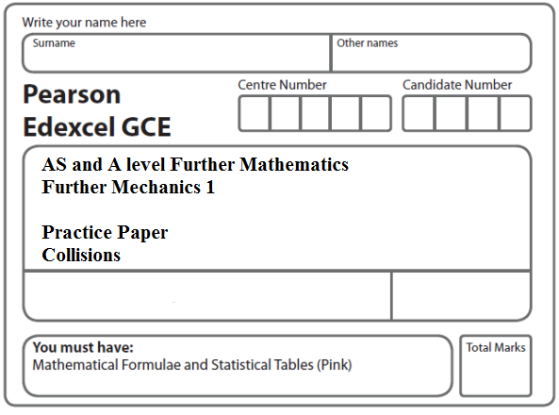

Instructions
- Use black ink or ball-point pen.
- If pencil is used for diagrams/sketches/graphs it must be dark (HB or B).
- Fill in the boxes at the top of this page with your name, centre number and candidate number.
- Answer all the questions and ensure that your answers to parts of questions are clearly labelled.
- Answer the questions in the spaces provided – there may be more space than you need.
- You should show sufficient working to make your methods clear. Answers without working may not gain full credit.
- Inexact answers should be given to three significant figures unless otherwise stated.
Information
- A booklet ‘Mathematical Formulae and Statistical Tables’ is provided.
- There are 8 questions in this question paper. The total mark for this paper is 100.
- The marks for each question are shown in brackets – use this as a guide as to how much time to spend on each question.
- Calculators must not be used for questions marked with a * sign.
Advice
• Read each question carefully before you start to answer it.
• Try to answer every question.
• Check your answers if you have time at the end.
• If you change your mind about an answer, cross it out and put your new answer and any working underneath.
1. A particle P of mass 3m is moving with speed 2u in a straight line on a smooth horizontal plane. The particle P collides directly with a particle Q of mass 4m moving on the plane with speed u in the opposite direction to P. The coefficient of restitution between P and Q is e.
(a) Find the speed of Q immediately after the collision.
(6)
Given that the direction of motion of P is reversed by the collision,
(b) find the range of possible values of e.
(5)
(Total 11 marks)
___________________________________________________________________________

2. A particle P of mass m is moving in a straight line on a smooth horizontal surface with speed 4u. The particle P collides directly with a particle Q of mass 3m which is at rest on the surface. The coefficient of restitution between P and Q is e. The direction of motion of P is reversed by the collision.
Show that e > $\frac{1}{3}$.
(Total 8 marks)
___________________________________________________________________________

3. A particle of mass m kg lies on a smooth horizontal surface. Initially the particle is at rest at a point O midway between a pair of fixed parallel vertical walls. The walls are 2 m apart. At time t = 0 the particle is projected from O with speed u m s^{–1} in a direction perpendicular to the walls. The coefficient of restitution between the particle and each wall is . The magnitude of the impulse on the particle due to the first impact with a wall is λmu N s.
(a) Find the value of λ.
(3)
The particle returns to O, having bounced off each wall once, at time t = 3 seconds.
(b) Find the value of u.
(6)
(Total 9 marks)
___________________________________________________________________________

4.
Figure 1
A particle P of mass 2 kg is released from rest at a point A on a rough inclined plane and slides down a line of greatest slope. The plane is inclined at 30° to the horizontal. The point B is 5 m from A on the line of greatest slope through A, as shown in Figure 1.
(a) Find the potential energy lost by P as it moves from A to B.
(2)
The speed of P as it reaches B is 4 m s^{–1}.
(b) (i) Use the work-energy principle to find the magnitude of the constant frictional force acting on P as it moves from A to B.
(ii) Find the coefficient of friction between P and the plane.
(7)
The particle P is now placed at A and projected down the plane towards B with speed 3 m s^{–1}. Given that the frictional force remains constant,
(c) find the speed of P as it reaches B.
(4)
(Total 13 marks)
___________________________________________________________________________
5. Three identical particles, A, B and C, lie at rest in a straight line on a smooth horizontal table with B between A and C. The mass of each particle is m. Particle A is projected towards B with speed u and collides directly with B. The coefficient of restitution between each pair of particles is $\frac{2}{3}$.
(a) Find, in terms of u,
(i) the speed of A after this collision,
(ii) the speed of B after this collision.
(7)
(b) Show that the kinetic energy lost in this collision is $\frac{5}{\text{36}}$mu².
(4)
After the collision between A and B, particle B collides directly with C.
(c) Find, in terms of u, the speed of C immediately after this collision between B and C.
(4)
(Total 15 marks)
___________________________________________________________________________

6. Three particles P, Q and R lie at rest in a straight line on a smooth horizontal table with Q between P and R. The particles P, Q and R have masses 2m, 3m and 4m respectively. Particle P is projected towards Q with speed u and collides directly with it. The coefficient of restitution between each pair of particles is e.
(a) Show that the speed of Q immediately after the collision with P is (1 + e)u.
(6)
After the collision between P and Q there is a direct collision between Q and R.
Given that e = , find
(b) (i) the speed of Q after this collision,
(ii) the speed of R after this collision.
(6)
Immediately after the collision between Q and R, the rate of increase of the distance between P and R is V.
(c) Find V in terms of u.
(3)
(Total 15 marks)
___________________________________________________________________________

7. A particle A of mass m is moving with speed u on a smooth horizontal floor when it collides directly with another particle B, of mass 3m, which is at rest on the floor. The coefficient of restitution between the particles is e. The direction of motion of A is reversed by the collision.
(a) Find, in terms of e and u,
(i) the speed of A immediately after the collision,
(ii) the speed of B immediately after the collision.
(7)
After being struck by A the particle B collides directly with another particle C, of mass 4m, which is at rest on the floor. The coefficient of restitution between B and C is 2e. Given that the direction of motion of B is reversed by this collision,
(b) find the range of possible values of e,
(6)
(c) determine whether there will be a second collision between A and B.
(3)
(Total 16 marks)
___________________________________________________________________________

8. Three identical particles P, Q and R, each of mass m, lie in a straight line on a smooth horizontal plane with Q between P and R. Particles P and Q are projected directly towards each other with speeds 4u and 2u respectively, and at the same time particle R is projected along the line away from Q with speed 3u. The coefficient of restitution between each pair of particles is e. After the collision between P and Q there is a collision between Q and R.
(a) Show that e > $\frac{2}{3}$.
(7)
It is given that e = $\frac{3}{4}$.
(b) Show that there will not be a further collision between P and Q.
(6)
(Total 13 marks)

TOTAL FOR PAPER: 100 MARKS

