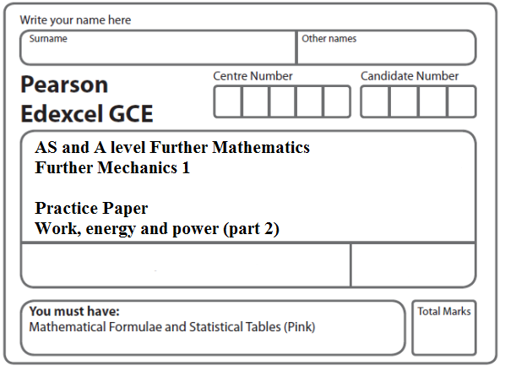

Instructions
- Use black ink or ball-point pen.
- If pencil is used for diagrams/sketches/graphs it must be dark (HB or B).
- Fill in the boxes at the top of this page with your name, centre number and candidate number.
- Answer all the questions and ensure that your answers to parts of questions are clearly labelled.
- Answer the questions in the spaces provided – there may be more space than you need.
- You should show sufficient working to make your methods clear. Answers without working may not gain full credit.
- Inexact answers should be given to three significant figures unless otherwise stated.
Information
- A booklet ‘Mathematical Formulae and Statistical Tables’ is provided.
- There are 7 questions in this question paper. The total mark for this paper is 80.
- The marks for each question are shown in brackets – use this as a guide as to how much time to spend on each question.
- Calculators must not be used for questions marked with a * sign.
Advice
• Read each question carefully before you start to answer it.
• Try to answer every question.
• Check your answers if you have time at the end.
• If you change your mind about an answer, cross it out and put your new answer and any working underneath.
1.

Figure 2

A particle P of mass 10 kg is projected from a point A up a line of greatest slope AB of a fixed rough plane. The plane is inclined at angle α to the horizontal, where tan α = $\frac{5}{\text{12}}$ and AB = 6.5 m, as shown in Figure 2. The coefficient of friction between P and the plane is μ. The work done against friction as P moves from A to B is 245 J.
(a) Find the value of μ.
(5)
The particle is projected from A with speed 11.5 m s^{–1}. By using the work-energy principle,
(b) find the speed of the particle as it passes through B.
(4)
(Total 9 marks)
___________________________________________________________________________

2.
Figure 2

A particle P of mass 2 kg is released from rest at a point A on a rough inclined plane and slides down a line of greatest slope. The plane is inclined at 30° to the horizontal. The point B is 5 m from A on the line of greatest slope through A, as shown in Figure 2.
(a) Find the potential energy lost by P as it moves from A to B.
(2)
The speed of P as it reaches B is 4 m s^{–1}.
(b) (i) Use the work-energy principle to find the magnitude of the constant frictional force acting on P as it moves from A to B.
(ii) Find the coefficient of friction between P and the plane.
(7)
The particle P is now placed at A and projected down the plane towards B with speed 3 m s^{–1}. Given that the frictional force remains constant,
(c) find the speed of P as it reaches B.
(4)
(Total 13 marks)
___________________________________________________________________________

3.

Figure 3

A particle P of mass 0.5 kg is projected from a point A up a line of greatest slope AB of a fixed plane. The plane is inclined at 30° to the horizontal and AB = 2 m with B above A, as shown in Figure 32. The particle P passes through B with speed 5 m s^{–1}. The plane is smooth from A to B.
(a) Find the speed of projection.
(4)
The particle P comes to instantaneous rest at the point C on the plane, where C is above B and BC = 1.5 m. From B to C the plane is rough and the coefficient of friction between P and the plane is μ.
By using the work-energy principle,
(b) find the value of μ.
(6)
(Total 10 marks)
___________________________________________________________________________

4. The point A lies on a rough plane inclined at an angle θ to the horizontal, where sin θ = $\frac{\text{24}}{\text{25}}$. A particle P is projected from A, up a line of greatest slope of the plane, with speed U m s⁻¹. The mass of P is 2 kg and the coefficient of friction between P and the plane is $\frac{5}{\text{12}}$. The particle comes to instantaneous rest at the point B on the plane, where AB =1.5 m. It then moves back down the plane to A.
(a) Find the work done against friction as P moves from A to B.
(4)
(b) Use the work-energy principle to find the value of U.
(4)
(c) Find the speed of P when it returns to A.
(3)
(Total 11 marks)
___________________________________________________________________________

5. A car of mass 1200 kg pulls a trailer of mass 400 kg up a straight road which is inclined to the horizontal at an angle α, where sin α = $\frac{1}{\text{14}}$. The trailer is attached to the car by a light inextensible towbar which is parallel to the road. The car’s engine works at a constant rate of 60 kW. The non-gravitational resistances to motion are constant and of magnitude 1000 N on the car and 200 N on the trailer.
At a given instant, the car is moving at 10 m s^{–1}. Find
(a) the acceleration of the car at this instant,
(5)
(b) the tension in the towbar at this instant.
(4)
The towbar breaks when the car is moving at 12 m s^{–1}.
(c) Find, using the work-energy principle, the further distance that the trailer travels before coming instantaneously to rest.
(5)
(Total 14 marks)
___________________________________________________________________________

6. Two particles A and B, of masses 3m and 4m respectively, lie at rest on a smooth horizontal surface. Particle B lies between A and a smooth vertical wall which is perpendicular to the line joining A and B. Particle B is projected with speed 5u in a direction perpendicular to the wall and collides with the wall. The coefficient of restitution between B and the wall is .
(a) Find the magnitude of the impulse received by B in the collision with the wall.
(3)

After the collision with the wall, B rebounds from the wall and collides directly with A.
The coefficient of restitution between A and B is e.
(b) Show that, immediately after they collide, A and B are both moving in the same direction.
(7)

The kinetic energy of B immediately after it collides with A is one quarter of the kinetic
energy of B immediately before it collides with A.
(c) Find the value of e.
(4)
(Total 14 marks)
___________________________________________________________________________

7. The points A and B are 10 m apart on a line of greatest slope of a fixed rough inclined plane, with A above B. The plane is inclined at 25° to the horizontal. A particle P of mass 5 kg is released from rest at A and slides down the slope. As P passes B, it is moving with speed
7 m s^{–1}.

(a) Find, using the work-energy principle, the work done against friction as P moves from
A to B.
(4)
(b) Find the coefficient of friction between the particle and the plane.
(5)
(Total 9 marks)

TOTAL FOR PAPER: 80 MARKS

