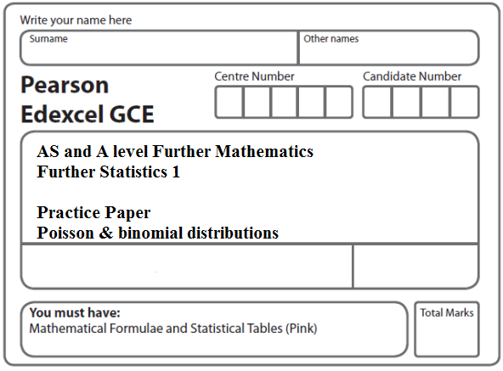
Instructions
- Use black ink or ball-point pen.
- If pencil is used for diagrams/sketches/graphs it must be dark (HB or B).
- Fill in the boxes at the top of this page with your name, centre number and candidate number.
- Answer all the questions and ensure that your answers to parts of questions are clearly labelled.
- Answer the questions in the spaces provided – there may be more space than you need.
- You should show sufficient working to make your methods clear. Answers without working may not gain full credit.
- Inexact answers should be given to three significant figures unless otherwise stated.
Information
- A booklet ‘Mathematical Formulae and Statistical Tables’ is provided.
- There are 9 questions in this question paper. The total mark for this paper is 94.
- The marks for each question are shown in brackets – use this as a guide as to how much time to spend on each question.
Advice
• Read each question carefully before you start to answer it.
• Try to answer every question.
• Check your answers if you have time at the end.
• If you change your mind about an answer, cross it out and put your new answer and any working underneath.
1. Patients arrive at a hospital accident and emergency department at random at a rate of
6 per hour.

(a) Find the probability that, during any 90 minute period, the number of patients arriving at the hospital accident and emergency department is

(i) exactly 7,

(ii) at least 10.
(5)

A patient arrives at 11.30 a.m.

(b) Find the probability that the next patient arrives before 11.45 a.m.
(3)
(Total 8 marks)
___________________________________________________________________________

2. (a) Write down the conditions under which the Poisson distribution can be used as an approximation to the binomial distribution.
(2)

The probability of any one letter being delivered to the wrong house is 0.01.
On a randomly selected day Peter delivers 1000 letters.

(b) Using a Poisson approximation, find the probability that Peter delivers at least 4 letters to the wrong house.

Give your answer to 4 decimal places.
(3)
(Total 5 marks)
___________________________________________________________________________

3. A disease occurs in 3% of a population.

(a) State any assumptions that are required to model the number of people with the disease in a random sample of size n as a binomial distribution.
(2)
(b) Using this model, find the probability of exactly 2 people having the disease in a random sample of 10 people.
(3)
(c) Find the mean and variance of the number of people with the disease in a random sample of 100 people.
(2)

A doctor tests a random sample of 100 patients for the disease. He decides to offer all patients a vaccination to protect them from the disease if more than 5 of the sample have the disease.

(d) Using a suitable approximation, find the probability that the doctor will offer all patients a vaccination.
(3)

(Total 10 marks)
___________________________________________________________________________
4. A student is investigating the numbers of cherries in a Rays fruit cake. A random sample of Rays fruit cakes is taken and the results are shown in the table below.

Number of cherries | 0 | 1 | 2 | 3 | 4 | 5 | ≥ 6
Frequency | 24 | 37 | 21 | 12 | 4 | 2 | 0

(a) Calculate the mean and the variance of these data.
(3)
(b) Explain why the results in part (a) suggest that a Poisson distribution may be a suitable model for the number of cherries in a Rays fruit cake.
(1)

The number of cherries in a Rays fruit cake follows a Poisson distribution with mean 1.5.

A Rays fruit cake is to be selected at random.
Find the probability that it contains

(c) (i) exactly 2 cherries,

(ii) at least 1 cherry.
(4)

Rays fruit cakes are sold in packets of 5.

(d) Show that the probability that there are more than 10 cherries, in total, in a randomly selected packet of Rays fruit cakes, is 0.1378 correct to 4 decimal places.
(3)

Twelve packets of Rays fruit cakes are selected at random.

(e) Find the probability that exactly 3 packets contain more than 10 cherries.
(3)
(Total 14 marks)
___________________________________________________________________________

5. A company receives telephone calls at random at a mean rate of 2.5 per hour.
(a) Find the probability that the company receives
(i) at least 4 telephone calls in the next hour,
(ii) exactly 3 telephone calls in the next 15 minutes.
(5)
(b) Find, to the nearest minute, the maximum length of time the telephone can be left
unattended so that the probability of missing a telephone call is less than 0.2.
(3)

The company puts an advert in the local newspaper. The number of telephone calls
received in a randomly selected 2 hour period after the paper is published is 10.
(c) Test at the 5% level of significance whether or not the mean rate of telephone calls
has increased. State your hypotheses clearly.
(5)
(Total 13 marks)
___________________________________________________________________________

6. A random variable X has the distribution B(12, p).

(a) Given that p = 0.25, find

(i) P(X < 5),

(ii) P(X ≥ 7).
(3)
(b) Given that P(X = 0) = 0.05, find the value of p to 3 decimal places.
(3)
(c) Given that the variance of X is 1.92, find the possible values of p.
(4)
(Total 10 marks)
___________________________________________________________________________

7. The probability of an electrical component being defective is 0.075.
The component is supplied in boxes of 120.

(a) Using a suitable approximation, estimate the probability that there are more than 3 defective components in a box.
(5)

A retailer buys 2 boxes of components.

(b) Estimate the probability that there are at least 4 defective components in each box.
(2)
(Total 7 marks)
___________________________________________________________________________

8. As part of a selection procedure for a company, applicants have to answer all 20 questions of a multiple choice test. If an applicant chooses answers at random the probability of choosing a correct answer is 0.2 and the number of correct answers is represented by the random variable X.

(a) Suggest a suitable distribution for X.
(2)

Each applicant gains 4 points for each correct answer but loses 1 point for each incorrect answer. The random variable S represents the final score, in points, for an applicant who chooses answers to this test at random.

(b) Show that S = 5X – 20.
(2)
(c) Find E(S) and Var(S).
(4)

An applicant who achieves a score of at least 20 points is invited to take part in the final stage of the selection process.

(d) Find P(S ≥ 20).
(4)

Cameron is taking the final stage of the selection process which is a multiple choice test consisting of 100 questions. He has been preparing for this test and believes that his chance of answering each question correctly is 0.4.

(e) Using a suitable approximation, estimate the probability that Cameron answers more than half of the questions correctly.
(5)
(Total 17 marks)
___________________________________________________________________________
9. A telesales operator is selling a magazine. Each day he chooses a number of people to telephone. The probability that each person he telephones buys the magazine is 0.1.

(a) Suggest a suitable distribution to model the number of people who buy the magazine from the telesales operator each day.
(1)
(b) On Monday, the telesales operator telephones 10 people. Find the probability that he sells at least 4 magazines.
(3)
(c) Calculate the least number of people he needs to telephone on Tuesday, so that the probability of selling at least 1 magazine, on that day, is greater than 0.95.
(3)

A call centre also sells the magazine. The probability that a telephone call made by the call centre sells a magazine is 0.05. The call centre telephones 100 people every hour.

(d) Using a suitable approximation, find the probability that more than 10 people telephoned by the call centre buy a magazine in a randomly chosen hour.
(3)
(Total 10 marks)

TOTAL FOR PAPER: 94 MARKS

