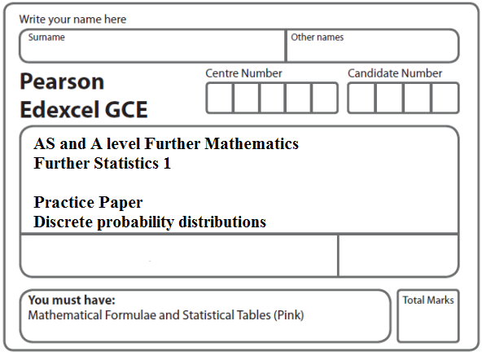
Instructions
- Use black ink or ball-point pen.
- If pencil is used for diagrams/sketches/graphs it must be dark (HB or B).
- Fill in the boxes at the top of this page with your name, centre number and candidate number.
- Answer all the questions and ensure that your answers to parts of questions are clearly labelled.
- Answer the questions in the spaces provided – there may be more space than you need.
- You should show sufficient working to make your methods clear. Answers without working may not gain full credit.
- Inexact answers should be given to three significant figures unless otherwise stated.
Information
- A booklet ‘Mathematical Formulae and Statistical Tables’ is provided.
- There are 7 questions in this question paper. The total mark for this paper is 101.
- The marks for each question are shown in brackets – use this as a guide as to how much time to spend on each question.
Advice
• Read each question carefully before you start to answer it.
• Try to answer every question.
• Check your answers if you have time at the end.
• If you change your mind about an answer, cross it out and put your new answer and any working underneath.
1. A discrete random variable X has the probability function

P(X = x) =

(a) Show that k =
(3)
(b) Find E(X).
(2)
(c) Show that E(X ²) = $\frac{4}{3}$
(2)
(d) Find Var(1 – 3X)
(3)
(Total 10 marks)
___________________________________________________________________________

2. The discrete random variable X has the following probability distribution, where p and q are constants.

x | –2 | –1 |  |  | 2
P(X = x) | p | q | 0.2 | 0.3 | p

(a) Write down an equation in p and q.
(1)

Given that E(X) = 0.4,

(b) find the value of q.
(3)
(c) Hence find the value of p.
(2)

Given also that E(X²) = 2.275,

(d) find Var(X).
(2)

Sarah and Rebecca play a game.

A computer selects a single value of X using the probability distribution above.

Sarah’s score is given by the random variable S = X and Rebecca’s score is given by the random variable R = .

(e) Find E(R).
(3)

Sarah and Rebecca work out their scores and the person with the higher score is the winner. If the scores are the same, the game is a draw.

(f) Find the probability that

(i) Sarah is the winner,

(ii) Rebecca is the winner.
(4)
(Total 15 marks)
___________________________________________________________________________

3. In a quiz, a team gains 10 points for every question it answers correctly and loses 5 points for every question it does not answer correctly. The probability of answering a question correctly is 0.6 for each question. One round of the quiz consists of 3 questions.

The discrete random variable X represents the total number of points scored in one round.
The table shows the incomplete probability distribution of X.

x | 30 | 15 | 0 | –15
P(X = x) | 0.216 |  |  | 0.064

(a) Show that the probability of scoring 15 points in a round is 0.432.
(2)
(b) Find the probability of scoring 0 points in a round.
(1)
(c) Find the probability of scoring a total of 30 points in 2 rounds.
(3)
(d) Find E(X).
(2)
(e) Find Var(X).
(3)

In a bonus round of 3 questions, a team gains 20 points for every question it answers correctly and loses 5 points for every question it does not answer correctly.

(f) Find the expected number of points scored in the bonus round.
(3)
(Total 14 marks)
___________________________________________________________________________

4. The discrete random variable X has the probability distribution

x | 1 | 2 | 3 | 4
P(X = x) | k | 2k | 3k | 4k

(a) Show that k = 0.1
(1)

Find

(b) E(X )
(2)
(c) E(X ²)
(2)
(d) Var (2 – 5X )
(3)

Two independent observations X₁ and X₂ are made of X.

(e) Show that P(X₁ + X₂ = 4) = 0.1
(2)
(f ) Complete the probability distribution table for X₁ + X₂.
(2)

y | 2 | 3 | 4 | 5 | 6 | 7 | 8
P(X₁ + X₂ = y) | 0.01 | 0.04 | 0.10 |  | 0.25 | 0.24

(g) Find P(1.5 < X₁ + X₂ ≤ 3.5)
(2)
(Total 14 marks)
___________________________________________________________________________

5. A fair blue die has faces numbered 1, 1, 3, 3, 5 and 5. The random variable B represents the score when the blue die is rolled.

(a) Write down the probability distribution for B.
(2)
(b) State the name of this probability distribution.
(1)
(c) Write down the value of E(B).
(1)

A second die is red and the random variable R represents the score when the red die is rolled.

The probability distribution of R is

r | 2 | 4 | 6
P(R = r)

(d) Find E(R).
(2)
(e) Find Var(R).
(3)

Tom invites Avisha to play a game with these dice.

Tom spins a fair coin with one side labelled 2 and the other side labelled 5. When Avisha sees the number showing on the coin she then chooses one of the dice and rolls it. If the number showing on the die is greater than the number showing on the coin, Avisha wins, otherwise Tom wins.

Avisha chooses the die which gives her the best chance of winning each time Tom spins the coin.

(f) Find the probability that Avisha wins the game, stating clearly which die she should use in each case.
(4)
(Total 13 marks)
___________________________________________________________________________

6. The score S when a spinner is spun has the following probability distribution.

s | 0 | 1 | 2 | 4 | 5
P(S = s) | 0.2 | 0.2 | 0.1 | 0.3 | 0.2

(a) Find E(S).
(2)
(b) Show that E(S²) = 10.4.
(2)
(c) Hence find Var(S).
(2)
(d) Find

(i) E(5S – 3),

(ii) Var(5S – 3).
(4)
(e) Find P(5S – 3 > S + 3).
(3)

The spinner is spun twice.

The score from the first spin is S₁ and the score from the second spin is S₂.

The random variables S₁ and S₂ are independent and the random variable X = S₁ × S₂.

(f) Show that P({S₁ = 1} ∩ X < 5) = 0.16.
(2)
(g) Find P(X < 5).
(3)
(Total 18 marks)
___________________________________________________________________________

7. A spinner is designed so that the score S is given by the following probability distribution.

s | 0 | 1 | 2 | 4 | 5
P(S = s) | p | 0.25 | 0.25 | 0.20 | 0.20

(a) Find the value of p.
(2)
(b) Find E(S).
(2)
(c) Show that E(S ²) = 9.45.
(2)
(d) Find Var(S).
(2)

Tom and Jess play a game with this spinner. The spinner is spun repeatedly and S counters are awarded on the outcome of each spin. If S is even then Tom receives the counters and if S is odd then Jess receives them. The first player to collect 10 or more counters is the winner.

(e) Find the probability that Jess wins after 2 spins.
(2)
(f) Find the probability that Tom wins after exactly 3 spins.
(4)
(g) Find the probability that Jess wins after exactly 3 spins.
(3)
(Total 17 marks)

TOTAL FOR PAPER: 101 MARKS

