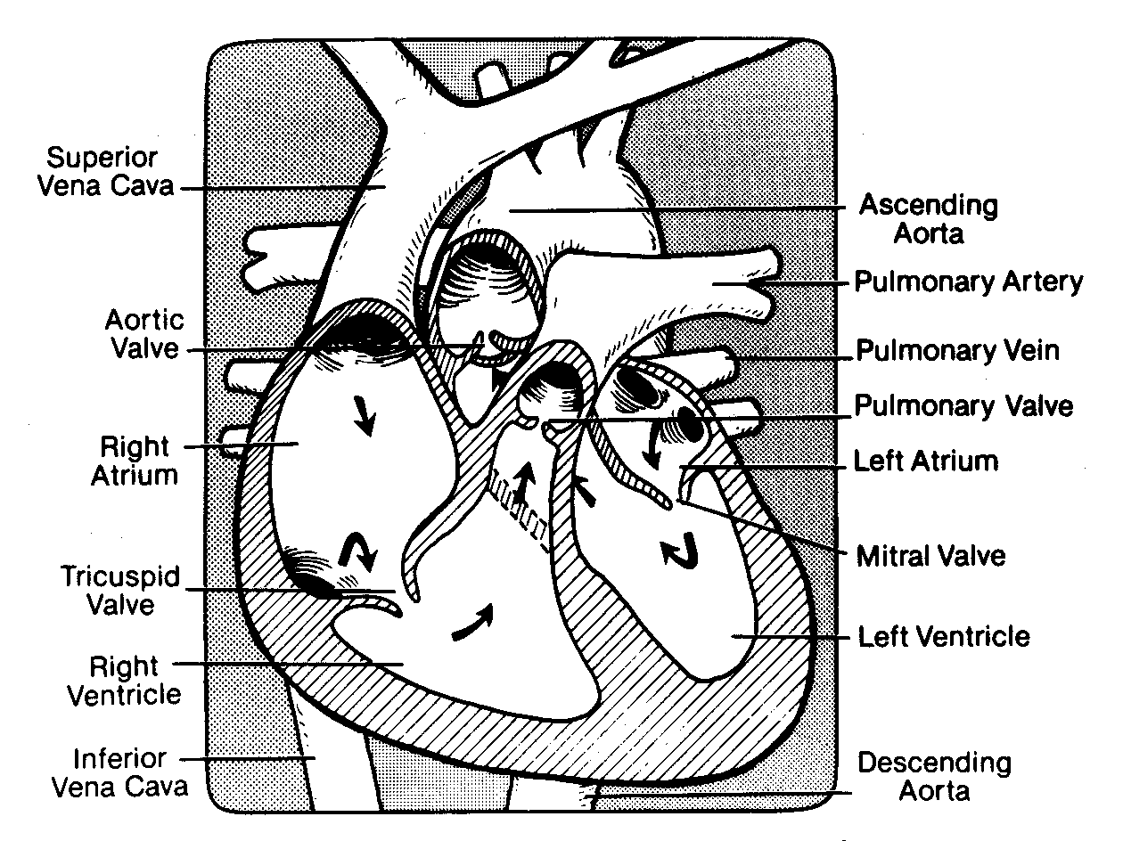
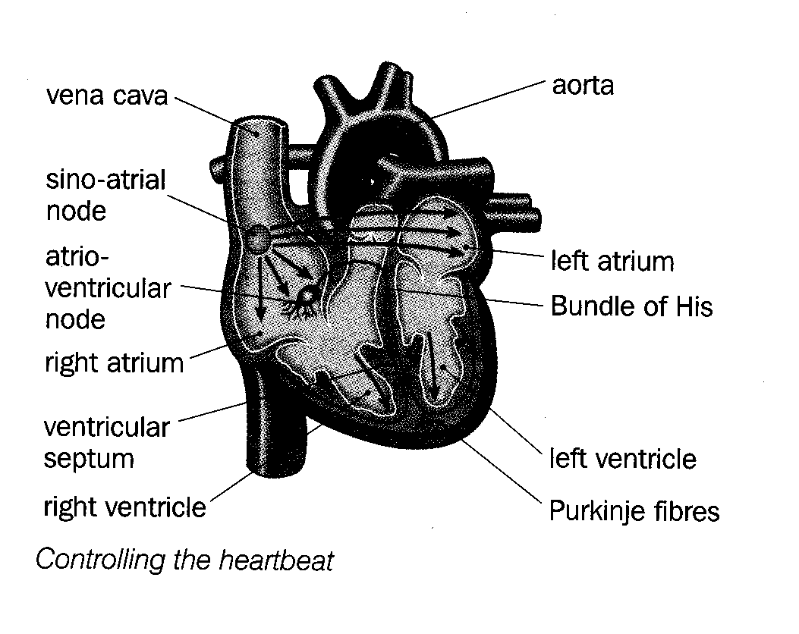
Initiating the heart beat
- Cardiac muscle cells are joined by intercalary discs which allow for rapid transmission of waves of excitation.
- Cardiac muscle is myogenic – can contract/relax without external stimulation.
- Contraction is started in the sinoatrial node (SAN or pacemaker).
- SAN → electrical impulses → wave of depolarisation in atrial walls.
- Both atria contract at the same time – in the rhythm from the SAN.
- Collagen fibres prevent the impulses from the atria reaching the ventricles (these must contract after the atria).
- The atrio-ventricular node (AVN) picks up the impulses from the SAN and sends out impulses 0.1s later along muscle fibres called Purkinje fibres (these exist in both left and right ventricles and together are called the bundle of His.
- Bundles of His carry the impulses to the bottom so that both ventricles contract (at the same time) from the bottom up.
- These changes may be detected by an electrocardiagram (ECG)
- Fibrillation happens when the wave of excitation becomes chaotic – small sections of cardiac muscle contract while others relax – usually fatal.
SAN wall of right wall of left
atrium atrium

AVN

Purkinje fibres
(Bundle of His)

contraction of contraction of
right ventricle left ventricle

apex (bottom) of
ventricle

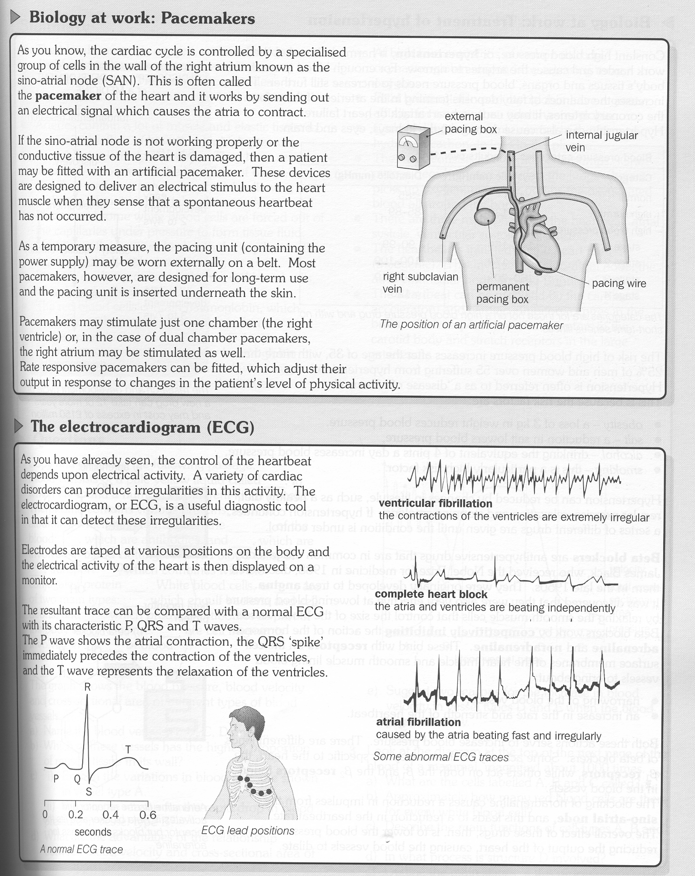
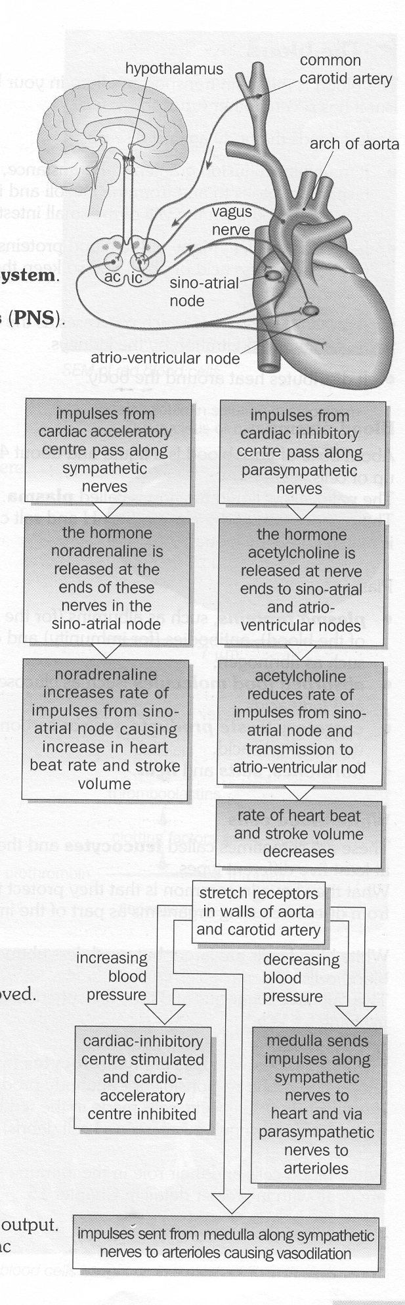

Control of the heart beat

- The heart rate is controlled by the autonomic nervous system (little conscious control)
- The autonomic NS has two sets of nerves:-
  - sympathetic – increases cardiac output by increasing heart rate and stroke volume.
  - parasympathetic – decreases cardiac output by decreasing heart rate and stroke volume.
- The cardiac output is set by two centres in the medulla of the brain:-
  - cardiac acceleratory centre – linked to the SAN, AV node & bundle of His by the sympathetic NS.
  - cardiac inhibitory centre – linked to SAN, AVN by the parasympathetic NS (vagus nerve).
- Sensory receptors in carotid body senses blood pH (>CO₂ → a fall in blood pH).
- If blood pH falls, impulses are sent → acceleratory centre → increased cardiac output.
- Stretch receptors and pressure in the walls of the aorta and carotid arteries sense raised blood pressure → impulses to inhibitory centre → reduced cardiac output. (Reverse happens for low blood pressure).

