Instructions
- Use black ink or ball-point pen.
  - Fill in the boxes at the top of this page with your name,
centre number and candidate number.
- Answer all questions.
- Without sufficient working, correct answers may be awarded no marks.
- Answer the questions in the spaces provided
– there may be more space than you need.
- Calculators may be used.
- You must NOT write anything on the formulae page.
Anything you write on the formulae page will gain NO credit.
Information
- The total mark for this paper is 100.
- The marks for each question are shown in brackets
– use this as a guide as to how much time to spend on each question.
Advice
- Read each question carefully before you start to answer it.
- Check your answers if you have time at the end.
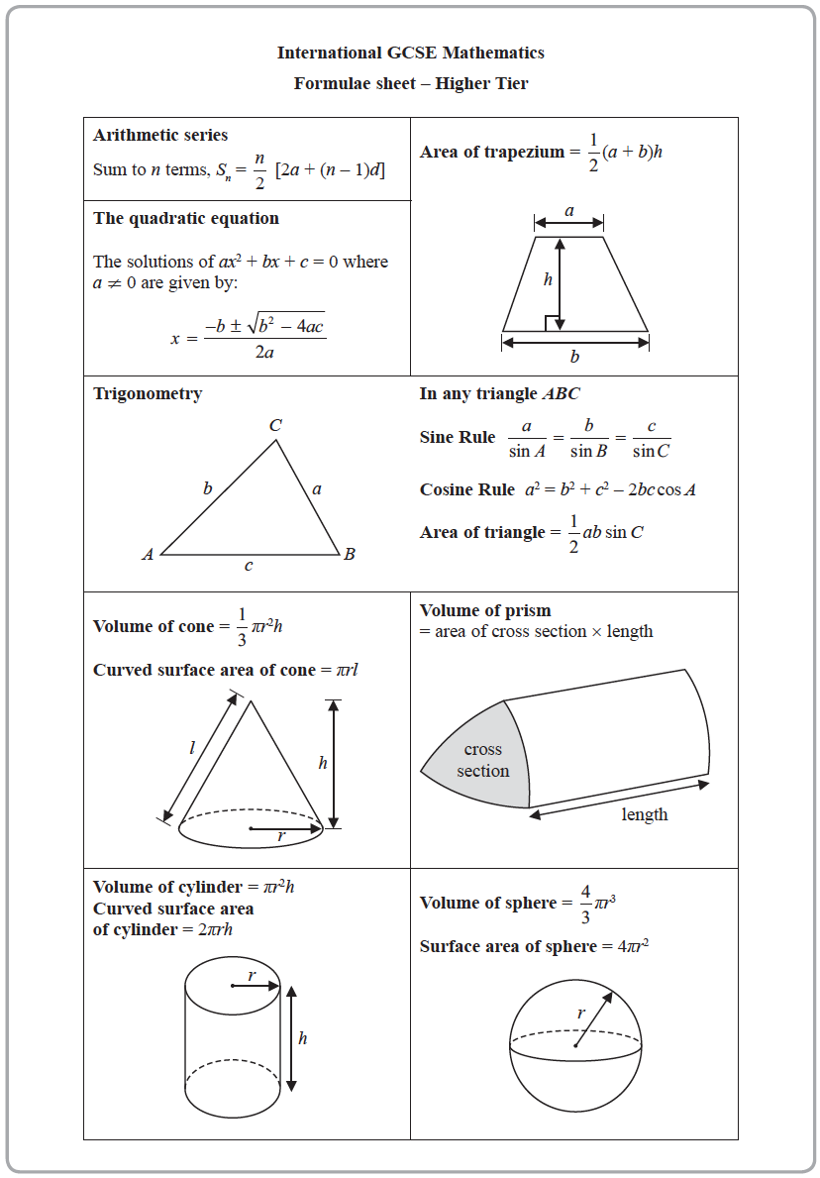
Answer ALL TWENTY FIVE questions.
Write your answers in the spaces provided.
You must write down all the stages in your working.

1 The diagram shows a cylinder.

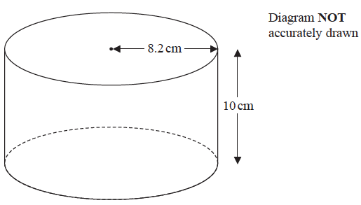

The cylinder has radius 8.2 cm and height 10 cm.
The cylinder is empty.
Pam pours 1.5 litres of water into the cylinder.
Work out the depth of the water in the cylinder.
Give your answer correct to 1 decimal place.

....................................................cm
(Total for Question 1 is 3 marks)
___________________________________________________________________________

2 Each interior angle of a regular polygon is 162°
Work out the number of sides the polygon has.

.......................................................
(Total for Question 2 is 3 marks)
___________________________________________________________________________

3 E = {11, 12, 13, 14, 15, 16, 17, 18, 19, 20}
A = {even numbers}
B = {multiples of 3}
List the members of the set
(i) A B

.......................................................
(ii) A B

.......................................................
(iii) A′

.......................................................
(Total for Question 3 is 3 marks)
___________________________________________________________________________

4 Solve 4x – 13 = 17 + 8x

x = .......................................................
(Total for Question 4 is 2 marks)
___________________________________________________________________________

5 (a) Write 720 as a product of its prime factors.
Show your working clearly.

.......................................................
(3)
(b) Find the smallest whole number that 720 can be multiplied by to give a square number.

.......................................................
(1)
(Total for Question 5 is 4 marks)
___________________________________________________________________________

6 Lorenzo increases all the prices on his restaurant menu by 8%
Before the increase, the price of a dessert was $4.25
(a) Work out the price of the dessert after the increase.

$ .......................................................
(3)

After the increase, the price of lasagne is $9.45
(b) Work out the price of lasagne before the increase.

$ .......................................................
(3)
(Total for Question 6 is 6 marks)
___________________________________________________________________________

7 The diagram shows isosceles triangle ABC.

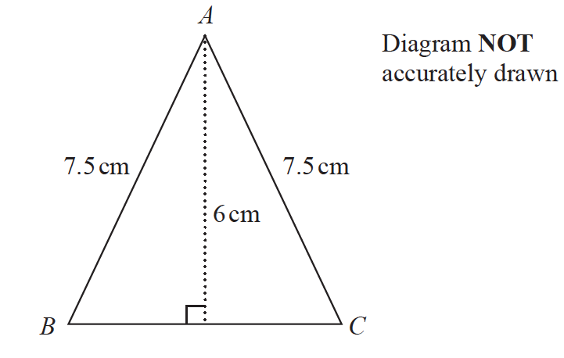

AB = AC = 7.5 cm.
The height of the triangle is 6 cm.
Calculate the area of the triangle.

....................................................cm²
(Total for Question 7 is 4 marks)
___________________________________________________________________________

8 There are 10 people in a lift.
These 10 people have a mean weight of 79.2 kg.
3 of these people get out of the lift.
These 3 people have a mean weight of 68 kg.
Work out the mean weight of the 7 people left in the lift.

....................................................kg
(Total for Question 8 is 3 marks)
___________________________________________________________________________

9 (a) Simplify t⁹ ÷ t³

.......................................................
(1)
(b) Simplify w⁵ × w⁷

.......................................................
(1)
(c) Simplify (5xy²)³

.......................................................
(2)
(Total for Question 9 is 4 marks)
___________________________________________________________________________

10 Change 22 metres per second to a speed in kilometres per hour.
Show your working clearly.

....................................................km/h
(Total for Question 10 is 3 marks)
___________________________________________________________________________

11 3 years ago, the ratio of Tom’s age to Clemmie’s age was 2 : 7
Tom is now 15 years old and Clemmie is now x years old.
Find the value of x.

x = .......................................................
(Total for Question 11 is 3 marks)
___________________________________________________________________________

12

A box, in the shape of a cuboid, is going to be put on a table.
The whole of one face of the box will be in contact with the table.
The force exerted by the box on the table is always 105 newtons.
The box is 5 m by 4 m by 3 m.
The greatest pressure exerted by the box on the table is P newtons/m²
The least pressure exerted by the box on the table is Q newtons/m²
Work out the value of P – Q

....................................................
(Total for Question 12 is 3 marks)
___________________________________________________________________________

13 (a) On the Venn diagram, shade the set (A B)′ C
E
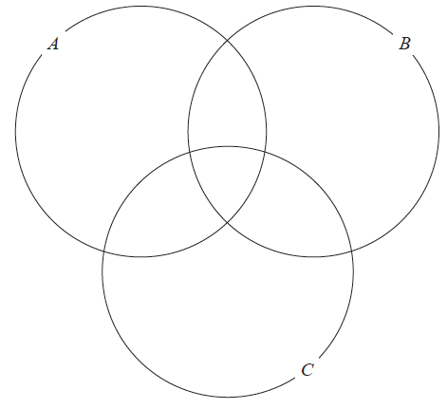
(1)
(b) Use set notation to describe the shaded region in the Venn diagram below.
E
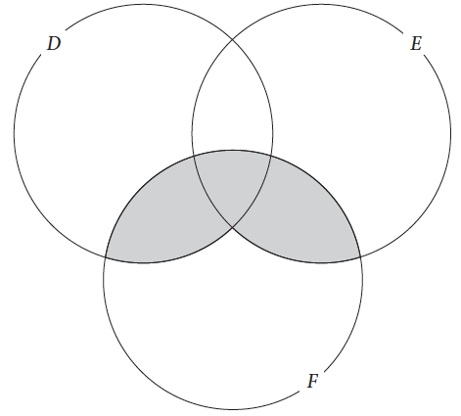

.......................................................
(1)
(Total for Question 13 is 2 marks)
___________________________________________________________________________

14 Each day that Barney goes to college, he either goes by bus or he walks.
The probability that Barney will go to college by bus on any day is 0.3
When Barney goes to college by bus, the probability that he will be late is 0.2
When Barney walks to college, the probability that he will be late is 0.1
(a) Complete the probability tree diagram.

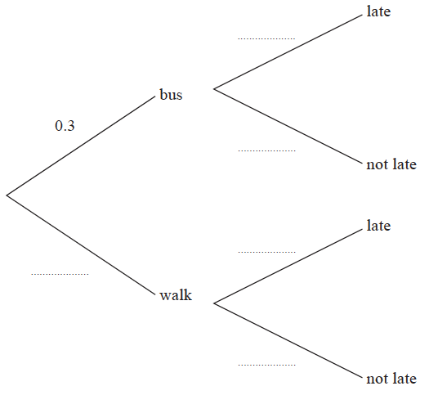
(2)

Barney will go to college on 200 days next year.
(b) Work out an estimate for the number of days Barney will be late for college next year.

.......................................................
(4)
(Total for Question 14 is 6 marks)
___________________________________________________________________________

15 The straight line L₁ has equation 2y = 6x − 5
The straight line L₂ is perpendicular to L₁ and passes through the point (9. −1)
Find an equation for L₂
Give your answer in the form ay + bx = c

.......................................................
(Total for Question 15 is 4 marks)
___________________________________________________________________________

16 A particle P is moving along a straight line.
The fixed point O lies on this line.
At time t seconds, the displacement, s metres, of P from O is given by
s = 4t³ − 6t² + 5t
At time t seconds, the velocity of P is v m/s.
(a) Find an expression for v in terms of t.

v = .......................................................
(2)
(b) Find the time at which the acceleration of the particle is 6 m/s²

....................................................... seconds
(3)
(Total for Question 16 is 5 marks)
___________________________________________________________________________

17 The histogram shows information about the ages of all the passengers travelling on a plane.
No one on the plane is older than 80 years.

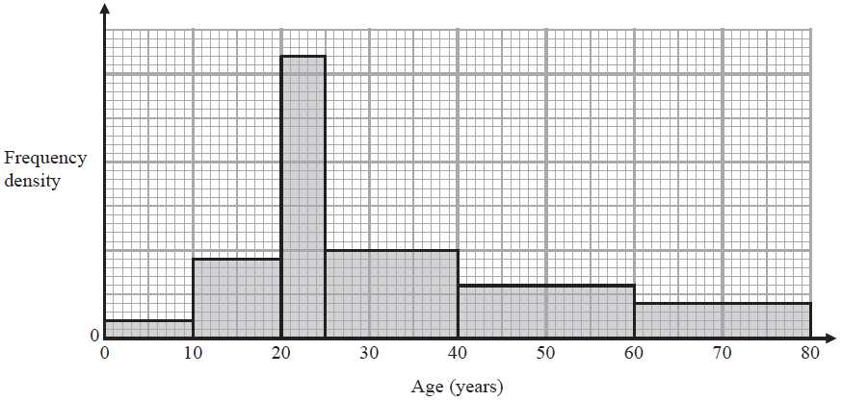

24 passengers on the plane are aged between 40 years and 60 years.
(a) Work out the total number of passengers on the plane.

.......................................................
(3)

A passenger on the plane is picked at random.
(b) Work out an estimate for the probability that this person is older than 55 years.

.......................................................
(2)
(Total for Question 17 is 5 marks)
___________________________________________________________________________

18 (a) Expand and simplify (x + 2)(2x + 3)(x – 7)
Show your working clearly.

.......................................................
(3)
(b) Make m the subject of p² =

.......................................................
(3)
(Total for Question 18 is 6 marks)
___________________________________________________________________________

19 The 25th term of an arithmetic series is 44.5
The sum of the first 30 terms of this arithmetic series is 765
Find the 16th term of the arithmetic series.
Show your working clearly.

.......................................................
(Total for Question 19 is 5 marks)
___________________________________________________________________________

20 a = 25 × 10^{14n} where n is an integer.
Find an expression, in terms of n, for
Give your answer in standard form.

.......................................................
(Total for Question 20 is 3 marks)
___________________________________________________________________________

21 A curve has equation y = f (x)
There is only one maximum point on the curve.
The coordinates of this maximum point are (4, 3)
(a) Write down the coordinates of the maximum point on the curve with equation
(i) y = f (x – 5)

(............................ , ............................)
(ii) y = 3f (x)

(............................ , ............................)
(2)

Here is the graph of y = a sin(bx)° for 0 ⩽ x ⩽ 360

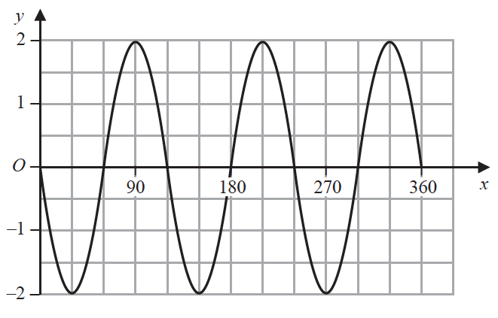

(b) Find the value of a and the value of b.

a = .......................................................
b = .......................................................
(2)
(Total for Question 21 is 4 marks)
___________________________________________________________________________

22 Solve the simultaneous equations
2x² + 3y² = 5
y = 2x + 1
Show clear algebraic working.

......................................................................................................................................................
(Total for Question 22 is 5 marks)
___________________________________________________________________________

23
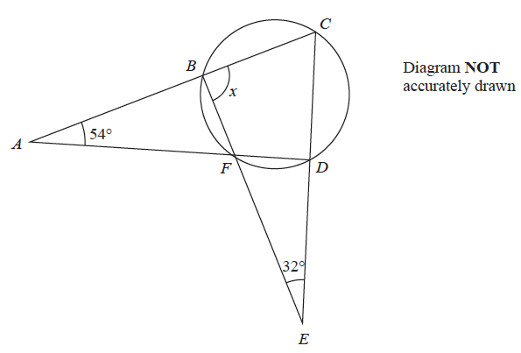

B, C, D and F are points on a circle.
ABC, AFD, BFE and CDE are straight lines.
Work out the size of angle x.
Show your working clearly.

x = .......................................................°
(Total for Question 23 is 4 marks)
___________________________________________________________________________

24
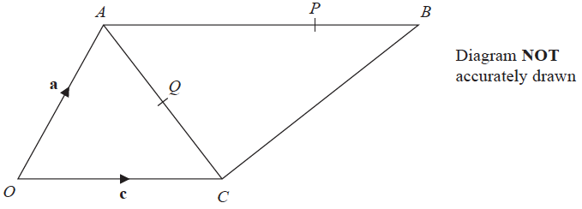

= a = c = 2c
P is the point on AB such that AP : PB = 3 : 1
Q is the point on AC such that OQP is a straight line.
Use a vector method to find AQ : QC
Show your working clearly.

AQ : QC = .......................................................
(Total for Question 24 is 5 marks)
___________________________________________________________________________

25 A boat sails from point X to point Y and then to point Z.
Y is on a bearing of 280° from X.
Z is on a bearing of 220° from Y.
The distance from X to Y is 3.5 km.
The distance from Y to Z is 6 km.
Work out the bearing of Z from X.
Give your answer correct to 1 decimal place.

.......................................................°
(Total for Question 25 is 5 marks)
___________________________________________________________________________

TOTAL FOR PAPER IS 100 MARKS

