Instructions
- Use black ink or ball-point pen.
  - Fill in the boxes at the top of this page with your name,
centre number and candidate number.
- Answer all questions.
- Without sufficient working, correct answers may be awarded no marks.
- Answer the questions in the spaces provided
– there may be more space than you need.
- Calculators may be used.
- You must NOT write anything on the formulae page.
Anything you write on the formulae page will gain NO credit.
Information
- The total mark for this paper is 100.
- The marks for each question are shown in brackets
– use this as a guide as to how much time to spend on each question.
Advice
- Read each question carefully before you start to answer it.
- Check your answers if you have time at the end.
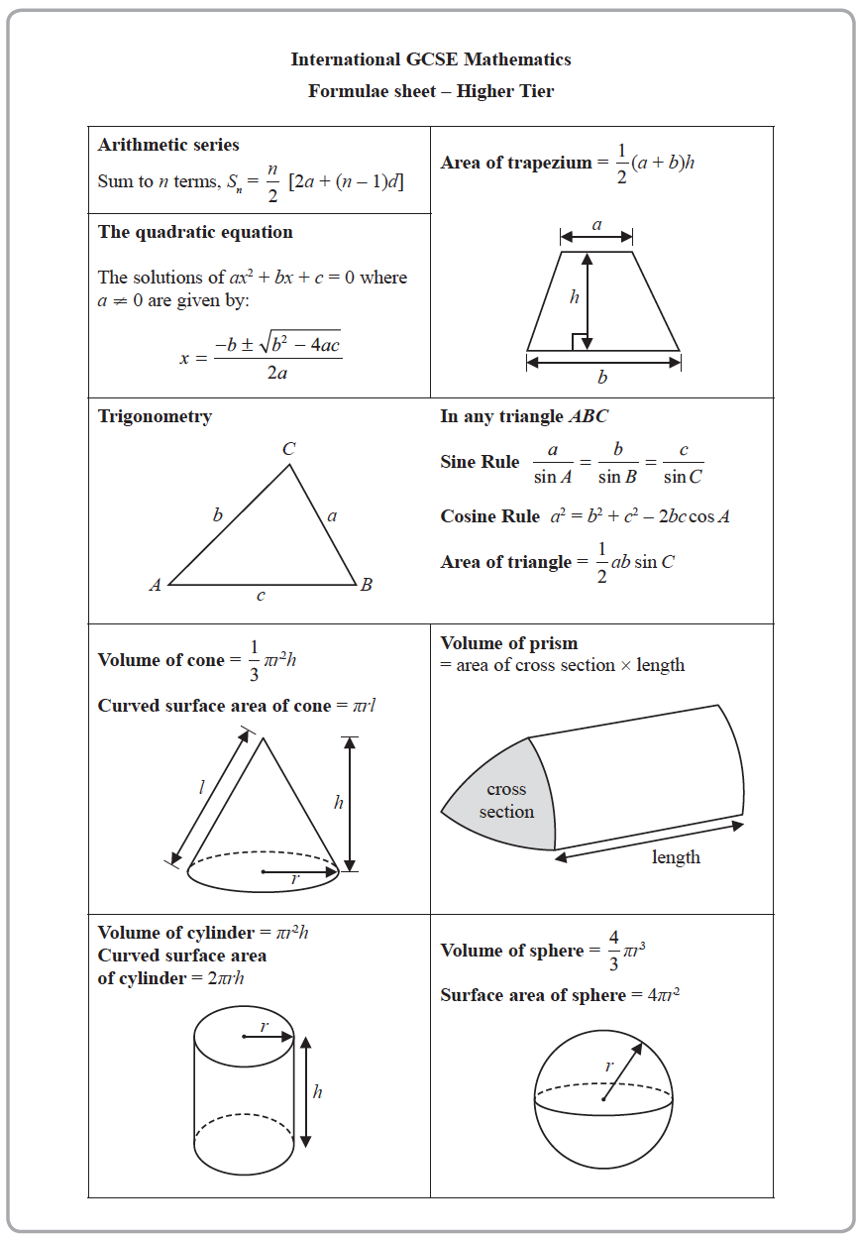
Answer ALL TWENTY FOUR questions.
Write your answers in the spaces provided.
You must write down all the stages in your working.

1 The table shows information about the heights, in cm, of 48 sunflowers in a garden centre.

Height of sunflower (h cm) | Frequency
90 < h ⩽ 100 | 8
100 < h ⩽ 110 | 12
110 < h ⩽ 120 | 15
120 < h ⩽ 130 | 10
130 < h ⩽ 140 | 3

Work out an estimate for the mean height of the sunflowers.

.......................................................cm
(Total for Question 1 is 4 marks)
___________________________________________________________________________

2 Use ruler and compasses to construct the perpendicular bisector of the line DE.
You must show all your construction lines.

(Total for Question 2 is 2 marks)
___________________________________________________________________________

3 E = {1, 2, 3, 4, 5, 6, 7, 8, 9, 10}
A = {2, 3, 5, 7}
B = {4, 6, 8, 10}
(a) Explain why A B =

......................................................................................................................................................
......................................................................................................................................................
......................................................................................................................................................
(1)

x ∈ E and x A B
(b) Write down the two possible values of x.

............................. , .............................
(1)

Set C is such that
A B C = E
A C = {2}
B C ′ = {4, 6, 10}
(c) List all the members of set C.

.............................................................................................................
(2)
(Total for Question 3 is 4 marks)
___________________________________________________________________________

4 A cylinder has diameter 14 cm and height 20 cm.
Work out the volume of the cylinder.
Give your answer correct to 3 significant figures.

.......................................................cm³
(Total for Question 4 is 2 marks)
___________________________________________________________________________

5 Josh buys and sells books for a living.
He buys 120 books for £4 each.
He sells of the books for £5 each.
He sells 40% of the books for £7 each.
He sells the rest of the books for £8 each.
(a) Calculate Josh’s percentage profit.

.......................................................%
(5)

One book that Josh owns had a value of £15 on the 1st May 2019
The value of this book had increased by 20% in the last year.
(b) Find the value of the book on the 1st May 2018

£......................................................
(3)
(Total for Question 5 is 8 marks)
___________________________________________________________________________

6 ABC and DEF are similar triangles.

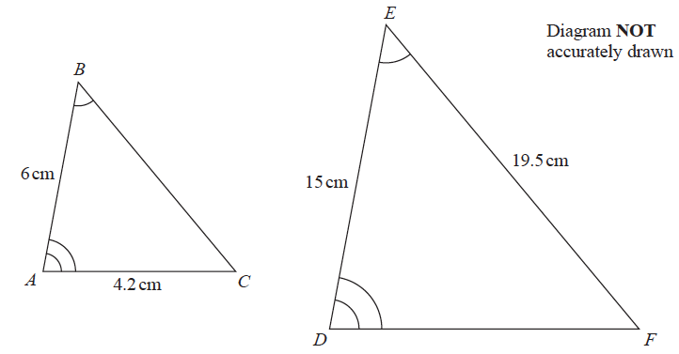

(a) Work out the length of DF.

.......................................................cm
(2)
(b) Work out the length of BC.

.......................................................cm
(2)
(Total for Question 6 is 4 marks)
___________________________________________________________________________

7 30 students in a class sat a Mathematics test.
The mean mark in the test for the 30 students was 26.8
13 of the 30 students in the class are boys.
The mean mark in the test for the boys was 25
Find the mean mark in the test for the girls.
Give your answer correct to 3 significant figures.

.......................................................
(Total for Question 7 is 3 marks)
___________________________________________________________________________

8 Change a speed of x kilometres per hour into a speed in metres per second.
Simplify your answer.

.......................................................m/s
(Total for Question 8 is 3 marks)
___________________________________________________________________________

9 Solve the simultaneous equations
x + 2y = –0.5
3x – y = 16
Show clear algebraic working.

x =.......................................................
y =.......................................................
(Total for Question 9 is 3 marks)
___________________________________________________________________________

10 The straight line L has gradient 5 and passes through the point with coordinates (0, –3)
(a) Write down an equation for L.

.......................................................
(2)
(b)
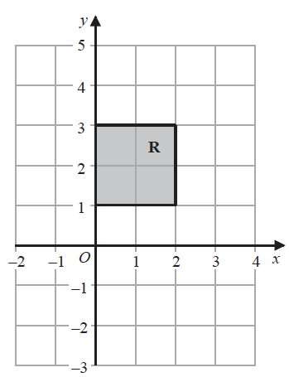

The region R, shown shaded in the diagram, is bounded by four straight lines.
Write down the inequalities that define R.

......................................................................................................................................................
(2)
(Total for Question 10 is 4 marks)
___________________________________________________________________________

11 The table gives the average crowd attendance per match for each of five football clubs
for one season.
Football club | Average crowd attendance
Monaco | 9.5 × 10³
Chelsea | 4.2 × 10⁴
Juventus | 3.9 × 10⁴
Oxford United | 8.3 × 10³
Barcelona | 7.7 × 10⁴

(a) Find the difference between the average crowd attendance for Barcelona and the
average crowd attendance for Monaco.
Give your answer in standard form.

.......................................................
(2)

Antonio says,
“The average crowd attendance for Chelsea is approximately 50 times that for Oxford United.”
(b) Is Antonio correct?
You must give a reason for your answer.

......................................................................................................................................................
......................................................................................................................................................
......................................................................................................................................................
(2)

During last season the cost of a ticket to watch Seapron United increased by 15% and then
decreased by 8%
(c) Work out the overall percentage change in the cost of a ticket to watch Seapron
United during last season.

.......................................................%
(2)
(Total for Question 11 is 6 marks)
___________________________________________________________________________

12 ABCD is a trapezium.

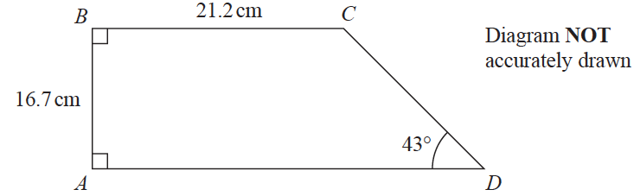

Calculate the perimeter of the trapezium.
Give your answer correct to 3 significant figures.

.......................................................cm
(Total for Question 12 is 4 marks)
___________________________________________________________________________

13 The table gives information about the times taken, in minutes, for 80 taxi journeys.

Time taken (t minutes) | Frequency
0 < t ⩽ 5 | 7
5 < t ⩽ 10 | 10
10 < t ⩽ 15 | 12
15 < t ⩽ 20 | 19
20 < t ⩽ 25 | 18
25 < t ⩽ 30 | 14

(a) Complete the cumulative frequency table.

Time taken (t minutes) | Cumulative frequency
0 < t ⩽ 5
0 < t ⩽ 10
0 < t ⩽ 15
0 < t ⩽ 20
0 < t ⩽ 25
0 < t ⩽ 30

(1)
(b) On the grid provided, draw a cumulative frequency graph for your table.
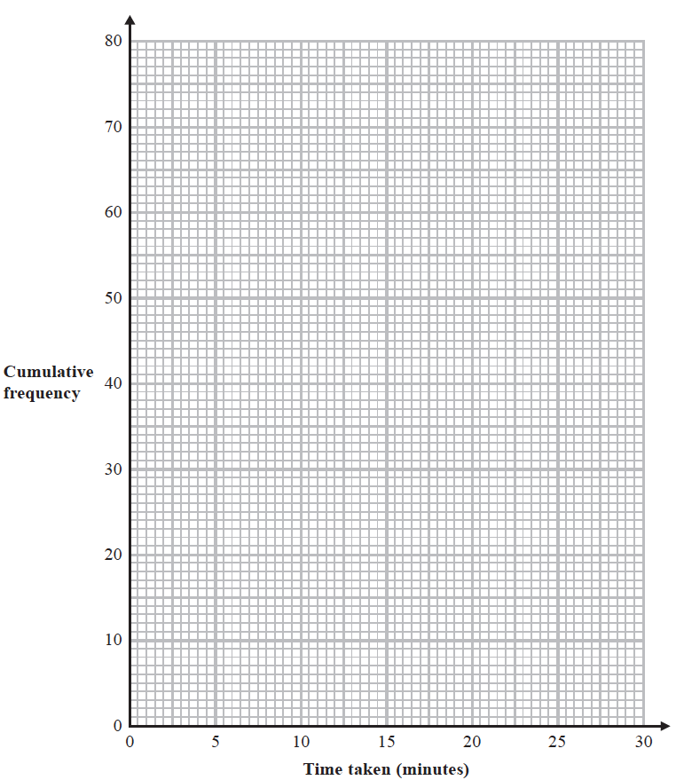
(2)

(c) Use your graph to find an estimate for the median.

.......................................................minutes
(1)
(d) Use your graph to find an estimate for the interquartile range.

.......................................................minutes
(2)
(Total for Question 13 is 6 marks)
___________________________________________________________________________

14 Here are two vectors.

= =

Find the magnitude of

.......................................................
(Total for Question 14 is 3 marks)
___________________________________________________________________________

15 Make x the subject of the formula y =

.......................................................
(Total for Question 15 is 4 marks)
___________________________________________________________________________

16 Show that can be written in the form a  b, where a and b are integers.
Show each stage of your working clearly and give the value of a and the value of b.

(Total for Question 16 is 3 marks)
___________________________________________________________________________

17 y is directly proportional to the cube of x
y = 20 h when x = h (h ≠ 0)
(a) Find a formula for y in terms of x and h

y =.......................................................
(3)
(b) Find x in terms of h when y = 67.5 h
Give your answer in its simplest form.

x =.......................................................
(2)
(Total for Question 17 is 5 marks)
___________________________________________________________________________

18 The diagram shows a solid cuboid.

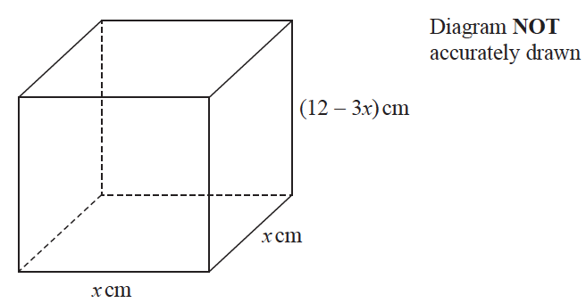

The total surface area of the cuboid is A cm²
Find the maximum value of A.

.......................................................
(Total for Question 18 is 5 marks)
___________________________________________________________________________

19 ABCD is a quadrilateral.

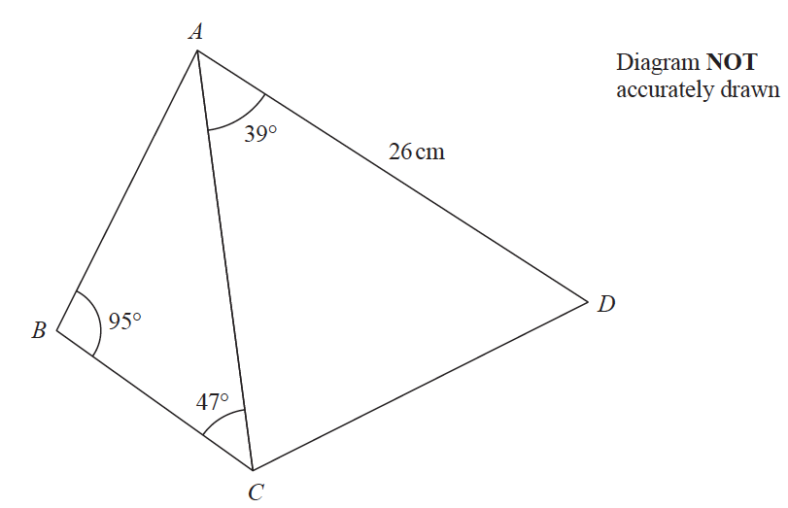

The area of triangle ACD is 250 cm²
Calculate the area of the quadrilateral ABCD.
Show your working clearly.
Give your answer correct to 3 significant figures.

.......................................................cm²
(Total for Question 19 is 6 marks)
___________________________________________________________________________

20 The equation of the line L is y = 9 − x
The equation of the curve C is x² − 3xy + 2y² = 0
L and C intersect at two points.
Find the coordinates of these two points.
Show clear algebraic working.

(............................. , .............................) and (............................. , .............................)
(Total for Question 20 is 5 marks)
___________________________________________________________________________

21 The diagram shows cuboid ABCDEFGH.

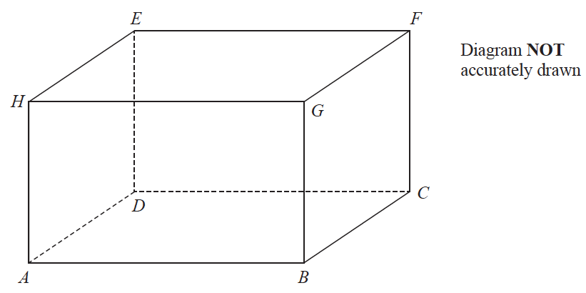

For this cuboid
the length of AB : the length of BC : the length of CF = 4 : 2 : 3
Calculate the size of the angle between AF and the plane ABCD.
Give your answer correct to one decimal place.

.......................................................°
(Total for Question 21 is 3 marks)
___________________________________________________________________________

22 Simplify fully

.......................................................
(Total for Question 22 is 3 marks)
___________________________________________________________________________

23 Boris has a bag that only contains red sweets and green sweets.
Boris takes at random 2 sweets from the bag.
The probability that Boris takes exactly 1 red sweet from the bag is
Originally there were 3 red sweets in the bag.
Work out how many green sweets there were originally in the bag.
Show your working clearly.

.......................................................
(Total for Question 23 is 5 marks)
___________________________________________________________________________

24 The function f is such that f (x) = 3x – 2
(a) Find f (5)

.......................................................
(1)

The function g is such that g (x) = 2x² – 20x + 9 where x ⩾ 5
(b) Express the inverse function g^{–1} in the form g^{–1}(x) = ...

g^{–1}(x) = .......................................................
(4)
(Total for Question 24 is 5 marks)
___________________________________________________________________________
TOTAL FOR PAPER IS 100 MARKS

