Instructions
- Use black ink or ball-point pen.
- Fill in the boxes at the top of this page with your name,
- centre number and candidate number.
- Answer all questions.
- Without sufficient working, correct answers may be awarded no marks.
- Answer the questions in the spaces provided
  - there may be more space than you need.
- Calculators may be used.
- You must NOT write anything on the formulae page.
- Anything you write on the formulae page will gain NO credit.

Information
- The total mark for this paper is 100.
- The marks for each question are shown in brackets
  - use this as a guide as to how much time to spend on each question.
Advice
- Read each question carefully before you start to answer it.
- Check your answers if you have time at the end.

This publication may be reproduced only in accordance with Edexcel Limited copyright policy. ©2012 Edexcel Limited.
Printer’s Log. No. P40661A
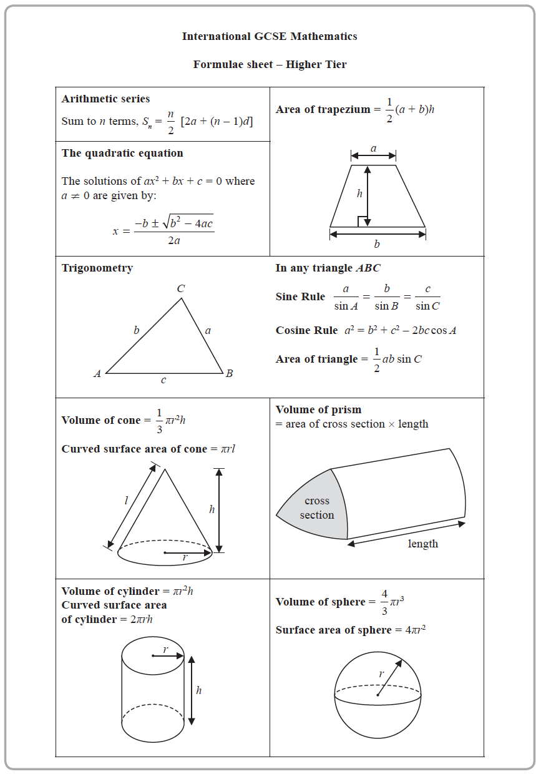
Practice for Summer Examination (Part two)

1 (a) Expand and simplify (y + 4)(2 − y)

.......................................................
(2)
(b) Factorise fully 15b⁵c − 35b³c⁹

.......................................................
(2)
(Total for Question 1 is 4 marks)
___________________________________________________________________________

2 Show that

(Total for Question 2 is 3 marks)
___________________________________________________________________________

3

Triangle ABC is similar to triangle PQR
AB = 4 cm | PQ = 12 cm | RQ = 16.5 cm | AC = x cm | PR = y cm

(a) Calculate the length of BC

....................................................... cm
(2)
(b) Write down an expression for y in terms of x

y = .......................................................
(1)
(Total for Question 3 is 3 marks)
___________________________________________________________________________

4 Each side of a regular octagon has a length of 18 mm, correct to the nearest 0.5 mm
(a) Write down the lower bound of the length of each side of the octagon.

....................................................... mm
(1)
(b) Write down the upper bound of the length of each side of the octagon.

....................................................... mm
(1)
(Total for Question 4 is 2 marks)
___________________________________________________________________________

5 The scale diagram shows the position on a map of a house, A

House C is on a bearing of 110° from A
The distance from A to C is 700 m
(a) Mark the position of C on the diagram with a cross (×)
Label your cross C

(3)
(b) Write the scale of the map in the form 1 : n

1 : ............................
(1)
(Total for Question 5 is 4 marks)
___________________________________________________________________________

6 A bag contains only pink sweets, white sweets, green sweets and red sweets.
The table gives each of the probabilities that, when a sweet is taken at random from
the bag, the sweet will be green or the sweet will be red.
Sweet | pink | white | green | red
Probability |  |  | 0.2 | 0.35

The ratio
number of pink sweets : number of white sweets = 2 : 1
There are 28 red sweets in the bag.
Work out the number of white sweets in the bag.

.......................................................
(Total for Question 6 is 5 marks)
___________________________________________________________________________

7 Find the lowest common multiple (LCM) of 28, 42 and 63
Show your working clearly.

.......................................................
(Total for Question 7 is 3 marks)
___________________________________________________________________________

8 The table gives information about the average house price in England in 2018 and
in 2019

Year | 2017 | 2018 | 2019
Average house price (£) |  | 228 314 | 231 776

(a) Work out the percentage increase in the average house price from 2018 to 2019
Give your answer correct to one decimal place.

....................................................... %
(2)
The average house price in 2019 was 7.7% greater than the average house price in 2017
(b) Work out the average house price in 2017
Give your answer correct to 3 significant figures.

£ .......................................................
(3)
(Total for Question 8 is 5 marks)
___________________________________________________________________________

9 The frequency table gives information about the number of points scored by a player.

Number of points | Frequency
0 | 13
1 | 17
2 | 8
3 | x
4 | 11

The mean number of points scored is 2
Work out the value of x

x = .......................................................
(Total for Question 9 is 4 marks)
___________________________________________________________________________

10 Solve the simultaneous equations
3x + 5y = 3.1
6x + 3y = 3.75
Show clear algebraic working.

x = .......................................................

y = .......................................................
(Total for Question 10 is 3 marks)
___________________________________________________________________________

11 The diagram shows a regular 10-sided polygon, ABCDEFGHIJ
Show that x = y

(Total for Question 11 is 4 marks)
___________________________________________________________________________

12 a = 6 × 10⁴⁰
Work out the value of a³
Give your answer in standard form.

.......................................................
(Total for Question 12 is 3 marks)
___________________________________________________________________________

13 A zip wire is shown as the dashed line AC in the diagram.
The zip wire is supported by two vertical posts AB and CD standing on
horizontal ground.

CD = 2.6 m BD = 12 m

The zip wire makes an angle x with the horizontal, as shown in the diagram.
The design of the zip wire requires the angle x to be at least 5°
Work out the least possible height of the post AB
Give your answer correct to 3 significant figures.

....................................................... m
(Total for Question 14 is 3 marks)
___________________________________________________________________________
14 Diyar recorded the distance, in kilometres, that he cycled each day for 11 days.
Here are his results.

8 | 10 | 12 | 13 | 5 | 23 | 21 | 7 | 5 | 16 | 14

Find the interquartile range of his results.

....................................................... km
(Total for Question 15 is 3 marks)
___________________________________________________________________________

15 D, E, F and G are points on a circle, centre O
EOG is a diameter of the circle.

Angle EGD = 42°

Calculate the size of angle DFG
Give a reason for each stage of your working.

Angle DFG = ....................................................... °
(Total for Question 16 is 4 marks)
___________________________________________________________________________

16 Show that

can be written in the form where a and b are integers.

(Total for Question 17 is 3 marks)
___________________________________________________________________________

17
PTQ is a diameter of a circle.
RTS is a chord of the circle.

TQ = 3 cm ST = 4 cm TR = 12 cm

Calculate the radius of the circle.

....................................................... cm
(Total for Question 19 is 3 marks)
___________________________________________________________________________

18 The histogram gives information about the heights, h cm, of some tomato plants.
There are 12 tomato plants for which 75 < h ≤ 85
One of the tomato plants is selected at random.
Find an estimate for the probability that this tomato plant has a height greater than
82.5 cm

.......................................................
(Total for Question 20 is 4 marks)
___________________________________________________________________________

19 An arithmetic series has first term a and common difference d, where d is a
prime number.

The sum of the first n terms of the series is S_{n} and
S_{m} = 39
S_{2m} = 320
Find the value of d and the value of m
Show clear algebraic working.

d = .......................................................

m = .......................................................
(Total for Question 26 is 5 marks)
___________________________________________________________________________
TOTAL FOR PAPER IS 68 MARKS

