Instructions
- Use black ink or ball-point pen.
- Fill in the boxes at the top of this page with your name,
- centre number and candidate number.
- Answer all questions.
- Without sufficient working, correct answers may be awarded no marks.
- Answer the questions in the spaces provided
  - there may be more space than you need.
- Calculators may be used.
- You must NOT write anything on the formulae page.
- Anything you write on the formulae page will gain NO credit.

Information
- The total mark for this paper is 100.
- The marks for each question are shown in brackets
  - use this as a guide as to how much time to spend on each question.

Advice
- Read each question carefully before you start to answer it.
- Check your answers if you have time at the end.
This publication may be reproduced only in accordance with Edexcel Limited copyright policy. ©2012 Edexcel Limited.
Printer’s Log. No. P406660A
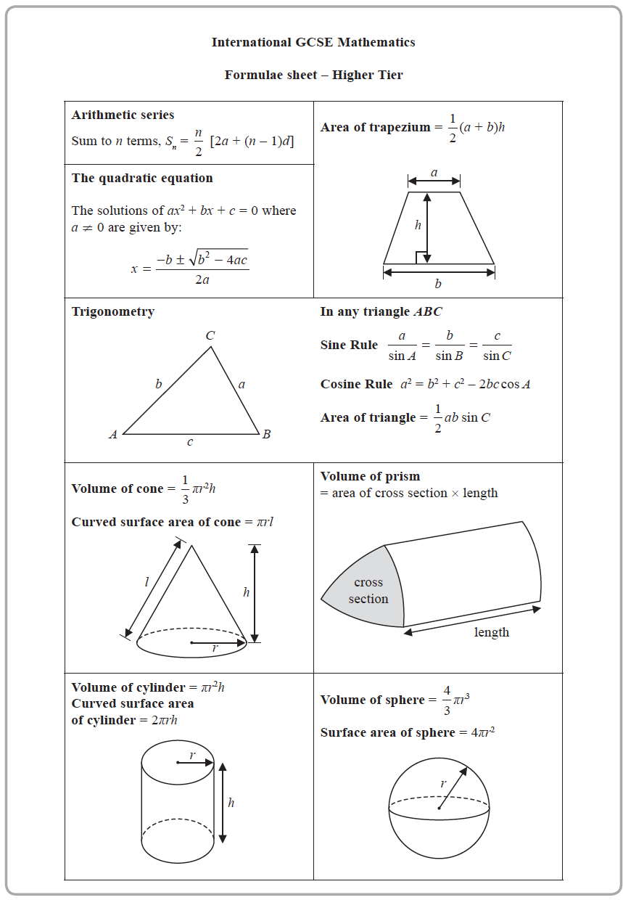
Practice for Summer Examination (Part one)

1 (a) Simplify a⁷ × a⁴

......................................................
(1)
(b) Simplify w¹⁵ ÷ w³

......................................................
(1)
(c) Simplify (8x⁵y³)²

......................................................
(2)
(d) Make t the subject of c = t ³ – 8v

......................................................
(2)
(Total for Question 1 is 6 marks)
___________________________________________________________________________

2 Danil, Gabriel and Hadley share some money in the ratios 3 : 5 : 9
The difference between the amount of money that Gabriel receives and the amount of
money that Hadley receives is 196 euros.
Work out the amount of money that Danil receives.
...................................................... euros
(Total for Question 2 is 3 marks)
___________________________________________________________________________

3 The diagram shows triangle ABC
Work out the length of the side AB
Give your answer correct to 3 significant figures.
...................................................... cm
(Total for Question 3 is 3 marks)
___________________________________________________________________________

4 Sarah makes and sells mugs.
One day she makes 150 mugs.
Her total cost for making these mugs is £1140
Of these mugs
are small mugs
32% are medium mugs
and the rest are large mugs
Here is Sarah’s price list for selling each mug.
Sarah sells all 150 mugs.
Work out her percentage profit.
Give your answer correct to the nearest whole number.
......................................................%
(Total for Question 4 is 5 marks)
___________________________________________________________________________

5 Jenny has six cards.
Each card has a whole number written on it so that
the smallest number is 5
the largest number is 24
the median of the six numbers is 14
the mode of the six numbers is 8
Jenny arranges her cards so that the numbers are in order of size.
(a) For the remaining four cards, write on each dotted line a number that could be on
the card.

(3)
A basketball team plays 6 games.
After playing 5 games, the team has a mean score of 21 points per game.
After playing 6 games, the team has a mean score of 23 points per game.
(b) Work out the number of points the team scored in its 6th game.

......................................................
(3)
(Total for Question 5 is 6 marks)
___________________________________________________________________________

6 (a) Solve the inequality 5x – 7 ≤ 2

......................................................
(2)
(b) (i) Factorise y² – 2y – 35

......................................................
(2)
(ii) Hence, solve y² – 2y – 35 = 0

......................................................
(1)
(Total for Question 6 is 5 marks)
___________________________________________________________________________

7 E = {4, 5, 6, 7, 8, 9, 10, 11, 12, 13, 14, 15}
A ∩ B = {5, 10, 15}
B' = {7, 8, 9, 11, 12, 13, 14}
A' = {4, 6, 7, 8, 14}
Complete the Venn diagram for this information.
(Total for Question 7 is 3 marks)
___________________________________________________________________________

8 a = 4.2 × 10^{–24} b = 3 × 10¹⁴⁵
Work out the value of a × b
Give your answer in standard form.

......................................................
(Total for Question 8 is 2 marks)
___________________________________________________________________________

9 The diagram shows isosceles triangle ABC
AB = AC = 17.5 cm BC = 28 cm
Calculate the area of triangle ABC

...................................................... cm²
(Total for Question 9 is 4 marks)
___________________________________________________________________________

10 Himari invests 200 000 yen for 3 years in a savings account paying compound
interest.
The rate of interest is 1.8% for the first year and x% for each of the second year and the
third year.
The value of the investment at the end of the third year is 209 754 yen.
Work out the value of x
Give your answer correct to one decimal place.

x = ......................................................
(Total for Question 11 is 3 marks)
___________________________________________________________________________

11 The table gives information about the times, in minutes, taken by 80 customers to do
their shopping in a supermarket.

Time taken (t minutes) | Frequency
0 < t ≤ 10 | 7
10 < t ≤ 20 | 26
20 < t ≤ 30 | 24
30 < t ≤ 40 | 14
40 < t ≤ 50 | 7
50 < t ≤ 60 | 2

(a) Complete the cumulative frequency table.

Time taken (t minutes) | Cumulative frequency
0 < t ≤ 10
10 < t ≤ 20
20 < t ≤ 30
30 < t ≤ 40
40 < t ≤ 50
50 < t ≤ 60

(1)
(b) On the grid on the next page, draw a cumulative frequency graph for your table.
(2)
(c) Use your graph to find an estimate for the median time taken.

...................................................... minutes
(1)
One of the 80 customers is chosen at random.
(d) Use your graph to find an estimate for the probability that the time taken by this
customer was more than 42 minutes.

......................................................
(2)
(Total for Question 12 is 6 marks)
___________________________________________________________________________

12 (a) Expand and simplify 5x(x + 2)(3x – 4)

.................................................................................
(3)
(b) Simplify completely

......................................................
(3)
(Total for Question 13 is 6 marks)
___________________________________________________________________________

13 Aika has 2 packets of seeds, packet A and packet B
There are 12 seeds in packet A and 7 of these are sunflower seeds.
There are 15 seeds in packet B and 8 of these are sunflower seeds.
Aika is going to take at random a seed from packet A and a seed from packet B
(a) Complete the probability tree diagram.
(2)
(b) Calculate the probability that Aika will take two sunflower seeds.

......................................................
(2)
(Total for Question 14 is 4 marks)
___________________________________________________________________________

14 A is inversely proportional to C ²
A = 40 when C = 1.5
Calculate the value of C when A = 1000

C = ......................................................
(Total for Question 15 is 3 marks)
___________________________________________________________________________

15 A and B are two similar vases.
Vase A has height 10 cm.
Vase B has height 15 cm.
The difference between the volume of vase A and the volume of vase B is 1197 cm³
Calculate the volume of vase A

...................................................... cm³
(Total for Question 17 is 4 marks)
___________________________________________________________________________

16
w = 3.45 correct to 2 decimal places.
x = 1.9 correct to 1 decimal place.
y = 5 correct to the nearest whole number.
Work out the lower bound of the value of A
Show your working clearly.

......................................................
(Total for Question 18 is 3 marks)
___________________________________________________________________________

17 Solve the simultaneous equations
3x² + y² – xy = 5
y = 2x – 3
Show clear algebraic working.

............................................................................................................
(Total for Question 19 is 5 marks)
___________________________________________________________________________

18 (a) Express 7 + 12x – 3x² in the form a + b(x + c)² where a, b and c are integers.

.................................................................................
(3)
C is the curve with equation y = 7 + 12x – 3x²
The point A is the maximum point on C
(b) Use your answer to part (a) to write down the coordinates of A

(..................... , .....................)
(1)
(Total for Question 20 is 4 marks)
___________________________________________________________________________

________________________________________________________________________
TOTAL FOR PAPER IS 75 MARKS

