Instructions
- Use black ink or ball-point pen.
  - Fill in the boxes at the top of this page with your name,
centre number and candidate number.
- Answer all questions.
- Without sufficient working, correct answers may be awarded no marks.
- Answer the questions in the spaces provided
– there may be more space than you need.
- Calculators may be used.
- You must NOT write anything on the formulae page.
Anything you write on the formulae page will gain NO credit.
Information
- The total mark for this paper is 100.
- The marks for each question are shown in brackets
– use this as a guide as to how much time to spend on each question.
Advice
- Read each question carefully before you start to answer it.
- Check your answers if you have time at the end.

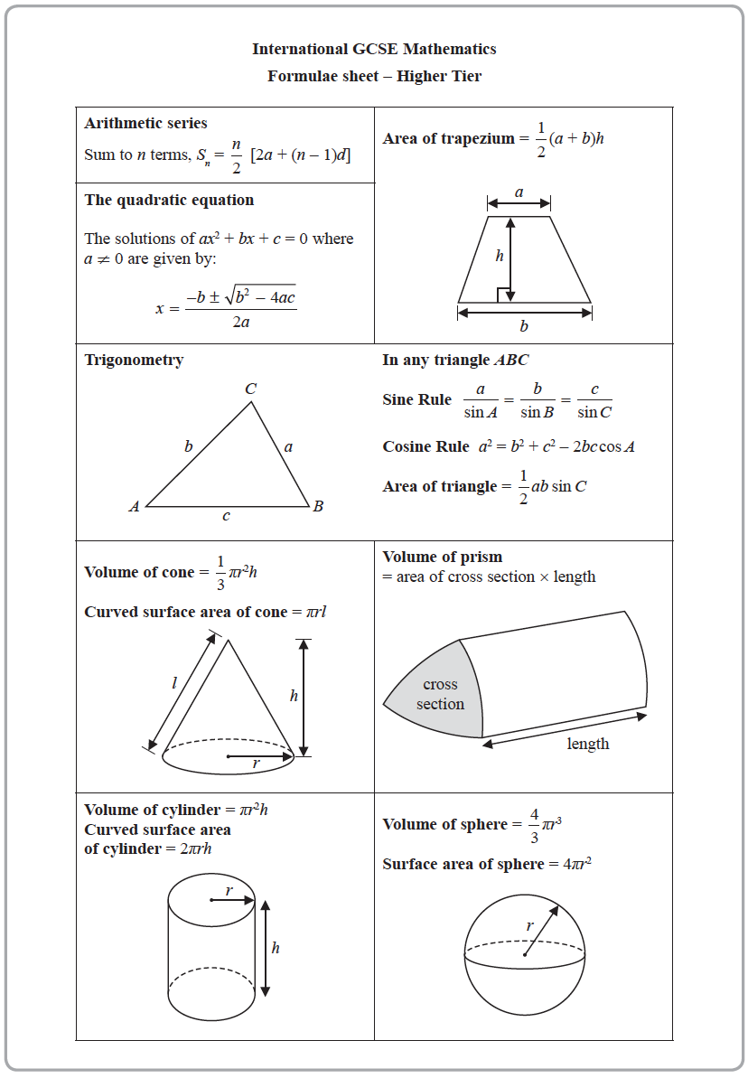
Answer ALL TWENTY FOUR questions.
Write your answers in the spaces provided.
You must write down all the stages in your working.

1 Show that

(Total for Question 1 is 3 marks)
___________________________________________________________________________

2 Jalina left her home at 10 00 to cycle to a park.
On her way to the park, she stopped at a friend’s house and then continued her journey to
the park.
Here is the distance-time graph for her journey to the park.

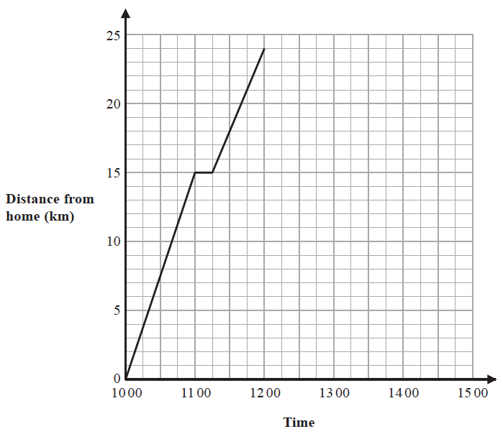

(a) On her journey to the park, did Jalina cycle at a faster speed before or after she
stopped at her friend’s house?
Give a reason for your answer.

......................................................................................................................................................
......................................................................................................................................................
......................................................................................................................................................
(1)

Jalina stayed at the park for 45 minutes.
She then cycled, without stopping, at a constant speed of 16 km/h from the park back to
her home.
(b) Show all this information on the distance-time graph.

(2)
(c) Work out Jalina’s average cycling speed, in kilometres per hour, for the complete
journey to the park and back.
Do not include the times when she was not cycling in your calculation.
Give your answer correct to 1 decimal place.

....................................................... km/h
(3)
(Total for Question 2 is 6 marks)
___________________________________________________________________________

3 (a) Simplify e⁹ ÷ e⁵

.......................................................
(1)
(b) Simplify (y²)⁸

.......................................................
(1)
(c) Expand and simplify (x + 9)(x – 2)

....................................................................
(2)
(d) Factorise fully 16c⁴p² + 20cp³

.......................................................
(2)
(Total for Question 3 is 6 marks)
___________________________________________________________________________

4 (a) Complete the table of values for y = x² − 3x − 1

x | −2 | −1 | 0 | 1 | 2 | 3 | 4
y |  |  | −1 |  | −3 |  | 3
(2)
(b) On the grid, draw the graph of y = x² − 3x – 1 for all values of x from −2 to 4
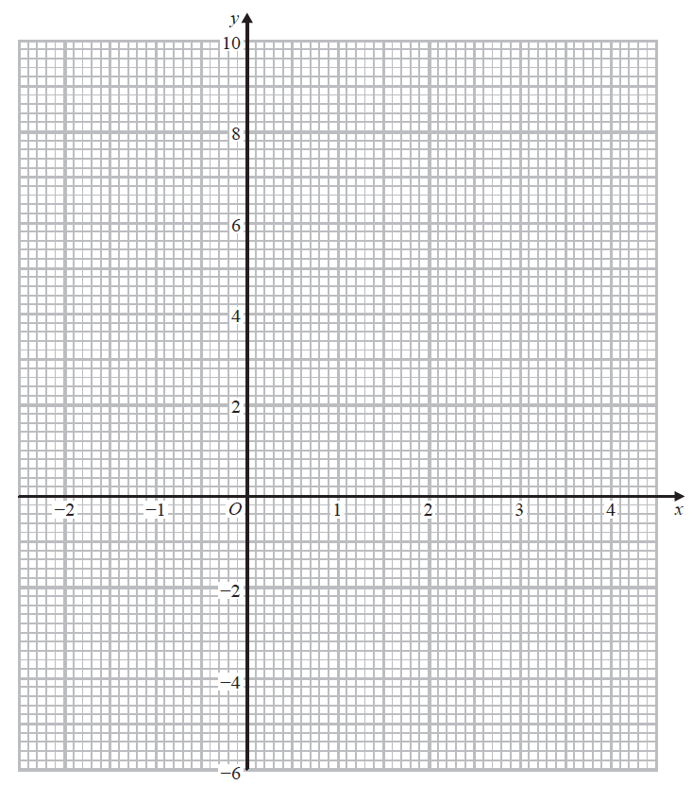
(2)
(Total for Question 4 is 4 marks)
___________________________________________________________________________

5 Becky has a biased 6-sided dice.
The table gives information about the probability that, when the dice is thrown, it will
land on each number.

Number | 1 | 2 | 3 | 4 | 5 | 6
Probability | 2x | 0.18 | 2x | 3x | 0.26 | x

Becky is going to throw the dice 200 times.
Work out an estimate for the number of times that the dice will land on an even number.

.......................................................
(Total for Question 5 is 4 marks)
___________________________________________________________________________

6 The diagram shows a solid cuboid made from wood.

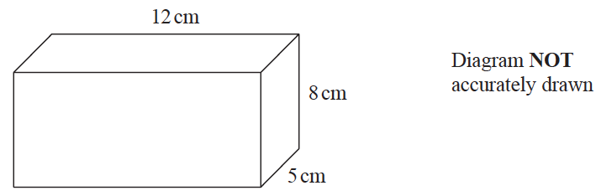

The wood has density 0.7 g/cm³
Work out the mass of the cuboid.

....................................................... grams
(Total for Question 6 is 3 marks)
___________________________________________________________________________

7 (a) Write 5.7 × 10⁶ as an ordinary number.

....................................................................
(1)
(b) Write 0.004 in standard form.

....................................................................
(1)
(c) Work out

....................................................................
(2)
(Total for Question 7 is 4 marks)
___________________________________________________________________________

8 On 1st January 2016 Li bought a boat for $170 000
The value of the boat depreciates by 8% per year.
Work out the value of the boat on 1st January 2019
Give your answer correct to the nearest dollar.

$ .......................................................
(Total for Question 8 is 3 marks)
___________________________________________________________________________

9 The diagram shows a shape made from a right-angled triangle and a semicircle.

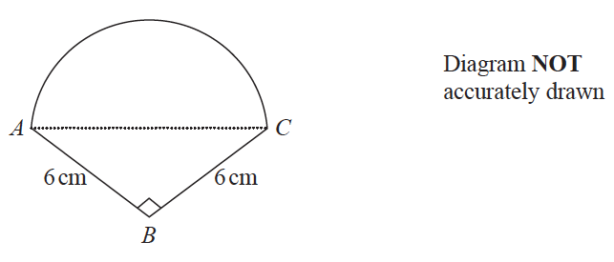

AC is the diameter of the semicircle.
BA = BC = 6 cm
Angle ABC = 90°
Work out the area of the shape.
Give your answer correct to 1 decimal place.

....................................................... cm²
(Total for Question 9 is 5 marks)
___________________________________________________________________________

10 A = 2^{n} × 3 × 5^{m}
Write 8A as a product of powers of its prime factors.

.......................................................
(Total for Question 10 is 2 marks)
___________________________________________________________________________

11 C = b − a
a = 6 correct to the nearest integer
b = 15 correct to the nearest 5
Work out the upper bound for the value of C
Show your working clearly.

.......................................................
(Total for Question 11 is 3 marks)
___________________________________________________________________________

12 (a) Factorise 2x² − 7x + 6

.......................................................
(2)
(b) Solve = 7 − 2m
Show clear algebraic working.

m = .......................................................
(4)
(c) Write in the form y^{b} where b is a fraction.

.......................................................
(2)
(Total for Question 12 is 8 marks)
___________________________________________________________________________

13 In group C, there are 6 girls and 8 boys.
In group D, there are 3 girls and 7 boys.
A team is made by picking at random one child from group C and one child from group D.
(a) Complete the probability tree diagram.

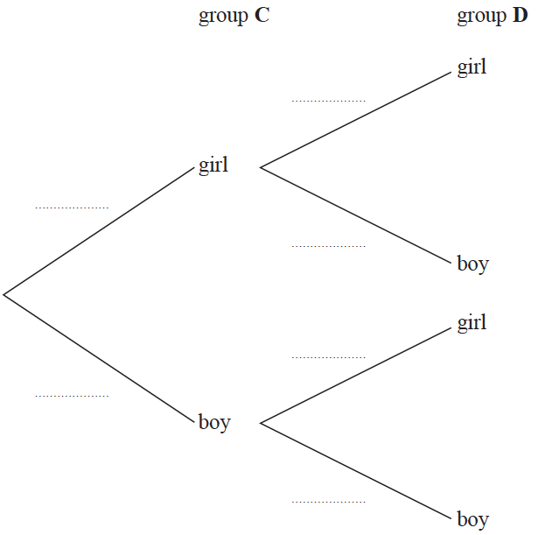
(2)
(b) Work out the probability that there are two boys in the team.

.......................................................
(2)

After the first team has been picked, a second team is picked.
One child is picked at random from the children left in group C and one child is picked
at random from the children left in group D.
(c) Work out the probability that there are two boys in each of the two teams.

.......................................................
(3)
(Total for Question 13 is 7 marks)
___________________________________________________________________________

14 E = {positive integers less than 20}
A = {x : x < 12}
B = {x : 7 ⩽ x < 16}
(a) List the members of A ∩ B

..................................................................................
(2)

C is a set such that C ⊂ A and n(C) = 3
Given that all members of C are even numbers,
(b) list the members of one possible set C.

..................................................................................
(1)
(Total for Question 14 is 3 marks)
___________________________________________________________________________

15 Use algebra to show that the recurring decimal

(Total for Question 15 is 2 marks)
___________________________________________________________________________

16 Here are the first five terms of an arithmetic sequence.

7 | 10 | 13 | 16 | 19

Find the sum of the first 100 terms of this sequence.

.......................................................
(Total for Question 16 is 2 marks)
___________________________________________________________________________

17 A and B are two similar vases.

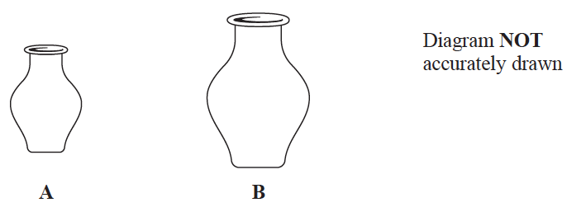

Vase A has height 24 cm.
Vase B has height 36 cm.
Vase A has a surface area of 960 cm²
(a) Work out the surface area of vase B.

....................................................... cm²
(2)

Vase B has a volume of V cm³
(b) Find in terms of V, an expression for the volume, in cm³, of vase A.

....................................................... cm³
(2)
(Total for Question 17 is 4 marks)
___________________________________________________________________________

18 The diagram shows triangle PQR.

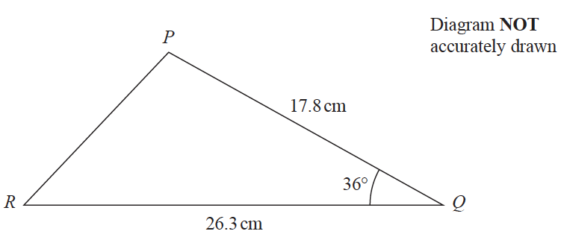

Calculate the length of PR.
Give your answer correct to 3 significant figures.

....................................................... cm
(Total for Question 18 is 3 marks)
___________________________________________________________________________

19 The table gives information about the heights of some trees.

Height (h metres) | Frequency
0 < h ⩽ 20 | 15
20 < h ⩽ 35 | 48
35 < h ⩽ 40 | 21
40 < h ⩽ 50 | 16

On the grid, draw a histogram for this information.
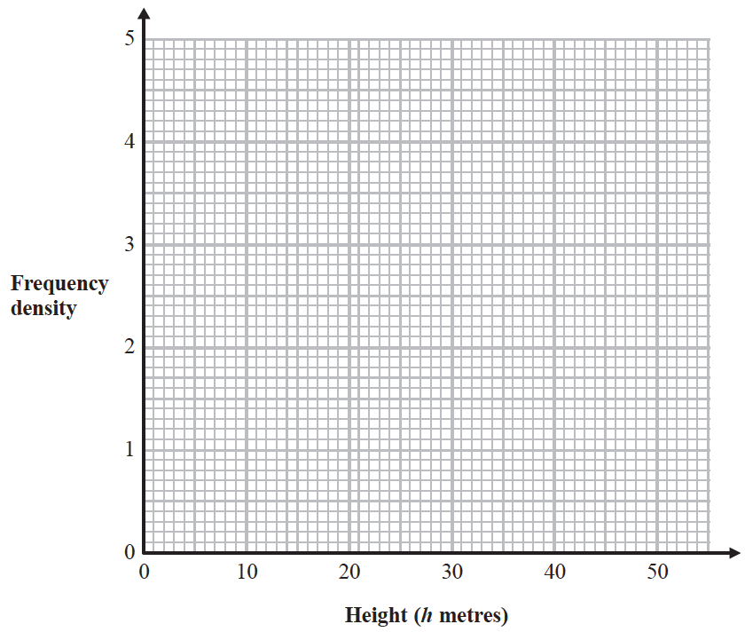

(Total for Question 19 is 3 marks)
___________________________________________________________________________

20
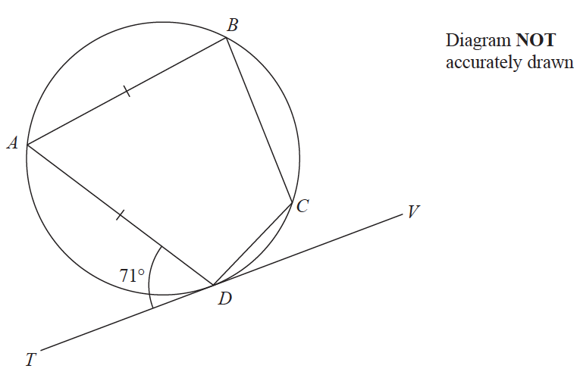

A, B, C and D are points on a circle.
TDV is the tangent to the circle at D.
AB = AD
Angle ADT = 71°
Work out the size of angle BCD.
Give a reason for each stage of your working.

....................................................... °
(Total for Question 20 is 5 marks)
___________________________________________________________________________

21 A solid is made from a hemisphere and a cylinder.
The plane face of the hemisphere coincides with the upper plane face of the cylinder.

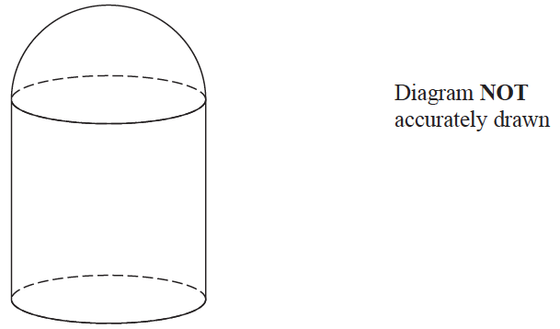

The hemisphere and the cylinder have the same radius.
The ratio of the radius of the cylinder to the height of the cylinder is 1 : 3
Given that the solid has volume 792π cm³
work out the height of the solid.

....................................................... cm
(Total for Question 21 is 5 marks)
___________________________________________________________________________

22 The graph of y = sin x° for 0 ⩽ x ⩽ 360 is drawn on the grid.
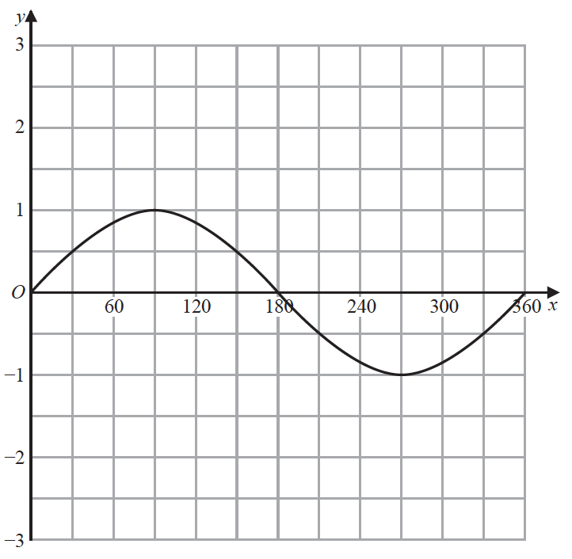
(a) On the grid, draw the graph of y = 2 sin (x + 30)° for 0 ⩽ x ⩽ 360
(2)
(b) (i) Write x² − 6x + 10 in the form (x a)² + b where a and b are integers.

.......................................................
(2)
(ii) Hence, describe fully the single transformation that maps the curve with equation
y = x² onto the curve with equation y = x² − 6x + 10
......................................................................................................................................................
......................................................................................................................................................
(2)
(Total for Question 22 is 6 marks)
___________________________________________________________________________

23 ABCD is a kite with AB = AD and CB = CD.
B is the point with coordinates (10, 19)
D is the point with coordinates (2, 7)
Find an equation of the line AC.
Give your answer in the form py + qx = r where p, q and r are integers.

.......................................................
(Total for Question 23 is 5 marks)
___________________________________________________________________________

24 A particle P is moving along a straight line that passes through the fixed point O.
The displacement, s metres, of P from O at time t seconds is given by
s = t ³ − 6t ² + 5t − 4
Find the value of t for which the acceleration of P is 3 m/s²

t = .......................................................
(Total for Question 24 is 4 marks)
___________________________________________________________________________
TOTAL FOR PAPER IS 100 MARKS

