Instructions
- Use black ink or ball-point pen.
  - Fill in the boxes at the top of this page with your name,
centre number and candidate number.
- Answer all questions.
- Without sufficient working, correct answers may be awarded no marks.
- Answer the questions in the spaces provided
– there may be more space than you need.
- Calculators may be used.
- You must NOT write anything on the formulae page.
Anything you write on the formulae page will gain NO credit.
Information
- The total mark for this paper is 100.
- The marks for each question are shown in brackets
– use this as a guide as to how much time to spend on each question.
Advice
- Read each question carefully before you start to answer it.
- Check your answers if you have time at the end.
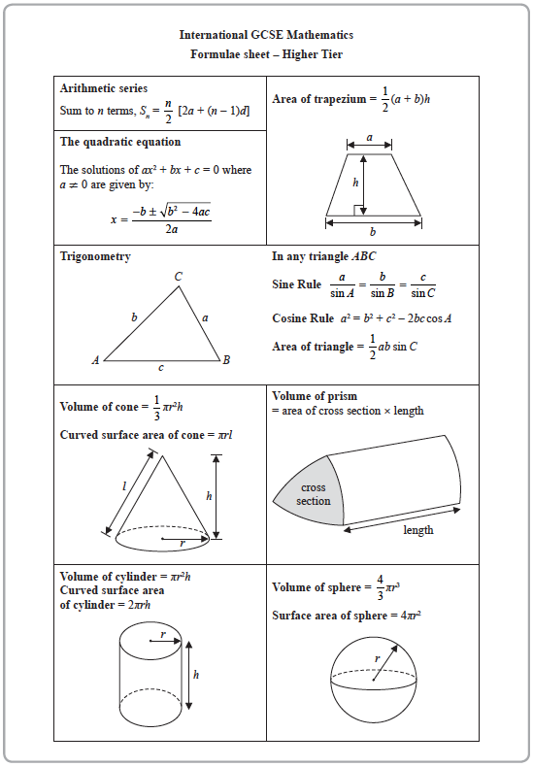
Answer ALL TWENTY ONE questions.
Write your answers in the spaces provided.
You must write down all the stages in your working.

1 (a) Factorise fully 4p + 6pq

.......................................................
(2)
(b) Expand and simplify (e + 3)(e – 5)

.......................................................
(2)
(c) Solve y =
Show clear algebraic working.

y = .......................................................
(3)
(Total for Question 1 is 7 marks)
______________________________________________________________________________

2
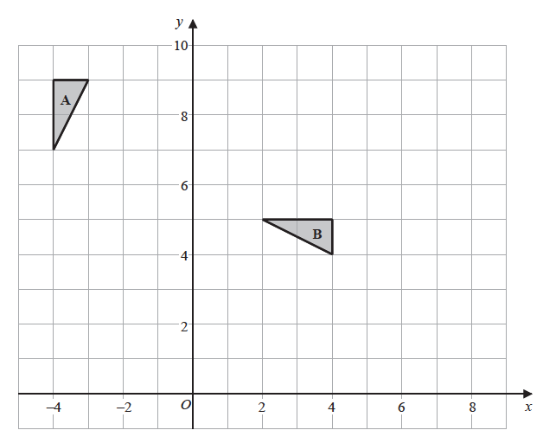
(a) Describe fully the single transformation that maps triangle A onto triangle B.
.............................................................................................................................................................
.............................................................................................................................................................
(3)
(b) On the grid, translate triangle A by the vector
Label the new triangle C.
(1)

(c) On the grid, enlarge triangle D with scale factor and centre (−4, 2)
(2)
(Total for Question 2 is 6 marks)
______________________________________________________________________________

3 Here is a biased 5-sided spinner.
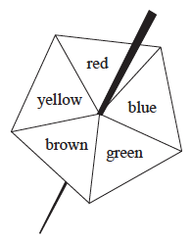

When the spinner is spun, it can land on red, blue, green, brown or yellow.
The table gives the probabilities that the spinner lands on red or on blue or on green.

Colour | red | blue | green | brown | yellow
Probability | 0.15 | 0.26 | 0.33

When the spinner is spun once, the probability that the spinner lands
on brown is 0.06 more than the probability that the spinner lands on yellow.
Jenine spins the spinner 150 times.
Work out an estimate for the number of times the spinner lands on yellow.

.......................................................
(Total for Question 3 is 4 marks)
______________________________________________________________________________

4 The table gives information about the price of gold.

 | 1st February 2016 | 1st March 2016
Price of one ounce of  gold (dollars) | 1126.50 | 1236.50

(a) Work out the percentage increase in the price of gold between 1st February 2016 and
1st March 2016
Give your answer correct to 3 significant figures.

....................................................... %
(3)

The price of one ounce of gold on 1st February 2016 was 1126.50 dollars.
The price of gold increased by 19% from 1st February 2016 to 1st July 2016
(b) Work out the price of one ounce of gold on 1st July 2016
Give your answer correct to the nearest dollar.

.......................................................dollars
(3)
(Total for Question 4 is 6 marks)
______________________________________________________________________________

5
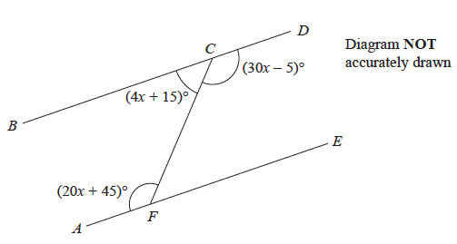
BCD and AFE are straight lines.
Show that BCD is parallel to AFE.
Give reasons for your working.

(Total for Question 5 is 5 marks)
______________________________________________________________________________

6 (a) Complete the table of values for y = x² – 5x + 6

x | 0 | 1 | 2 | 3 | 4 | 5
y | 6 |  | 0 | 0 | 2

(1)
(b) On the grid, draw the graph of y = x² – 5x + 6 for 0 ⩽ x ⩽ 5

(2)
(c) By drawing a suitable straight line on the grid, find estimates for the solutions of the
equation
x² – 5x = x – 7

.......................................................
(3)
(Total for Question 6 is 6 marks)
______________________________________________________________________________

7 The table shows the volumes, in km³, of four oceans.

Ocean | Volume (km³)
Arctic Ocean | 1.88 × 10⁷
Atlantic Ocean | 3.10 × 10⁸
Indian Ocean | 2.64 × 10⁸
Southern Ocean | 7.18 × 10⁷

(a) Write 7.18 × 10⁷ as an ordinary number.

.......................................................
(1)
(b) Calculate the total volume of these four oceans.

....................................................... km³
(2)

The volume of the South China Sea is 9 880 000 km³
(c) Write 9 880 000 in standard form.

.......................................................
(1)
(Total for Question 7 is 4 marks)
______________________________________________________________________________

8 The diagram shows an isosceles triangle.

The area of the triangle is 12 cm²
Work out the perimeter of the triangle.
Give your answer correct to 3 significant figures.

.......................................................cm
(Total for Question 8 is 4 marks)
______________________________________________________________________________

9 The table shows information about the speeds of 60 cycles.

Speed (s km/h) | Frequency
0 < s ⩽ 10 | 3
10 < s ⩽ 20 | 16
20 < s ⩽ 30 | 24
30 < s ⩽ 40 | 10
40 < s ⩽ 50 | 5
50 < s ⩽ 60 | 2

(a) Complete the cumulative frequency table.

Speed (s km/h) | Cumulative frequency
0 < s ⩽ 10
0 < s ⩽ 20
0 < s ⩽ 30
0 < s ⩽ 40
0 < s ⩽ 50
0 < s ⩽ 60
(1)
(b) On the grid, draw a cumulative frequency graph for your table.

(2)
(c) Use your graph to find an estimate for the interquartile range of the speeds.

....................................................... km/h
(2)
(Total for Question 9 is 5 marks)
______________________________________________________________________________

10 Here is triangle ABD.

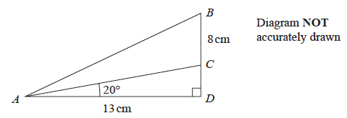

The point C lies on BD.
AD = 13 cm BC = 8 cm angle ADB = 90° angle CAD = 20°
Calculate the size of angle BAC.
Give your answer correct to 1 decimal place.

....................................................... °
(Total for Question 10 is 5 marks)
______________________________________________________________________________

11 Express as a single fraction in its simplest terms.

.......................................................
(Total for Question 11 is 3 marks)
______________________________________________________________________________

13 All the students in Year 11 at a school must study at least one of Geography (G), History (H)
and Religious Studies (R).
In Year 11 there are 65 students.
Of these students
15 study Geography, History and Religious Studies
21 study Geography and History
16 study Geography and Religious Studies
30 study Geography
18 study only Religious Studies
37 study Religious Studies
(a) Using this information, complete the Venn diagram to show the number of students in
each region of the Venn diagram.

E

(3)

A student in Year 11 who studies both History and Religious Studies is chosen at random.
(b) Work out the probability that this student does not study Geography.

.......................................................
(2)
(Total for Question 13 is 5 marks)
______________________________________________________________________________

14 T is directly proportional to the cube of r
T = 21.76 when r = 4
(a) Find a formula for T in terms of r

.......................................................
(3)
(b) Work out the value of T when r = 6

.......................................................
(1)
(Total for Question 14 is 4 marks)
______________________________________________________________________________

15 The total surface area of a solid hemisphere is equal to the curved surface area of a cylinder.
The radius of the hemisphere is r cm.
The radius of the cylinder is twice the radius of the hemisphere.
Given that
volume of hemisphere : volume of cylinder = 1 : m
find the value of m.

m = .......................................................
(Total for Question 15 is 4 marks)
______________________________________________________________________________

16 (a) Rationalise the denominator of where a is an integer and b is a prime number.
Simplify your answer.

.......................................................
(3)
(b) Given that where x ≠ y
find the value of m.

m = .......................................................
(1)
(Total for Question 16 is 4 marks)
______________________________________________________________________________

20 A bowl contains n pieces of fruit.
Of these, 4 are oranges and the rest are apples.
Two pieces of fruit are going to be taken at random from the bowl.
The probability that the bowl will then contain (n – 6) apples is
Work out the value of n
Show your working clearly.

.......................................................
(Total for Question 20 is 6 marks)
______________________________________________________________________________

21 (2x + 23), (8x + 2) and (20x – 52) are three consecutive terms of an arithmetic sequence.
Prove that the common difference of the sequence is 12

.......................................................
(Total for Question 21 is 4 marks)
______________________________________________________________________________

TOTAL FOR PAPER IS ?? MARKS

