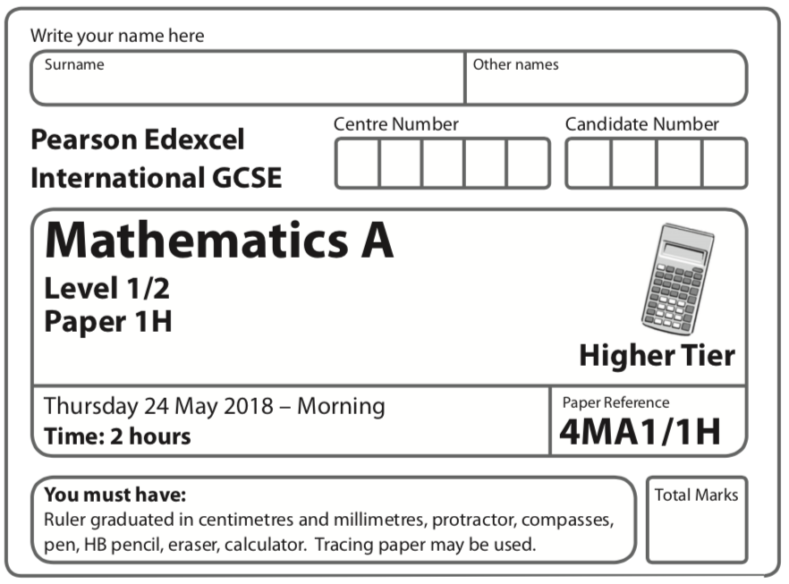
Instructions
- Use black ink or ball-point pen.
  - Fill in the boxes at the top of this page with your name,
centre number and candidate number.
- Answer all questions.
- Without sufficient working, correct answers may be awarded no marks.
- Answer the questions in the spaces provided
– there may be more space than you need.
- Calculators may be used.
- You must NOT write anything on the formulae page.
Anything you write on the formulae page will gain NO credit.
Information
- The total mark for this paper is 100.
- The marks for each question are shown in brackets
– use this as a guide as to how much time to spend on each question.
Advice
- Read each question carefully before you start to answer it.
- Check your answers if you have time at the end.

Answer all TWENTY questions.

Write your answers in the spaces provided.

You must write down all the stages in your working.

1 The table shows information about the weights, in kg, of 40 parcels.

Weight of parcel ( p kg) | Frequency
0 < p ⩽ 1 | 19
1 < p ⩽ 2 | 12
2 < p ⩽ 3 | 5
3 < p ⩽ 4 | 2
4 < p ⩽ 5 | 2

(a) Write down the modal class.

.......................................................
(1)
(b) Work out an estimate for the mean weight of the parcels.

....................................................... kg
(4)
(Total for Question 1 is 5 marks)
____________________________________________________________________________

2 There are some people in a cinema.
of the people in the cinema are children.
For the children in the cinema,
number of girls : number of boys = 2 : 7
There are 170 girls in the cinema.
Work out the number of adults in the cinema.

.......................................................
(Total for Question 2 is 5 marks)
____________________________________________________________________________
3 (a) Simplify y⁵ × y⁹

.......................................................
(1)
(b) Simplify (2m³)⁴

.......................................................
(2)
(c) Solve 5(x + 3) = 3x – 4
Show clear algebraic working.

x = .......................................................
(3)
(d) (i) Factorise x² + 2x – 24

.......................................................
(2)
(ii) Hence, solve x² + 2x – 24 = 0

.......................................................
(1)
(Total for Question 3 is 9 marks)
____________________________________________________________________________
4 Here is a Venn diagram.

E

(a) Write down the numbers that are in the set
(i) A

....................................................................
(ii)

....................................................................
(2)

Brian writes down the statement = Ø
(b) Is Brian’s statement correct?
You must give a reason for your answer.
.........................................................................................................................................................
.........................................................................................................................................................
(1)

One of the numbers in the Venn diagram is picked at random.
(c) Find the probability that this number is in set C ′

.......................................................
(2)
(Total for Question 4 is 5 marks)
____________________________________________________________________________

5 (a) Write 8 × 10⁴ as an ordinary number.

.......................................................
(1)
(b) Work out (3.5 × 10⁵) ÷ (7 × 10⁸)
Give your answer in standard form.

.......................................................
(2)
(Total for Question 5 is 3 marks)
____________________________________________________________________________

6

M, N and P are points on a circle, centre O.
MON is a diameter of the circle.
MP = 3.5 cm
PN = 9.7 cm
Angle MPN = 90°
Work out the circumference of the circle.
Give your answer correct to 3 significant figures.

....................................................... cm
(Total for Question 6 is 4 marks)
____________________________________________________________________________

7 Chao bought a boat for HK$160 000.
The value of the boat depreciates by 4% each year.
(a) Work out the value of the boat at the end of 3 years.
Give your answer correct to the nearest HK$.

HK$.......................................................
(3)

Jalina gets a salary increase of 5%
Her salary after the increase is HK$252 000.
(b) Work out Jalina’s salary before the increase.

HK$.......................................................
(3)
(Total for Question 7 is 6 marks)
____________________________________________________________________________

8 A = 3⁵ × 5 × 7³
B = 2³ × 3 × 7⁴
(a) (i) Find the Highest Common Factor (HCF) of A and B.

.......................................................
(ii) Find the Lowest Common Multiple (LCM) of A and B.

.......................................................
(2)

A = 3⁵ × 5 × 7³
B = 2³ × 3 × 7⁴
C = 2^{p} × 5^{q} × 7^{r}
Given that
the HCF of B and C is 2³ × 7
the LCM of A and C is 2⁴ × 3⁵ × 5² × 7³
(b) find the value of p, the value of q and the value of r.

p = .......................................................
q = .......................................................
r = .......................................................
(2)
(Total for Question 8 is 4 marks)
____________________________________________________________________________
9 The diagram shows a right-angled triangle.

Five of these triangles are put together to make a shape.

Calculate the perimeter of the shape.
Give your answer correct to 3 significant figures.

....................................................... cm
(Total for Question 9 is 5 marks)
____________________________________________________________________________
10 The cumulative frequency graph shows information about the length, in minutes, of each
of 80 films.

(a) Use the graph to find an estimate for the interquartile range.

....................................................... minutes
(2)

Clare says,
“More than 35% of these films are over 120 minutes long.”
(b) Is Clare correct?
Give a reason for your answer.

.........................................................................................................................................................
.........................................................................................................................................................
(3)
(Total for Question 10 is 5 marks)
____________________________________________________________________________

11 (a) Expand and simplify (2x – 1)(x + 3)(x – 5)

...................................................................................
(3)
(b) Solve 3x² + 6x – 5 = 0
Show your working clearly.
Give your solutions correct to 3 significant figures.

.......................................................
(3)
(Total for Question 11 is 6 marks)
____________________________________________________________________________

12 The diagram shows two straight lines drawn on a grid.
(a) Write down the solution of the simultaneous equations
3y = | 2x + 6
4x + 3y = | 24

x = .......................................................
y = .......................................................
(1)
(b) Show, by shading on the grid, the region defined by all five of the inequalities
x ⩾ 0 | y ⩾ 0 | x + y ⩾ 4 | 3y ⩽ 2x + 6 | 4x + 3y ⩽ 24

Label the region R.

(3)
(Total for Question 12 is 4 marks)
____________________________________________________________________________
13

L, M and N are points on a circle, centre O.
QMT is the tangent to the circle at M.
(a) (i) Find the size of angle NOM.

....................................................... °

(ii) Give a reason for your answer.
.........................................................................................................................................................

.........................................................................................................................................................
(2)
(b) (i) Find the size of angle NMQ.

.......................................................

(ii) Give a reason for your answer.
.........................................................................................................................................................

.........................................................................................................................................................
(2)
(Total for Question 13 is 4 marks)
____________________________________________________________________________

15 (a) Simplify fully

.......................................................
(2)
(b) Express as a single fraction in its simplest form.

.......................................................
(3)
(Total for Question 15 is 5 marks)
____________________________________________________________________________
16 A frustum is made by removing a small cone from a large cone.
The cones are mathematically similar.

The large cone has base radius r cm and height h cm.
Given that

volume of frustum | =
volume of large cone | =

find an expression, in terms of h, for the height of the frustum.

....................................................... cm
(Total for Question 16 is 4 marks)
____________________________________________________________________________
19 Jack plays a game with two fair spinners, A and B.
Spinner A can land on the number 2 or 3 or 5 or 7.
Spinner B can land on the number 2 or 3 or 4 or 5 or 6.
Jack spins both spinners.
He wins the game if one spinner lands on an odd number and the other spinner lands on
an even number.
Jack plays the game twice.
Work out the probability that Jack wins the game both times.

.......................................................
(Total for Question 19 is 4 marks)
____________________________________________________________________________

____________________________________________________________________________

TOTAL FOR PAPER IS ??? MARKS

