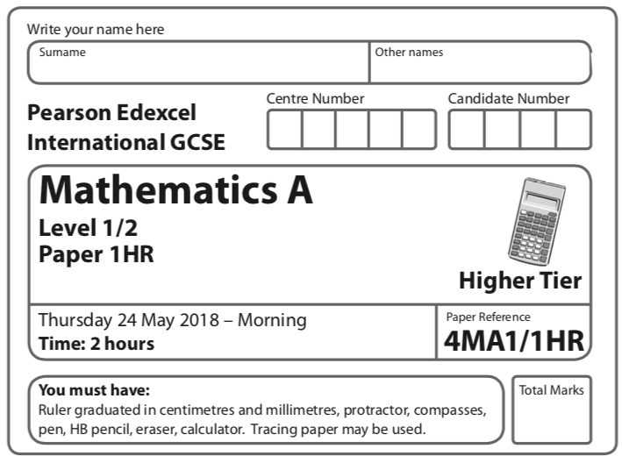
Instructions
- Use black ink or ball-point pen.
  - Fill in the boxes at the top of this page with your name,
centre number and candidate number.
- Answer all questions.
- Without sufficient working, correct answers may be awarded no marks.
- Answer the questions in the spaces provided
– there may be more space than you need.
- Calculators may be used.
- You must NOT write anything on the formulae page.
Anything you write on the formulae page will gain NO credit.
Information
- The total mark for this paper is 100.
- The marks for each question are shown in brackets
– use this as a guide as to how much time to spend on each question.
Advice
- Read each question carefully before you start to answer it.
- Check your answers if you have time at the end.

Answer ALL TWENTY THREE questions.

Write your answers in the spaces provided.

You must write down all the stages in your working.

1 Here is a hexagon ABCDEF.

CD is parallel to AF.
Work out the area of hexagon ABCDEF.

....................................................... cm²
(Total for Question 1 is 4 marks)
____________________________________________________________________________
2 The table gives information about the times, in hours, some students spent doing sport
one week.

Time (T hours) | Frequency
0 < T ⩽ 2 | 5
2 < T ⩽ 4 | 9
4 < T ⩽ 6 | 24
6 < T ⩽ 8 | 40
8 < T ⩽ 10 | 7

Calculate an estimate for the mean time these students spent doing sport.
Give your answer in hours, correct to 1 decimal place.

....................................................... hours
(Total for Question 2 is 4 marks)
____________________________________________________________________________

3

(a) Reflect triangle S in the line y = x
Label the new triangle R.
(2)
(b) Translate triangle S by the vector
Label the new triangle T.
(1)
(Total for Question 3 is 3 marks)
____________________________________________________________________________

4 Anna and Lionel share $675 in the ratio 4 : 5
Lionel gives of his share of the money to his mother.
How much money does Lionel give to his mother?

$.......................................................
(Total for Question 4 is 3 marks)
____________________________________________________________________________

5 E = n² + n + 5
Ali thinks that the value of E will be a prime number for any whole number value of n.
Is Ali correct?
You must give a reason for your answer.

.........................................................................................................................................................
.........................................................................................................................................................
(Total for Question 5 is 2 marks)
____________________________________________________________________________

6

ABC and DEF are parallel lines.
BG = BE
Angle DEG = 38°
Angle GEB = 65°
Find the size of angle ABG.

....................................................... °
(Total for Question 6 is 3 marks)
____________________________________________________________________________

7 Here are the first four terms of an arithmetic sequence.
6 | 10 | 14 | 18

(a) Find an expression, in terms of n, for the nth term of this sequence.

.......................................................
(2)
(b) Write down an expression, in terms of n, for the (n + 1)th term of this sequence.

.......................................................
(1)
(Total for Question 7 is 3 marks)
____________________________________________________________________________

8 (a) Write 1 390 000 in standard form.

..................................................................................
(1)
(b) Write 0.005 in standard form.

..................................................................................
(1)
(Total for Question 8 is 2 marks)
____________________________________________________________________________

9 Here is an empty pool in the shape of a cuboid.

The width of the pool is 3 m.
The length of the pool is 12 m.
The top of the pool is 2.5 m above the base of the pool.
Jeb is going to put water in the pool.
The level of the surface of the water will be 60 cm below the top of the pool.
Water flows into the pool at 400 litres per minute.
1 m³ = 1000 litres
How long will it take to fill the pool to 60 cm below the top of the pool?
Give your answer in hours and minutes.

............................ hours ............................ minutes
(Total for Question 9 is 4 marks)
____________________________________________________________________________
10 Solve
3x + 2y = 15
10x − 4y = 2
Show clear algebraic working.

x = .......................................................
y = .......................................................
(Total for Question 10 is 3 marks)
____________________________________________________________________________

11 Change a speed of 72 kilometres per hour to a speed in metres per second.

....................................................... metres per second
(Total for Question 11 is 3 marks)
____________________________________________________________________________
12 A company makes cars.
In 2016, the company made 350 cars.
In the first 6 months of 2017, the company made 25 cars each month.
In the last 6 months of 2017, the company made 45 cars each month.
(a) Work out the percentage increase in the number of cars the company made from
2016 to 2017.

....................................................... %
(4)

The company’s income in 2017 was $500 000 more than the company’s income in 2016.
The company’s income in 2017 was 8% more than the company’s income in 2016.
(b) Work out the company’s income in 2016.

$.......................................................
(3)
(Total for Question 12 is 7 marks)
____________________________________________________________________________
13 Each month Edna spends all her income on rent, on travel and on other living expenses.
She spends of her income on rent.
She spends of her income on travel.
She spends $420 of her income on other living expenses.
Work out her income each month.

$.......................................................
(Total for Question 13 is 4 marks)
____________________________________________________________________________
14 (a) Simplify (2e² f ³)³

.......................................................
(2)
(b) Expand and simplify (3x − 4y)(x + 3y)

.......................................................
(2)

can be written in the form a ^{k}
(c) Find the value of k.

k = .......................................................
(2)
(d) Simplify

.......................................................
(2)
(Total for Question 14 is 8 marks)
____________________________________________________________________________
15 There are two bags of counters, bag X and bag Y.
There are 20 counters in bag X.
11 of the counters are blue and the rest are red.
There are 16 counters in bag Y.
9 of the counters are blue and the rest are red.
Arkady takes at random a counter from bag X and takes at random a counter from bag Y.
(a) Complete the probability tree diagram.

(3)
(b) Work out the probability that the two counters are both red.

.......................................................
(2)
(c) Work out the probability that the two counters are both red or are both blue.

.......................................................
(3)
(Total for Question 15 is 8 marks)
____________________________________________________________________________

16

The points B, C, Y and X lie on a circle.
AXY and ABC are straight lines.
AX = 12 cm | XY = x cm | AB = x cm | BC = 4 cm

(a) Show that x² – 8x – 144 = 0

(3)
(b) Find the length of AC.
Show your working clearly.
Give your answer correct to 3 significant figures.

....................................................... cm
(4)
(Total for Question 16 is 7 marks)
____________________________________________________________________________

17 The table gives information about the areas, in hectares, of some farms in Spain.

Area (A hectares) | Frequency
0 < A ⩽ 20 | 40
20 < A ⩽ 50 | 90
50 < A ⩽ 100 | 140
100 < A ⩽ 300 | 140
300 < A ⩽ 350 | 40

On the grid, draw a histogram for this information.

(Total for Question 17 is 3 marks)
____________________________________________________________________________

21 (a) Show that x(x – 1)(x + 1) = x³ – x

(1)
(b) Prove that the difference between a whole number and the cube of this number is
always a multiple of 6.

(3)
(Total for Question 21 is 4 marks)
____________________________________________________________________________

22 A 3-D shape consists of a hollow sphere made of metal.
The diagram shows a cross section drawn through the centre, O, of the sphere.
The internal radius of the sphere is 1.2 m.
The thickness of the metal is t cm.
The density of the metal is 2700 kg per m³
The mass of the 3-D shape is 1980 kg.
Work out the value of t.
Give your answer correct to 2 significant figures.

t = .......................................................
(Total for Question 22 is 5 marks)
____________________________________________________________________________
23 Work out the sum of the multiples of 3 between 1 and 1000.

.......................................................
(Total for Question 23 is 4 marks)
____________________________________________________________________________

TOTAL FOR PAPER IS ?? MARKS

