Level 1 – Using Formatting, Simple Formula & Sorts

1. Open the spreadsheet called ‘Burgers’ and save it to your area.

2. Correct the width of the columns so that all the data shows properly
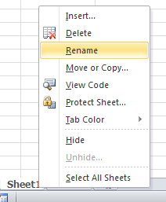
- Place the cursor between the column headings so you see a two headed arrow.
- Hold the right hand mouse button down and move he line

3. Rename the sheet tab as ‘burgers’.
- Using the mouse, left click on the tab and choose rename.

4. Make the headings in cells B2, C2 and D2 bold, red and size 12. Adjust the width of the columns as necessary.

5. In column D3, write a formula to calculate the calories that are not from ‘Fat’.

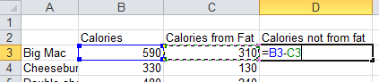
- Top tip: a formula always starts with an = sign.
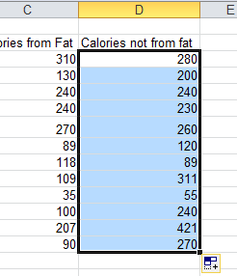
- You can copy a formula into other cells. Excel will automatically change the row or column references. This is called replication.
- Click on the cell where you entered the formula. Point at the bottom right hand corner and your mouse changes to a + sign.
- Hold the left hand mouse button down and drag the formula down the cells.
- The formula will be copied into the cells.

6.
- In cell C15, write the word ‘Average’.
- In cell C 16, write the word ‘Highest’
- In cell C 17, write the word ‘Lowest’
- In cell C18, write the word ‘Number in column’
- Make these words bold.

7a. In cell D15, write a formula to work out the average of cells D3 to D14
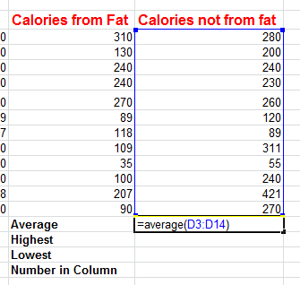

- Enter =average(
- Then use the mouse to select all of the numbers you want to find the average for.
- Close the bracket ) and press enter.

7b. In cell D16, write a formula to find the highest number in cells D3 to D14

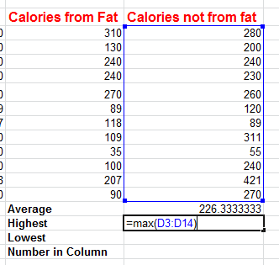

- Enter =max(
- Then use the mouse to select all of the numbers where you want to find the highest (maximum) value.
- Close the bracket ) and press enter.

7c. In cell D17, write a formula to find out the lowest number in cells D3 to D14
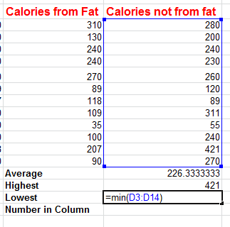
- Enter =min(
- Then use the mouse to select all of the numbers where you want to find the highest (minimum) value.
- Close the bracket ) and press enter.

7d. Format these answers as ‘number’ to 2 dp
- Select the numbers in cells D15 to D17.
- Right click with the mouse over the cells and choose Format.
- Choose Number format and set the number of decimal places to 2, as shown below.
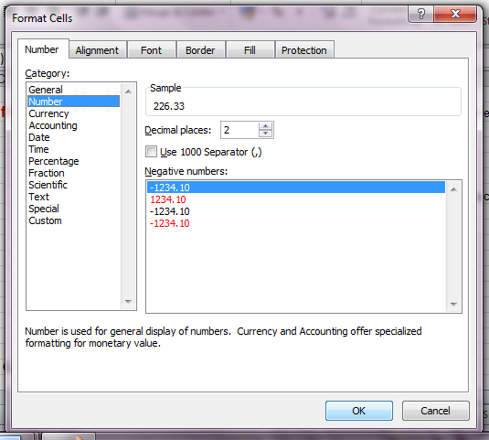

8. Highlight cells A3 to D14 and sort them on ‘calories from fat’ in descending order, so that the foods with the most fat are at the top.
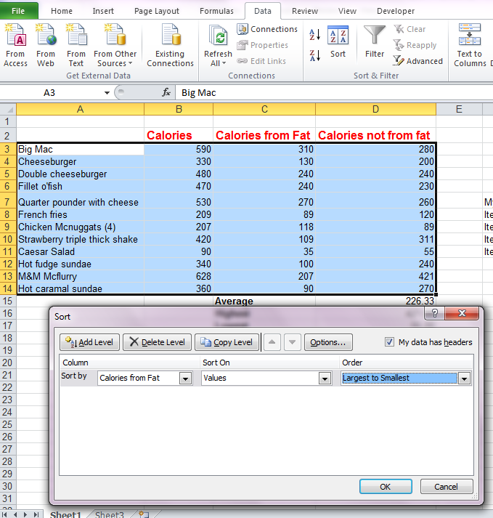

- Select cells A3 to D14
- From the Data ribbon, choose the A-Z option.
- A Sort window appears.
- Choose Calories from fat to Sort by.
- Set the Order to Largest to Smallest.

Level 2 - Adding Pie Charts

9. Go to cell F7.

10. Make the headings in cells F7, G7 and H7 bold and centre aligned.

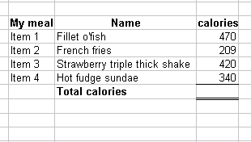
11. In cells G8, G9, G10 and G11 pick 4 items from the list of burgers/foods and write their names.

In cells H8, H9, H10, H11 enter the calories for each item

12. Make ‘total calories’ in cell G12 bold.

13. Put a border into cell H12 as shown in the diagram, so that there is a single line at the top of the cell and a double line at the bottom.


14. In cell H12, add up the total number of calories in your meal choice by using the ‘autosum’ button.


15. Highlight cells G8 to H11 and create a pie chart.
- Select the cells then go to Insert and choose a pie chart.

- From the Layout menu (make sure you are clicked on the chart or this menu won’t appear) choose Chart Title and add the title “My Menu Choice”.
- Go to the ‘data labels’ tab and choose an option.
- Position your chart underneath your menu choice.

Level 3 – Using Absolute Cell References and

the If Function

The burger chain are holding a promotion. They are going to increase portion sizes by 12.5%. You will need to adjust the values for your meal. Read on for how to do this.
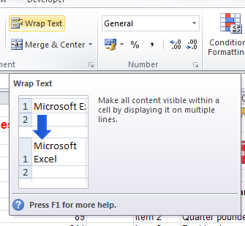
16. The title in cell I7 is too long. Make row 7 wider and use wrap the text to make the title go onto two lines.

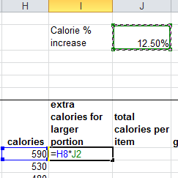
17. The value of 12.5% has been written into cell J2 – have a look.

In cell I8 multiply the calories for your first item of food by the 12.5% increase in cell J2 (don’t just write in 12.5%, make sure you multiply by the number in the correct cell).

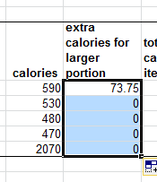
Drag the formula in cell I8 down to cells I9, I10 and I11. Do the answers look right? They probably don’t. They probably look like the example on the left. Because the cell reference changes, the value is multiplied by 0 instead of 12.5%.

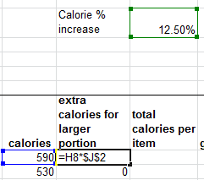
To make the formula work we need to use an absolute cell reference before? You use these when you don’t want Excel to be too clever and change cells for you. Go back to cell I8 and try putting a $ before the J and a $ before the 2 so it looks like $J$2, shown in the image on the right. Press ‘Enter’ and now try dragging your formula down, it should work this time.

18. In cell J8, write a formula to add together the original amount of calories per item and the extra amount of calories. Copy the formula to J9, J10, J11.

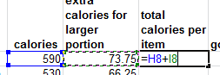
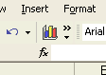
19. In cell K8, use the fx tool to write an IF formula.
If the value in cell J8 is less than 450 calories, you want the word ‘Good’ to display. If the value in cell J8 is not less than 450 calories, you want the word ‘Bad’ to display.

Your ‘IF’ formula should look something like this

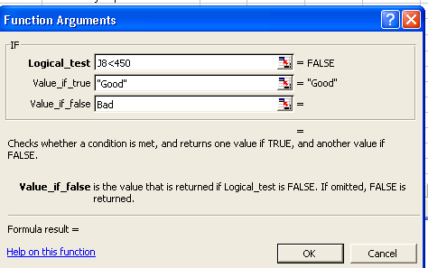
When you have written it, copy the formula in cell K8 to K9, K10 and K11 and check to see if it has put the right words next to the calorie values.

20. Insert your name as a header
- Go to View, Page Layout View to do this

21. Go to Print BUT before you print out, set the page orientation to landscape and choose scaling to fit on one page.

22. Show your formulas
- Go to Formulas, Show formula to do this.
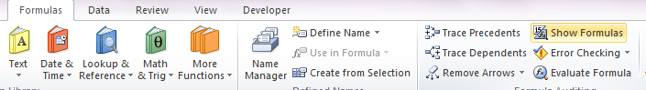

24. Print your work again. Check that it does fit to one page with all of the data showing.

