Name: _______________________________________________
Carbohydrates, inorganic ions and water
Date:
Time: 20 minutes
Total marks available: 20
Total marks achieved: ______

Questions
Q1.
Draw a diagram to show the molecules produced when two molecules of the monomer below join
together during a condensation reaction.
(3)
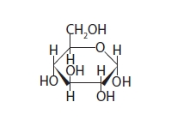

Q2.
Explain how the dipolar nature of water is essential for living organisms.
(2)
.............................................................................................................................................
.............................................................................................................................................
.............................................................................................................................................
.............................................................................................................................................
.............................................................................................................................................
.............................................................................................................................................

Q3.
Mineral ions such as calcium, nitrate and magnesium are transported in the xylem
vessels. These mineral ions are dissolved in water.
Explain how calcium, nitrate and magnesium ions are used by plants.
(3)
.............................................................................................................................................
.............................................................................................................................................
.............................................................................................................................................
.............................................................................................................................................
.............................................................................................................................................
.............................................................................................................................................
.............................................................................................................................................
.............................................................................................................................................
.............................................................................................................................................
.............................................................................................................................................
.............................................................................................................................................
.............................................................................................................................................

Q4.
Enzymes act as biological catalysts.
Amylase is an enzyme present in saliva that catalyses the hydrolysis of starch into maltose.
*(a) Describe the structure of starch.
(5)
.............................................................................................................................................
.............................................................................................................................................
.............................................................................................................................................
.............................................................................................................................................
.............................................................................................................................................
.............................................................................................................................................
.............................................................................................................................................
.............................................................................................................................................
.............................................................................................................................................
.............................................................................................................................................
.............................................................................................................................................
.............................................................................................................................................
(b) Explain the meaning of the following terms.
(i) Condensation
(2)
.............................................................................................................................................
.............................................................................................................................................
.............................................................................................................................................
.............................................................................................................................................
.............................................................................................................................................
.............................................................................................................................................
(ii) Hydrolysis
(2)
.............................................................................................................................................
.............................................................................................................................................
.............................................................................................................................................
.............................................................................................................................................
.............................................................................................................................................
.............................................................................................................................................
(c) Bread contains a high proportion of starch. If bread is chewed for a long period of time it begins to taste sweet.
Suggest why bread tastes sweet after chewing for a long period of time.
(1)
.............................................................................................................................................
.............................................................................................................................................
.............................................................................................................................................
.............................................................................................................................................
(Total for question = 10 marks)

Q5.
Glucose exists in two different forms called α-glucose and β-glucose.
The diagram shows the structure of an α-glucose molecule.
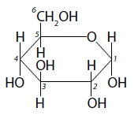
Draw the products that are formed from a condensation reaction between two α-glucose molecules.
(2)

(Total for question = 2 marks)

Examiner's Report
Q1.
A common error here was the discussion that the enzyme would be denatured, rather than the active site. Nevertheless, many then went on to correctly identify that the active site shape would change and this would prevent the formation of enzyme-substrate complexes. As a result over 50% of candidates gained the maximum two marks for this question.
Most candidates correctly included the presence of water as a result of the reaction.
Almost 40% of candidates also drew the correct glycosidic bond together with the remaining groups drawn correctly, giving them the maximum three marks.
A common error was to omit the H on C5 or to fail to show the glyosidic bond correctly.
A few candidates did not try this question or chose to join the wrong molecules, e.g. amino acids despite being given a diagram of molecule R to copy and use.
This response gained all three marks.
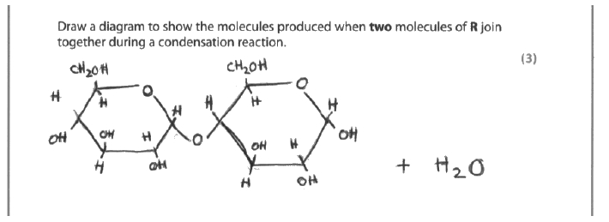
Results Plus: Examiner Comments
This is a typical example of the many complete correct response we saw.

This response gained two of the available marks.
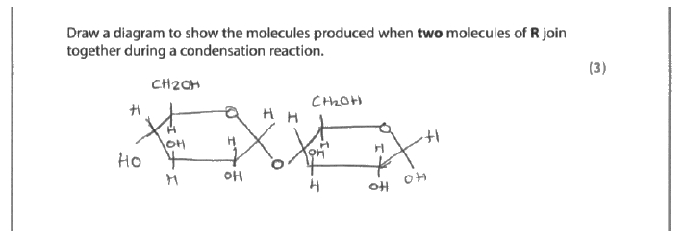
Results Plus: Examiner Comments
This candidate has drawn the disaccharide produced correctly, but unfortunately ignored the water that has been produced from the condensation reaction.

This response gained no marks.
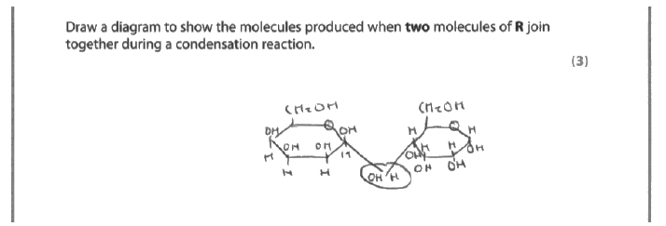
Results Plus: Examiner Comments
This candidate has drawn the disaccharide produced correctly, but unfortunately ignored the water that has been produced from the condensation reaction.

Q2.
A significant number of candidates either failed to describe the dipole nature of water or did so inaccurately. Common answers referred to the positive and negative charges on the hydrogen and oxygen, which was incorrect. Others did identify that these were slight charges and so gained the mark. Others gave the idea that water can form hydrogen bonds.
However, many candidates identified an essential property of water, e.g. it is a good solvent or referred to its cohesive and adhesive or thermal properties. However, without the inclusion of an accurate description of the charges or hydrogen bonding this gave many candidates a maximum score of only one mark.
Some candidates, when describing the ability of water to dissolve and/or transport molecules they failed to qualify this with reference to ions and/or polar molecules (or suitable examples) and so failed to get the credit here, as not everything is soluble in water.
This response gained both available marks.
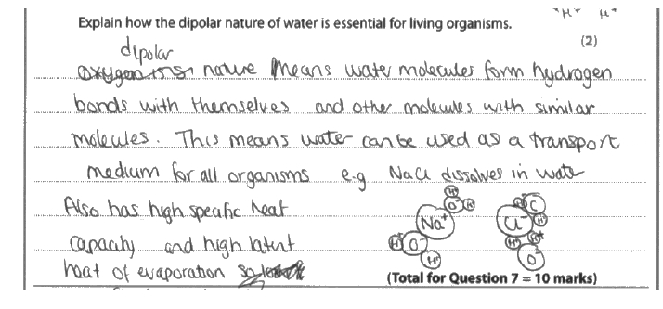
Results Plus: Examiner Comments
As well as describing how water can form hydrogen bonds, this candidate has gone on to give three good examples of the properties of water that make it essential for living organisms (solvent/transport medium, high specific heat capacity and high latent heat of evaporation). Only one of these examples would have been sufficient for the maximum mark.

This response gained one of the two marks available.
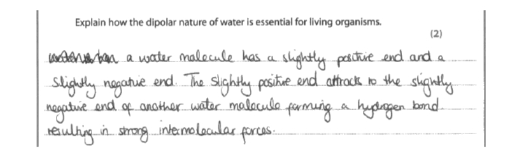
Results Plus: Examiner Comments
This is a good example of how the dipole nature of water provides hydrogen bonding, but does not go on to link this to a property of the water that is essential to life.

This response gained one of the available two marks.
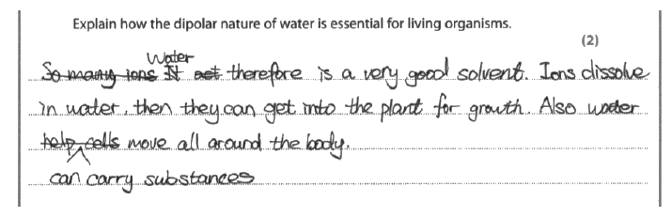
Results Plus: Examiner Comments
This response gives a good example of why water is essential, but has not linked this back to the dipole nature of water for the explanation.

This response gained no marks.
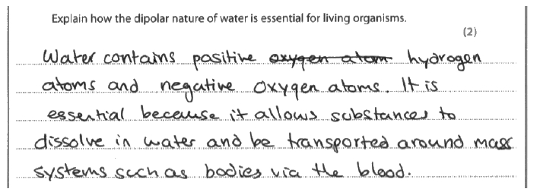
Results Plus: Examiner Comments
This response was close to gaining credit. However, the atoms in water are not fully charged so this is not clear enough for the alternative for hydrogen bonding mark.
It is also too vague for the property mark as it has not given an example of a molecule or type of molecule that can dissolve in water as not everything is water soluble.

Results Plus: Examiner Tip
At AS level try to be as clear and specific as possible as you may not get credit if your answer is open to too much interpretation - particularly if the interpretation can include possibilities that are wrong answers.

Q3.
This was a very straightforward question testing the knowledge of the importance of three specific mineral ions to plants. On the whole, most candidates were aware of the function of nitrates in providing nitrogen for the production of amino acids and DNA, but there were a few that incorrectly described nitrates as containing protein. Many were aware of the importance of magnesium in the production of chlorophyll, although some did refer to chloroplasts instead of chlorophyll. Although some candidates knew that calcium played a role in cell walls, not all were able to describe its specific role in the production of pectate required for the middle lamellae.
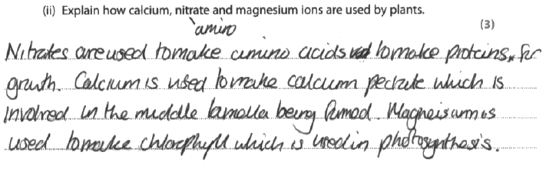
Results Plus: Examiner Comments
This response clearly gained all 3 marks for correctly describing nitrates as being required for making amino acid, calcium for calcium pectate and magnesium for chlorophyll.
3/3

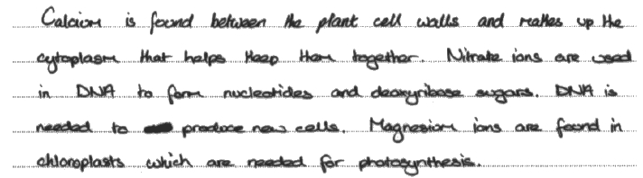
Results Plus: Examiner Comments
No mark was awarded for calcium in cell walls - lack of precise detail. No mark for magnesium being found in chloroplasts - should refer to chlorophyll.
1 mark was awarded for nitrates used in DNA to make nucleotides (the incorrect reference to deoxyribose sugars can be ignored).
1/3

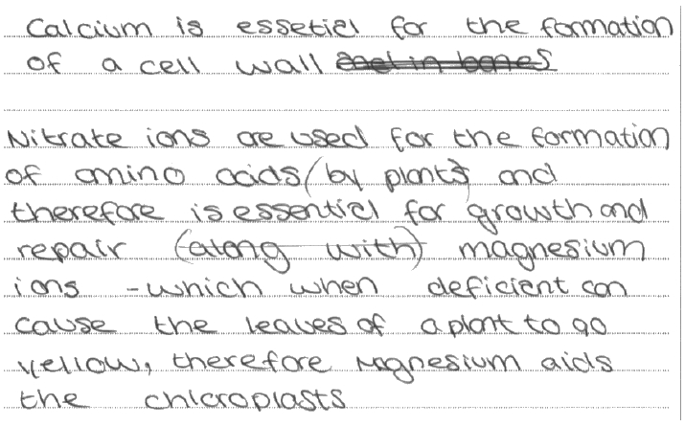
Results Plus: Examiner Comments
Another response which gained just 1 mark for nitrates being used in the formation of amino acids.
Common errors made here were referring to chloroplasts instead of chlorophyll, and to cell walls without specific details of pectin/pectate or middle lamellae.
1/3

Q4.
(a) This question was assessed for quality of written communication with examiners specifically checking the spelling of technical terms. Very few candidates were penalised for poor spelling. Where mistakes were made it was with the words glycosidic, amylopectin or accidentally writing amylase instead of amylose. Many candidates scored very highly with this question providing a high level of specific structural detail demonstrating that this area of the specification has been well covered and understood by most candidates. A few candidates did confuse the structure of starch and protein and surprisingly a lot of candidates did not mention that starch is made up of α-glucose.
This response scores all five marks available.
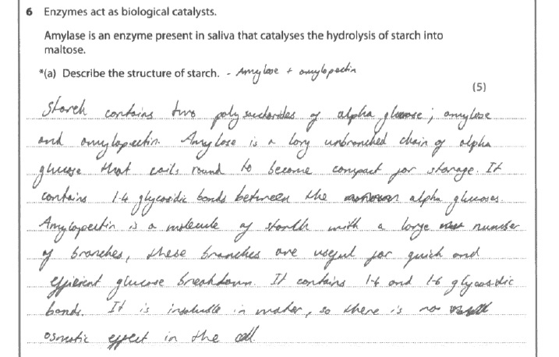
Results Plus: Examiner Comments
Credit was gained for recognising:
- starch is made from alpha glucose;
- amylose is coiled;
- amylose and amylopectin;
- glycosidic bonds;
- comparing the difference in bonding between amylose and amylopectin;
- amylopectin is branched.

This response gained three of the five available marks.
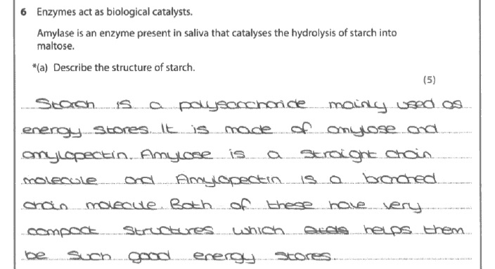
Results Plus: Examiner Comments
This response gained credit for:
- amylose and amylopectin;
- amylopectin is branched;
- both are compact molecules.

Results Plus: Examiner Tip
When describing the structure of polymers try to include the names of the monomers and bonds involved.

(b) (i) Few candidates struggled with explaining what is meant by a catalyst. The most common responses covered the idea that they speed up reactions by lowering the activation energy. There were some excellent responses that recognised that catalysts do not change the products or equilibrium of a reaction.
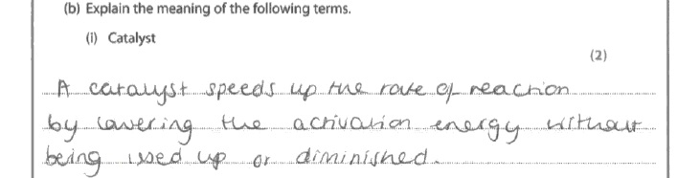
Results Plus: Examiner Comments
This response gains both available marks having made three clear points about catalysts.

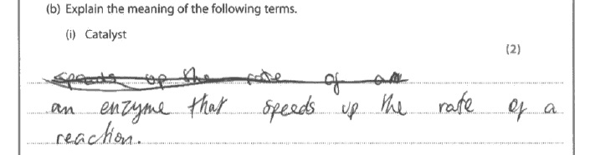
Results Plus: Examiner Comments
This response gained one mark for speeding up the rate of reaction.

Results Plus: Examiner Tip
Remember enzymes are catalysts, but not all catalysts are enzymes. When a question carries two or more marks you should include two or more clear points.

(b) (ii) Most candidates had a good grasp of what a hydrolysis reaction involves. Some candidates referred to 'breaking large molecule into small molecules' rather than specifically mentioning bonds. Most candidates recognised that water is used, although a few did state that water was produced and a small minority hedged their bets and stated that water was used or produced and therefore did not gain the mark.
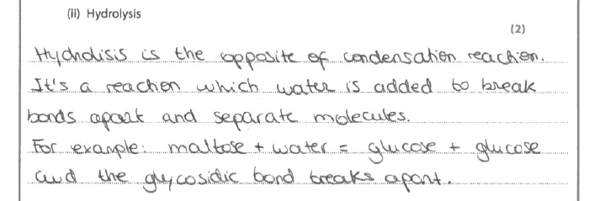
Results Plus: Examiner Comments
This response is typical of the many that gained both marks available.

Results Plus: Examiner Tip
Don't forget to avoid using = in a chemical equation.

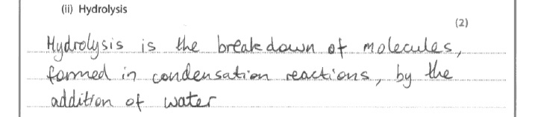
Results Plus: Examiner Comments
This response gains one mark for the use of water, but it does not mention bonds being broken.

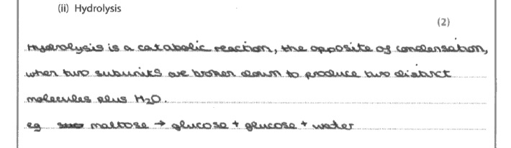
Results Plus: Examiner Comments
This response gained no marks. It does not mention bonds and has water being produced rather than used.

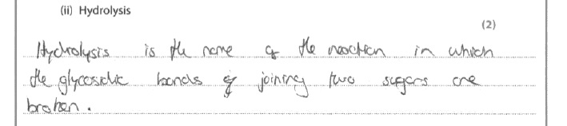
Results Plus: Examiner Comments
This response gained one mark for recognising that bonds are broken in hydrolysis reactions.

Results Plus: Examiner Tip
Don't forget that hydrolysis involves water.

(c) There were some excellent responses recognising that amylase in saliva breaks down starch into maltose that tastes sweeter than starch, but most candidates gained the mark available for recognising that a sugar is produced.
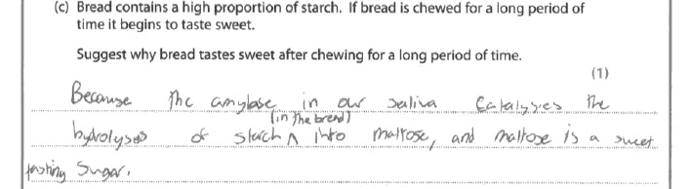
Results Plus: Examiner Comments
This is a good example of a response that gained the available mark.

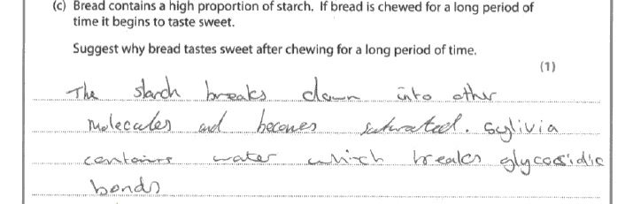
Results Plus: Examiner Comments
This is an example of a response that failed to gain the mark.

Results Plus: Examiner Tip
Although water is needed in hydrolysis reactions, thankfully water is not enough to break glycosidic bonds by itself.

Q5.
No Examiner's Report available for this question

Mark Scheme
Q1.
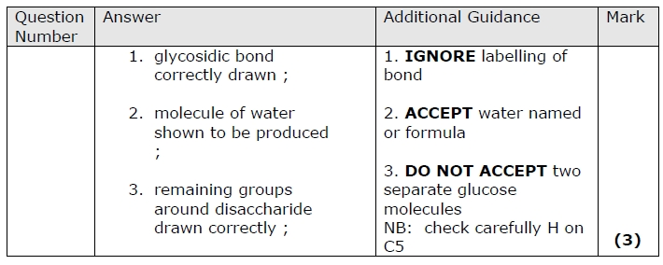

Q2.
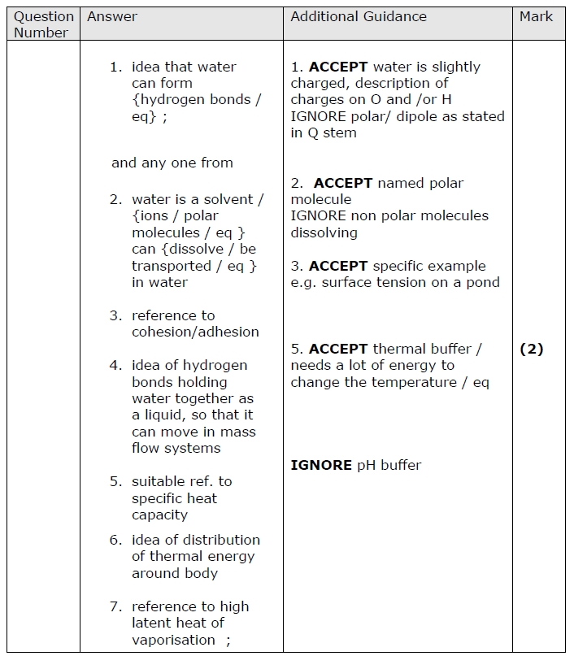

Q3.
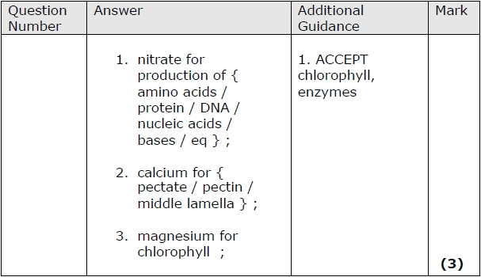

Q4.
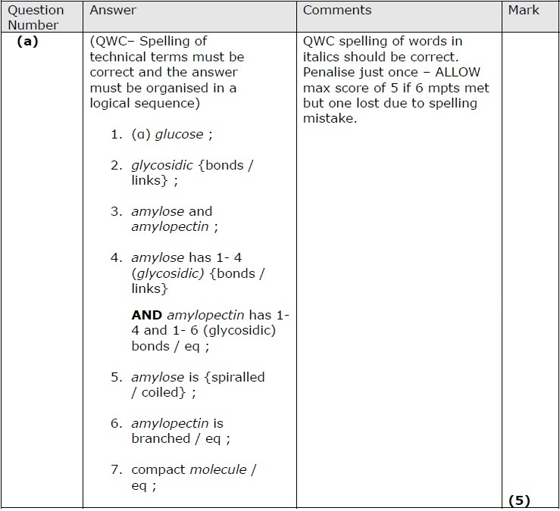
B i) condensation is: the joining of smaller molecules (monomers) to make larger molecules (polymers) ;

Releasing a molecule of water for each bond formed;

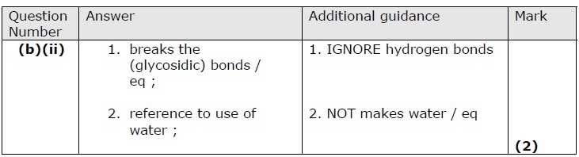
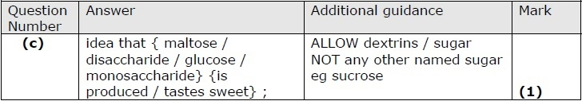

Q5.
