Name: _______________________________________________
Protein structure and function
Date:
Time: 40 minutes
Total marks available: 32
Total marks achieved: ______

Questions
Q1.
There are three different types of haemoglobin in the blood of an adult human. Each haemoglobin molecule is composed of four polypeptide chains.
The table shows information about these types of haemoglobin.
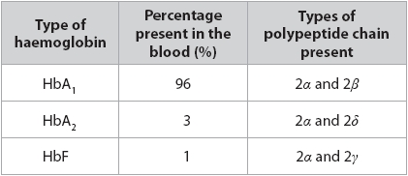
Calculate the ratio of polypeptide chains present in the blood of an adult human.
(3)
Answer ...........................................................

(Total for question = 3 marks)

Q2.
During mitosis, microtubules form the spindle.
These microtubules are made of a protein called tubulin.
Individual tubulin molecules are globular with a diameter of 25 nm.
Thousands of tubulin molecules are assembled together to form long, hollow microtubules.
(i) Describe the differences between a fibrous protein and an individual tubulin molecule.
(2)
.............................................................................................................................................
.............................................................................................................................................
.............................................................................................................................................
.............................................................................................................................................
.............................................................................................................................................
.............................................................................................................................................
.............................................................................................................................................
.............................................................................................................................................
(ii) A microtubule is 40 μm in length.
Calculate how many times longer this microtubule is than a single tubulin molecule.
(2)
Answer ...........................................................

(Total for question = 4 marks)

Q3.
Answer the question with a cross in the box you think is correct . If you change your mind about an answer, put a line through the box and then mark your new answer with a cross .
The diagram shows the tertiary structure of a molecule of the enzyme RNase.
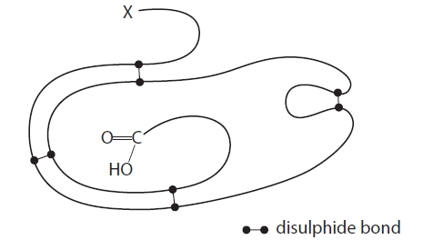
(i) Which chemical group is found at position X?
(1)
A amino
B carboxyl
C hydroxyl
D nitrate
(ii) Give the meaning of the term tertiary structure of a protein.
(2)
.............................................................................................................................................
.............................................................................................................................................
.............................................................................................................................................
.............................................................................................................................................
.............................................................................................................................................
.............................................................................................................................................

(Total for question = 3 marks)

Q4.
Cattle with bovine spongiform encephalopathy (BSE) have microscopic holes in their brain tissue.
This disease involves the misfolding of proteins which then form clumps.
Clumps of misfolded proteins can be seen with an electron microscope.
The misfolded proteins have a changed secondary structure. Therefore they cannot be digested by some protease enzymes.
(i) Describe what is meant by the secondary structure of a protein.
(2)
.............................................................................................................................................
.............................................................................................................................................
.............................................................................................................................................
.............................................................................................................................................
.............................................................................................................................................
.............................................................................................................................................
.............................................................................................................................................
.............................................................................................................................................
(ii) Explain why the misfolded protein cannot be digested by some protease enzymes.
(3)
.............................................................................................................................................
.............................................................................................................................................
.............................................................................................................................................
.............................................................................................................................................
.............................................................................................................................................
.............................................................................................................................................
.............................................................................................................................................
.............................................................................................................................................
.............................................................................................................................................

(Total for question = 5 marks)

Q5.
Leeches are parasites that feed by sucking blood. When they bite, they secrete saliva into the wound. The saliva contains a globular protein called hirudin.
Explain why this protein is soluble in water.
(3)
.............................................................................................................................................
.............................................................................................................................................
.............................................................................................................................................
.............................................................................................................................................
.............................................................................................................................................
.............................................................................................................................................
.............................................................................................................................................
.............................................................................................................................................
.............................................................................................................................................
.............................................................................................................................................
.............................................................................................................................................
.............................................................................................................................................
.............................................................................................................................................
.............................................................................................................................................
.............................................................................................................................................
.............................................................................................................................................
.............................................................................................................................................
.............................................................................................................................................
.............................................................................................................................................

(Total for question = 3 marks)

Q6.
The primary amino acid sequence of a protein determines its final three-dimensional structure.
The diagram shows two amino acids, cysteine and glycine.
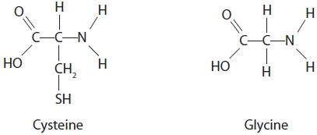
(i) The chemical groups used to form a peptide bond are
(1)
A −NH₂ and −COOH
B −CH₂ and −COOH
C −CH and −CH₂
D −NH₂ and −CH
(ii) The curliness of hair is the result of disulphide bonds between hair proteins.
The more bonds, the curlier the hair.
In recent years, hair straightening has become more popular.
Thioglycolate is used by hairdressers before the hair is straightened.
The process is completed using a second chemical to reverse the effect of the thioglycolate.
Explain how this method keeps the hair straight.
(2)
.............................................................................................................................................
.............................................................................................................................................
.............................................................................................................................................
.............................................................................................................................................
.............................................................................................................................................
.............................................................................................................................................

Q7.
The protein collagen is found in tendons, ligaments and the walls of arteries.
Explain how the structure of collagen is related to its function.
(2)
.............................................................................................................................................
.............................................................................................................................................
.............................................................................................................................................
.............................................................................................................................................
.............................................................................................................................................
.............................................................................................................................................

Q8.
Some of the cells in the pancreas secrete proteins.
The diagram represents a pancreatic cell.
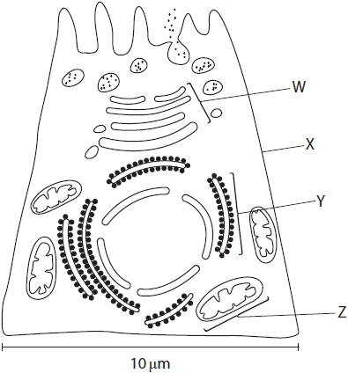
The secreted proteins are made from amino acids.
Two amino acids join together to form a dipeptide.
Draw a diagram to show the structure of a dipeptide.
(3)

(Total for question = 3 marks)

Q9.
Amino acids can be hydrophilic or hydrophobic. The diagram shows a polypeptide chain composed of 10 amino acids.
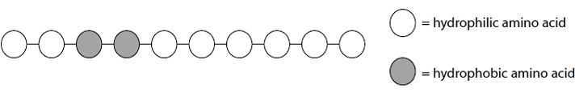
This polypeptide was placed in a beaker of distilled water.
Draw a diagram to show the structure of this polypeptide in the beaker.
(3)


(Total for question = 3 marks)

Q10.
Collagen is a structural protein found in connective tissue.
The diagram shows the components of a typical collagen fibre.
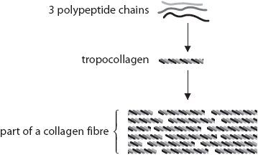
(i) Explain the significance of repeating sequences of amino acids in the formation of tropocollagen.
(2)
.............................................................................................................................................
.............................................................................................................................................
.............................................................................................................................................
.............................................................................................................................................
.............................................................................................................................................
.............................................................................................................................................
(ii) Which of the following bonds holds the 3 polypeptide chains together in the tropocollagen?
(1)
A ester
B glycosidic
C hydrogen
D peptide

(Total for question = 3 marks)

Mark Scheme
Q1.
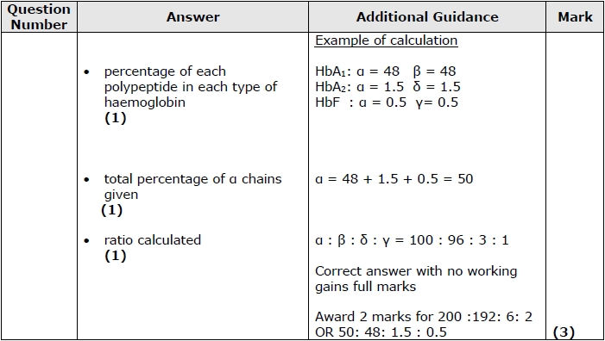

Q2.
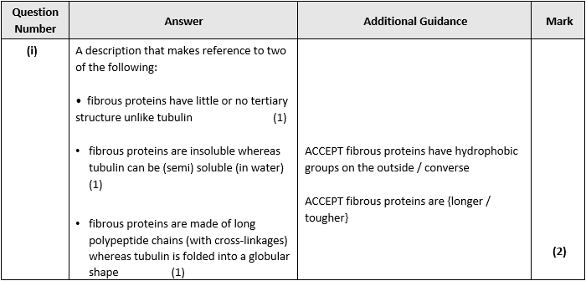
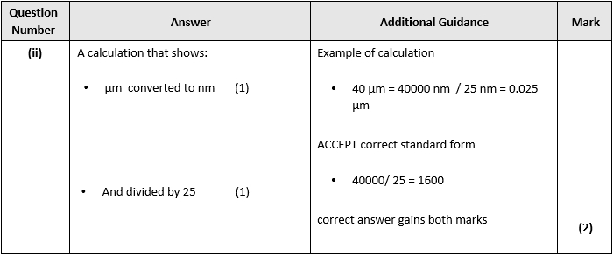

Q3.
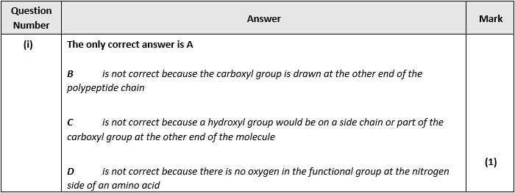
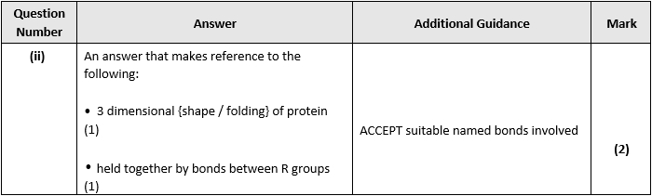

Q4.
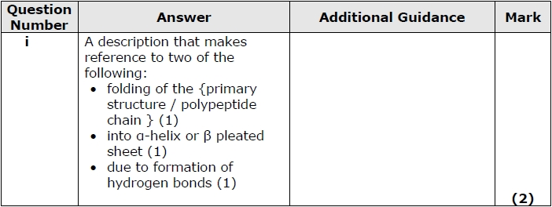
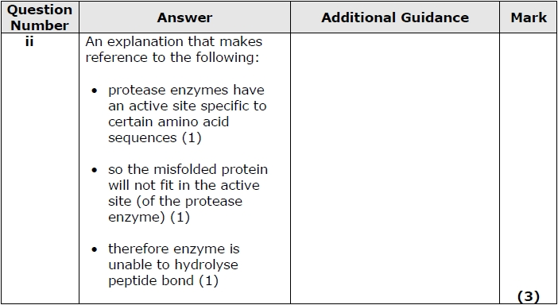

Q5.
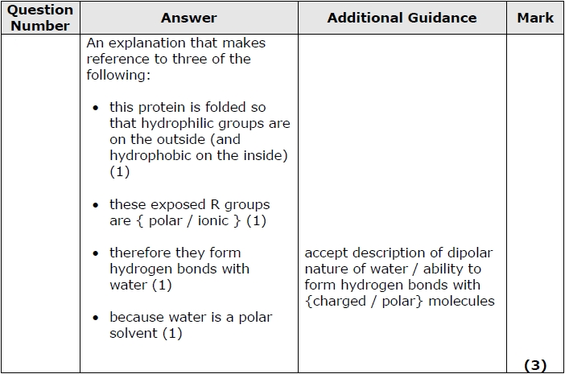

Q6.
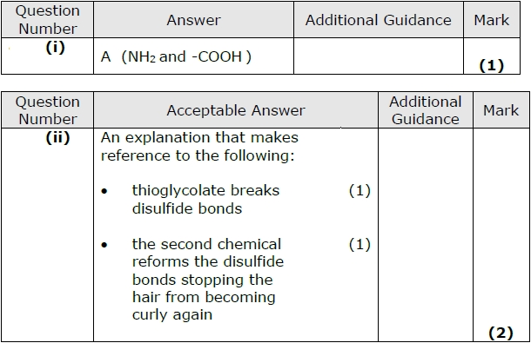

Q7.
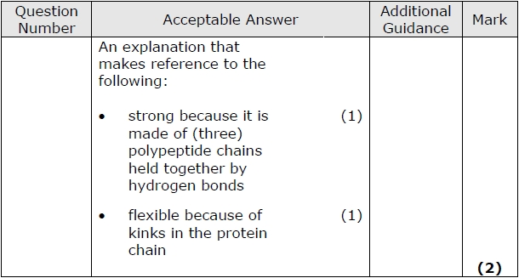

Q8.
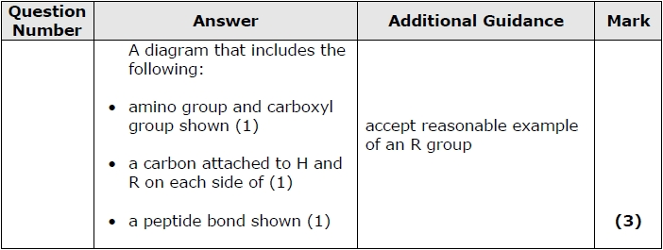

Q9.
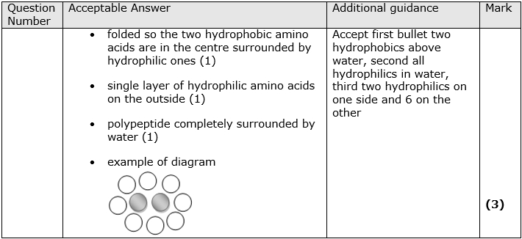

Q10.
