Name: _______________________________________________
Surface area and gaseous exchange
Date:
Time: 30 minutes
Total marks available: 29
Total marks achieved: ______

Questions
Q1.
Each individual cell in an insect's body is supplied with oxygen from a tracheole.
The diagram shows the appearance of tracheoles in a resting insect.
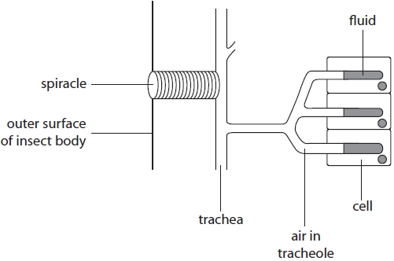
The diameter of a tracheole is 1μm.
Calculate the magnification of the tracheoles in this diagram.
(2)
Answer ...........................................................

Q2.
Each individual cell in an insect's body is supplied with oxygen from a tracheole.
The diagram shows the appearance of tracheoles in a resting insect.
The concentration of lactic acid in the cytoplasm of the cells is higher when the insect is active. This can change the volume of fluid in the ends of the tracheoles.
Explain how an increase in the concentration of lactic acid will affect gas exchange between the tracheoles and the cells in an active insect.
(5)
.............................................................................................................................................
.............................................................................................................................................
.............................................................................................................................................
.............................................................................................................................................
.............................................................................................................................................
.............................................................................................................................................
.............................................................................................................................................
.............................................................................................................................................
.............................................................................................................................................
.............................................................................................................................................
.............................................................................................................................................
.............................................................................................................................................
.............................................................................................................................................

Q3.
Body size can affect gas exchange in insects.
The photograph shows a great green bush cricket, Tettigonia viridissima.
This animal is 4.5cm long and is the largest insect found in the UK.
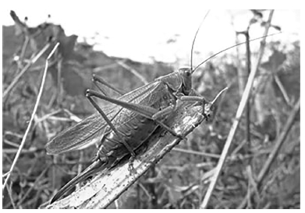
A student investigated the effect of oxygen and carbon dioxide on the breathing rate of an insect.
The insect was placed in either atmospheric air, exhaled human air, pure oxygen or a gas mixture. Its breathing rate was then measured.
The table shows the results of this investigation.
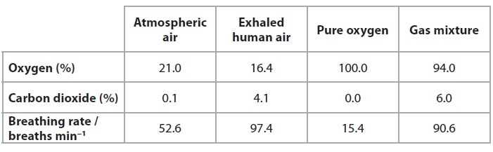
(i) The data suggests that the breathing rate in this insect is increased by
(1)
A carbon dioxide
B oxygen
C carbon dioxide and oxygen
D neither carbon dioxide nor oxygen
(ii) Describe how the student should treat this insect in an ethical manner during this investigation.
(2)
.............................................................................................................................................
.............................................................................................................................................
.............................................................................................................................................
.............................................................................................................................................
.............................................................................................................................................
.............................................................................................................................................

Q4.
Many animals have specialised organs for gas exchange and transport.
*(a) The diagram below shows the lungs of a mammal.
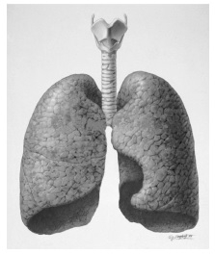
Describe and explain how the lungs of a mammal are adapted for rapid gas exchange.
(5)
.............................................................................................................................................
.............................................................................................................................................
.............................................................................................................................................
.............................................................................................................................................
.............................................................................................................................................
.............................................................................................................................................
.............................................................................................................................................
.............................................................................................................................................
.............................................................................................................................................
.............................................................................................................................................
.............................................................................................................................................
.............................................................................................................................................
(b) Daphnia have a circulatory system with a heart that pumps blood into cavities surrounding their organs.
The photograph below shows the location of the heart in a Daphnia.
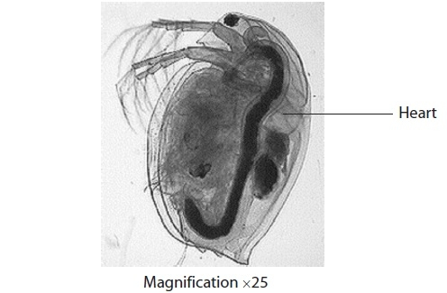
(i) Suggest how the heart of a Daphnia enables organs to carry out effective gas exchange.
(2)
.............................................................................................................................................
.............................................................................................................................................
.............................................................................................................................................
.............................................................................................................................................
.............................................................................................................................................
.............................................................................................................................................
.............................................................................................................................................

(ii) In mammals, blood passes through the heart twice for each circulation of the body.
Suggest how this type of circulation enables mammals to carry out effective gas exchange.
(3)
.............................................................................................................................................
.............................................................................................................................................
.............................................................................................................................................
.............................................................................................................................................
.............................................................................................................................................
.............................................................................................................................................
.............................................................................................................................................
.............................................................................................................................................
(Total for Question = 10 marks)

Q5.
A student investigated how the exposure of a young plant called Arabidopsis thaliana to different concentrations of carbon dioxide affected the density of stomata in its adult leaves.
He put one plant in a greenhouse where the carbon dioxide concentration was regulated at 350 ppm. He waited for two weeks then measured the number of stomata on a leaf from the plant.
He repeated this procedure using a greenhouse with a carbon dioxide concentration of 550 ppm and a greenhouse with a carbon dioxide concentration of 750 ppm.
His results are shown in the graph.
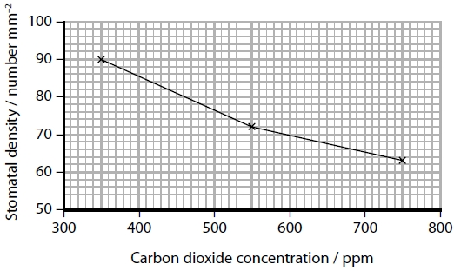
The student concluded that there was a negative correlation between stomatal density and the concentration of carbon dioxide.
Discuss the improvements that the student needs to make before being confident that this conclusion is supported.
(5)
.............................................................................................................................................
.............................................................................................................................................
.............................................................................................................................................
.............................................................................................................................................
.............................................................................................................................................
.............................................................................................................................................
.............................................................................................................................................
.............................................................................................................................................
.............................................................................................................................................
.............................................................................................................................................

(Total for question = 5 marks)

Q6.
Body size can affect gas exchange in insects.
The photograph shows a great green bush cricket, Tettigonia viridissima.
This animal is 4.5cm long and is the largest insect found in the UK.
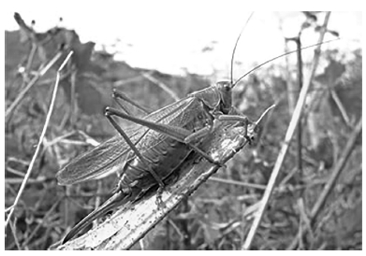
Explain why the gas exchange system in insects limits their maximum body size.
(2)
.............................................................................................................................................
.............................................................................................................................................
.............................................................................................................................................
.............................................................................................................................................
.............................................................................................................................................
.............................................................................................................................................

Q7.
The image below shows a part of the underside of a leaf as seen by a student using a microscope.
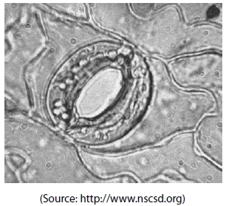
(i) The stomata in the image is open because the
(1)
A guard cells are turgid and the thin part of the cellulose wall stretches more than the thick part
B guard cells are flaccid and the thin part of the cellulose wall stretches less than the thick part
C guard cells are turgid and the thick part of the cellulose wall stretches more than the thin part
D guard cells are flaccid and the thick part of the cellulose wall stretches less than the thin part
(ii) Which row of the table correctly shows the method of water absorption by guard cells and the change in size of the stomatal pore?
(1)
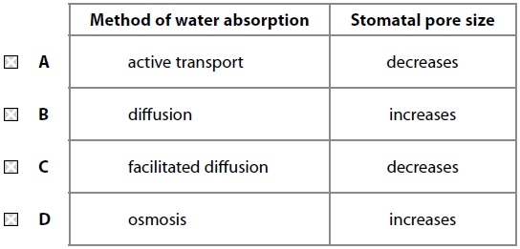

(Total for question = 2 marks)

Mark Scheme
Q1.
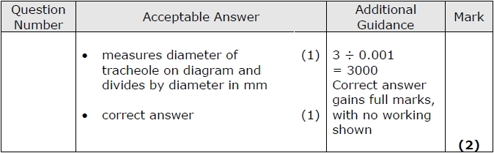

Q2.
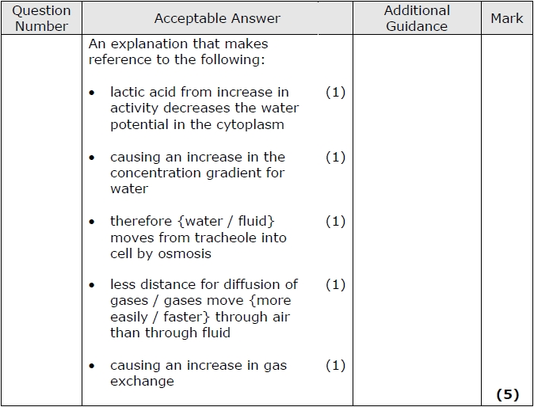

Q3.
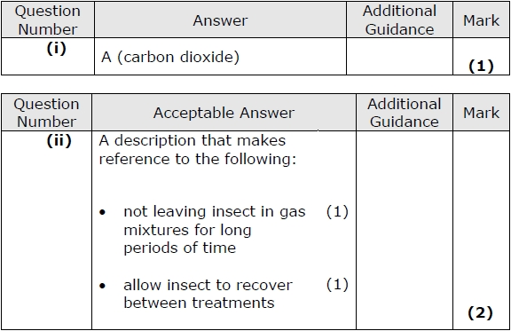

Q4.
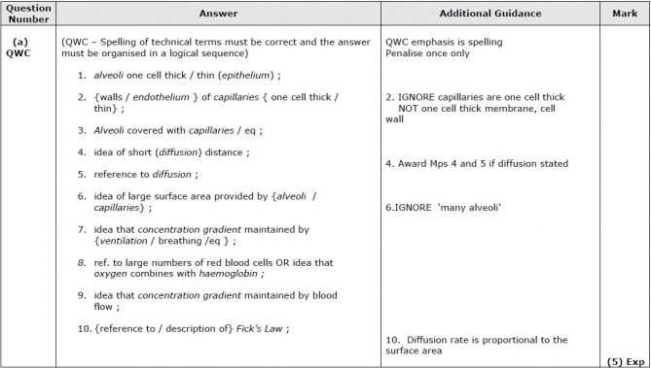
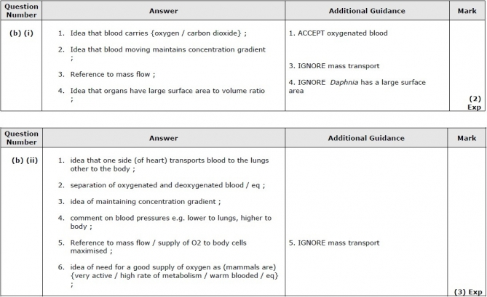

Q5.
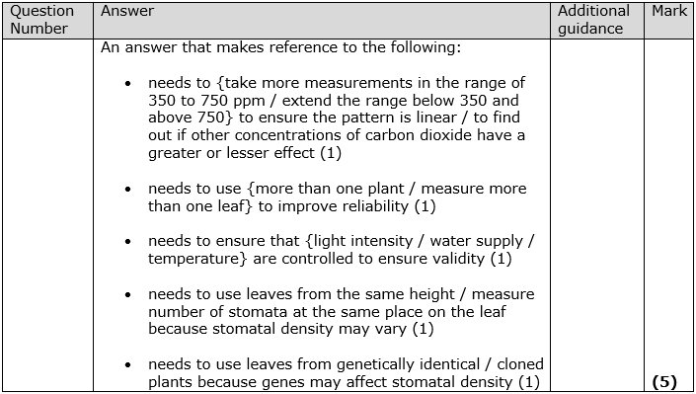

Q6.
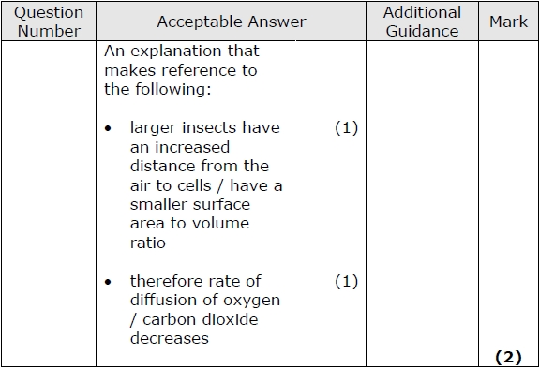

Q7.
