Elements, Compounds, Mixtures & Separating Techniques
Q1. This question is about elements, compounds and mixtures.
(a) Substance A contains only one type of atom. Substance A does not conduct electricity.
Which type of substance is A? Tick (✓) one box.

Compound |  | Mixture
Metallic element |  | Non-metallic element
(1)
(b) Substance B contains two types of atoms. The atoms are chemically combined together in fixed proportions.
Which type of substance is B? Tick (✓) one box.

Compound |  | Mixture
Metallic element |  | Non-metallic element
(1)
(c) What is the name of the elements in Group 0 of the periodic table? Tick (✓) one box.

Alkali metals |  | Noble gases
Halogens |  | Transition metals
(1)
(d) Neon is in Group 0.
What type of particles are in a sample of neon? Tick (✓) one box.

Atoms
Ions
Molecules
(1)
Q2. This question is about water.
A student investigated the concentration of salt in sea water.
This is the method used.
1. Filter the sea water to remove sand.
2. Measure the mass of an empty evaporating dish.
3. Measure 50 cm³ of sea water into the evaporating dish.
4. Heat the evaporating dish and sea water.
5. Evaporate the sea water to dryness.
6. Measure the mass of the evaporating dish and salt.
(a) What equipment should the student use to measure:
The mass of evaporating dish ______________________________
The volume of sea water ___________________________________ (2)
(b) The table below shows the student’s results.

 | Mass in g
Evaporating dish | 30.44
Evaporating dish and salt | 30.49
The student used 50 cm³ of sea water.
Calculate the mass of salt in 1000 cm³ of this sea water.
___________________________________________________________________
___________________________________________________________________
___________________________________________________________________
___________________________________________________________________
Mass of salt = _______________ g (3)
(c) The salt must be completely dry.
Which two extra steps are needed to show that the salt is completely dry? Tick (✓) two boxes.

Filter the sea water again. |  | Measure the mass of the empty evaporating dish again.
Heat the evaporating dish and salt again. |  | Measure the mass of the evaporating dish and salt again.
Measure the 50 cm³ of sea water again.
(2)
Two students, Y and Z, distil sea water to collect water.
The figure below shows the apparatus used by each student to collect the water.
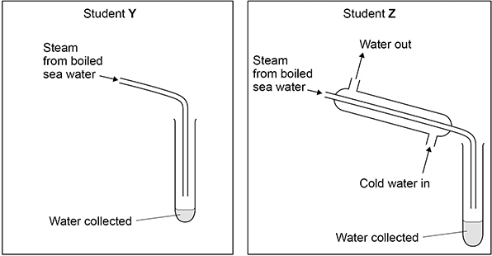
(d) Students Y and Z boil the same volume of sea water for the same period of time.
Explain why student Y collects a smaller volume of water than student Z.
___________________________________________________________________
___________________________________________________________________
___________________________________________________________________
___________________________________________________________________ (2)
(e) Water obtained by distillation does not need to be sterilised and is safe to drink.
Suggest why.
___________________________________________________________________
___________________________________________________________________ (1)
(g) A student tests the pH of fresh water using universal indicator solution.
When added to the fresh water, the colour of the universal indicator solution is green.
What is the pH of this fresh water?
pH = _____ (1)

Q3. This question is about elements, compounds and mixtures.
Figure 1 shows five different substances, A, B, C, D and E.
represent atoms of different elements.
Figure 1
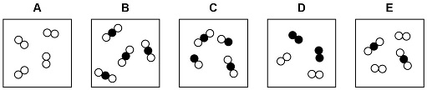
Use Figure 1 to answer parts (a) to (c)
(a) Which substance is only one compound? Tick (✓) one box.

A |  | B |  | C |  | D |  | E
(1)
(b) Which substance is a mixture of elements? Tick (✓) one box.

A |  | B |  | C |  | D |  | E
(1)
(c) Which substance is a mixture of an element and a compound? Tick (✓) one box.

A |  | B |  | C |  | D |  | E
(1)
Substances are separated from a mixture using different methods.
(e) Sand does not dissolve in water. A pupil separates a mixture of sand & water by filtration.
Draw a diagram of the apparatus the pupil could use.
You should label: • where the sand is collected
• where the water is collected.
Diagram (3)
(f) A student distils a sample of salt solution to produce pure water.
Figure 2 shows the apparatus.
Figure 2
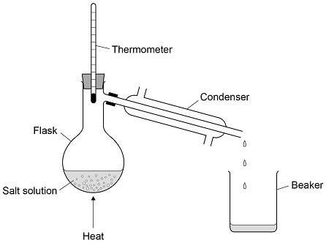
What temperature would you expect the thermometer to show? Tick (✓) one box.

0 °C |  | 50 °C
10 °C |  | 100 °C
(1)
(g) Describe how the process of distillation shown in Figure 2 produces pure water from salt solution.
___________________________________________________________________
___________________________________________________________________
___________________________________________________________________
___________________________________________________________________
___________________________________________________________________
___________________________________________________________________
___________________________________________________________________
___________________________________________________________________ (4)

Q4. This question is about mixtures.
(a) Substances are separated from a mixture using different methods.
Draw one line from each substance and mixture to the best method of separation.

Substance and mixture |  | Method of separation
 |  | Chromatography
Ethanol from ethanol and water |  | Crystallisation
Salt from sea water |  | Electrolysis
The different colours in black ink |  | Filtration
 |  | Fractional distillation
(3)
Q5. Rock salt is a mixture of sand and salt.
Salt dissolves in water. Sand does not dissolve in water. Some students separated rock salt.
This is the method used.
1. Place the rock salt in a beaker.
2. Add 100 cm³ of cold water.
3. Allow the sand to settle to the bottom of the beaker.
4. Carefully pour the salty water into an evaporating dish.
5. Heat the contents of the evaporating dish with a Bunsen burner until salt crystals form.
(a) Suggest one improvement to step 2 to make sure all the salt is dissolved in the water.
___________________________________________________________________
___________________________________________________________________ (1)
(b) The salty water in step 4 still contained very small grains of sand.
Suggest one improvement to step 4 to remove all the sand.
___________________________________________________________________
___________________________________________________________________ (1)
(c) Suggest one safety precaution the students should take in step 5.
___________________________________________________________________
___________________________________________________________________ (1)

