Instructions
- Use black ink or ball-point pen.
  - Fill in the boxes at the top of this page with your name,
centre number and candidate number.
- Answer all questions.
- Without sufficient working, correct answers may be awarded no marks.
- Answer the questions in the spaces provided
– there may be more space than you need.
- Calculators may be used.
- You must NOT write anything on the formulae page.
Anything you write on the formulae page will gain NO credit.
Information
- The total mark for this paper is 100.
- The marks for each question are shown in brackets
– use this as a guide as to how much time to spend on each question.
Advice
- Read each question carefully before you start to answer it.
- Check your answers if you have time at the end.
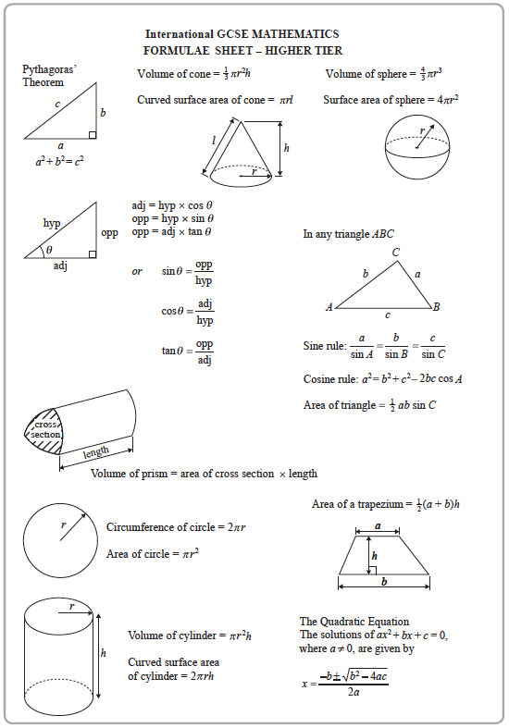
Answer ALL TWENTY FOUR questions.
Write your answers in the spaces provided.
You must write down all the stages in your working.

1 Jerry drove 315 kilometres from London to Leeds.
His average speed was 75 km/h.
Work out how long it took Jerry to drive from London to Leeds.
Give your answer in hours and minutes.

............................ hours ............................ minutes
(Total for Question 1 is 3 marks)
______________________________________________________________________________

2 Point A has coordinates (4, −1)
Point B has coordinates (9, 7)
Work out the coordinates of the midpoint of the line AB.

( ............................ , ............................ )
(Total for Question 2 is 2 marks)
______________________________________________________________________________

3 E = {whole numbers from 3 to 18}
A = {3, 6, 9, 18}
B = {3, 6, 9, 12, 15}
C = {6, 12, 18}
(a) List the members of the set
(i) A ∩ B

....................................................................................
(ii) A ∪ C

....................................................................................
(2)

Sasha writes down
12 A
(b) Is Sasha correct?
Give a reason for your answer.
............................................................................................................................................................................
............................................................................................................................................................................
(1)
(Total for Question 3 is 3 marks)
______________________________________________________________________________

4 A circle has diameter 18 cm.
Work out the circumference of the circle.
Give your answer correct to 1 decimal place.

.......................................................cm
(Total for Question 4 is 2 marks)
______________________________________________________________________________

5 Josh has 40 counters in a bag.
In the bag, there are
18 red counters
13 blue counters
9 yellow counters
Josh puts some more red counters into the bag.
Josh is now going to take at random a counter from the bag.
The probability that he will take a red counter is
Work out the probability that he will take a yellow counter.

.......................................................
(Total for Question 5 is 3 marks)
______________________________________________________________________________

6 (a) Factorise y² + y

.......................................................
(1)
(b) Solve 3(m + 7) = 12 – 5m
Show clear algebraic working.

m = .......................................................
(3)
(c) Expand and simplify (g – 7)(g + 2)

.......................................................
(2)
(d) Write down the inequality shown on this number line.

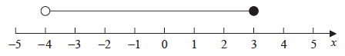

.......................................................
(2)
(Total for Question 6 is 8 marks)
______________________________________________________________________________

7 There are 96 cards on a table.
Each card is either red or black.
The ratio of the number of red cards to the number of black cards is 5 : 7
There is a circle on 35% of the red cards.
There is a circle on of the black cards.
On how many of the 96 cards is there a circle?

.......................................................
(Total for Question 7 is 5 marks)
______________________________________________________________________________

8 On the grid, draw the graph of y + 3x = 4 for values of x from −2 to 3

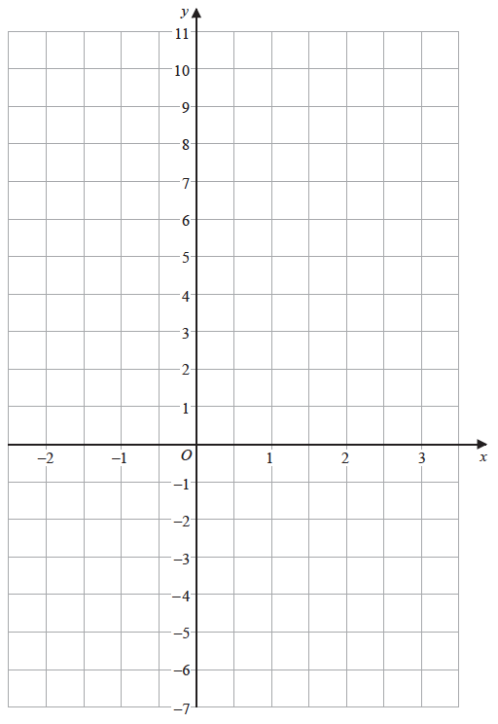
(Total for Question 8 is 3 marks)
______________________________________________________________________________

9
Work out the length of RP.
Give your answer correct to 3 significant figures.

.......................................................cm
(Total for Question 9 is 3 marks)
______________________________________________________________________________

10 Emily made 6 cakes.
It cost her a total of £7.60 to make the cakes.
Emily sold 2 of the cakes for £3.50 each.
She sold the other 4 cakes for £4.25 each.
Work out Emily’s percentage profit.
Give your percentage correct to the nearest whole number.

.......................................................%
(Total for Question 10 is 4 marks)
______________________________________________________________________________

11 Here is a solid prism.

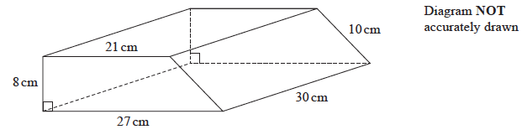

The cross section of the prism is a trapezium.
Work out the total surface area of the prism.

.......................................................cm²
(Total for Question 11 is 3 marks)
______________________________________________________________________________

12 There are 40 children at a kindergarten.
24 of the children are boys and 16 of the children are girls.
The boys have a mean height of 113 cm.
The girls have a mean height of 110 cm.
Calculate the mean height of all 40 children at the kindergarten.

....................................................... cm
(Total for Question 12 is 3 marks)
______________________________________________________________________________

13 Remi invests 18 000 dirham in a savings account for 3 years.
He gets 1.2% per year compound interest.
How much money will Remi have in his savings account at the end of the 3 years?
Give your answer to the nearest dirham.

....................................................... dirham
(Total for Question 13 is 3 marks)
______________________________________________________________________________

14 The grouped frequency table gives information about the distances that 120 people travel
to get to work.

Distance (d km) | Frequency
0 < d ⩽ 5 | 8
5 < d ⩽ 10 | 20
10 < d ⩽ 15 | 27
15 < d ⩽ 20 | 29
20 < d ⩽ 25 | 18
25 < d ⩽ 30 | 11
30 < d ⩽ 35 | 7

(a) Complete the cumulative frequency table.

Distance (d km) | Cumulative frequency
0 < d ⩽ 5
0 < d ⩽ 10
0 < d ⩽ 15
0 < d ⩽ 20
0 < d ⩽ 25
0 < d ⩽ 30
0 < d ⩽ 35

(1)
(b) On the grid, draw a cumulative frequency graph for your table.

(2)
(c) Use your graph to find an estimate for the interquartile range of the distances travelled.

.......................................................km
(2)
(Total for Question 14 is 5 marks)
______________________________________________________________________________

15 (a) Simplify g⁸ ÷ g²

.......................................................
(1)
(b) Simplify 6e²m⁷ × 3em⁴

.......................................................
(2)
(c) Simplify

.......................................................
(2)
(d) Factorise x² – 1

.......................................................
(1)
(e) Make k the subject of f =

.......................................................
(3)
(Total for Question 15 is 9 marks)
______________________________________________________________________________

16 The diagram shows triangle PQR.

A is a point on PR and B is a point on QR so that AB is parallel to PQ.
AR = 5 cm
AB = 6 cm
PQ = 15 cm
(a) Work out the length of AP.

....................................................... cm
(3)

Given that the area of triangle PQR is 88 cm²
(b) work out the area of triangle ARB.

....................................................... cm²
(2)
(Total for Question 16 is 5 marks)
______________________________________________________________________________

17 Use algebra to show that the recurring decimal

(Total for Question 17 is 2 marks)
______________________________________________________________________________

18 a = b = c =
(a) Write 2b – c as a column vector.

.......................................................
(2)

Cho says that the vector a – b is parallel to the vector c
(b) Is Cho correct?
Give a reason for your answer.
............................................................................................................................................................................
............................................................................................................................................................................
(2)
(Total for Question 18 is 4 marks)
______________________________________________________________________________

19 (a) Express as a single fraction.
Give your answer as simply as possible.

...................................................................................
(3)
(b) Solve the inequality 6(x –1)² > 24
Show clear algebraic working.

...................................................................................
(4)
(Total for Question 19 is 7 marks)
______________________________________________________________________________

20
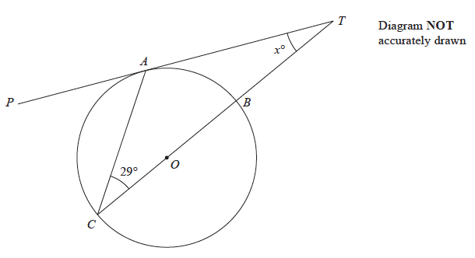

A, B and C are points on a circle, centre O.
TAP is a tangent to the circle.
TBOC is a straight line.
Angle ACT = 29°
Work out the value of x.
Give a reason for each stage in your working.

x = .......................................................
(Total for Question 20 is 4 marks)
______________________________________________________________________________

21 The functions f and g are such that
f (x) = x + 3
g (x) =
(a) Work out f (3)

.......................................................
(1)
(b) State the value of x that cannot be included in any domain of g.

.......................................................
(1)
(c) Solve f^{–1} (x) = gf (x)
Show clear algebraic working.

.......................................................
(6)
(Total for Question 21 is 8 marks)
______________________________________________________________________________

22 The diagram shows a parallelogram LMNP.

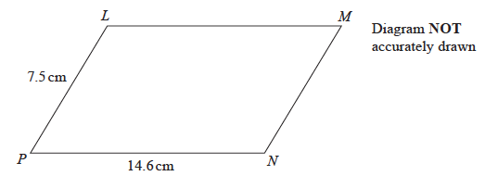

LN = 13.3 cm
Calculate the area of the parallelogram.
Give your answer correct to 3 significant figures.

....................................................... cm²
(Total for Question 22 is 4 marks)
______________________________________________________________________________

23 M =

a = 5.3 correct to 1 decimal place.
b = 346.6 correct to 1 decimal place.
c = 80.0 correct to 1 decimal place.
Calculate the upper bound for the value of M.
Show your working clearly.

.......................................................
(Total for Question 23 is 3 marks)
______________________________________________________________________________

24 There are only 3 white and 5 black counters in box X.
There are only 4 white and 3 black counters in box Y.

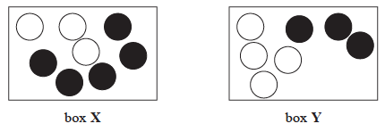

Michael takes at random 2 counters from box X and puts both counters into box Y.
He then takes at random 1 counter from box Y and puts this counter into box X.
Work out the probability that there is now an equal number of white counters and
black counters in box Y.

.......................................................
(Total for Question 24 is 4 marks)
______________________________________________________________________________

TOTAL FOR PAPER IS 100 MARKS

