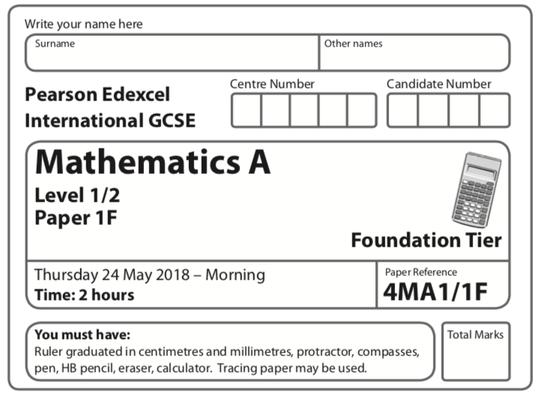
Instructions
- Use black ink or ball-point pen.
  - Fill in the boxes at the top of this page with your name, centre number and
candidate number.
- Answer all questions.
- Without sufficient working, correct answers may be awarded no marks.
- Answer the questions in the spaces provided
– there may be more space than you need.
- Calculators may be used.
- You must NOT write anything on the formulae page.
Anything you write on the formulae page will gain NO credit.
Information
- The total mark for this paper is 100.
- The marks for each question are shown in brackets
– use this as a guide as to how much time to spend on each question.
Advice
- Read each question carefully before you start to answer it.
- Check your answers if you have time at the end.
Answer ALL TWENTY ONE questions.

Write your answers in the spaces provided.

You must write down all the stages in your working.

Question 1

5 (a) Simplify 6x + 8x − 3x

.......................................................
(1)
(b) Simplify 4e × 5f

.......................................................
(1)
(c) Solve 8p = 24

p = .......................................................
(1)
(d) Solve k – 4 = 13

k = .......................................................
(1)
(e) Simplify 10t + 4d − 3t + 2d

.......................................................
(2)
(Total for Question 5 is 6 marks)
____________________________________________________________________________

Question 2

9 You can use this graph to change between temperatures in degrees Celsius (°C) and
temperatures in degrees Fahrenheit (°F).
The temperature in Dubai on Monday increased by 20 °C from midnight to midday.
(a) What is this temperature increase in degrees Fahrenheit?

....................................................... °F
(2)

Maninder says,
“30 °C is the same as 86 °F, therefore 60 °C will be the same as 172 °F.”
(b) Is Maninder correct?
Give a reason for your answer.
.........................................................................................................................................................
.........................................................................................................................................................
(1)
(Total for Question 9 is 3 marks)
____________________________________________________________________________
Question 3

16 (a) Simplify y⁵ × y⁹

.......................................................
(1)
(b) Simplify (2m³)⁴

.......................................................
(2)
(c) Solve 5(x + 3) = 3x − 4
Show clear algebraic working.

x = .......................................................
(3)
(d) (i) Factorise x² + 2x − 24

.......................................................
(2)
(ii) Hence, solve x² + 2x – 24 = 0

.......................................................
(1)
(Total for Question 16 is 9 marks)
____________________________________________________________________________
Question 4

17 Here is a Venn diagram.

E

(a) Write down the numbers that are in the set
(i) A

....................................................................
(ii)

....................................................................
(2)

Brian writes down the statement = Ø
(b) Is Brian’s statement correct?
You must give a reason for your answer.
.........................................................................................................................................................
.........................................................................................................................................................
(1)

One of the numbers in the Venn diagram is picked at random.
(c) Find the probability that this number is in set C′

.........................................
(2)
(Total for Question 17 is 5 marks)
____________________________________________________________________________
Question 5

19 (a) On the grid, draw the graph of y = 2x + 3 for values of x from −2 to 3.

(3)
(b) Show, by shading on the grid, the region that satisfies all three of the inequalities

x ⩽ 2 | y ⩾ 1 | y ⩽ 2x + 3

Label the region R.
(2)
(Total for Question 19 is 5 marks)
____________________________________________________________________________

Question 6

8 (a) Find the value of 25 – 4g when g = –3

.......................................................
(2)
(b) Expand and simplify x(2x + 1) + 3(x – 2) + 7

.......................................................
(3)
(Total for Question 8 is 5 marks)

Question 7

18 (a) Make a the subject of the formula M = ac – bd

.......................................................
(2)
(b) Solve the inequality 5x – 4 < 39

.......................................................
(2)
(c) Factorise fully 18e² f ³ – 12e³ f

.......................................................
(2)
(Total for Question 18 is 6 marks)
____________________________________________________________________________
Question 8

20 Show that

(Total for Question 20 is 3 marks)
____________________________________________________________________________

Question 9

24
= 2n
(a) Find the value of n.

n = .......................................................
(2)

(13^{–6})⁴ × 13⁵ = 13^{k}
(b) Find the value of k.

k = .......................................................
(2)
(Total for Question 24 is 4 marks)

TOTAL FOR PAPER IS 46 MARKS

Marking Scheme

Question 1

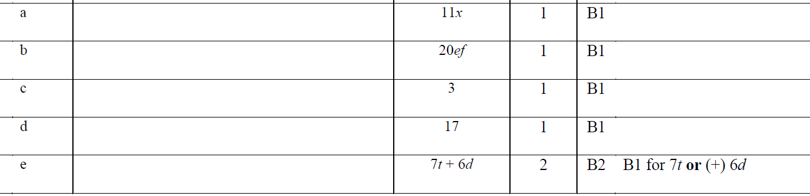

Question 2

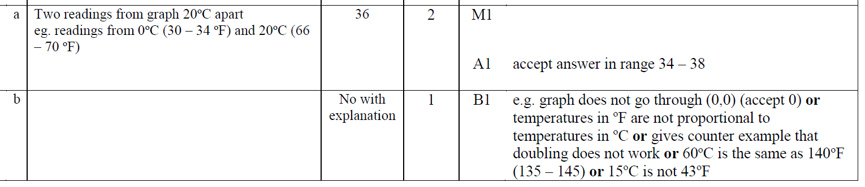

Question 3

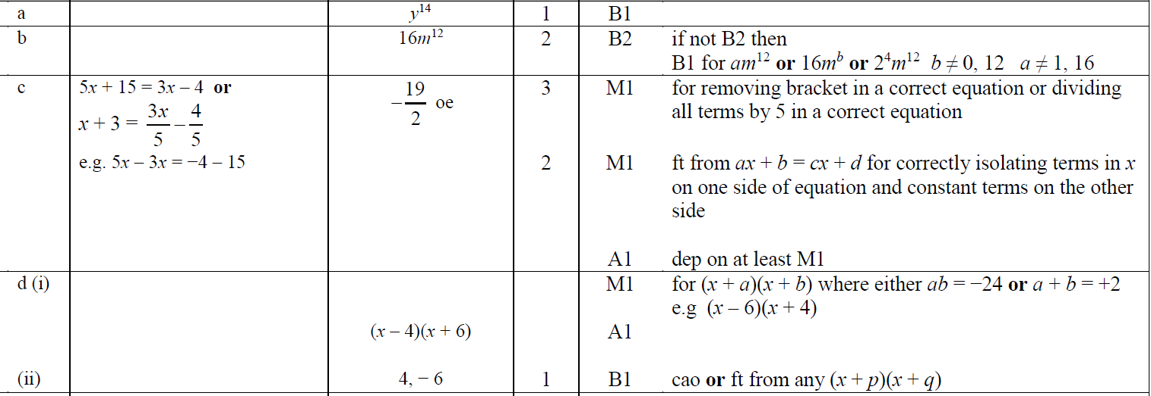

Question 4

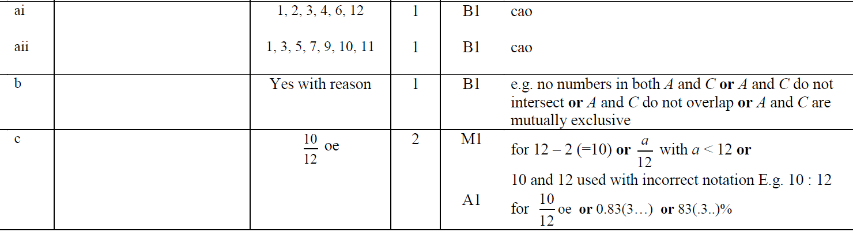

Question 5

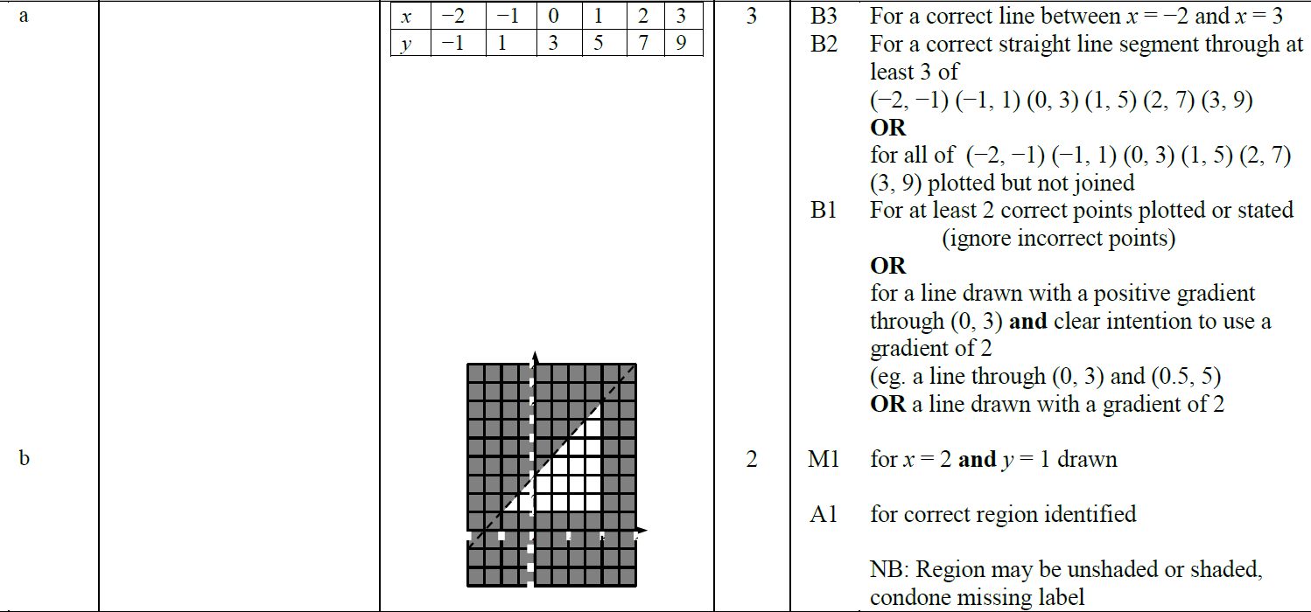

Question 6

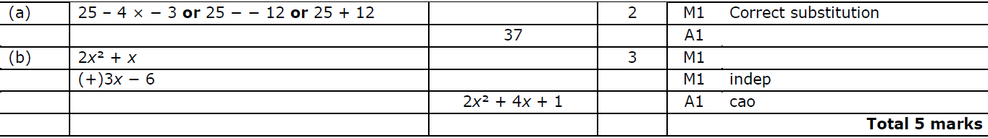

Question 7

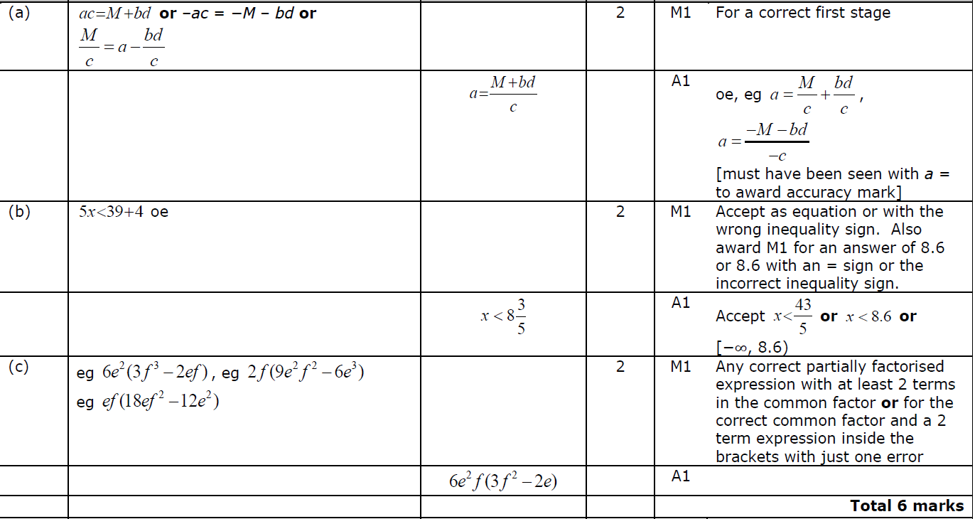

Question 8

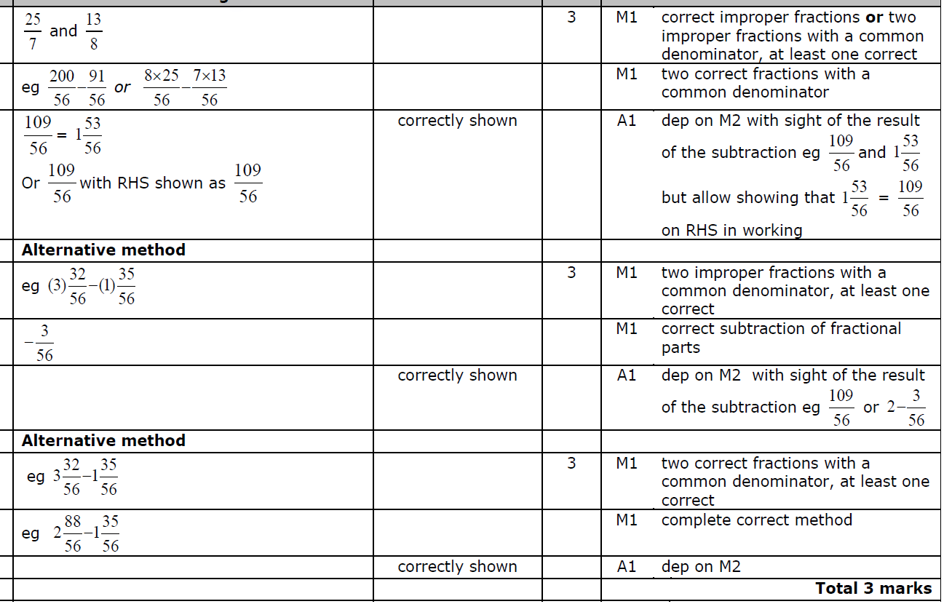

Question 9

