A Brief History of Outremer
The Kingdom of Jerusalem, 1099-1149

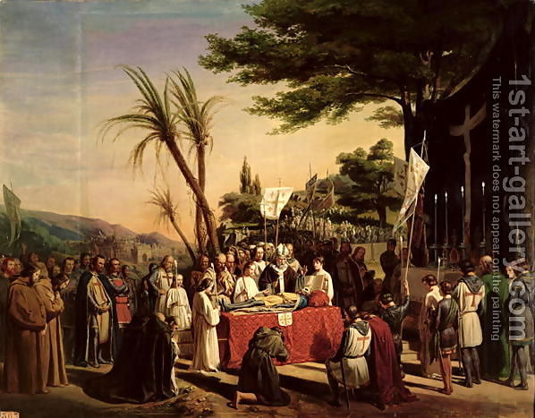
In the wake of the First Crusade, Baldwin of Bouillon temporarily secured the new state of Jerusalem after he defeated a Fatimid counterattack, the Battle of Ascalon, 1099. He became the first ruler of Jerusalem, although he declined the title ‘King’, backed by Arnulf of Chocques, who assumed the title of Patriarch of Jerusalem. But the latter was not long for his position, being ousted by Daibert of Pisa, who had been appointed to replace Adhemar by the Pope after Adhemar died.

Godfrey died in 1100. Daibert hoped to put Bohemund in control but Daibert’s natural supporters, the Pisans, were absent and Bohemund was away fighting the Danishmends. Baldwin of Edessa, Godfrey’s brother, took the opportunity to become the first King of Jerusalem, cleverly crowning himself in Bethlehem, away from Daibert. Baldwin had opposing views to Daibert over the Investiture Controvery. The two did not get on and it was not long before Daibert was exiled from Jerusalem, charged with embezzlement.
Oil painting of Godfrey’s funeral

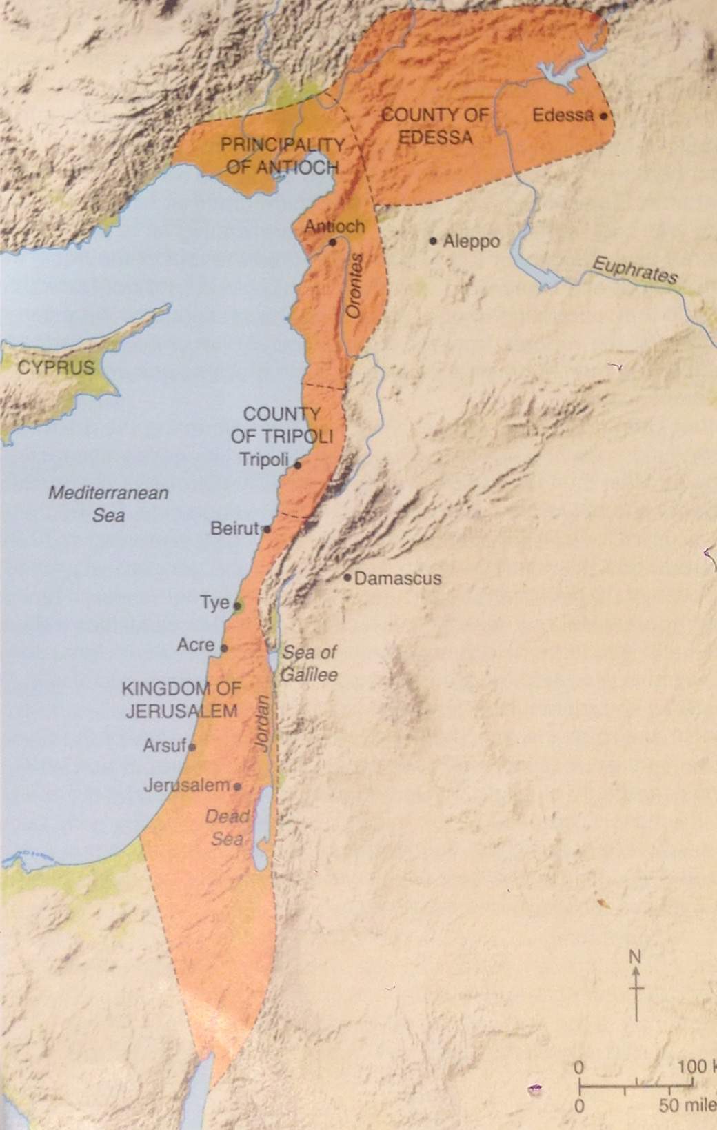
Baldwin set to securing his southern border against the Fatimids, fighting three battles against them at Ramla (1101, 1102 and 1105). In the second battle, Stephen of Blois, who had returned as part of a follow up crusade launched in 1101, perished. Baldwin also worked with the Genoese to capture Caesarea in 1101. These sailors also assisted in the capture of Sidon in 1104. The Italians were rewarded with tax exemptions and Baldwin’s coastal territory, taken from the Fatimids, attracted trade from Europe and the Muslim world. These ports also gave pilgrims from Europe safer passage to Jerusalem, attracting pilgrims and crusaders and generating income. In 1110, King Sigurd of Norway arrived as both pilgrim and crusader. He visited Jerusalem before Baldwin recruited his help in taking Sidon, along with the Venetians. Another coastal town fell to the crusaders, Sigurd received a piece of the true cross and the Venetians were given a church.

Baldwin did much to secure the new Kingdom of Jerusalem. He also played a key role in helping the other states of Outremer gain firmer footing. He paid a ransom to the Danishmends in 1103 to have Bohemund back after his earlier capture. Tripoli fell to the Franks with his help in 1109. But on his death in 1118 there was much work still to be done. He had failed to capture Tyre and was present at Antioch’s failed siege of Shaizar in 1111. His successor and cousin, Baldwin II left Edessa in the hands of an old rival, Joscelin I.


Baldwin II’s first problem was the disastrous defeat of the Franks by the Turks of Aleppo at the Battle of the Field of Blood in 1119. He arrived too late to help but combined with Pons of Tripoli to check any Muslim advance at the Battle of Hab, 1120, securing northern Outremer for the time being. In the wake of this, the Council of Nablus was held in Jerusalem, which aimed at improving the piety of the Frankish clergy and set out harsh laws forbidding Christian-Muslim relationships. The military order of the Knights Templars was set up to protect pilgrims in the Holy Land, although they became the backbone of Outremer’s military. The rulers of Jerusalem saw the value in these warrior monks: in 1120 the future King Fulk stayed with the order, and Baldwin II is known to have gifted them the Temple complex in Jerusalem as their HQ.
The Templars Cross

These events set the tone for Baldwin II’s reign. He spent most of his time on military campaign (totaling nineteen campaigns in a thirteen year reign). He even spent 1123-1124 as a captive of the Turks. He captured Tyre with the help of the Venetians in 1124, finally securing the coastal region north of Ascalon. Although he participated in an unsuccessful siege at Aleppo, he was undoubtedly a capable military leader, winning battles throughout his reign at Azaz, Zerdana, Damascus, Ascalon, Raphania and Antioch.

In 1126 the crusaders made an attempt to take Damascus. Although this failed, Fulk of Anjou, who had come to assist, remained with his associates. Baldwin II allowed Fulk to marry his eldest daughter, Melisende, and they had a son, the future Baldwin III, in 1130. Baldwin II’s death (1131) left a complicated situation: Fulk, Melisende and Baldwin were to rule jointly.

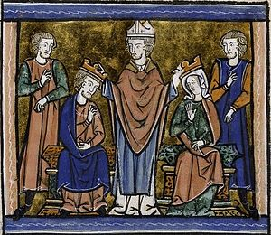
It appears that with Baldwin II out of the way, Fulk intended to dominate Jerusalem ahead of his wife. His Angevin followers were given positions of power, at least until one of the traditional Levantine nobles, Count Hugh of Jaffa rebelled in 1134. Hugh had been rumoured to have had an affair with Melisende and was eventually besieged in Jaffa. The terms of his surrender were extremely lenient but he was later assaulted by an unnamed knight and died of his injuries. It appears that Fulk consulted Melisende in everything after this episode.
The joint coronation of Fulk and Melisende

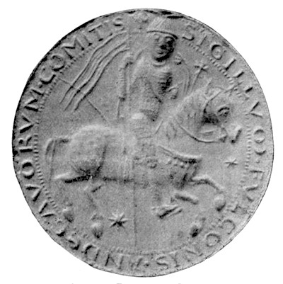
Away from home, like his predecessors, Fulk was concerned with military matters. He fell out and defeated Pons of Tripoli in 1132. In the north he had to deal with the growing threat of the Muslim Turks and the aggressive Byzantine emperor, John II Comnenus. In 1137 he came to the aid of Raymond II of Tripoli, whose town of Barrin was attacked by Zengi. Unfortunately for the Franks, the town fell. Further south, Fulk constructed a string of castles to defend against the Fatimids. He entrusted the castle of Bethgibelin to the Hospitallers to hold on his behalf. Fulk died whilst hunting in 1143 and with Baldwin II a teenager Melisende called the shots on her own. During this time Jerusalem looks for aid from Europe, which yielded the failed Second Crusade, and tried to forge a mutual alliance with Damascus against the increasingly formidable Turkish leader, Nur ad-Din.
The seal of King Fulk

A Brief History of Outremer
The County of Tripoli, 1099-1149

At the start of the First Crusade, Raymond of Toulouse appeared the most likely candidate to rule Jerusalem, but by its completion he was no longer the forerunner. His main supporter, Adhemar, had died and his backing of Peter Bartholomew lost him credibility. Raymond was left without any land and had to look to remaining unconquered territory. He managed to capture Tortosa in 1102 and set his eyes on Tripoli as his capital. But by his death in 1105 the coastal stronghold was still in Muslim hands.

Raymond’s succession was contentious. Tancred, a crusader prince and Prince of Galilee, backed Raymond’s close companion, William Jordan, but this was disputed by Raymond’s illegitimate son, Betrand. Meanwhile, the siege of Tripoli continued with the help of Baldwin I of Jerusalem, Baldwin II of Edessa and Tancred (serving as the regent of Antioch). The city fell in 1109, but so too did William Jordan in the siege. The new County was solely in the hands of Betrand.

Betrand died three years later and his son Pons began his rule until 1137. It was Pons, along with Baldwin II of Jerusalem that halted the Turks at the Battle of Hab, 1120, ensuring no Muslim follow up occurred after the Battle of the Field of Blood, 1119. But his relationship with the Jerusalem monarchy was not always positive. He had a dispute with Fulk of Jerusalem and was defeated by him at the Battle of Rugia, 1132. Eventually, Pons was captured by the Turks of Damascus and executed in 1137.

Pons’ son, Raymond II, succeeded to the countship. Raymond had to worry about the growing power of the Byzantine emperor, John II Comnenus, and in his first year as Count acknowledged himself as a vassal of John. Raymond’s rocky start got worse when he found his town of Barrin assailed by Zengi. Despite the assistance of Fulk of Jerusalem, Raymond was captured and handed over Barrin in exchange for his own release.

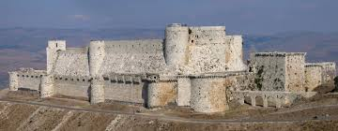
The port of Tripoli was one of the most important to the Franks of Outremer. The County had a large number of ethnic minorities including Sunni Muslims and Shi’ite Assassins. The military orders also had a strong presence. In 1142, Raymond II gave the castle of Krak de Chevaliers to the Hospitallers.
The formidable Krak des Chevaliers
A Brief History of Outremer
The County of Edessa, 1099-1149

Edessa had been seized during the First Crusade by Baldwin, brother of Godfrey of Bouillon, in 1098. By 1099 a Catholic archbishop had been appointed over the city, despite it traditionally being a Greek Orthodox city. Then, on the death of his brother Godfrey in 1100, Baldwin travelled south to assume control of Jerusalem, passing the County of Edessa to his cousin, now Baldwin II. He was joined by Joscelin de Courtenay, who held the fortress of Turbessel for him.

Baldwin II got off to a disastrous start. He teamed up with Bohemund I and Tancred, Prince of Galilee, to assault the Seljuk town of Harran, only to be captured in 1104, along with Joscelin de Courtenay. Tancred ruled as regent of Edessa until Baldwin’s release in 1108, at which point Tancred was forced out rather unwillingly. The following year, Baldwin II assisted in the capture of Tripoli and he worked with the other Franks still further in their attempt to take Shaizar in 1111. Relationships soured between Baldwin II and Joscelin de Courtenay, with the former stripping the latter of Turbessel. But on the death of his cousin in 1118, Baldwin was made King of Jerusalem. Joscelin in fact backed Baldwin’s claim to the throne and received the county in return.

Joscelin was captured again in 1122. Baldwin II came to his aid only to be captured himself. Joscelin escaped in 1123 and secured Baldwin II’s release in 1124. The favour was repaid when Baldwin came to Joscelin’s aid to defend Azaz from the Seljuks in 1125. This victory restored some prestige to the Franks in the north after the disasterous Battle of the Field of Blood (1119). Between 1127 and 1130 Jocelin then became embroiled in a dispute with Bohemund II of Antioch, the two engaging in a series of skirmishes. Then, in his final year (1131), Jocelin attempted but failed to capture Aleppo.
The fortress of Turbessel
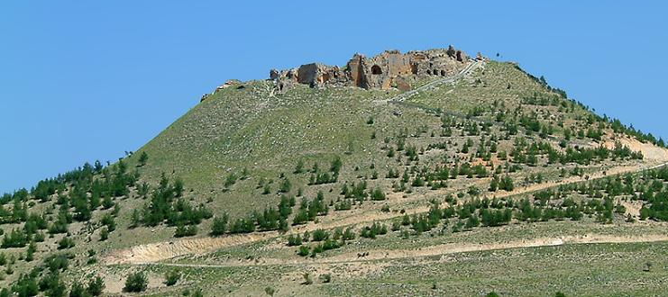
Joscelin I’ son, Joscelin II, assumed control of Edessa in 1131. He had to face the growing power of the Byzantines and Turks. In 1137, Joscelin had to acknowledge himself as a vassal of John II Comnenus. The following year he found himself engaged in an unsuccessful siege of Shaizar with John and Raymond of Antioch. In 1142 John then took hostages from Joscelin to ensure his good behaviour towards the Byzantines. Meanwhile, the rise of Zengi was a major concern for Joscelin, and rightly so. He made an alliance with Kara Arslan to fight against Zengi but to no avail. In 1144 Zengi captured Joscelin and the latter was forced to move his capital to Turbessel. A brief counterattack helped retake Edessa in 1146, but it was only held for a month. The first capital of Outremer had fallen and petitions for help were sent to Europe, eventually prompting the Second Crusade.

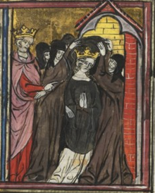
The Counts of Edessa had a track record of marrying into Armenian Christian families. Baldwin I married Arda, an Armenian princess, although the marriage did not last. Joscelin I married Beatrice, a woman from the same family as Arda. Baldwin II married Morphia, yet another Armenian noblewoman, who helped locate him whilst in captivity in order to negotiate for his release in 1124. The Armenians were notable neighbours of Edessa as well as prominent minority within their domains. But owing to Antioch’s aggressive expansion on the coastal regions, the Armenians began to distrust the Franks and looked to the Byzantines for help.
Arda being sent away

A Brief History of Outremer
The Principality of Antioch, 1099-1149

More than any other state in Outremer, Antioch’s Frankish possession irked the Byzantines. The crusader princes of the First Crusade had sworn to give land previously held by the Byzantines back to them but when Antioch was captured in 1098, Bohemund of Tarranto claimed it for himself. The Norman looked like he was a strong ally of Alexios I, the Byzantine emperor, but he had a track record of raiding Byzantine lands before the First Crusade.

With the aid of Daibert of Pisa, Bohemund attempted to capture the key port of Latakia, but called this off, fearing Byzantine retaliation. Daibert ensured that Catholic bishops filled the vacant bishoprics in Antioch’s cities, such as Tarsus, Misis and Artah, despite it being a traditionally Greek Orthodox area. Even John IV, Patriarch of Antioch was forced into retirement, presumably due to pro-Byzantine sympathies. Bohemund would surely have been Daibert’s preferred choice to succeed Godfrey’s rule of Jerusalem, had he not been captured by the Danishmends in 1100 at the Battle of Melitene. In his stead, the regency of Antioch passes to Bohemund’s nephew, Tancred, who took Latakia. Baldwin II of Edessa paid the ransom for his release in 1103 and Baldwin I, Baldwin II of Edessa, Bohemund and Tancred fought together at the Battle of Harran in 1104, only to be defeated by the Turks and for Baldwin II to be captured. The Byzantines capitalised on this moment of vulnerability, taking the port of Latakia and parts of Cilicia from Antioch.
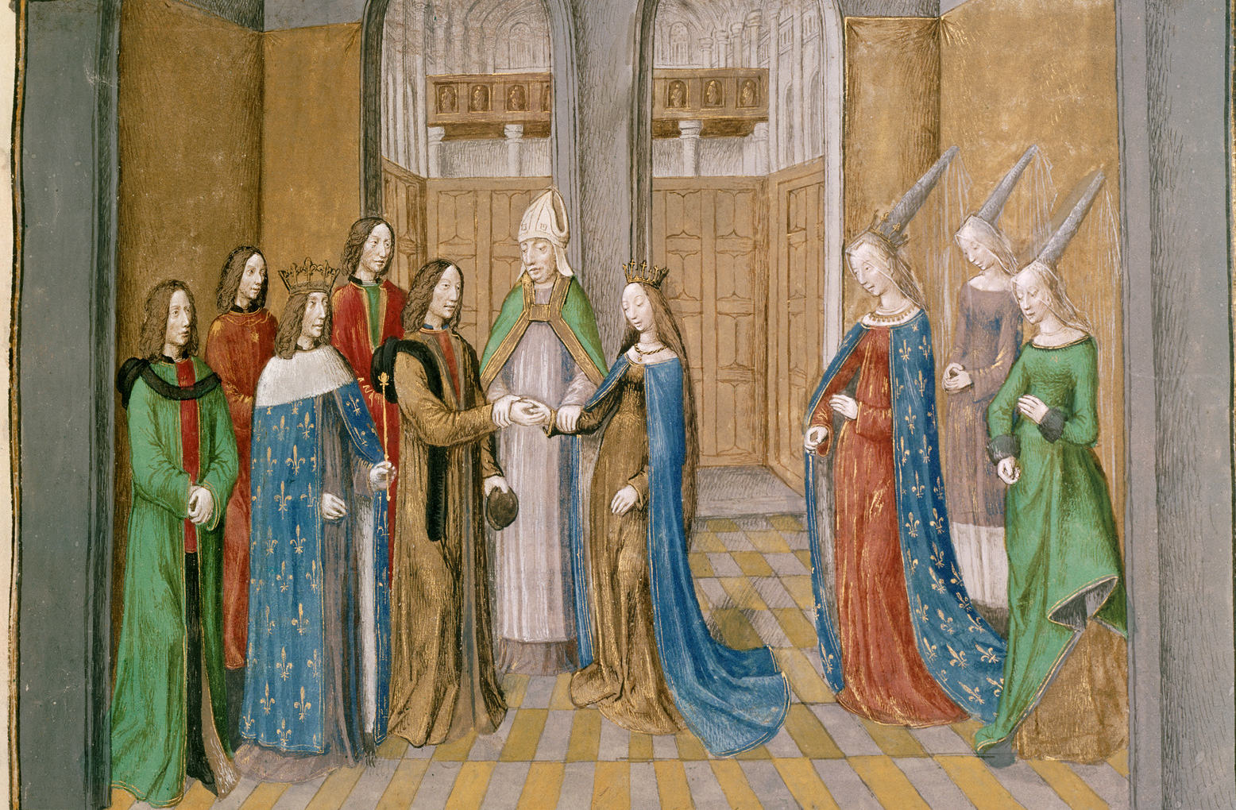
In 1105 Bohemund began touring Europe to drum up support for another crusade, trading on his celebrity status as one of the heroes of the First Crusade. He even gained the daughter of Philip I of France, Constance’s, hand in marriage. But he launched his crusade against Alexios I in 1108 and it ended pitifully. He was forced to admit he was a vassal of Alexios at the Treaty of Devol. Tancred, ruling in his absence declined to accept this and Alexios could not pursue the matter at the time. By 1110 he had retaken Latakia again. Bohemund died in Italy in 1111, a broken man.
The marriage of Bohemund and Constance

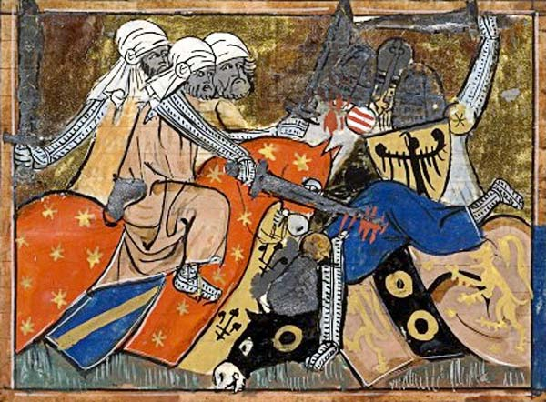
Bohemund’s son, Bohemund II was only an infant at the time of his father’s death. Consequently, Tancred continued his regency but he died the following year (1112). During his regency Tancred participated in a number of Frankish coalition efforts, including the capture of Tripoli (1109) and the failed siege of Shaizar (1111). The regency then passed to Roger of Salerno, who is most notable for his defeat and death at the hands of Il-Ghazi’s army at the Battle of the Field of Blood, 1119. So devastating was the defeat that when Baldwin II arrived with aid the following year he had to select his own men to marry the Antiochene noble widows in order to regenerate the nobility of the region.
Depiction of a scene from the Battle of the Field of Blood

For the time being, Baldwin II acted as regent of Antioch, despite himself doing a stint in captivity (1123-24). In 1126 Bohemund II finally took over the principality. He did not last long, dying in 1130, though not before capturing Capharda in 1127 and engaging in a series of small-scale battles with Joscelin I of Edessa (1127-1130). Fulk of Jerusalem ruled as regent until 1136, at which time he married Raymond of Poitios, a loyal supporter, to the infant daughter of Bohemund II, Constance.

Raymond I of Antioch had a turbulent time of it, especially when it came to the Byzantine emperor John II Comnenus. In 1137, John arrived at Antioch ready to besiege it. Raymond was forced to swear allegiance to the Byzantine emperor and a deal was struck that Raymond would cede Antioch to Constantinople if the Byzantines helped him secure Aleppo for himself. Aleppo did not fall, nor did an attempted siege of Shaizar succeed. It is possible that Raymond (and Joscelin II of Edessa, who was present too) did little to help John’s efforts. But in 1142 John returned to Antioch only to be barred entry. John had to retire for the winter and in the meantime John died. John’s successor, Manuel I Comnenus, was hardly any less formidable. By 1145, Raymond found himself in Constantinople acknowledging Byzantine overlordship. Raymond died in 1149, falling in the Battle of Inab against Nur ad-Din, who proceeded to seize parts of Antioch’s territory and exact tribute from the capital.

