Reactions of Daibert
Select a reaction to the following events and explain your selection:
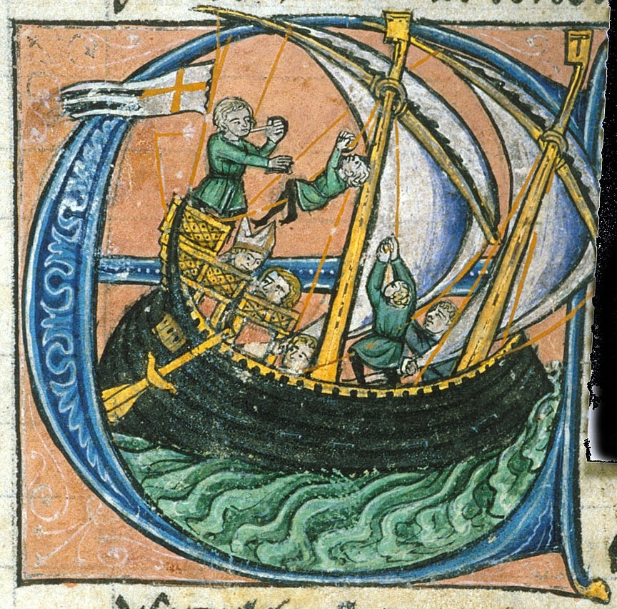
2)

4)

7)

12)

16)

18)

20)

23)

