County of Jaffa
The County of Jaffa was granted to Hugh I of Jaffa in 1106. He was the cousin of Baldwin II of Jerusalem and Joscelin I of Edessa. After the rebellion of Hugh II under the reign of Fulk and Melisende in 1134, the possession of Jaffa itself passed to the direct rule of the crown. Before this, the county controlled the following:
- Lordship of Ramla. This was
given to Baldwin I of Ramla after
Hugh II’s rebellion.
- Lordship of Ibelin. Barisan of
Ibelin received this as his own in
1134. Through marriage, Ibelin
and Ramla became united under
the Ibelin family.
- Lordship of Mirabel – also granted
to Barrison in 1134 and
consequently became part of the
Ibelin family’s territory.

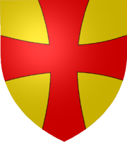

Ibelin coat of arms

Principality of Galilee

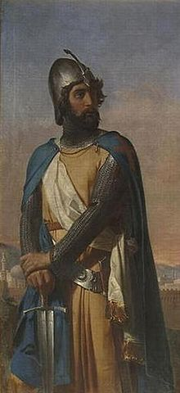
Tancred received this territory, comprising of Tiberias, Haifa, Bethsan and Nazareth, in 1099. The following lordships were vassals of the Prince of Galilee:
- Lordship of Beirut after it was captured in 1110.
- Lordship of Banias after the Assassins granted it to Baldwin II in 1128.
- Lordship of Toron, which built to help besiege Tyre. The Lords of Toron became powerful in their own right and it became an independent seigneury in 1107. Humphrey II of Toron was constable of Jerusalem (the most important officer in the Kingdom of Jerusalem, commanding the army) under Baldwin III.

Painting of Tancred
Lordships of Sidon
When Sidon was captured in late 1110, it was given to Eustace Grenier, a very prominent noble and constable of Jerusalem (the most important officer in the Kingdom of Jerusalem, commanding the army) under Baldwin II. He commanded the armies of Jerusalem, acting as regent when Baldwin was captured in 1123, scoring a victory against the Fatimids at the battle of Yibneh. Sidon was smaller than the other so-called main four lordships and was probably comparable in significance to other towns such as Beirut.
- The lordship of Caesarea was
controlled by Eustace as well and
remained under the rule
of the Grenier family after his
death.

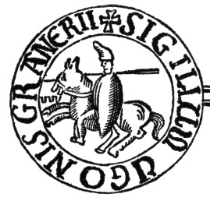
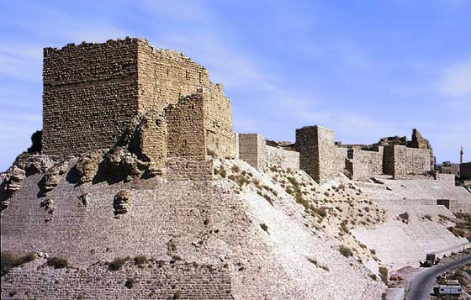
Seal of Hugh Grenier, lord of Caesarea & grandson of Eustace
Remains of Kerak Castle
Lordship of Oultrejourdain
Oultrejourdain, meaning ‘beyond the Jordan’ was a vaguer area than the other lordships and most of the inhabitants were Shi’ite Bedouins. Bordering near Damascus, Oultrejourdain had an important role in the defense of Outremer. Consequently, it was the home of important castles:
- Baldwin I built Montreal, perhaps to defend the caravan trade routes, in 1115. This was the capital of the lordship until the construction of Kerak.
- In 1126 Pagan the Butler was named lord of Oultrejourdain by Baldwin II. During the reign of Fulk and Melisende, in 1142, Pagan constructed the
castle of Kerak, which
replaced Montreal as the
dominant castle of the region
and its capital.

