The Odyssey:

A booklet for going through the text

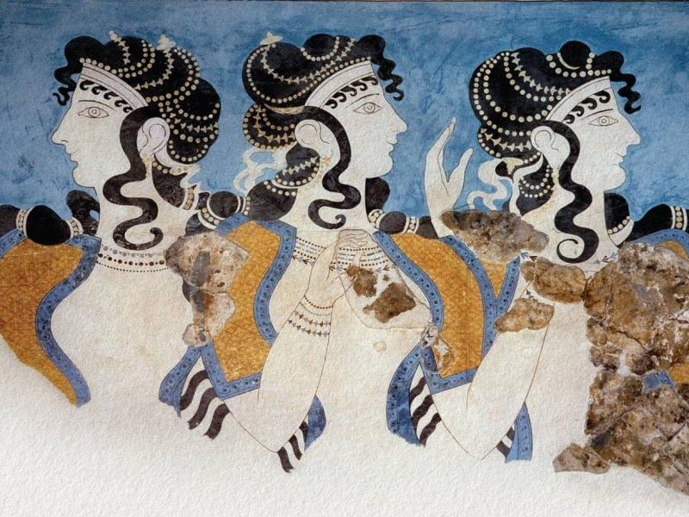
Contents

Epic Techniques 4
Odysseus’ Leadership 11
Civilisation and Barbarism 14
Involvement of the Gods 16
Glossary 18

Epic Techniques
Book 9
Technique | Description & Effect of Technique | Example 1 | Example 2 | Example 3
Epithets | Descriptive phrases which stress a person’s characteristics (and help to establish them in the audience’s memory).
Similes | Used at particularly dramatic moments. Often taken from nature and help to make a scene more vivid.
Gruesome details | Shocks the audience and their sense of horror makes them listen more intently.
Pathos | Making the audience feel sorry for the suffering of the characters, getting them more involved in the story.
Other

Book 10
Technique | Description & Effect of Technique | Example 1 | Example 2 | Example 3
Epithets | Descriptive phrases which stress a person’s characteristics (and help to establish them in the audience’s memory).
Similes | Used at particularly dramatic moments. Often taken from nature and help to make a scene more vivid.
Gruesome details | Shocks the audience and their sense of horror makes them listen more intently.
Pathos | Making the audience feel sorry for the suffering of the characters, getting them more involved in the story.
Other

Book 19
Technique | Description & Effect of Technique | Example 1 | Example 2 | Example 3
Epithets | Descriptive phrases which stress a person’s characteristics (and help to establish them in the audience’s memory).
Similes | Used at particularly dramatic moments. Often taken from nature and help to make a scene more vivid.
Gruesome details | Shocks the audience and their sense of horror makes them listen more intently.
Pathos | Making the audience feel sorry for the suffering of the characters, getting them more involved in the story.
Other

Book 21
Technique | Description & Effect of Technique | Example 1 | Example 2 | Example 3
Epithets | Descriptive phrases which stress a person’s characteristics (and help to establish them in the audience’s memory).
Similes | Used at particularly dramatic moments. Often taken from nature and help to make a scene more vivid.
Gruesome details | Shocks the audience and their sense of horror makes them listen more intently.
Pathos | Making the audience feel sorry for the suffering of the characters, getting them more involved in the story.
Other

Book 22
Technique | Description & Effect of Technique | Example 1 | Example 2 | Example 3
Epithets | Descriptive phrases which stress a person’s characteristics (and help to establish them in the audience’s memory).
Similes | Used at particularly dramatic moments. Often taken from nature and help to make a scene more vivid.
Gruesome details | Shocks the audience and their sense of horror makes them listen more intently.
Pathos | Making the audience feel sorry for the suffering of the characters, getting them more involved in the story.
Other

Xenia

Book | Type of Xenia | Plot point
 | Supplication of the guest
 | Offering guest food and drink
 | Offering guest something to bathe with
 | Offering guest a bed for the night
 | Guest being courteous/polite
 | Other

Odysseus’ Leadership
Episode | Good Leadership  (Actions / Words) | Bad Leadership  (Actions / Words) | Verdict
Cicones

Lotus Eaters

Cyclops

Bag of Winds

Laestrygonians

Circe

In Ithaca

Civilisation and Barbarism

Book | Character(s) / Place | Plot point/Quote
9
10

19
21
22

Involvement of the Gods
Episode | God / Goddess Involved | What role do they play in the episode? | How does this add to (or diminish) the excitement? | Verdict on Gods’ contribution

BOOK 9
Cicones

Lotus Eaters

Cyclops

BOOK 10
Aeolus + Bag of Winds

Laestrygonians

Circe

BOOK 19
Odysseus and Penelope

Odysseus and Eurycleia

BOOK 21
Archery contest

BOOK 22
Killings

Glossary
Term | Meaning
Achaeans | another name for Greeks
Aeaea | home of Circe, the enchantress
aegis | worn by Zeus & Athena to show power
Aeolia | land of Aeolus
Aeolus | god of the winds
Alcinous | King of the Phaeacians
Amphitrite | goddess of the sea
Aphrodite | goddess of love
Athene/Athena | Odysseus' patron deity
bard | reciter epic poems
Calypso | nymph who keeps Odysseus for 7 years
Charybdis | whirlpool opposite Scylla
Cicones | people whose land the men refused to leave
Circe | witch who turned men into pigs
Cyclops, Cyclopes | One-eyed giant/giants
Elpenor | drunk man who broke his neck
epic poem | long story of hero's adventures
epic formula | repeated phrase
[Homeric] epithet | repeated adjective used with character's name
Eurylochus | challenger to Odysseus' authority
Hades | the underworld, land of the dead
Hermes | messenger god (appears twice)
Homer | person who recorded/ 'wrote' the Odyssey
Hyperion | Sun-god owner of cattle
Ino | sea-nymph whose veil helped Odysseus
Ismarus | land of the Cicones
Ithaca | Odysseus' homeland
kleos | immortal fame & reputation
Laertes | father of Odysseus
Laestrygonians | giants who hurl stones at the fleet
Leucothoe | another name for Ino
libation | poured offering to a god
Lotus-eaters | people whose fruit makes crew forget home
Nausicaa | Phaeacian princess who welcomes Odysseus
Ogygia | island home of Calypso
Olympus | mountain where the gods live
Penelope | wife of Odysseus
Phaeacian | inhabitants of Scherie
Polyphemus | Cyclops whom Odysseus blinds
Poseidon | father of Cyclops who obstructs Odysseus
Scherie | land of the Phaeacians
Scylla | six-headed monster oppoiste Charybdis
Sirens | singing sea-creatures (lure sailors)
suppliant | person who pleads for help
Styx | river of the underworld
Teiresias | (Theban) prophet (met in the Underworld)
Telemachus | Odysseus' son
Thrinacie | Sun-god's land with forbidden cattle
Troy | place of war from which Odysseus is returning
xenia | guest friendship, bond between guest and host
Zeus | King of the gods

