Further Maths GCSE
Trigonometric Equations and Identities
1 | 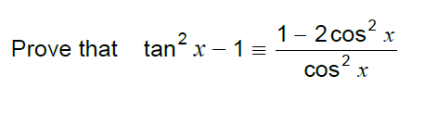
2 | 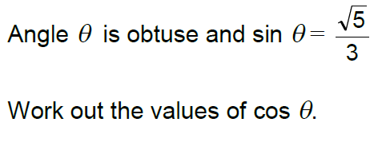
3 | 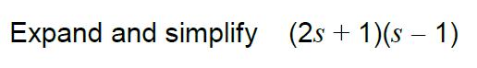
4 | 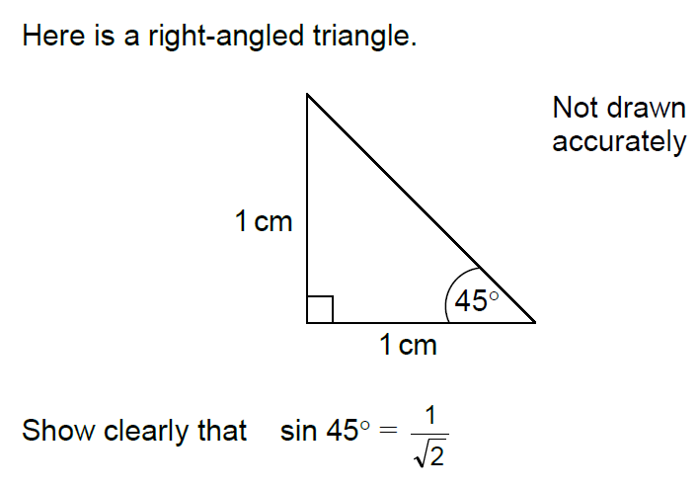
5 | 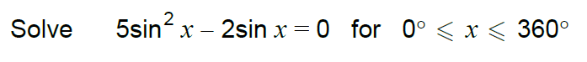
6 | 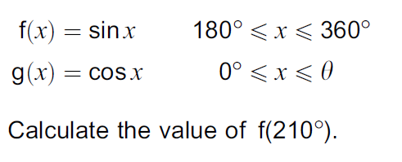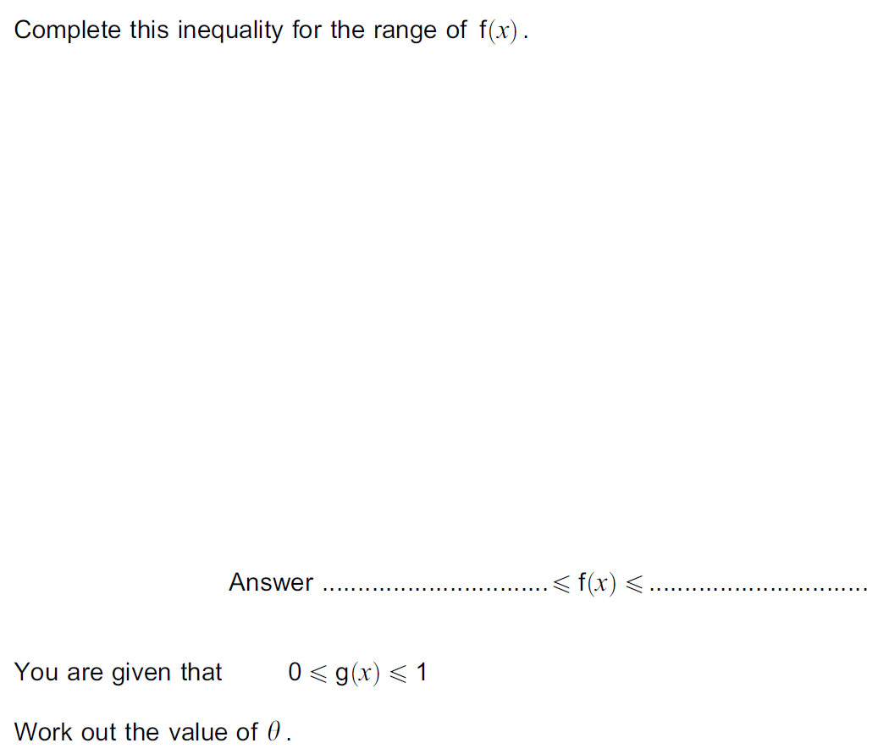
7
8
9 | 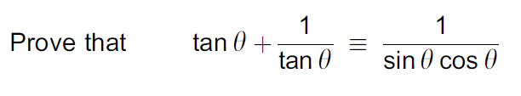
10 | 