Further Maths GCSE
Trigonometry
1 | 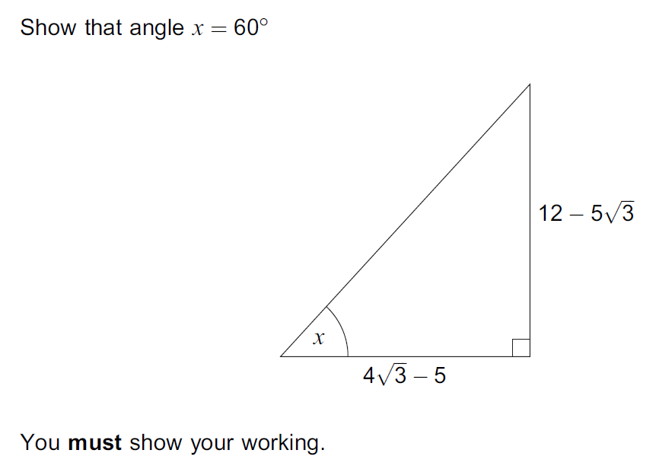
2 | 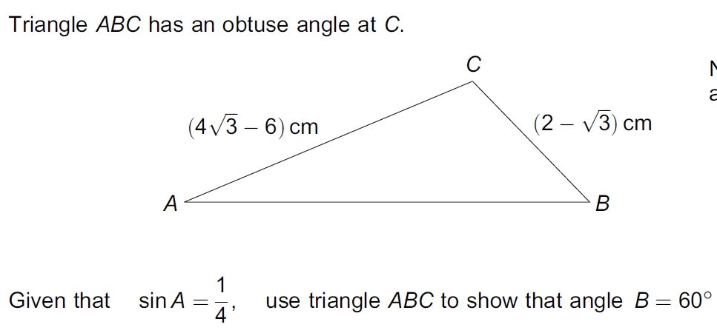
3 | 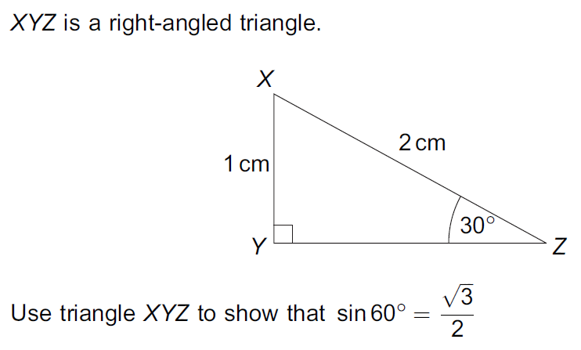
4 | 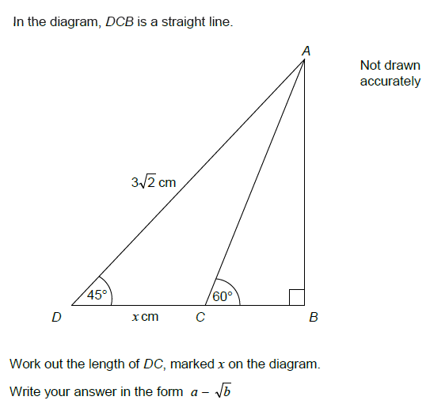
5 | 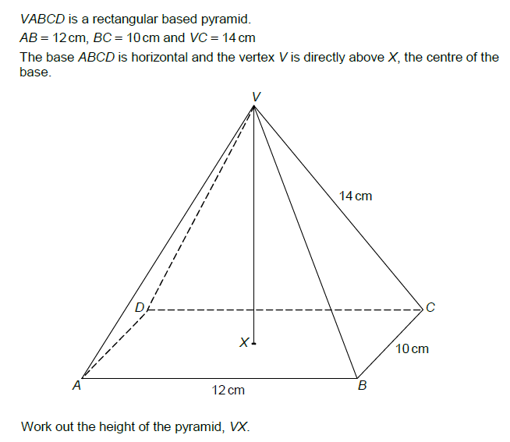  Work out the angle between VC and the plane ABCD
6 | 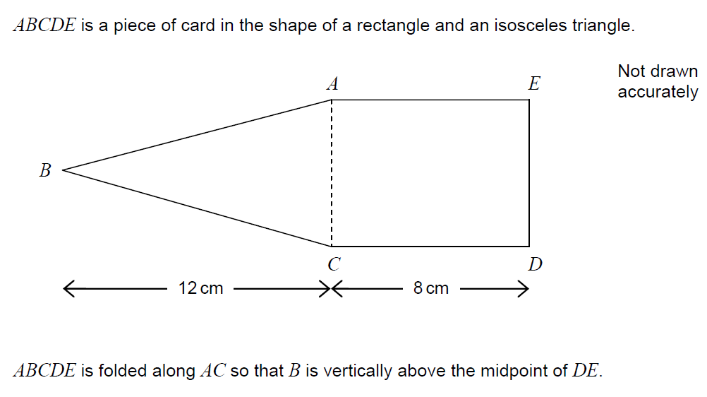  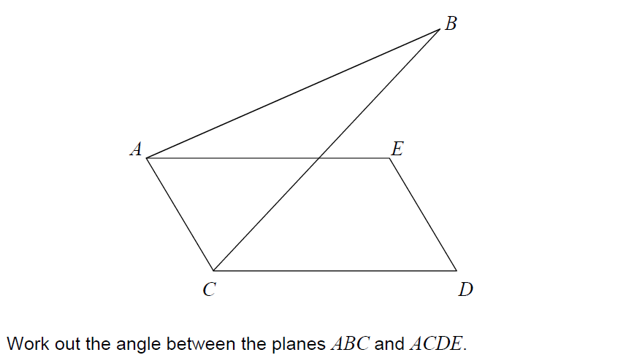
7 | 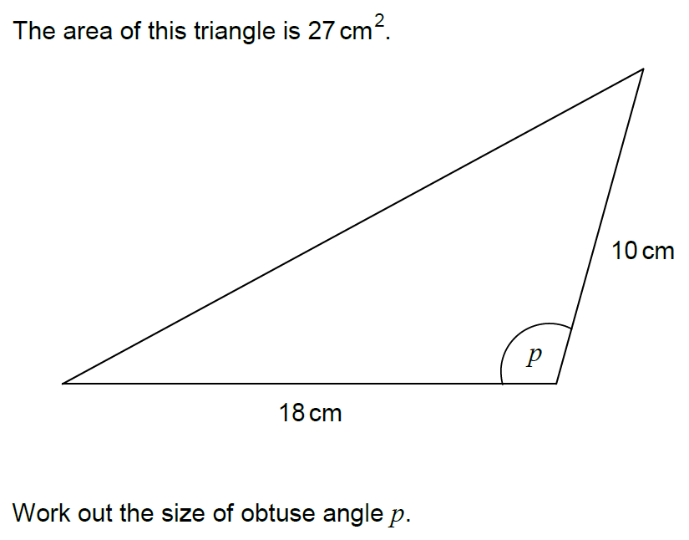
8 | 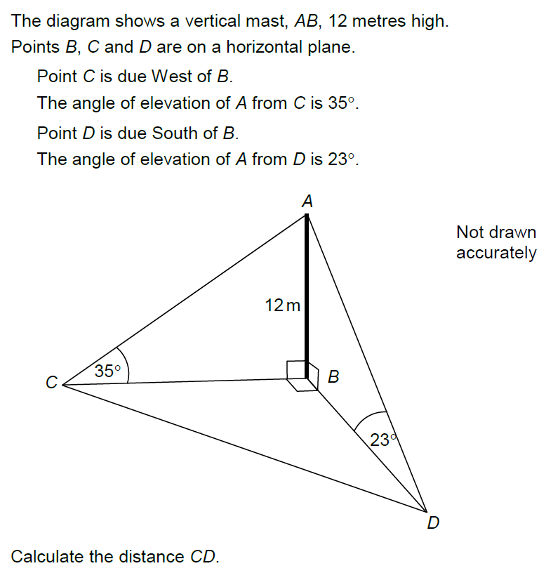  Calculate the Bearing of D from C to the nearest degree
9 | 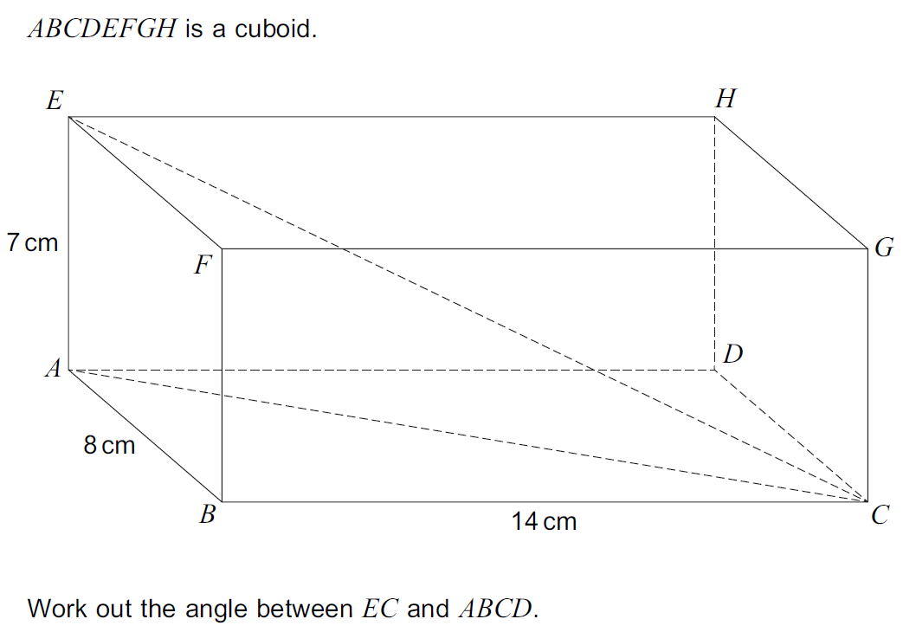
10 | 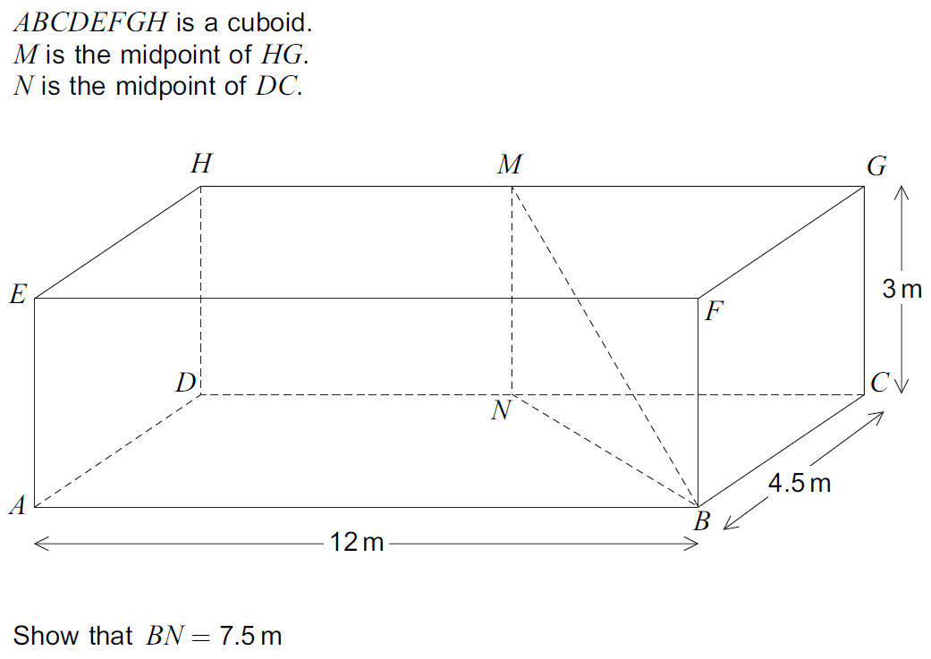  Work out the angle between MB and the plane ABCD  Work out the obtuse angle betweent the planes MNB and CDHG
11 | 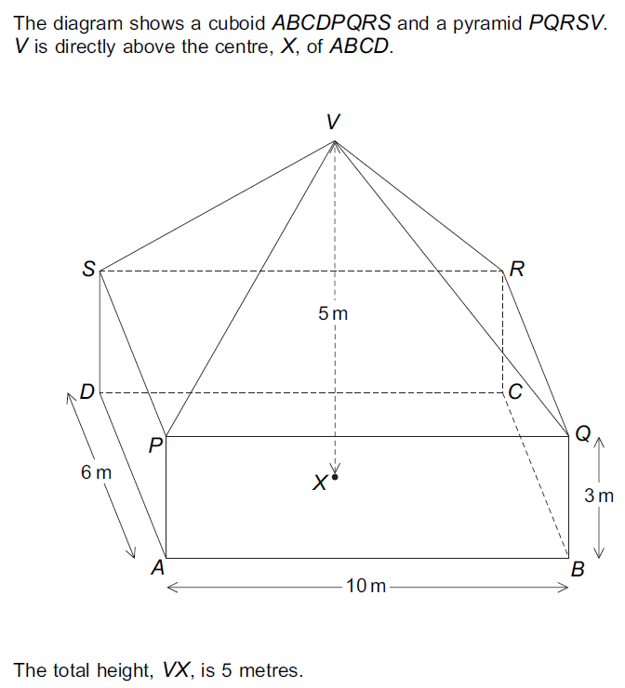  Work out the angle between VA and the plane ABCD  Work out the angles between the planes VQR and PQRS

