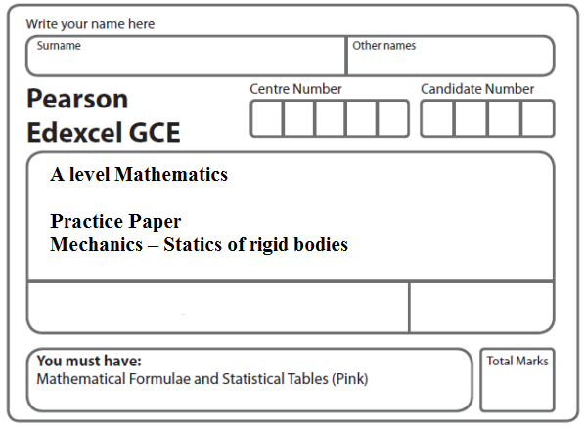
Instructions
- Use black ink or ball-point pen.
- If pencil is used for diagrams/sketches/graphs it must be dark (HB or B).
- Fill in the boxes at the top of this page with your name, centre number and candidate number.
- Answer all the questions and ensure that your answers to parts of questions are clearly labelled.
- Answer the questions in the spaces provided – there may be more space than you need.
- You should show sufficient working to make your methods clear. Answers without working may not gain full credit.
- Inexact answers should be given to three significant figures unless otherwise stated.
Information
- A booklet ‘Mathematical Formulae and Statistical Tables’ is provided.
- There are 9 questions in this question paper. The total mark for this paper is 96.
- The marks for each question are shown in brackets – use this as a guide as to how much time to spend on each question.
- Calculators must not be used for questions marked with a * sign.
Advice
• Read each question carefully before you start to answer it.
• Try to answer every question.
• Check your answers if you have time at the end.
• If you change your mind about an answer, cross it out and put your new answer and any working underneath.
1.

Figure 1

A ladder, of length 5 m and mass 18 kg, has one end A resting on rough horizontal ground and its other end B resting against a smooth vertical wall. The ladder lies in a vertical plane perpendicular to the wall and makes an angle α with the horizontal ground, where tan α = , as shown in Figure 1. The coefficient of friction between the ladder and the ground is μ. A woman of mass 60 kg stands on the ladder at the point C, where AC = 3 m. The ladder is on the point of slipping. The ladder is modelled as a uniform rod and the woman as a particle.

Find the value of μ.
(Total 9 marks)
___________________________________________________________________________

2.

Figure 2

A uniform rod AB, of mass 5 kg and length 4 m, has its end A smoothly hinged at a fixed point. The rod is held in equilibrium at an angle of 25° above the horizontal by a force of magnitude F newtons applied to its end B. The force acts in the vertical plane containing the rod and in a direction which makes an angle of 40° with the rod, as shown in Figure 2.

(a) Find the value of F.
(4)
(b) Find the magnitude and direction of the vertical component of the force acting on the rod at A.
(4)
(Total 8 marks)
___________________________________________________________________________

3. A ladder AB, of weight W and length 2l, has one end A resting on rough horizontal ground. The other end B rests against a rough vertical wall. The coefficient of friction between the ladder and the wall is . The coefficient of friction between the ladder and the ground is μ. Friction is limiting at both A and B. The ladder is at an angle θ to the ground, where tan θ = . The ladder is modelled as a uniform rod which lies in a vertical plane perpendicular to the wall.

Find the value of μ.
(Total 9 marks)
___________________________________________________________________________

4. A rough circular cylinder of radius 4a is fixed to a rough horizontal plane with its axis horizontal. A uniform rod AB, of weight W and length 6a√3, rests with its lower end A on the plane and a point C of the rod against the cylinder. The vertical plane through the rod is perpendicular to the axis of the cylinder. The rod is inclined at 60° to the horizontal, as shown in Figure 3.

Figure 3

(a) Show that AC = 4a√3.
(2)
The coefficient of friction between the rod and the cylinder is and the coefficient of friction between the rod and the plane is μ. Given that friction is limiting at both A and C,

(b) find the value of μ.
(9)
(Total 11 marks)
___________________________________________________________________________

5.
Figure 4

A uniform rod AB, of mass m and length 2a, is freely hinged to a fixed point A. A particle of mass m is attached to the rod at B. The rod is held in equilibrium at an angle θ to the horizontal by a force of magnitude F acting at the point C on the rod, where AC = b, as shown in Figure 4. The force at C acts at right angles to AB and in the vertical plane containing AB.

(a) Show that F = .
(4)
(b) Find, in terms of a, b, g, m and θ,

(i) the horizontal component of the force acting on the rod at A,

(ii) the vertical component of the force acting on the rod at A.
(5)

Given that the force acting on the rod at A acts along the rod,

(c) find the value of .
(4)
(Total 13 marks)
___________________________________________________________________________

6.

Figure 5

A uniform rod AB has mass 4 kg and length 1.4 m. The end A is resting on rough horizontal ground. A light string BC has one end attached to B and the other end attached to a fixed point C. The string is perpendicular to the rod and lies in the same vertical plane as the rod. The rod is in equilibrium, inclined at 20° to the ground, as shown in Figure 5.

(a) Find the tension in the string.
(4)

Given that the rod is about to slip,

(b) find the coefficient of friction between the rod and the ground.
(7)
(Total 11 marks)
___________________________________________________________________________
7.

Figure 6

A uniform rod AB of weight W has its end A freely hinged to a point on a fixed vertical wall. The rod is held in equilibrium, at angle θ to the horizontal, by a force of magnitude P. The force acts perpendicular to the rod at B and in the same vertical plane as the rod, as shown in Figure 6. The rod is in a vertical plane perpendicular to the wall. The magnitude of the vertical component of the force exerted on the rod by the wall at A is Y.
(a) Show that .
(6)

Given that θ = 45°

(b) find the magnitude of the force exerted on the rod by the wall at A, giving your answer in terms of W.
(6)
(Total 12 marks)
___________________________________________________________________________
8.

Figure 7

A uniform plank AB, of weight 100 N and length 4 m, rests in equilibrium with the end A on rough horizontal ground. The plank rests on a smooth cylindrical drum. The drum is fixed to the ground and cannot move. The point of contact between the plank and the drum is C, where AC = 3 m, as shown in Figure 7. The plank is resting in a vertical plane which is perpendicular to the axis of the drum, at an angle α to the horizontal, where sin α = . The coefficient of friction between the plank and the ground is μ.

Modelling the plank as a rod, find the least possible value of μ.
(Total 10 marks)
___________________________________________________________________________

9.

Figure 8

A uniform rod AB, of mass 3m and length 4a, is held in a horizontal position with the end A against a rough vertical wall. One end of a light inextensible string BD is attached to the rod at B and the other end of the string is attached to the wall at the point D vertically above A, where AD = 3a. A particle of mass 3m is attached to the rod at C, where AC = x. The rod is in equilibrium in a vertical plane perpendicular to the wall as shown in Figure 8. The tension in the string is mg.

Show that

(a) x = 3a,
(5)
(b) the horizontal component of the force exerted by the wall on the rod has magnitude 5mg.
(3)

The coefficient of friction between the wall and the rod is μ. Given that the rod is about to slip,

(c) find the value of μ.
(5)
(Total 13 marks)

TOTAL FOR PAPER: 96 MARKS

