The Aeneid – Book 11

Read lines 1-99
Use image of tropaeum from Trajan’s column as inspiration to create and label own version with Mezentius’ arms.
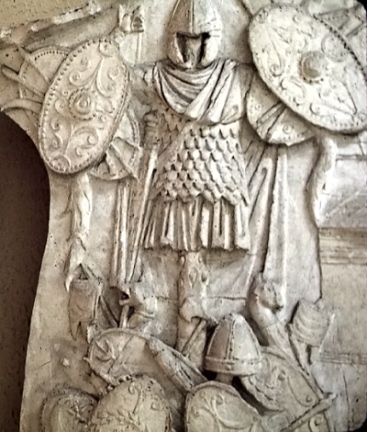

How do Venus and Juno highlight the suffering of their respective sides?

How does Aeneas use the past, present and future to encourage his people?
Future
Present
Past

Read the accompanying information ‘Preparing the Body’ and ‘Funerary Procession’ in the appendix and see what similarities and unique features you can find for Pallas’ funeral:
Similarities | Unique Features
How does Aeneas try to give comfort to balance Evander’s grief?

Comfort
Grief

Sketch Pallas’ funeral pyre and procession. Use labels if necessary.

Read lines 100-138
Write out the terms of the treaty signed here and note down what Aeneas and Drances wish could have been included in it:
Aeneas:

Drances:

Read lines 139-181
How do the following react to news of Pallas’ death?
The Arcadians:

The mothers of Pallateum:

Evander:

How does Evander feel about the following?

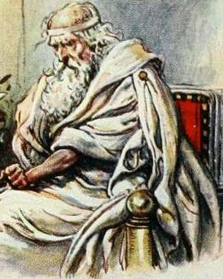

Read lines 182-225
Around each pyre, note down the signs of grief from the Trojan and Latin side of the war. Mark down how much pathos you feel for each:

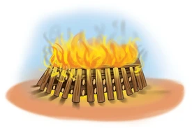

Latins
Trojans

What are the arguments for the Latins opposing and supporting Turnus?

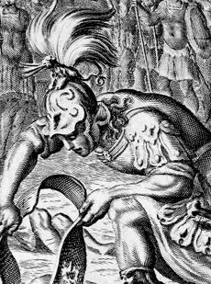



Read lines 226-375
Scan the QR code. How do the reasons for the sufferings of the Achaeans after Troy in the Homeric tradition compare to those given by Virgil’s Diomedes?

Homeric Tradition
k
Virgil’s Diomedes
Use the same code to help explain the references made by Diomedes:
Star is probably mentioned here because the appearance of certain stars in the sky was seen as a warning of storms
The deadly star of Minerva knows us well. So do the rocks of Euboea and Caphereus, the cape of vengeance. From that campaign we have been washed up on many shores. Menelaus, son of Atreus, is in exile in distant Egypt at the pillars of Proteus. Ulixes has seen the Cyclopes on Etna; shall I speak of the kingdom of Neoptolemus of Epirus? Of the new home of Idomeneus in Calabria? Of Locrians living on the shores of Libya? Even the leader of the great Achivi from Mycenae was struck down by the hand of an evil queen the moment he stepped over his own threshold! The adulterous lover had been waiting for Asia to fall. To think that the envious gods forbade me to return to the altars of my fathers or to see the wife I longed for and my beautiful land of Calydon. Even now I am pursued by hideous portents. My lost comrades have taken to the sky on wings. They have become birds and haunt the rivers – so cruelly have my people been punished – weeping till the rocks ring with the sound of their voices.
Most traditions have the followers of Diomedes transformed into birds after his death. Ovid claims they were friendly to Greeks and hostile to Italian sailors
Some stories have the people of Ajax the Lesser scattered from their homeland after his death

How has Virgil changed Diomedes’ character? Why do you think he has done this?

What two options does Latinus propose are offered to the Trojans? What help does he suggest for each option?
Option A:
Help:
Option B:
Help:
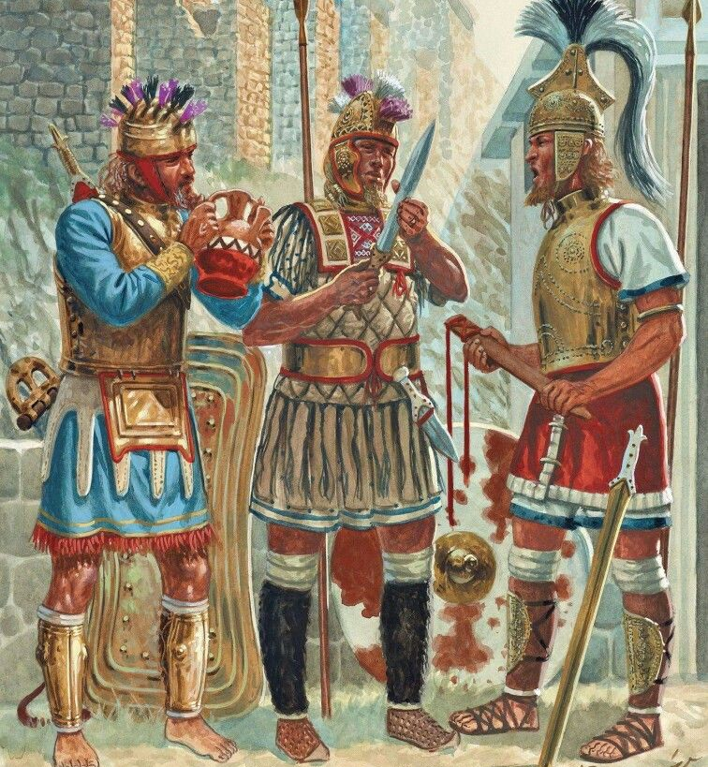

Decide which of the following are discussed in the words of Diomedes, Latinus and Drances:
Points
- Turnus is to blame
- Peace should be sought with Aeneas.
- The Trojans should be allowed to settle
- Italy has suffered enough
- Turnus should duel with Aeneas
- Trojans make fearsome opponents.
- Italy is blessed
- Tokens of peace should be sent to the Trojans
- Lavinia should marry Aeneas
- The Fates and gods are on the Trojans’ side
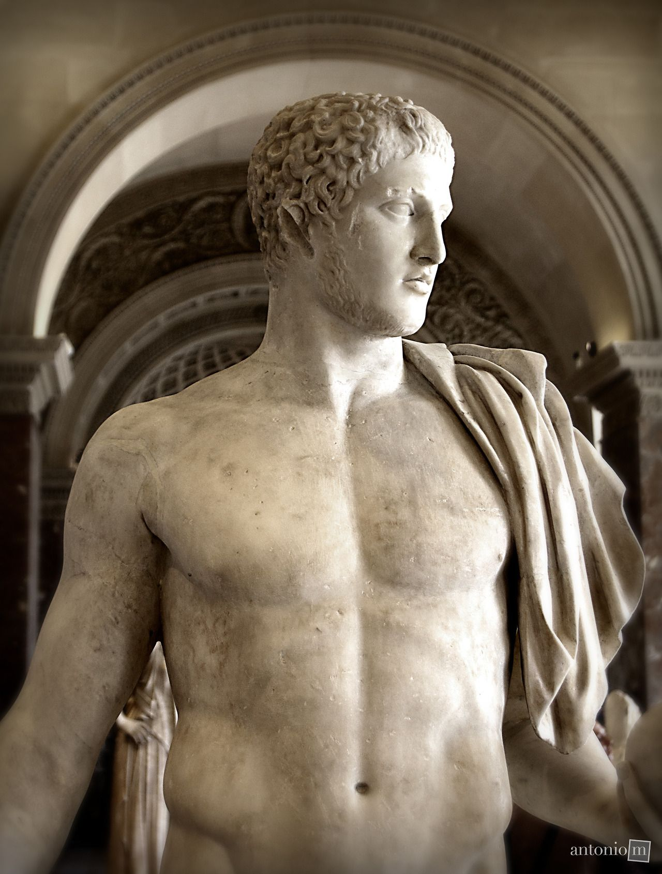


Diomedes

Drances
Latinus

Read lines 376-447
Arguments
- Drances can criticise him after he has contributed to the war
- It is time for war, not talk
- He has already slain many Trojans.
- Drances is trying to stir up panic
- More help is available from the cities of Italy
- The Trojans have lost many men already
- They have powerful allies: Messapus, Tolumnius and Camilla
- The Goddess of Victory is still with him
- He would take on Aeneas, even if Aeneas was mightier than Achilles
Place the nine arguments of Turnus in
the order of the most persuasive at the top:

How does Turnus address Drances and Latinus with different tones?
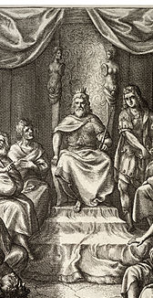
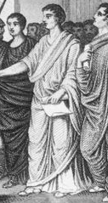

TONE

Latinus
Drances

Read lines 448-532
How do the following react to the news of the Trojan army approaching?
Characters: | Reaction:
Young men of Latium
Turnus

Latinus

Women of Latium
Camilla

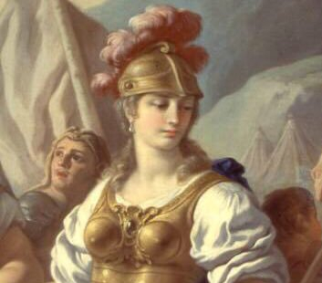
Compare the characterisation of the other women in this passage to Camilla. What gender roles are at play here?


Briefly sketch Turnus’ plan:

Read lines 216-259
Which of the following words apply to Cymodocea and the other nymphs’ visit to Aeneas? Explain your answer below:

Read lines 533-598
Complete the following for Camilla’s backstory. Indicate how the introduction and conclusion of the story mirror one another:
 | 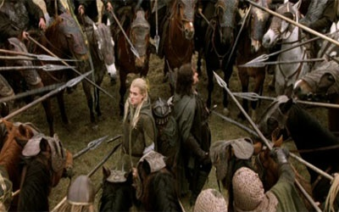 |     
 | 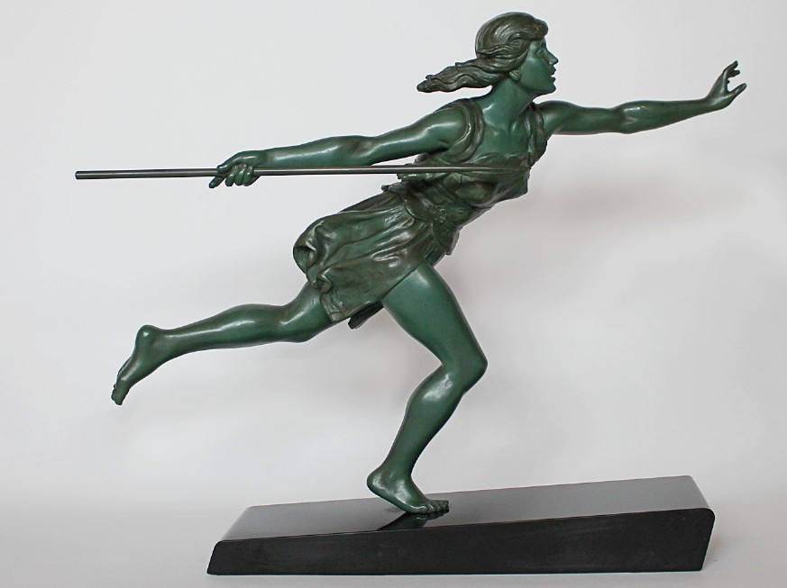 |   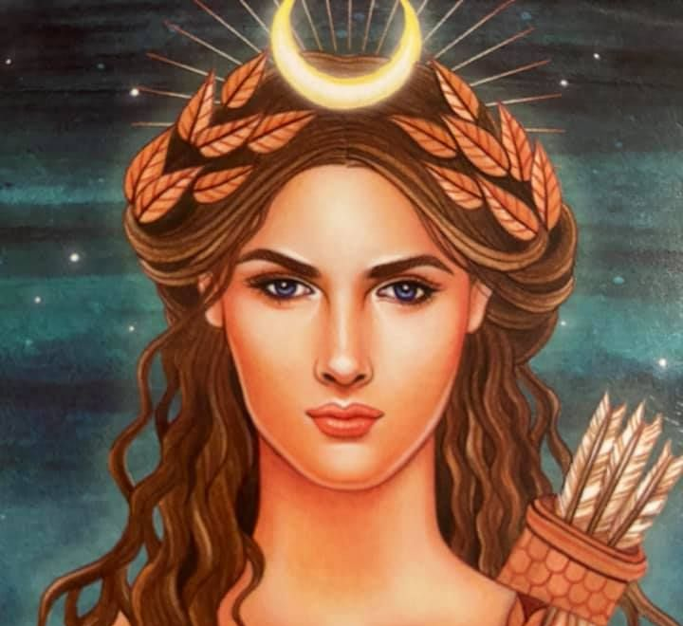  
Read lines 599-647
In two different colours, collect quotes to show how the Etruscan and Latin cavalry are equally eager and ferocious in battle:

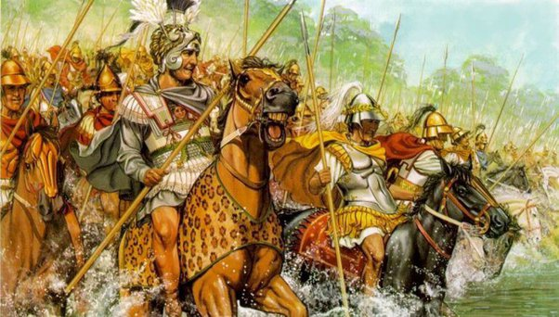
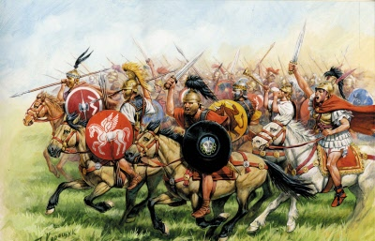

V

Latins
Etruscans

Read lines 648-868
How does Camilla appear to be an Amazonian warrior? Consider:
Her equipment:

Her manner of fighting:

Her companions:

Comparison to previous Amazons:

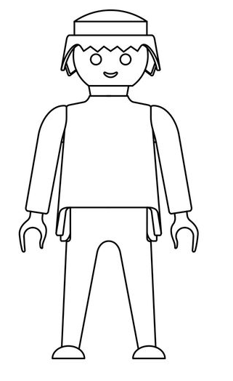

Extension: design a figure for Camilla.

Draw lines linking these victims of Camilla to the appropriate picture. Along your arrows, explain the reason:

Harpalycus


Amastrus


Ornytus

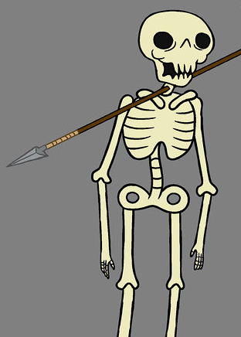
Orsilochus

Pagasus


Eunaeus

Chromis


Demophoon

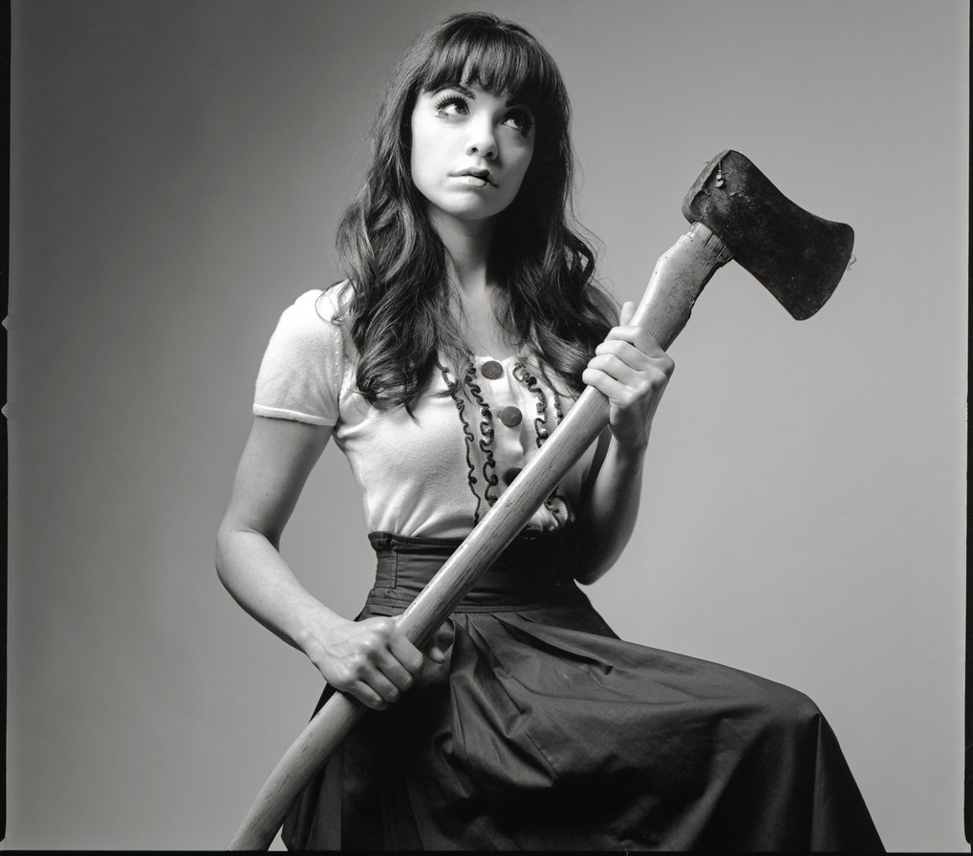
Liris

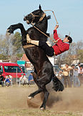
Butes

Tereus

How does Tarchon respond to Camilla’s aristeia?
Actions:
Words:
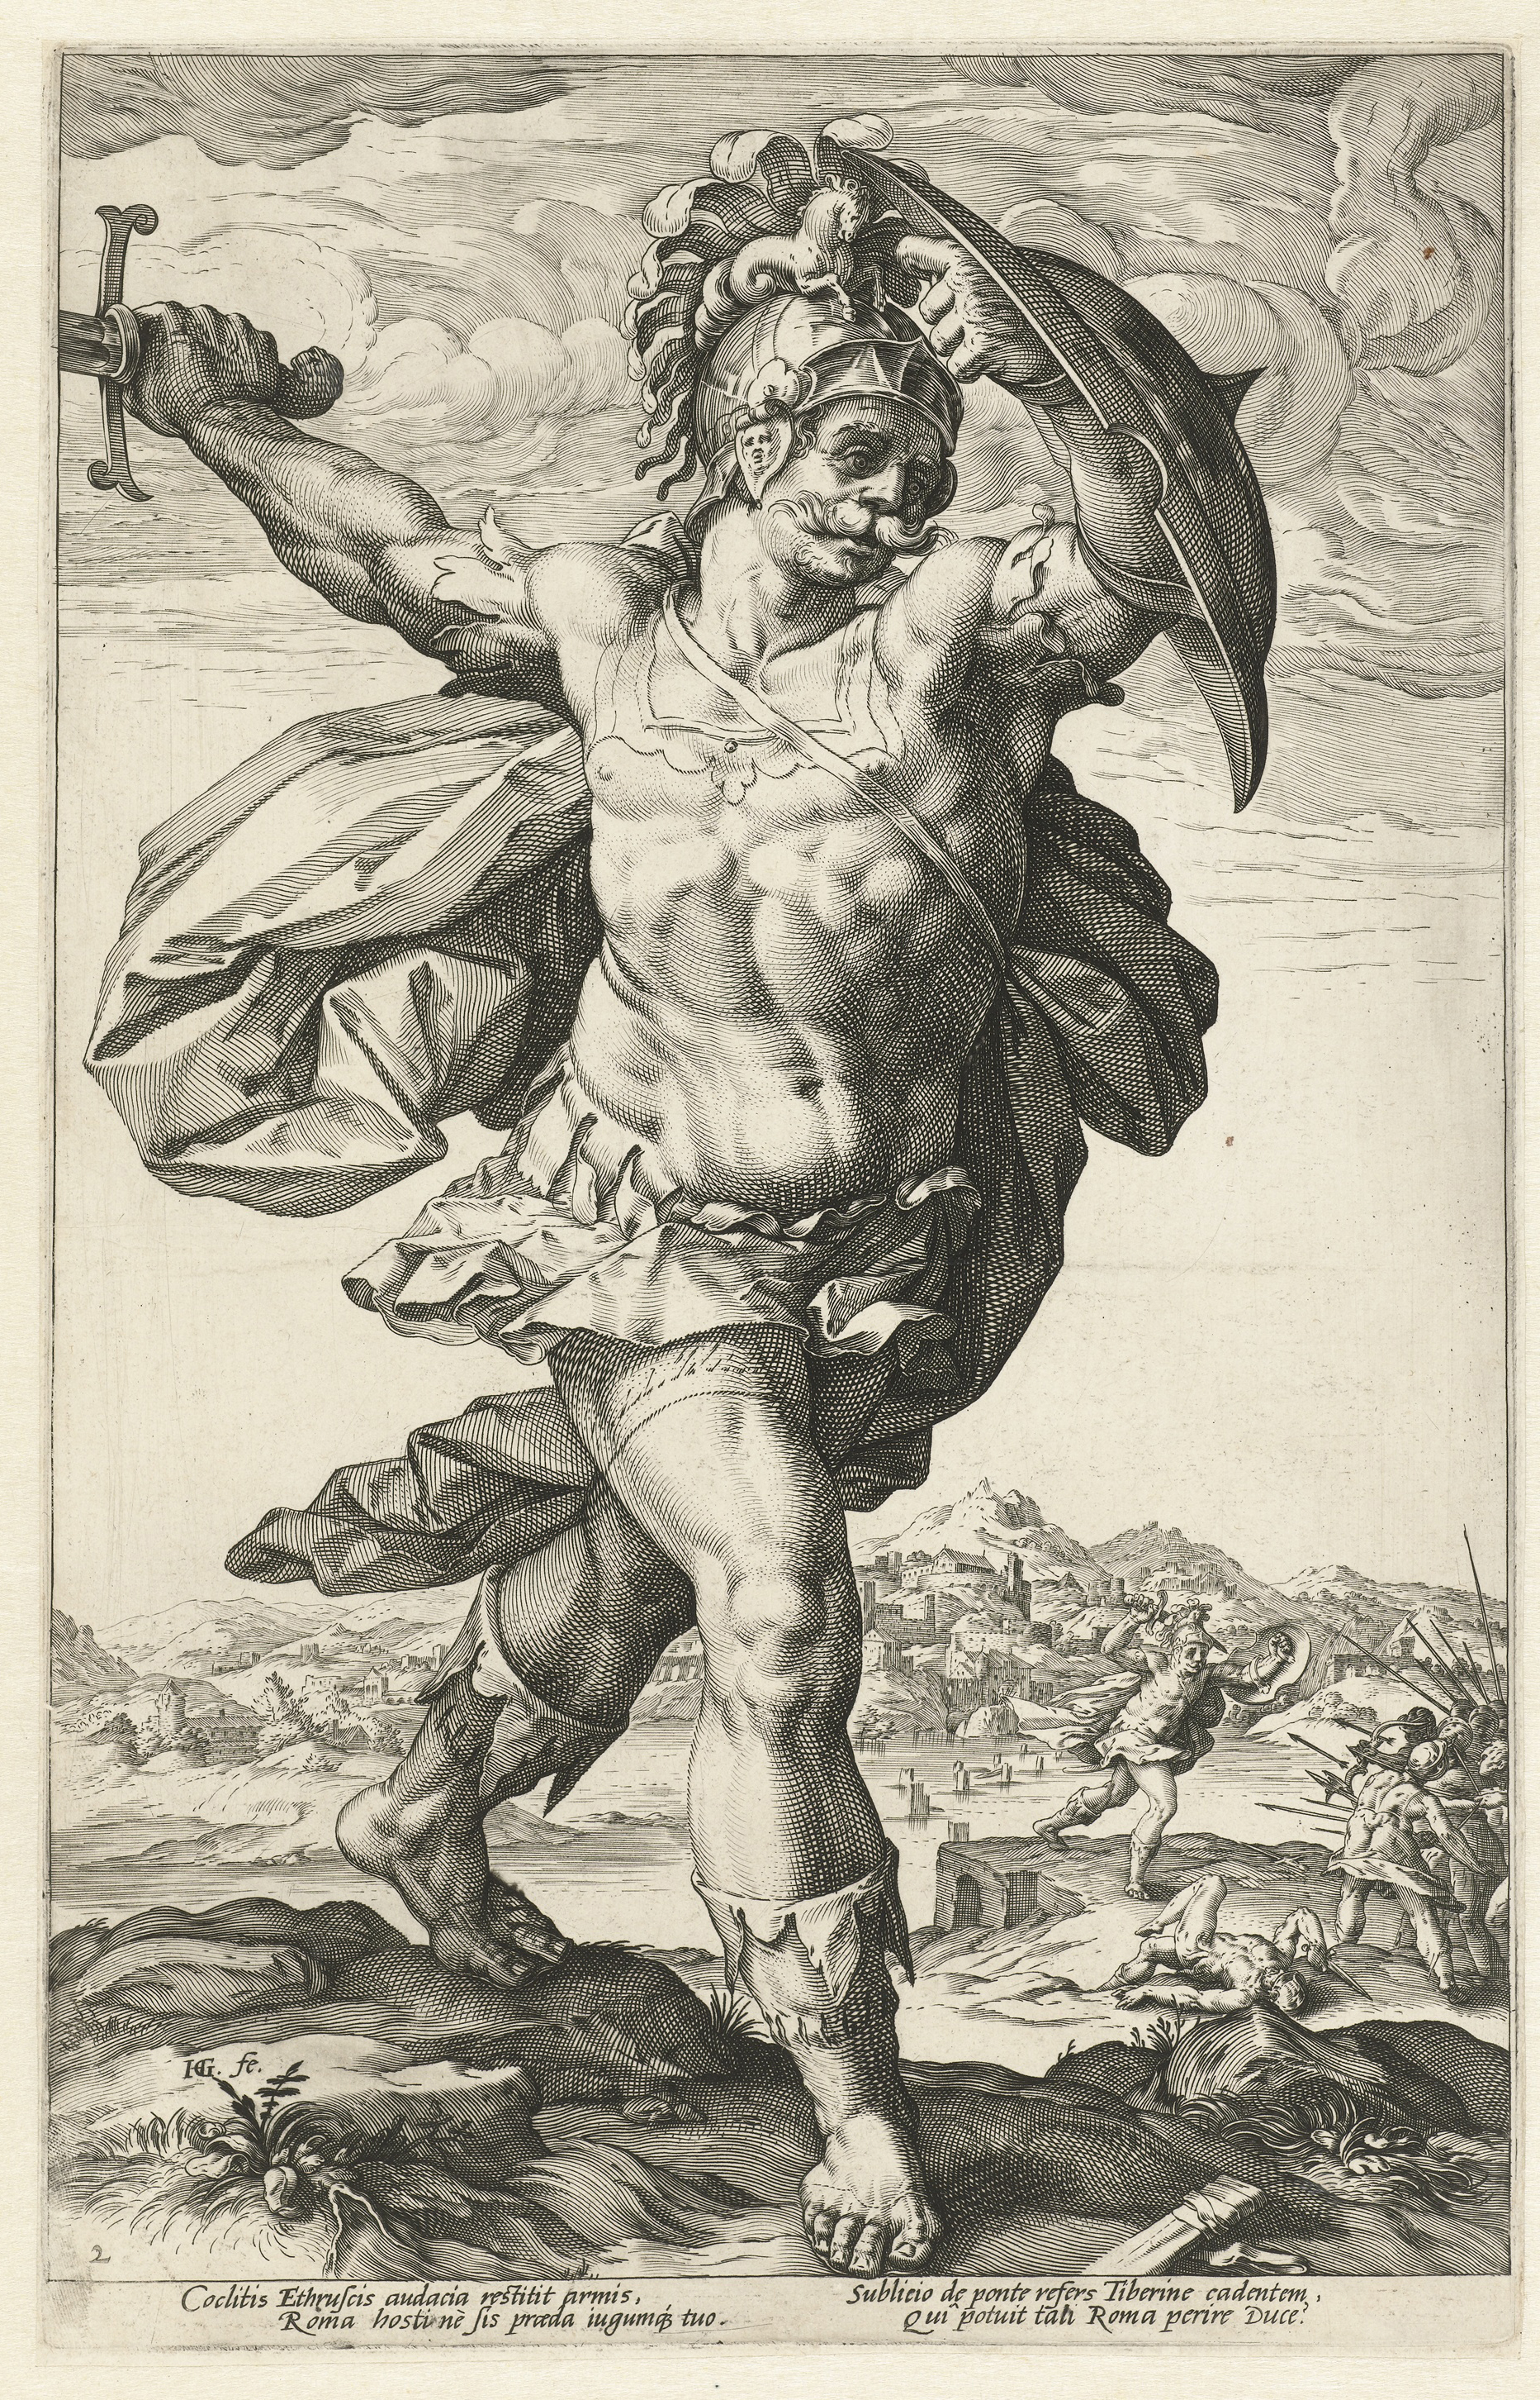

How does Arruns overcome Camilla?

Surround this picture with all the ways pathos is garnered for Camilla.

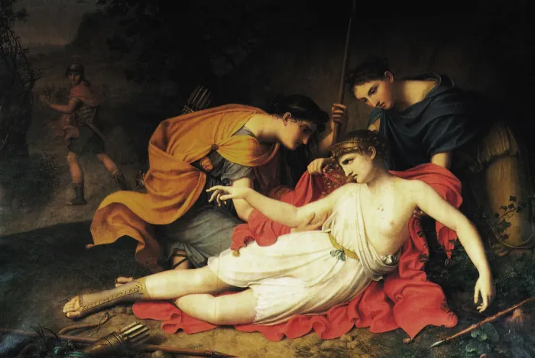

Read lines 869-916
What happened within and outside the gates of Latium?
Outside
Within
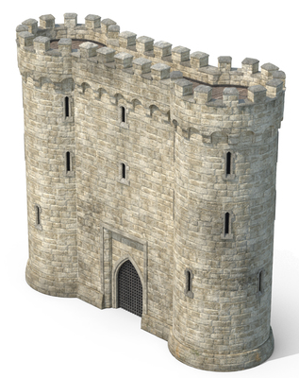

Complete the final development, ending the book in a stalemate:

Appendix – Roman Funerals and Burials
Preparing the Body
The treatment of the dead was extremely important to the Romans. The consequences of not receiving the proper rituals were drastic. For example, in Virgil’s Aeneid, Aeneas cannot enter the Underworld until he buries Misenus, a Trojan, whose body he finds washed up on the shore after he drowned. It was understood that without the correct burial rites, Misenus would not have been able to be carried across the Styx by Charon.

The Romans tried to catch the last breath of a dying person with a kiss. Next everyone present would call out the deceased’s name (if they died alone then this could be done in a ceremony later). The body had to be washed and anointed with perfume, before being dressed in their finest clothes. A coin was placed in the dead person’s mouth to pay Charon for ferrying them across the Styx. Wealthy families left the body in their atrium (main room) for eight days to allow their relatives to pay
their respects. Women were
important at this time as they
were expected to mourn the
dead while beating their chest.
This coin was especially made to serve as Charon’s payment

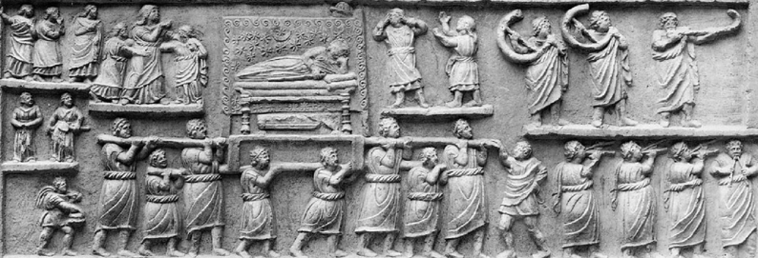
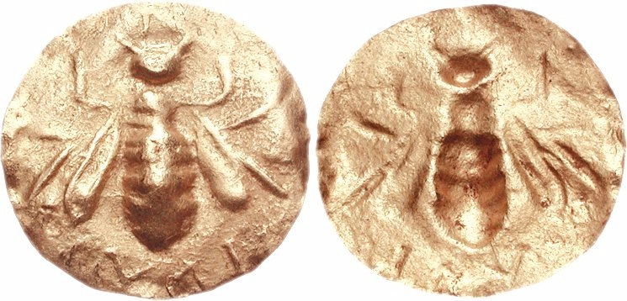
Funerary Procession
The funerary procession took the body from the house of the deceased to the place of burial and was itself an important ritual. It took place eight days after death. The procession was accompanied by flute and horn players. The whole family walked in the procession, along with slaves and freedmen. They wore funerary masks of other dead ancestors (Manes), made by placing wax on their face when they died. This gave the appearance of the dead ancestors accompanying the procession.

Wealthy families might also pay for professional mourners to come along too and an actor to mimic the deceased as they were in life. A eulogy was delivered: a speech praising the virtues of the deceased. Finally a sacrifice would take place, providing the meat for a feast shared by those present. The portion for the deceased was burnt on their pyre along with their body.

Sculpture depicting a funerary procession

