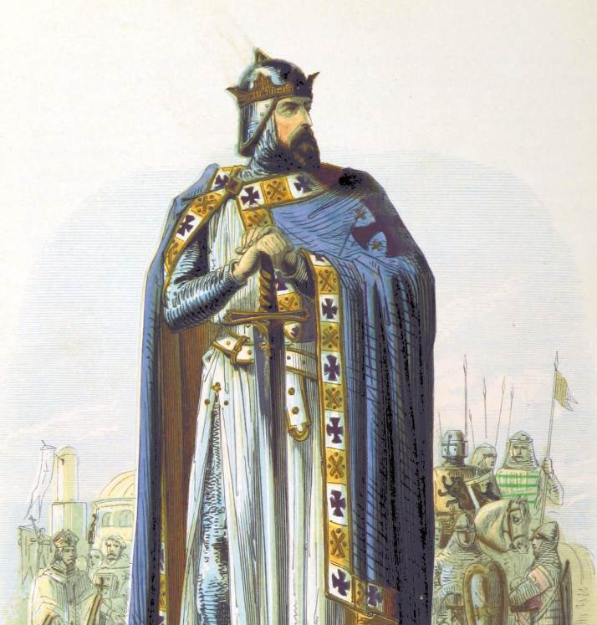
Jerusalem
In the wake of the First Crusade, Baldwin of Bouillon temporarily secured the new state of Jerusalem after he defeated a Fatimid counterattack, the Battle of Ascalon, 1099. He became the first ruler of Jerusalem, although he declined the title ‘King’, backed by Arnulf of Chocques, who assumed the title of the first ever ‘Latin Patriarch of Jerusalem’, establishing the predominance of the Catholic church above all other denominations in the kingdom.
Within their lands lived the largest population of Muslims in Outremer, as well as some Bedouin tribes and many different eastern denominations of Christians. It attracted pilgrims of all faiths and sects on account of the holy sites throughout the land and in the capital itself.

Right: manuscript showing Godfrey being made lord of Jerusalem.

Godfrey of Bouillon


Background: Frankish prince from Boulogne-sur-Mer who joined the First Crusade with his older brother, Eustace, and younger brother, Baldwin. Although the second son of Eustace II of Bolougne, he was still set to inherit the duchy of Lorraine.
Acquisition: Godfrey was instrumental in breaking into the city of Jerusalem in 1099, redeploying a belfry overnight and helping storm the walls. A month later he routed a Fatimid relief force led by al-Afdal. He refused to take the title of ‘king’ and instead was called advocatus (‘defender’) of the Holy Sepulchre
Reign: 1099-1100

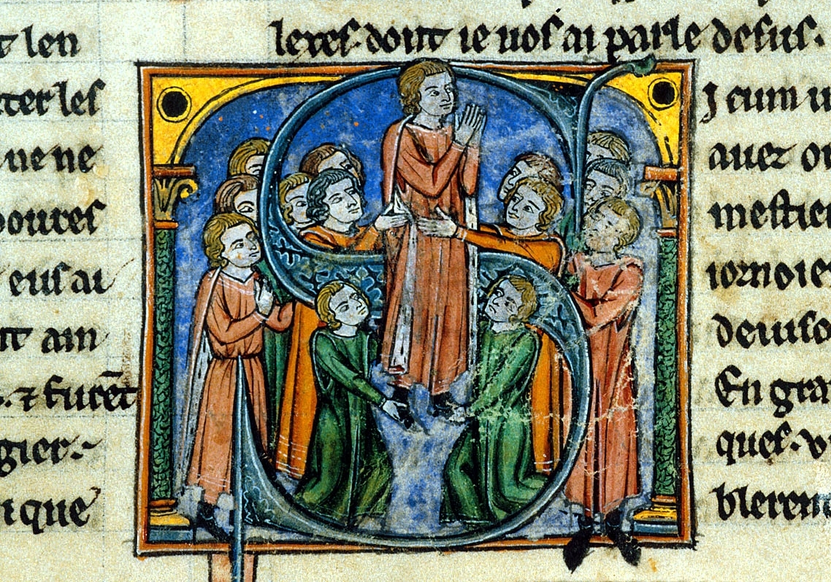

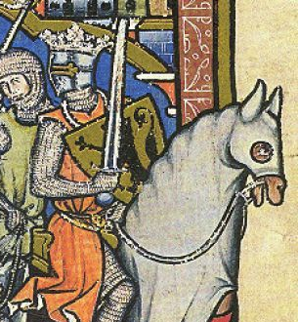
Tripoli
At the start of the First Crusade, Raymond of Toulouse appeared the most likely candidate to rule Jerusalem, but by its completion he was no longer the forerunner. His main supporter, Adhemar, had died and his backing of Peter Bartholomew lost him credibility. Raymond was left without any land and had to look to remaining unconquered territory. He looked to the port of Tripoli as his potential capital, but it fell to his son, Betrand, to become the first count.
The county fell under the religious jurisdiction of the Latin (i.e. Catholic) Patriarch of Jerusalem. The nobility followed this church, but the population were a mixture of Maronite Christians (established by Saint Maroun), Jacobite Christians (established by Saint Jacob Maradaeus), Eastern Orthodox Christians, and Sunni Muslims. The feared Shi’ite Nizari sect, known as the Assassins, also operated in this region, sometimes even working with the Franks.

Right: Tripoli’s most famous castle: Krak des Chevaliers.

Betrand of Toulouse

Background: Betrand was the eldest son of Raymond of Toulouse, the crusader prince. He was the acting count of Toulouse in his father’s stead and gained the title officially when Raymond died in 1105.
Acquisition: In 1108 Betrand travelled to the Holy Land to pursue his father’s claim of Tripoli, bringing with him a Genoese fleet. The city underwent a protracted siege at the hands of Baldwin I of Jerusalem, Baldwin II of Edessa and Tancred, Antioch’s regent. But Betrand had to contend with his cousin, William Jordan, who had accompanied his uncle Raymond on the First Crusade. Fortunately for Raymond, William Jordan died in the siege, hit by an arrow. Amidst rumours of assassination, Betrand became the first real count of Tripoli
Reign: 1109-1112

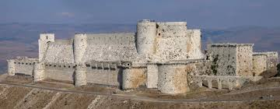

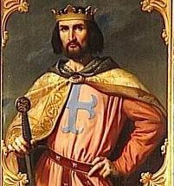
Edessa
Edessa had been seized during the First Crusade by Baldwin, brother of Godfrey of Bouillon, in 1098, who took the deceased governor Thoros’ daughter, Arda, as his wife.
The region was vast compared to most of the Frankish states but with a low population and was punctuated by a series of fortresses. The most important of these was Turbessel, which protected the south west of the country. The lords of Turbessel were usually the most trusted deputy of Edessa’s count.
By 1099 a Catholic archbishop had been appointed over the city, despite it traditionally being a Greek Orthodox city. But the population were predominantly Armenian Christian, hence why the counts, for political reasons, married Armenian princesses. Some Syriac and Orthodox Christians also lived there, as well as a Muslim Arab population.

Right: the hill fortress of Turbessel.

Baldwin of Boulogne

Background: Frankish prince from Boulogne-sur-Mer who joined the First Crusade with his older brothers, Eustace and Godfrey. He had started on a path to joining the Church but changed tack and became a knight. He had been widowed and was looking for a new wife too.
Acquisition: During the First Crusade, before the Franks reached Antioch, Baldwin had led his army to Edessa. He had received a message from the Armenian governor of Edessa, Thoros, calling for his help in liberating Edessa from the Seljuks, but the governor was killed shortly afterwards in a coup (Baldwin’s role is unclear) and Baldwin claimed the city, taking Thoros’ daughter, Arda, as his wife.
Reign: 1098-1100

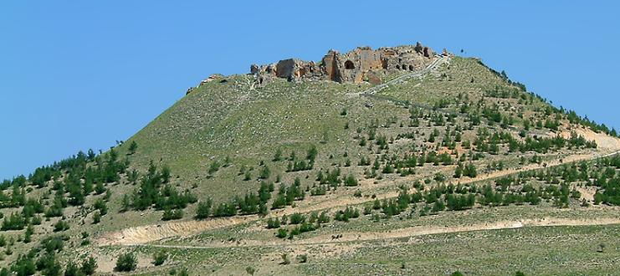

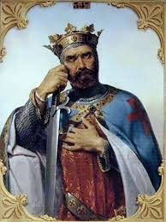
Antioch
More than any other state in Outremer, Antioch’s Frankish possession irked the Byzantines. The crusader princes of the First Crusade had sworn to give land previously held by the Byzantines back to them but when Antioch was captured in 1098, Bohemund of Taranto claimed it for himself. The Norman looked like he was a strong ally of Alexios I, the Byzantine emperor, but he had a track record of raiding Byzantine lands before the First Crusade.
One particularly contentious issue within the city was the Patriarch of Antioch, held one of the five most prestigious positions (known as ‘sees’) in all of Christendom. Initially Bohemund had the Greek Orthodox Patriarch reinstated when he took the city but with this denomination affiliated with the Byzantines, it became clear that a Latin (i.e. Catholic) patriarch would suit him better. The population, however, were largely Greek, with some Armenian Christians and a few Muslims living in the countryside.

Right: manuscript showing the siege of Antioch.

Bohemund of Taranto

Background: Bohemund was the eldest son of Robert Guiscard and his father’s deputy of campaign against the Byzantines. However, his mother’s marriage was decreed invalid and Bohemund did not inherit Guiscard’s Italian lands as he was expecting. He joined the First Crusade hungry for territory but swore to return all land previously held by the Byzantines to Alexios I.
Acquisition: At the siege of Antioch, Bohemund made contact with a commander on the walls named Firouz, who agreed to let the crusaders in. Bohemund did not reveal this until the other leaders agreed to appoint anyone who broke into the city as its prince.
Reign: 1099-1108 (during which his nephew Tancred often was regent)

